Common Equipment Link Signal Specification (PLC)

DOCUMENT ID: | NUMBER OF PAGES: 135
REVISION NO: v1.1 | CREATED ON: 2025.01.01
FILENAME: | LAST REVISED:
STATUS:Release
PREPARED BY:  Signature Date | REVIEWED BY:  Signature Date
REVIEWED BY:  Signature Date | REVIEWED BY:  Signature Date
APPROVED BY  Signature Date | APPROVED AND ACCEPTED BY  Signature Date

This document contains confidential information provided by ESWIN. No part of this document may be copied, reproduced, disclosed, or transferred by any means without prior written consent of ESWIN.

ESWIN reserves the right to make updates to the information in this document without prior notice or approval from others. Please consult the author of this document to ensure that you have the latest revision.

- NOTICE -
This is a preliminary version of Link Signal Specification for Equipment Automation, and is provided to help Equipment Makers(Venders) to acquire general idea regarding Link Signal guide lines. After determination of EAS, EAS Project team can have Operation Scenario discussion in detail to furnish specific requirement of each Equipment. If any modification is required to fulfill equipment specific operation requirement after Operation Scenario discussion, this specification is subjected to be modified accordingly.

Item | Version | Page | Change Place | Writer | Date
1 | v0.1 | All | Initial |  | 2025.01.01

Table of Contents

REVISION HISTORY 3
TABLE OF CONTENTS 4
- LINK SIGNAL 7
  - Upstream Link Signal (Upstream To Downstream) 7
  - Downstream Link Signal (Downstream To Upstram) 8
  - Link Signal Monitor (Stage & Multi Slot State Monitoring) 9
- SIGNAL SPECIFICATION 11
  - Signal Description 11
  - EQ to EQ Signal Appendix 13
- PRE-CHECK POINT 14
  - Shutter Open Pre Action 14
  - Point of Shutter Open Request 15
  - Robot Command 16
  - Condition check of Robot complete bit (Between PLC and Robot) 16
- TYPE OF TRANSFER INTERFACE BETWEEN EQUIPMENTS 18
  - Normal Transfer 18
  - Line Control Signals 19
    - Upstream Trouble Signal 19
    - Downstream Trouble Signal 20
    - Other Signal 20
  - Recovery Transfer 20
    - Cancel Request 20
    - Abort Request 21
    - Resume Request 21
  - Robot Interlock 21
- NORMAL TIMING CHART 23
  - Type 1 Time Chart (Robot-Single Stage) 23
  - Type 2 Time Chart (Robot-Single Stage/Shutter) 27
  - Type 3 Time Chart (Robot-Multiple Stage) 31
    - 1 Slot Case 32
    - 2 Slot Case 34
    - 4 Slot Case 36
  - Type 4 Time Chart (Robot-Multiple Stage/Shutter) 38
    - 1 Slot Shutter Case 39
    - 2 Slot Shutter Case 41
  - Type 5 Time Chart (Single Stage-Robot) 43
  - Type 6 Time Chart (Single Stage/Shutter-Robot) 47
  - Type 7 Time Chart (Multiple Stage-Robot) 51
    - 1 Slot Case 52
    - 2 Slot Case 54
    - 4 Slot Case 56
  - Type 8 Time Chart (Multiple Stage/Shutter-Robot) 58
    - 1 Slot Shutter Case 59
    - 2 Slot Shutter Case 61
  - Type 9 Time Chart (Conveyor-Conveyor) 63
  - Type 10 Time Chart (Single Stage-Robot : Exchange/One Action) 63
  - Type 11 Time Chart (Single Stage/Shuter-Robot : Exchange/One Action) 71
  - Type 12 Time Chart (Multiple Stage-Robot : Exchange/One Action) 76
  - Type 13 Time Chart (Multiple Stage/Shutter-Robot : Exchange/One Action) 79
  - Type 14 Time Chart (Single Stage-Robot : Exchange/Two Action) 83
  - Type 15 Time Chart (Single Stage/Shutter-Robot : Exchange/Two Action) 88
  - Type 16 Time Chart (Multiple Stage-Robot : Exchange/Two Action) 93
  - Type 17 Time Chart (Multiple Stage/Shutter-Robot : Exchange/Two Action) 96
- RECOVERY TIMING CHART 99
  - Cancel Request(No handling glass from upstream to downstream) 99
    - Stage(Upstream) - Robot(Downstream) 99
    - Robot(Upstream) - Stage(Downstream) 101
    - Conveyor 103
  - Abort Request(Handling glass from upstream to downstream) 105
    - Stage(Upstream) - Robot(Downstream) 105
    - Robot(Upstream) - Stage(Downstream) 107
    - Conveyor 109
  - Resume Request 111
    - Stage(Upstream) - Robot(Downstream) 111
    - Robot(Upstream) - Stage(Downstream) 113
    - Conveyor 115
- TIME OUT 117
  - Time out Table 117
  - Abnormal Case 118
    - Bit off on the Signal Handshake 118
    - Conveyer to conveyer 118
- LINE SPECIAL FUNCTION 119
  - Array Special Function 119
    - PECVD 119
  - Cell Special Function 121
    - PI 121
    - ODF 126
    - Recovery Transfer (Cell Inline only) 134
    - Manual Operation (Cell Inline only) 135

-

Link Signal

No | Name | Direction | Comments
1 | Upstream Inline | Upstream → Downstream | ON : Link-signal is possible
2 | Upstream Trouble | Upstream → Downstream | ON : Equipment State DOWN or EMS
3 | Send Able | Upstream → Downstream
4 | Send Start | Upstream → Downstream
5 | Send Complete | Upstream → Downstream
6 | Job Transfer | Upstream → Downstream
7 | Robot Interlock | Upstream → Downstream
8 | Shutter State | Upstream → Downstream
9 | Pin State | Upstream → Downstream
10 | Slot Pair Flag | Upstream → Downstream
11 | Arm Slot Pair Flag | Upstream → Downstream
12 | Slot No | Upstream → Downstream | Slot No has 6 bit
13 | Slot No | Upstream → Downstream | Slot No has 6 bit
14 | Slot No | Upstream → Downstream | Slot No has 6 bit
15 | Slot No | Upstream → Downstream | Slot No has 6 bit
16 | Slot No | Upstream → Downstream | Slot No has 6 bit
17 | Slot No | Upstream → Downstream | Slot No has 6 bit
18 | Exchange Possible | Upstream → Downstream
19 | Exchange Execute | Upstream → Downstream
20 | Cancel Request | Upstream → Downstream
21 | Cancel Ack | Upstream → Downstream
22 | Cancel Nack | Upstream → Downstream
23 | Abort Request | Upstream → Downstream
24 | Abort Ack | Upstream → Downstream
25 | Abort Nack | Upstream → Downstream
26 | Resume Request | Upstream → Downstream
27 | Resume Ack | Upstream → Downstream
28 | Resume Nack | Upstream → Downstream
29 | First Slot Exist | Upstream → Downstream | Robot Arm Slot Exist
30 | Second Slot Exist | Upstream → Downstream | Robot Arm Slot Exist
31 | Third Slot Exist | Upstream → Downstream | Reserved
32 | Fourth Slot Exist | Upstream → Downstream | Reserved
33 | Glass Exist | Upstream → Downstream | Ex)Conveyor to Conveyor
32 | Fourth Slot Exist | Downstream →Upstream | Reserved
33 | Glass Exist | Downstream → Upstream | Ex)Conveyor to Conveyor[Downstream -> upstream]
34 | Reserved
35~ 64 | Refer to Link Signal Monitor

Upstream Link Signal (Upstream To Downstream)

Downstream Link Signal (Downstream To Upstram)

No | Name | Direction | Comments
1 | Downstream Inline | Downstream →Upstream | ON : Link-signal is possible
2 | Downstream Trouble | Downstream →Upstream | ON : Equipment State DOWN or EMS
3 | Receive Able | Downstream →Upstream
4 | Receive Start | Downstream →Upstream
5 | Receive Complete | Downstream →Upstream
6 | Job Transfer | Downstream →Upstream
7 | Robot Interlock | Downstream →Upstream
8 | Shutter State | Downstream →Upstream
9 | Pin State | Downstream →Upstream
10 | Slot Pair Flag | Downstream →Upstream
11 | Arm Slot Pair Flag | Downstream →Upstream
12 | Slot No | Downstream →Upstream | Slot No has 6 bit
13 | Slot No | Downstream →Upstream | Slot No has 6 bit
14 | Slot No | Downstream →Upstream | Slot No has 6 bit
15 | Slot No | Downstream →Upstream | Slot No has 6 bit
16 | Slot No | Downstream →Upstream | Slot No has 6 bit
17 | Slot No | Downstream →Upstream | Slot No has 6 bit
18 | Exchange Possible | Downstream →Upstream
19 | Exchange Execute | Downstream →Upstream
20 | Cancel Request | Downstream →Upstream
21 | Cancel Ack | Downstream →Upstream
22 | Cancel Nack | Downstream →Upstream
23 | Abort Request | Downstream →Upstream
24 | Abort Ack | Downstream →Upstream
25 | Abort Nack | Downstream →Upstream
26 | Resume Request | Downstream →Upstream
27 | Resume Ack | Downstream →Upstream
28 | Resume Nack | Downstream →Upstream
29 | First Slot Exist | Downstream →Upstream | Robot Arm Slot Exist
30 | Second Slot Exist | Downstream →Upstream | Robot Arm Slot Exist
31 | Third Slot Exist | Downstream →Upstream | Reserved

  - Link Signal Monitor (Stage & Multi Slot State Monitoring)
Provide a screen on the touch panel for Equipment operation to monitor the link signals.
The states of the Uplink Signal and Downlink signal should preferably be able to be confirmed on one screen. And, for debugging purpose, it should be able to manually set on/off the signal from touch panel screen.

No | Name | Comments
01 | Abnormal | 1 : Abnormal  0 : Others
02 | Empty | 1 : Empty  0 : Others
03 | Idle | 1 : Idle  0 : Others
04 | Run | 1 : Run  0 : Others
05 | Complete | 1 : Complete  0 : Others
06 | Lift Up or Pin Up | 1 : Up  0 : Others
07 | Lift Down or Pin Down | 1 : Down  0 : Others
08 | Stopper Up or Shutter Open | 1 : Up or Open  0 : Others
09 | Stopper Down or Shutter Close | 1 : Down or Close  0 : Others
10 | Manual Operation | 1 : Manual Operation  0 : Auto Operation
11 | Body Moving | 1 : Moving  0 : Others
12 | Glass Exist Arm #1(Check Sensor on) | 1 : Glass Exist  0 : Glass Not Exist
13 | Glass Exist Arm #2(Check Sensor on) | 1 : Glass Exist  0 : Glass Not Exist
14 | Glass Exist Arm #3(Check Sensor on) | 1 : Glass Exist  0 : Glass Not Exist
15 | Glass Exist Arm #4(Check Sensor on) | 1 : Glass Exist  0 : Glass Not Exist
16 | Arm Stretch complete | When robot arm is completely stretched, This bit turn on  And This bit turn off when Robot arm is moving
17 | Arm Vacuum | 1 : adsorption  0 : otherwise
18 | Conveyor State | 1 : On  0 : Off
19 | Arm Vacuum | 1 : adsorption  0 : otherwise
20 | Conveyor State | 1 : On  0 : Off
21 | Reserved
22 | Reserved
23 | Arm Fold complete | When robot arm is completely folded, This bit turn on  And This bit turn off when Robot arm is moving
24 | Make Define #1 | Line or Machine Specific Item.
25 | Make Define #2 | Line or Machine Specific Item.
26 | Make Define #3 | Line or Machine Specific Item.
27 | Make Define #4 | Line or Machine Specific Item.
28 | Make Define #5 | Line or Machine Specific Item.
29 | Make Define #6 | Line or Machine Specific Item.
30 | Make Define #7 | Line or Machine Specific Item.
31 | Make Define #8 | Line or Machine Specific Item.
32 | Make Define #9 | Line or Machine Specific Item.

Signal Specification

Signal Description

Signal | Description
Upstream Inline | On :  - This Equipment sends possible glass.  - The inline mode is related only with job transferring and is necessary only between upstream equipment and downstream equipment.  - ​  Off :Handshake of Link-signal is not possible but not disconnected.  - The Inline mode can’t turn off while doing Handshake of Link-signal but it can turn off while doing Handshake of Link-signal when Bit of Trouble turn on  * Always Keep Watch
Upstream Trouble | Status : Equipment State is DOWN or EMS (emergency stop)  - On : Alarmed  - Off : Other  * Always Keep Watch  if OP want to pause the equipment , this signal has to turn on after cycle stop that is stopped after an execution of command is completed for glass flow
Downstream Inline | On :  - This Equipment sends possible glass.  - The inline mode is related only with job transferring and is necessary only between upstream equipment and downstream equipment.  - ​  Off :Handshake of Link-signal is not possible but not disconnected.  - The Inline mode can’t turn off while doing Handshake of Link-signal but it can turn off while doing Handshake of Link-signal when Bit of Trouble turn on  * Always Keep Watch
Downstream Trouble | Status : Equipment State is DOWN or EMS (emergency stop)  - On : Alarmed  - Off : Other  * Always Keep Watch  if OP want to pause the equipment , this signal has to turn on after cycle stop that is stopped after an execution of command is completed for glass flow
Send Able | When Upstream can transfer Glass, turn on the signal.
Send Start | When Upstream starts transfer Glass, turn on the signal.
Send Complete | When Upstream completed transfer Glass, turn on the signal.
Receive Able | When Downstream can transfer Glass, turn on the signal.
Receive Start | When Downstream starts transfer Glass, turn on the signal.
Receive Complete | When Downstream completed transfer Glass, turn on the signal.
Job Transfer | Determines the report timing of Transfer related Transfer Event. Equipment with Robot manages the Job Transfer.  When Job Transfer signal is turned on, Upstream reports Sent Out Job Event Report. When Job Transfer signal is turned off, Downstream reports Received Job Event Report.
Robot Interlock | It is the signal to prevent Equipment without Robot to perform any movement which can interfere with  Robot movement when it is transferring Glass
Shutter State | It indicates Shutter Open/Close state in Equipment with Shutter. ON : Shutter Open  OFF : Shutter Close
Pin State | It indicates Stage's Pin Up/Down state ON : Pin Up  OFF : Pin Down
Slot Pair Flag | Turn on the signal when transferring more than one Glass to Stage with Multi Slot.  It is used with Slot No signal and when it is turned on, it means Glass of Slot No+1 slot is included in Transfer.
Arm Slot Pair Flag | Turn on the signal when Slot Pair Flag signal is on and Robot is transferring 2 Glass by batch as sequential arm moving.  Turn off the signal when transfer is completed.
Slot No (1)  ~ Slot No (6) | Slot #1 ~ Slot #63  Slot No(6) is high bit (x 32) Ex) 001011 -> Slot #11  Pair slot defined rule with operation scenario, Normally N+1.  When pre-action need to use to send the slot position, here items should use for waiting front at slot position.
Exchange Possible | Indicates possibility of Exchange in Stage where Exchange is supported. ON : Exchange Possible  OFF : Exchange Impossible  This signal should always turn on if Exchange interface type be used.
Exchange Execute | Turn on the signal when Exchange starts between UP and Downstream and turn off the signal when Transfer is completed.
Cancel Request | It is signal to take measure when trouble occurs in Equipment with Robot performing Put or Get Sequence for Glass transfer.  If Robot does not have Glass, Cancel is possible and when Transfer Cancel is completed, resume re-transfer.
Cancel Ack | Recognition to Cancel Request.
Cancel Nack | Not Acknowledge to Cancel Request meaning to maintain state before the request.
Abort Request | It is signal to take measure when trouble occurs in Equipment with Robot performing Put or Get Sequence for Glass transfer.  If Robot has Glass, Abort is possible and Operator transfer Glass to Downstream manually then starts Abort.
Abort Ack | Recognition to Abort Request.
Abort Nack | Not Acknowledge to Abort Request meaning to maintain state before the request.
Resume Request | When trouble during Glass transfer between Up/Downstream is solved and can resume Transfer, operator starts Resume.
Resume Ack | Recognition to Resume Request.
Resume Nack | Not Acknowledge to Resume Request meaning to maintain state before the request.
First Slot Exist | Use the signal when transferring 4 Glass simultaneously  Turn on the signal when Glass is transfer to this slot of stage with Multi Slot.
Second Slot Exist | Use the signal when transferring 4 Glass simultaneously  Turn on the signal when Glass is transfer to this slot of stage with Multi Slot.
Third Slot Exist | Use the signal when transferring 4 Glass simultaneously  Turn on the signal when Glass is transfer to this slot of stage with Multi Slot.
Fourth Slot Exist | Use the signal when transferring 4 Glass simultaneously  Turn on the signal when Glass is transfer to this slot of stage with Multi Slot.
Arm Stretch Complete | When robot arm is completely stretched, This bit turn on And This bit turn off when Robot arm is moving
Arm Fold Complete | When robot arm is completely folded, This bit turn on And This bit turn off when Robot arm is moving
Arm Vacuum | If the adsorption ON, otherwise OFF
Pre Command | This signal is used to pre-action of shutter open or pin up or lift up on state between robot and stage  If Equipment’s shutter open time is more than Robot transfer time, Robot should on a bit of Shutter Open Request before the robot move to stage.  When ‘Remain time’ turns on , pre command of shutter open or pin up or and lift up is going to send the stage  Also the lifter at stage should stand by stage before robot send a glass to lifter

EQ to EQ Signal Appendix

Signal | Description
Transfer Stop Request | This signal is used to prevent job (glass) from staying in midway equipment of in-line system when buffer or un-loader is in a state of overflow condition. The buffer and loader does not transfer job (glass) to downstream any more while it receives “Transfer Stop Request Signal” from downstream for line control But in this time, the cycling glass in the equipment must be flow.  If there is no place to store glasses on the buffer or un-loader due to no empty cassette, this signal should be set “1”.  Other equipments, upon receiving this signal “1” from downstream equipment, should preserve this signal as “1” and pass to upstream equipment.  - Buffer  If “Transfer Stop Request” signal is received from downstream equipment, the glass should be buffered in itself because can’t flow to downstream.  Equipment vendor prepare “Transfer Stop Request” signal on glass count and off glass count setting function on touch panel.  - Loader  Job (glass) transfer from cassettes should be stopped if this signal is input from the downstream equipment. (Glass already fetched out from cassette should be unloaded to the downstream equipment.)  - Un-loader  If there is no place to store glasses on the un-loader due to no empty cassette, this signal should be set “1”.  - Other equipment  This signal input from the downstream equipment shall be output to the upstream equipment immediately.
Loading Stop Request | This signal is used to prevent job (glass) from staying in block control equipment of in-line system when buffer or un-loader is in a stage of overflow condition. The buffer and loader does not transfer job (glass) to downstream any more while it receives “Loading Stop Request Signal” from other downstream for line control  But in this time, the cycling glass in the equipment must be flow.
Pre-Action Signal | Refer to PLC Communication Spec 10.12

Pre-Check Point

Shutter Open Pre Action
When Equipment satisfy the condition to start Transfer, turn on 'Send Able' or 'Receive Able' and starts transfer.
Depending on Equipment, Shutter or Pin may operate before starting Transfer. For Example, according to Shutter or Pin signal defined in Up/Downstream Transfer Link-signal specification, it is possible in some case, Tack time is increased. Due to such reason, Equipment Vender may perform Shutter and Pin movement like below diagram.
In Details, Refer to PLC Communication Spec 10.12 Pre-action Signal (EQ to EQ)
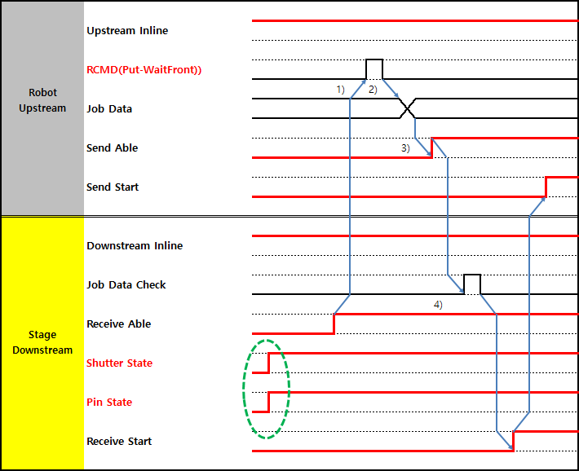

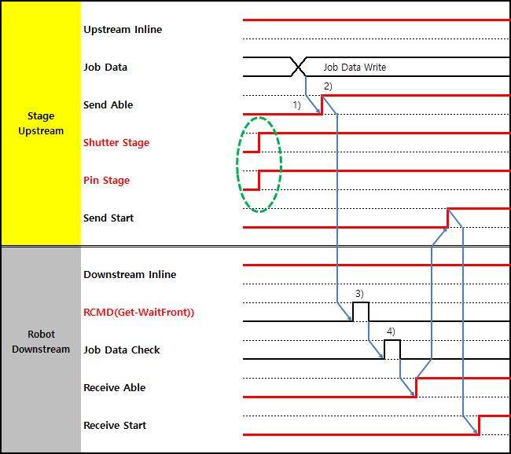

Point of Shutter Open Request
If Equipment’s shutter open time is more than Robot transfer time, Robot should on a bit of Shutter Open Request before the robot move to stage.
This Signal is used to area of bit from Equipment to Equipment
Detail and whether to use this item need discuss between Equipment Vendor.
In Details, Refer to PLC Communication Spec 10.12 Pre-action Signal (EQ to EQ)
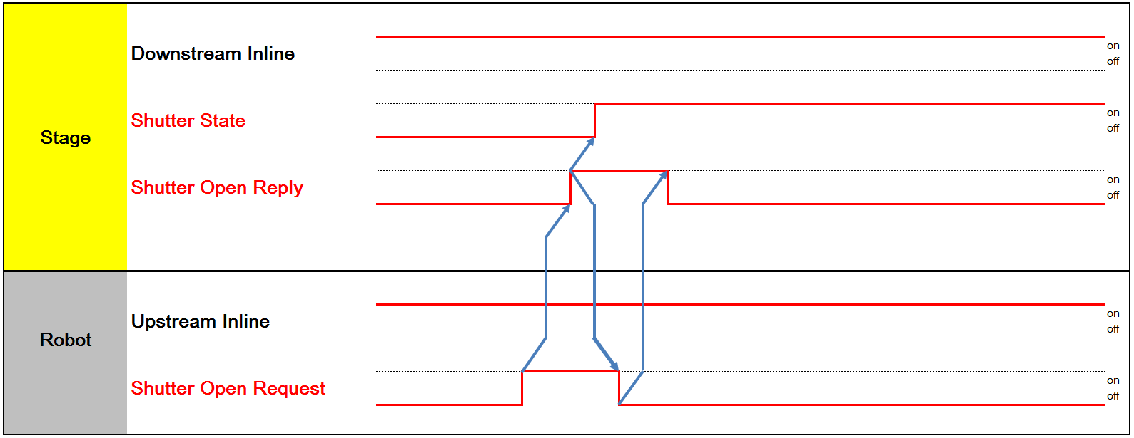

Robot Command
- Put : Indexer arm un-loads its glass onto the unit of counter stream Equipment.
- Get : Indexer arm loads a glass onto its one of arms from the unit of counter stream Equipment.
- Transfer(from-to) : Indexer executes get command at the get-position, moves and put command at the put-position
- Move(to) : Indexer robot moves to the specific position
- One action exchange : Indexer executes exchange command at the get-position that the stage of counter stream has available space.
- Two action exchange : Indexer executes exchange command at the get-position that the stage of counter stream has not available space. so, robot has to move with fold then it stretches for put- action.
- Batch Get/Put : Two or more robot arms conducts get or put action simultaneously(one-action), sequentially(two-action)

Condition check of Robot complete bit (Between PLC and Robot)
When Robot is overlap with moving then maybe robot signal is not sent from robot to downstream This problem is what to be condition in case complete bit doesn’t work normally
Robot vender must check signal of Robot stretch& Fold and Vacuum Sensor and Glass Exist then if all signal is normal, the Complete Signal is to be On

Condition of Send Complete | Condition of Receive Complete
Arm Stretch Complete: 'On' Arm Vacuum : 'Off'  Glass Exist : 'Off'’ Robot Interlock : 'On' | Arm Fold Complete : 'On' Arm Vacuum : 'On'  Glass Exist : 'On' Robot Interlock : 'On'
[Condition of Send Complete]
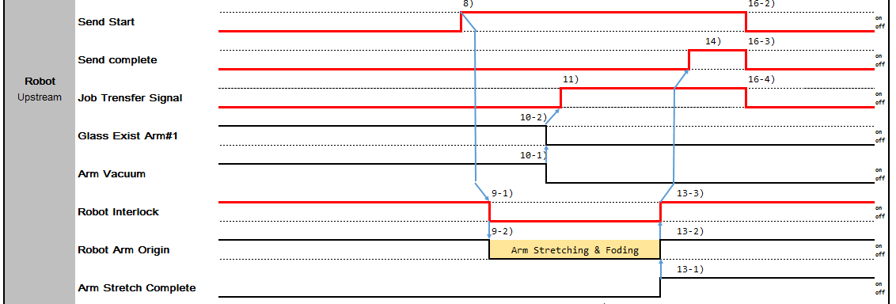
[Condition of Receive Complete]

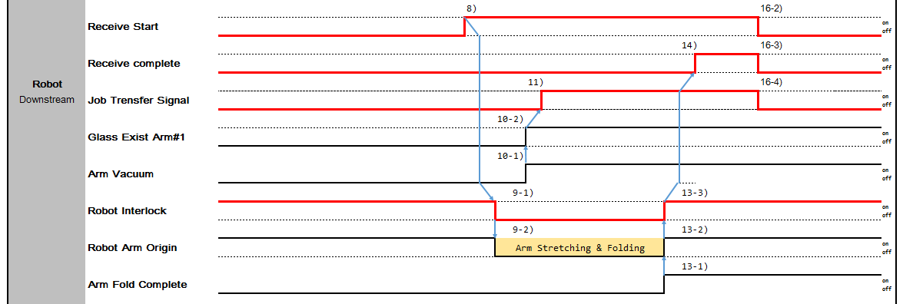

Type of transfer Interface between equipments
The Interface signal between upstream/downstream is required to transfer Glass. And the Interface signal system shall be classified by the unit structure of glass-out side or glass-in in the equipments.
It may be classified based on the action and the structure of upstream/downstream as following.

Normal Transfer

I/F Type | Glass-out | Glass-in | Action
Type 1 | Robot | Single Stage  (No Shutter, Self Controlled Shutter)  - PIN Stage  - CV(Pin CV, Big Roller CV, Gate CV)  - Turn Stage | Loading  Robot → Single Stage
Type 2 | Robot | Single Stage  (Includes Shutter, Need to Control Shutter)  - PIN Stage  - CV(Pin CV, Big Roller CV, Gate CV)  - Turn Stage | Loading  Robot → Single Stage
Type 3 | Robot | Multiple Stage  (No Shutter, Self Controlled Shutter)  - Buffer  - Cassette | Loading  Robot → Multiple Stage
Type 4 | Robot | Multiple Stage  (Includes Shutter, Need to Control Shutter)  - Buffer  - Cassette | Loading  Robot → Multiple Stage
Type 5 | Single Stage  (No Shutter, Self Controlled Shutter)  - PIN Stage  - CV(Pin CV, Big Roller CV, Gate CV)  - Turn Stage | Robot | Unloading Robot ← Single Stage
Type 6 | Single Stage  (Includes Shutter, Need to Control Shutter)  - PIN Stage  - CV(Pin CV, Big Roller CV, Gate CV)  - Turn Stage | Robot | Unloading Robot ← Single Stage
Type 7 | Multiple Stage  (No Shutter, Self Controlled Shutter)  - Buffer  - Cassette | Robot | Unloading  Robot ← Multiple Stage
Type 8 | Multiple Stage  (Includes Shutter, Need to Control Shutter)  - Buffer  - Cassette | Robot | Unloading  Robot ← Multiple Stage
Type 9 | Conveyor | Conveyor | Send/Receive CV → CV
Type 10 | Single Stage  (No Shutter, Self Controlled Shutter)  - PIN Stage  - CV(Pin CV, Big Roller CV, Gate CV) | Robot | Combination of Type1 and 5 One Action Exchange  Robot ↔ Single Stage

 | - Turn Stage
Type 11 | Single Stage  (Includes Shutter, Need to Control Shutter)  - PIN Stage  - CV(Pin CV, Big Roller CV, Gate CV)  - Turn Stage | Robot | Combination of Type2 and 6 One Action Exchange  Robot ↔ Single Stage
Type 12 | Multiple Stage  (No Shutter, Self Controlled Shutter)  - Buffer  - Cassette | Robot | Combination of Type3 and 7 Two Action Exchange  Robot ← Multiple Stage Robot → Multiple Stage
Type 13 | Multiple Stage  (Includes Shutter, Need to Control Shutter)  - Buffer  - Cassette | Robot | Combination of Type4 and 8 Two Action Exchange  Robot ← Multiple Stage Robot → Multiple Stage
Type 14 | Single Stage  (No Shutter, Self Controlled Shutter)  - PIN Stage  - CV(Pin CV, Big Roller CV, Gate CV)  - Turn Stage | Robot | Combination of Type1 and 5 Two Action Exchange  Robot ← Single Stage Robot → Single Stage
Type 15 | Single Stage  (Includes Shutter, Need to Control Shutter)  - PIN Stage  - CV(Pin CV, Big Roller CV, Gate CV)  - Turn Stage | Robot | Combination of Type2 and 6 Two Action Exchange  Robot ← Single Stage Robot → Single Stage
According to the situation, it may be operated as special type other than the types indicated above.

Line Control Signals

Upstream Trouble Signal
This signal sequentially transmits trouble occurrence from troubled equipment to downstream to disseminate alarm output to the operators.
- Troubled equipment
The troubled equipment should be out put to the downstream equipment and an alarm (buzzer, signal tower light, error code display…) should be issued to the operator.
- Un-loader
When this signal is received, un-loader should raise a warning.
- Other equipment
This signal input from the upstream equipment shall be output to the downstream equipment immediately.
- Machine Manual Equipment(Impossible Auto Run).
The Manual equipment should be out put to the downstream equipment.

Loader | Equipment 1 | Equipment 2 | Equipment 3  Alarm In Transfer Part | Equipment n |  | Unloader  Fire warning

Downstream Trouble Signal
This signal sequentially transmits trouble occurrence from troubled equipment to upstream to disseminate alarm output to the operators.
      - Troubled equipment
The troubled equipment should be out put to the upstream equipment and an alarm (buzzer, signal tower light, error code display…) should be issued to the operator.
      - Loader
When this signal is received, loader should raise a warning.
      - Other equipment
This signal input from the downstream equipment shall be output to the upstream equipment immediately.
      - Machine Manual Equipment(Impossible Auto Run).
The Manual equipment should be out put to the Upstream equipment.
Equipment 1
Equipment 3
Alarm In Transfer Part

Equipment n

Equipment 2
Fire warning
Loader

Unloader

Other Signal
It can refer at EQ to EQ Appendix Signal that Transfer Stop Signal and Loading Stop Signal

Recovery Transfer

Cancel Request

      - Cancel Request Condition
In case of normal transfer is impossible, Equipment Normal Mode, Impossible Auto Run due to Trouble occurred in transfer Unit(Robot or Stage) after Up/Downstream transfer has begun and job transfer signal is off

      - Recovery Operation
- Due to trouble occurred during Glass transfer, transfer is stopped.

- Transfer is not resumed even after Equipment Trouble is solve by Operator.
- When Operator Cancels after checking, manually return Robot to original position.
- Operator press Cancel Request at touch panel of Up or Downstream. (Equipment must support related function in Touch panel)
- Up or Downstream replies to Cancel Request and initialize transfer-related signals.
- When Upstream is ready to re-transfer, resume transfer.

Abort Request

      - Abort Request Condition
In case of normal transfer is impossible, Equipment Normal Mode, Impossible Auto Run due to Trouble occurred in transfer Unit(Robot or Stage) after Up/Downstream transfer has begun and Job Transfer Signal is On

      - Recovery Operation
- Due to trouble occurred during Glass transfer, transfer is stopped.
- Transfer is not resumed even after Equipment Trouble is solve by Operator.
- When Operator Aborts after checking, manually transfer Glass to Downstream
- Download or generate Job Data of Glass in Downstream manually
- Operator press Abort Request at touch panel of Up or Downstream. (Equipment must support related function in Touch panel)
- Up or Downstream replies to Abort Request and initialize transfer-related signals.
- Transfer is completed and Downstream reports 'Received Job Event'.

Resume Request

      - Resume Request Condition
In case of normal transfer is paused, Equipment Normal Mode, Impossible Auto Run due to Trouble occurred in unit except transfer Unit(Robot or Stage) after Up/Downstream transfer has begun and Operator decides normal transfer can be continued..

      - Resume Operation
- Due to trouble occurred during Glass transfer, transfer is stopped.
- Transfer is not resumed even after Equipment Trouble is solve by Operator.
- Operator press Resume Request at touch panel of Up or Downstream. (Equipment must support related function in Touch panel)
- Up or Downstream replies to Abort Request and resume paused transfer.

Robot Interlock
When Glass is ready to transferring to Equipment such as ‘Sendable’ ,’Receiveable’, ‘Sendstart’, ‘ReceiveStart’ at LinkSignal then the Robot movement is interface with upstream/downstream
While robot is moving, if the other side equipment send a signal to robot then robot maybe stop or trouble

so it has to prevent from equipment without robot to robot what is performing any movement

- When Robot Interlock is On then robot can’t move and the other side equipment can send all signals but except inline or Trouble Signal
- When Robot Interlock is Off the robot can move and the other side equipment can’t send all signals but except inline or Trouble Signal

Normal Timing Chart
If signal of the Equipment is not follow all Timing Chart below, Equipment must stop the operation and Upstream Trouble or Downstream Trouble bit is ON. When signal of Equipment back to normal, Equipment will continue to proceed with the operation and Upstream Trouble or Downstream Trouble bit is OFF.

Type 1 Time Chart (Robot-Single Stage)

Type | Glass-out | Glass-in | Action
Type 1 | Robot | Single Stage  (No Shutter, Self Controlled Shutter)  - PIN Stage  - Big Roller CV  - Gate CV  - Turn Stage | Loading  Robot → Single Stage
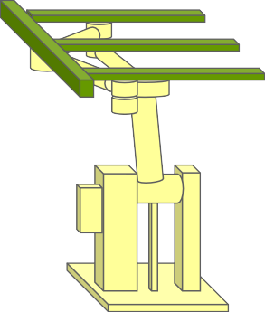
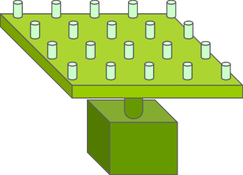

Pin Exist
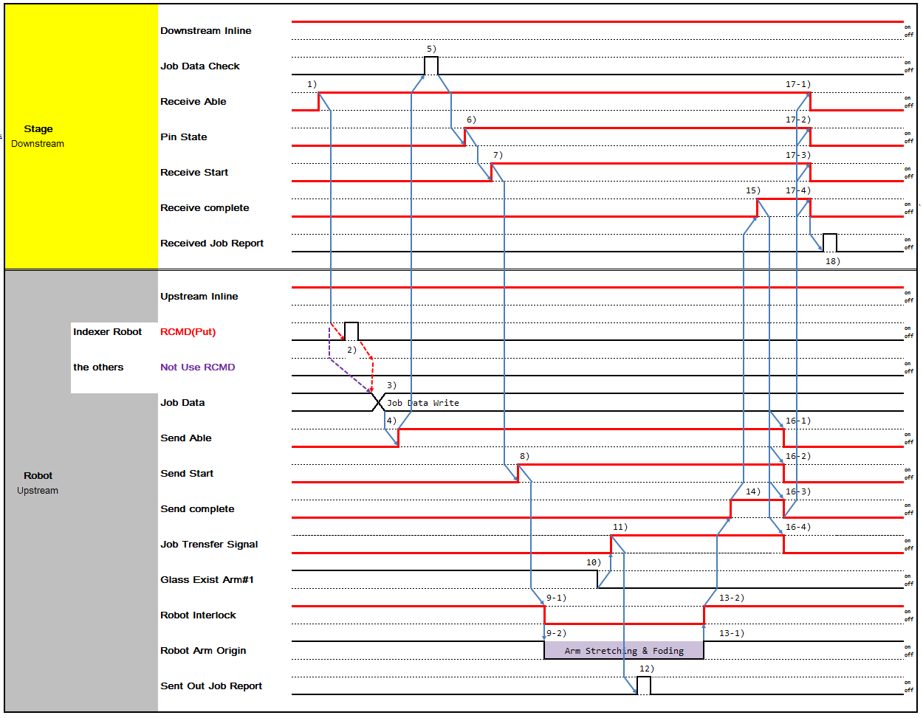

- No Pin Exist
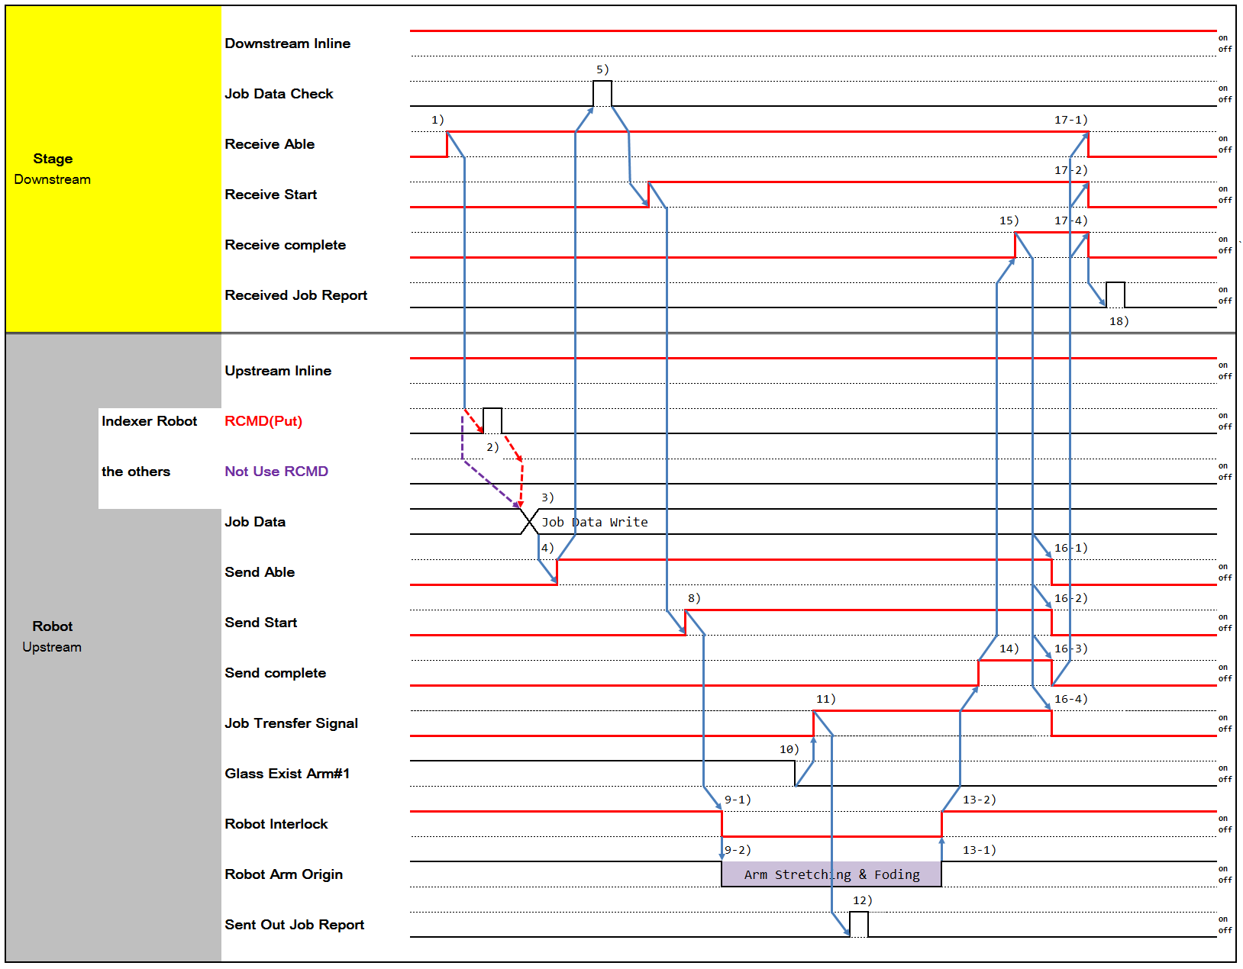

- When Downstream is ready to receive Panel, turn on 'Receive Able'.
- Robot Receives Put Command from Robot Controller.
- Write Job Data which will be send to Downstream.
- Turn on 'Send Able' when Upstream is ready to send Panel.
- Downstream checks Job Data of Panels to be received.
- If Job Data check is Ok, Lift Pin Stage up and turn on 'Pin State'.
- When Downstream is ready to receive Panel, turn on 'Receive Start'.
- Turn on 'Send Start' and Upstream start transferring.
9-1) After 'Send Start' is turned on, Robot moves and turns off Robot Interlock at the same time. Downstream doesn’t not perform any movement that interfere with Robot until Robot Interlock is turned on
9-2) Proceed with Robot Put Sequence.
- Glass existence is determined by Robot Fork Vacuum On/Off.
- When Glass Fork Vacuum is turn off, then turn on 'Job Transfer'.
- When 'Job Transfer' is on, Upstream reports 'Sent Out Report'. 13-1) Robot completes Put Sequence.
13-2) When Robot Arm returns to Original Position, remove Robot Interlock and turn on 'Robot Interlock' signal. Downstream can then Proceed with transfer-related activity.
- Turn on 'Send Complete' when Panel transfer to Downstream is completed.
- Turn on 'Receive Complete' after Panel Transfer is completed.
16-1,-2) Turn off 'Receive Start', 'Receive Able' when 'Receive Complete' is turned on. 17-1,-2) Turn off 'Receive Complete' when 'Receive Start', 'Receive Able' is turned off.
18-1,-2,-3,-4,-5) When 'Receive Complete' is turned off, turn off 'Pin State', 'Send Able', 'SendStart', 'Send Complete', 'Job transfer'.
19) After Upstream turns off 'Job Transfer' off, Downstream reports 'Received Job Report'.

Type 2 Time Chart (Robot-Single Stage/Shutter)

Type | Glass-out | Glass-in | Action
Type 2 | Robot | Single Stage  (Includes Shutter, Need to Control Shutter)  - PIN Stage  - Big Roller CV  - Gate CV  - Turn Stage | Loading  Robot → Single Stage
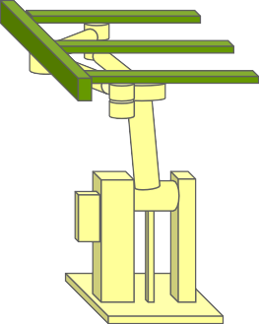
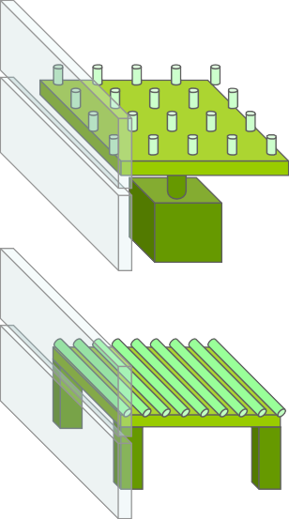

- Pin Exist
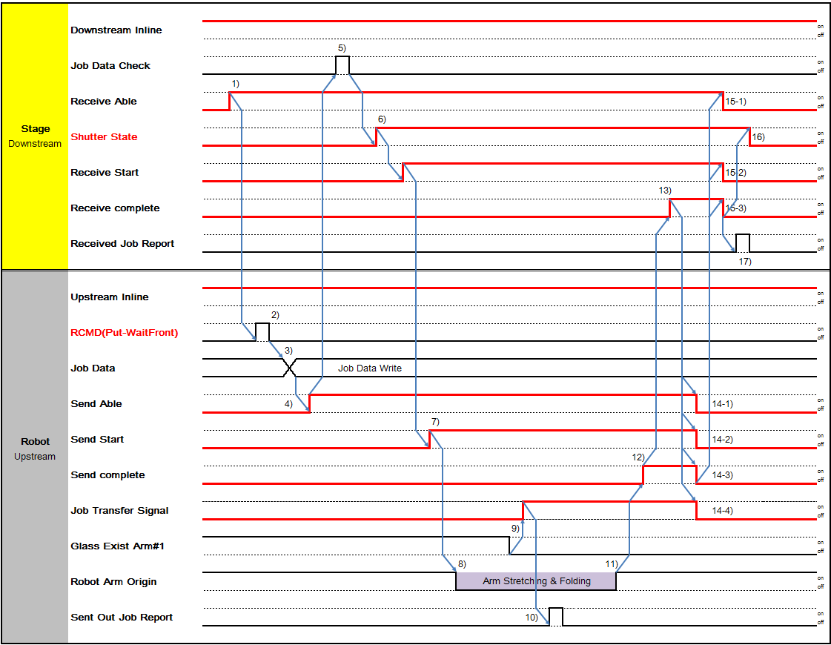

- No Pin Exist
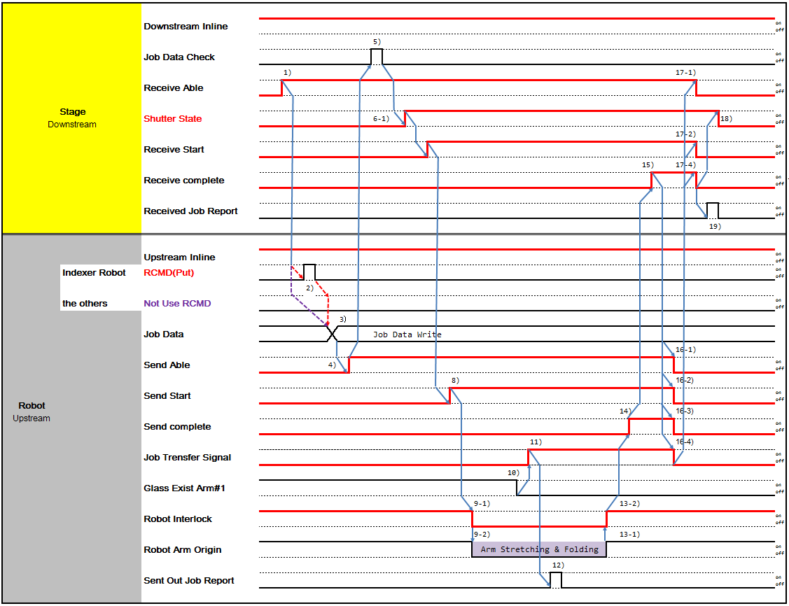

- When Downstream is ready to receive Panel, turn on 'Receive Able'.
- Robot Receives Put Command from Robot Controller.
- Write Job Data which will be send to Downstream.
- Turn on 'Send Able' when Upstream is ready to send Panel.
- Downstream checks Job Data of Panels to be received.
6-1,-2) If Job Data check is Ok, turn on 'Pin State', 'Shutter State'. According to Equipment, Two may move simultaneously or one may move prior to another. It depends on Equipment's decision.
- When Downstream is ready to receive Panel, turn on 'Receive Start'.
- Turn on 'Send Start' and Upstream start transferring.
9-1) After 'Send Start' is turned on, Robot moves and turns off Robot Interlock at the same time. Downstream doesn't not perform any movement that interfere with Robot until Robot Interlock is turned on
9-2) Proceed with Robot Put Sequence.
- Glass existence is determined by Robot Fork Vacuum On/Off.
- When Glass Fork Vacuum is turn off, then turn on 'Job Transfer'.
- When 'Job Transfer' is on, Upstream reports 'Sent Out Report'. 13-1) Robot completes Put Sequence.
13-2) When Robot Arm returns to Original Position, remove Robot Interlock and turn on 'Robot Interlock' signal. Downstream can then Proceed with transfer-related activity.
- Turn on 'Send Complete' when Panel transfer to Downstream is completed.
- Turn on 'Receive Complete' after Panel Transfer is completed.
16-1,-2) Turn off 'Receive Start', 'Receive Able' when 'Receive Complete' is turned on. 17-1,-2) Turn off 'Receive Complete' when 'Receive Start', 'Receive Able' is turned off.
18-1,-2,-3,-4,-5,-6) When 'Receive Complete' is turned off, turn off 'Pin State', 'Shutter State', 'Send Able', 'SendStart', 'Send Complete', 'Job transfer'.
19) After Upstream turns off 'Job Transfer' off, Downstream reports 'Received Job Report'.

Type 3 Time Chart (Robot-Multiple Stage)

Type | Glass-out | Glass-in | Action
Type 3 | Robot | Multiple Stage  (No Shutter, Self Controlled Shutter)  - Buffer  - Cassette | Loading  Robot → Multiple Stage
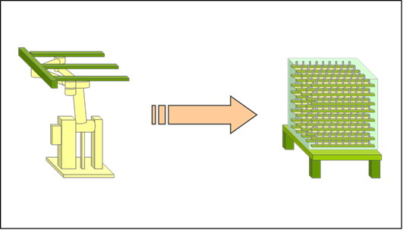

1 Slot Case
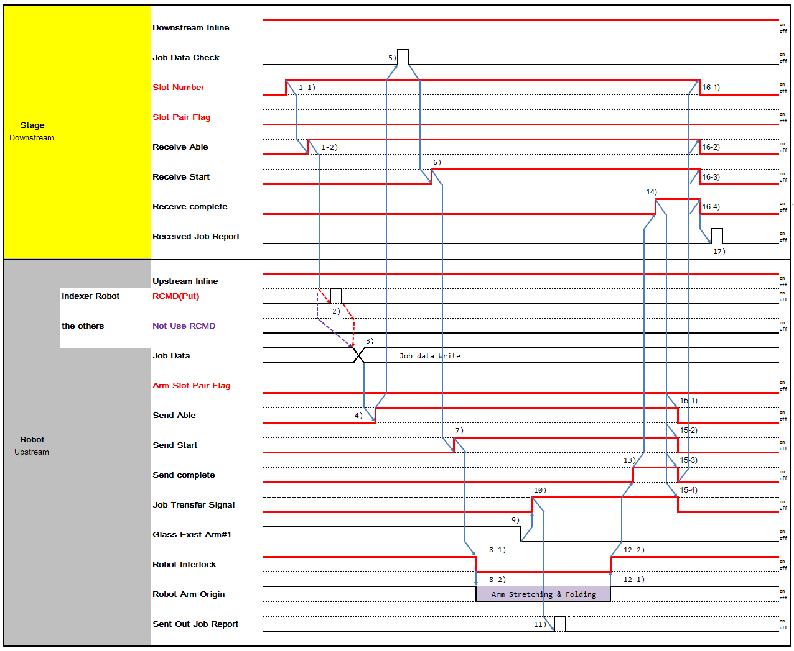

1-1) If Downstream is Multi Slot Stage, turn on 'Slot No' signal of which Panel will be transferred 1-2) When Downstream is ready to receive Panel, turn on 'Receive Able'.
- Robot Receives Put Command from Robot Controller.
- Write Job Data which will be send to Downstream.
- Turn on 'Send Able' when Upstream is ready to send Panel.
- Downstream checks Job Data of Panels to be received.
- When Downstream is ready to receive Panel, turn on 'Receive Start'.
- Turn on 'Send Start' and Upstream start transferring.
8-1) After 'Send Start' is turned on, Robot moves and turns off Robot Interlock at the same time. Downstream doesn't not perform any movement that interfere with Robot until Robot Interlock is turned on
8-2) Proceed with Robot Put Sequence.
- Glass existence is determined by Robot Fork Vacuum On/Off.
- When Glass Fork Vacuum is turn off, then turn on 'Job Transfer'.
- When 'Job Transfer' is on, Upstream reports 'Sent Out Report'. 12-1) Robot completes Put Sequence.
12-2) When Robot Arm returns to Original Position, remove Robot Interlock and turn on 'Robot Interlock' signal. Downstream can then Proceed with transfer-related activity.
- Turn on 'Send Complete' when Panel transfer to Downstream is completed.
- Turn on 'Receive Complete' after Panel Transfer is completed.
15-1,-2,-3) Turn off 'Receive Start', 'Receive Able', 'Slot Number' when 'Receive Complete' is turned on. 16-1,-2,-3) Turn off 'Receive Complete' when 'Receive Start', 'Receive Able', 'Slot Number' is turned off.
17-1,-2,-3,-4) When 'Receive Complete' is turned off, turn off' SendAble', 'SendStart', 'Send Complete', 'Job transfer'.
18) After Upstream turns off 'Job Transfer' off, Downstream reports 'Received Job Report'.

2 Slot Case
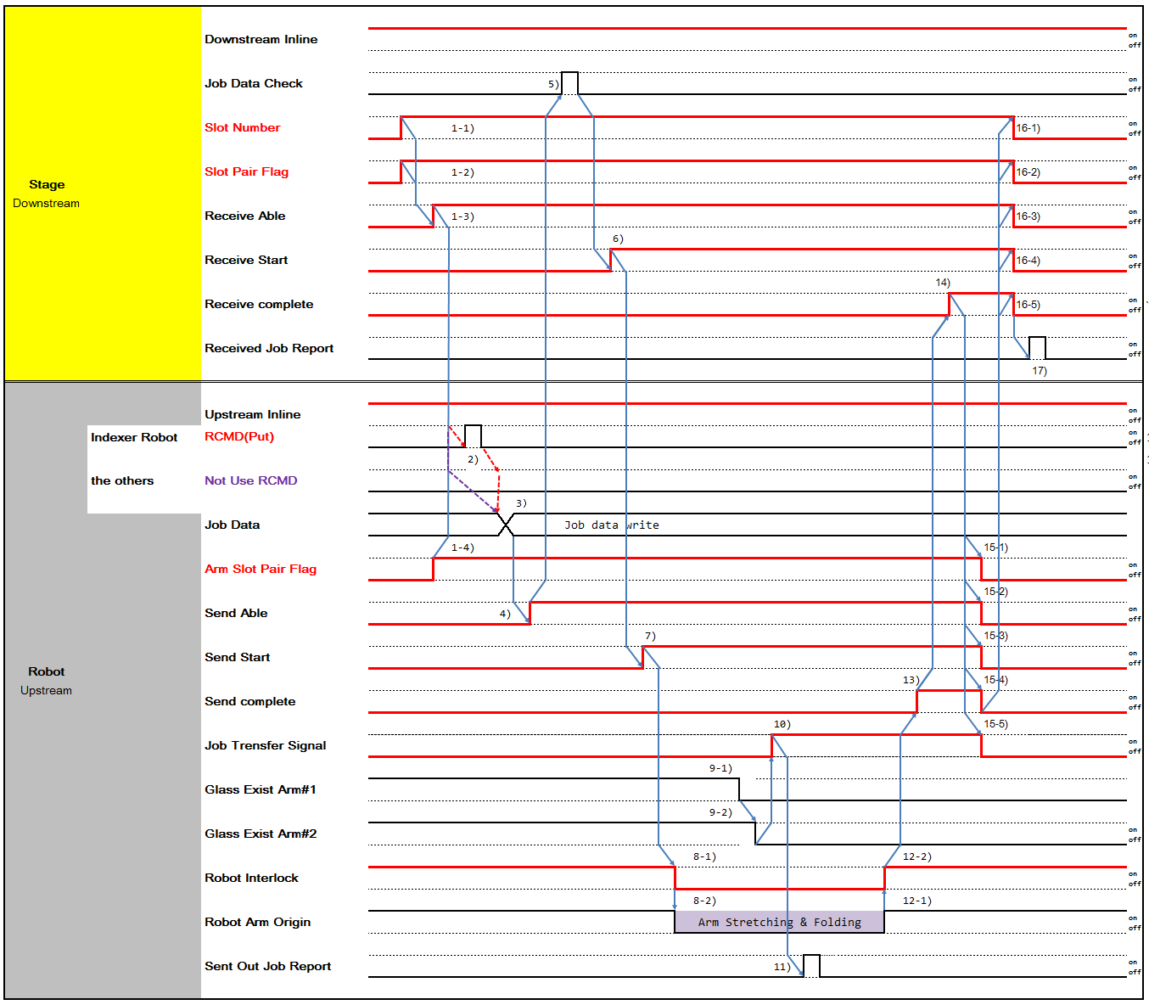

1-1) If Downstream is Multi Slot Stage and Robot transfers 2 Glass simultaneously, turn on 'Slot No' signal of lower Slot No.
1-2) If Robot transfers 2 Glass simultaneously, turn on 'Slot Pair Flag' which means to transfer Glass of Slot No and No+1 Slot.
1-3) When Downstream is ready to receive Panel, turn on 'Receive Able'. 1-4) Turn on 'Arm Slot Pair Flag' when Robot transfers 2 Panels.
- Robot Receives Put Command from Robot Controller.
- Write Job Data which will be send to Downstream.
- Turn on 'Send Able' when Upstream is ready to send Panel
- Downstream checks Job Data of Panels to be received.
- When Downstream is ready to receive Panel, turn on 'Receive Start'.
- Turn on 'Send Start' and Upstream start transferring.
8-1) After 'Send Start' is turned on, Robot moves and turns off Robot Interlock at the same time. Downstream doesn't not perform any movement that interfere with Robot until Robot Interlock is turned on
8-2) Proceed with Robot Put Sequence.
9-1,-2) Glass existence is determined by Robot Fork Vacuum On/Off.
- When Glass Fork Vacuum is turn off, then turn on 'Job Transfer'.
- When 'Job Transfer' is on, Upstream reports 'Sent Out Report'. 12-1) Robot completes Put Sequence.
12-2) When Robot Arm returns to Original Position, remove Robot Interlock and turn on 'Robot Interlock' signal. Downstream can then Proceed with transfer-related activity.
- Turn on 'Send Complete' when Panel transfer to Downstream is completed.
- Turn on 'Receive Complete' after Panel Transfer is completed.
15-1,-2,-3,-4) Turn off 'Receive Start', 'Receive Able', 'Slot Number', 'Slot pair Flag' when 'Receive Complete' is turned on.
16-1,-2,-3,-4) Turn off 'Receive Complete' when 'Receive Start', 'Receive Able’, ‘Slot Number', 'Slot Pair Flag' is turned off.
17-1,-2,-3,-4,-5) When 'Receive Complete' is turned off, turn off 'Arm Slot pair Flag' 'Send Able', 'SendStart', 'Send Complete', 'Job transfer'.
18) After Upstream turns off 'Job Transfer' off, Downstream reports 'Received Job Report'.

4 Slot Case
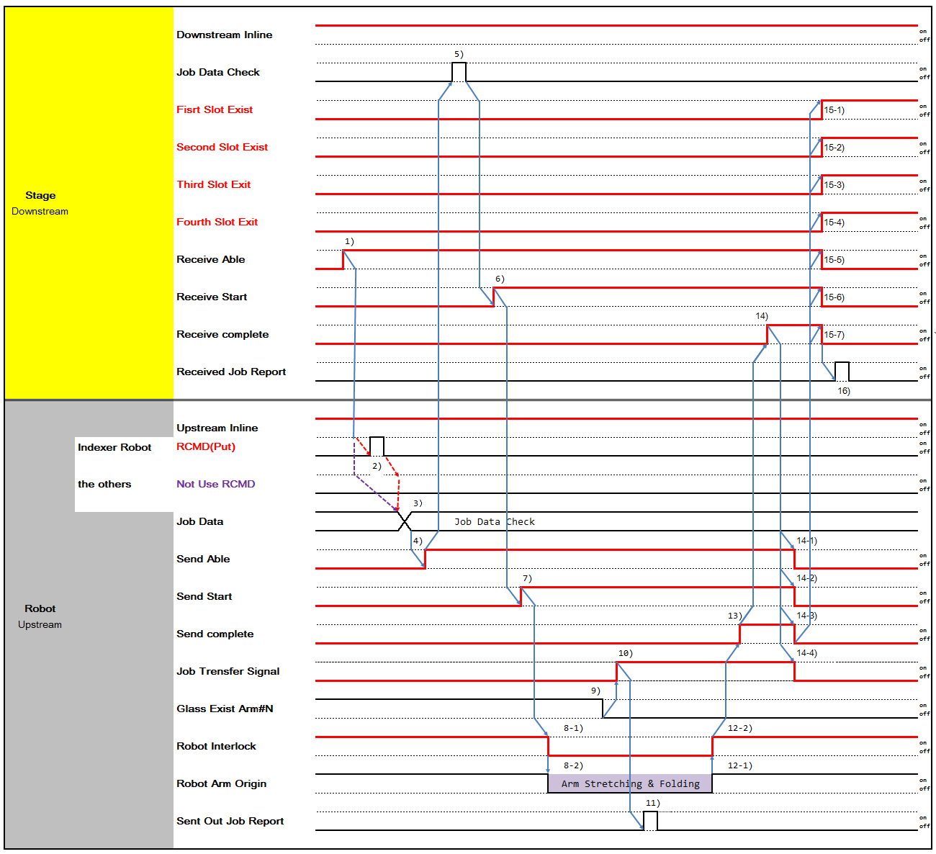

- When Downstream is ready to receive Panel, turn on 'Receive Able'.
- Robot Receives Put Command from Robot Controller.
- Write Job Data which will be send to Downstream.
- Turn on 'Send Able'.
- Downstream checks Job Data of Panels to be received.
- When Downstream is ready to receive Panel, turn on 'Receive Start'.
- Turn on 'Send Start' and Upstream start transferring.
8-1) After 'Send Start' is turned on, Robot moves and turns off Robot Interlock at the same time. Downstream doesn't not perform any movement that interfere with Robot until Robot Interlock is turned on
8-2) Proceed with Robot Put Sequence.
9-1,-2) Glass existence is determined by Robot Fork Vacuum On/Off.
- When Glass Fork Vacuum is turn off, then turn on 'Job Transfer'.
- When 'Job Transfer' is on, Upstream reports 'Sent Out Report'. 12-1) Robot completes Put Sequence.
12-2) When Robot Arm returns to Original Position, remove Robot Interlock and turn on 'Robot Interlock' signal. Downstream can then Proceed with transfer-related activity.
- Turn on 'Send Complete' when Panel transfer to Downstream is completed.
- Turn on 'Receive Complete' after Panel Transfer is completed.
15-1,-2,-3,-4,-5,-6)Turn off 'Receive Start', 'Receive Able', and turn on 'First Slot Exist', 'Second Slot Exist', 'Third Slot Exist', 'Fourth Slot Exist' when 'Receive Complete' is turned on.
16-1,-2,-3,-4,-5,-6) Turn on 'Receive Complete' when 'Receive Start', 'Receive Able' is off and 'First Slot Exist', 'Second Slot Exist', 'Third Slot Exist', 'Fourth Slot Exist' is on
17-1,-2,-3,-4) When 'Receive Complete' is turned off, turn off ‘Send Able', 'SendStart', 'Send Complete', 'Job transfer'.
- After Upstream turns off 'Job Transfer' off, Downstream reports 'Received Job Report'.

Type 4 Time Chart (Robot-Multiple Stage/Shutter)

Type | Glass-out | Glass-in | Action
Type 4 | Robot | Multiple Stage  (Includes Shutter, Need to Control Shutter)  - Buffer  - Cassette | Loading  Robot → Multiple Stage
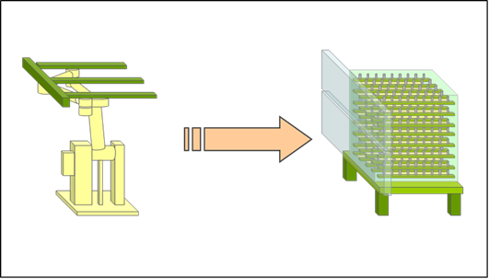

1 Slot Shutter Case
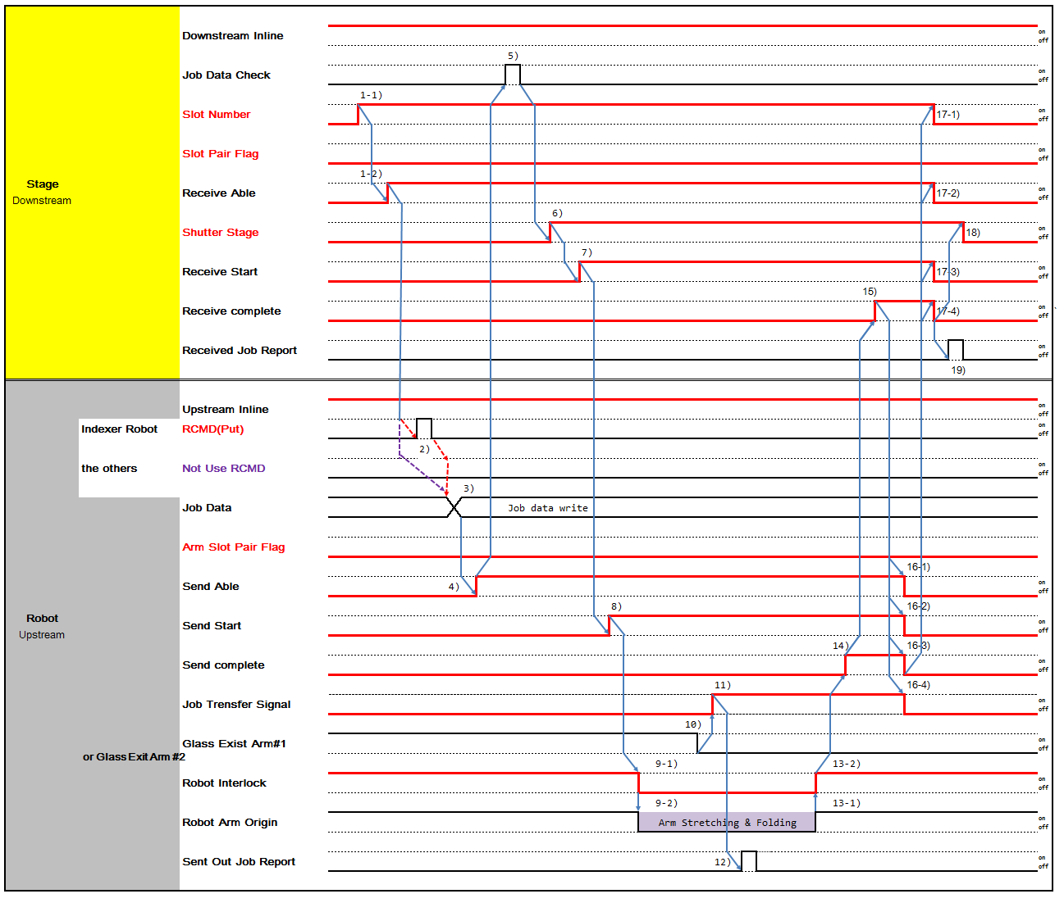

1-1) If Downstream is Multi Slot Stage, turn on 'Slot No' signal of which Panel will be transferred 1-2) When Downstream is ready to receive Panel, turn on 'Receive Able'.
- Robot Receives Put Command from Robot Controller.
- Write Job Data which will be send to Downstream.
- Turn on 'Send Able' when Upstream is ready to send Panel.
- Downstream checks Job Data of Panels to be received.
- If Job Data check is Ok, open Shutter and turn on 'Shutter State'.
- When Downstream is ready to receive Panel, turn on 'Receive Start'.
- Turn on 'Send Start' and Upstream start transferring.
9-1) After 'Send Start' is turned on, Robot moves and turns off Robot Interlock at the same time. Downstream doesn’t not perform any movement that interfere with Robot until Robot Interlock is turned on
9-2) Proceed with Robot Put Sequence.
- Glass existence is determined by Robot Fork Vacuum On/Off.
- When Glass Fork Vacuum is turn off, then turn on 'Job Transfer'.
- When 'Job Transfer' is on, Upstream reports 'Sent Out Report'. 13-1) Robot completes Put Sequence.
13-2) When Robot Arm returns to Original Position, remove Robot Interlock and turn on 'Robot Interlock' signal. Downstream can then Proceed with transfer-related activity.
- Turn on 'Send Complete' when Panel transfer to Downstream is completed.
- Turn on 'Receive Complete' after Panel Transfer is completed.
16-1,-2,-3) Turn off 'Receive Start', 'Receive Able', 'Slot Number' when 'Receive Complete' is turned on. 17-1,-2,-3) Turn off 'Receive Complete' when 'Receive Start', 'Receive Able’, ‘Slot Number' is turned off.
18-1,-2,-3,-4,-5) When 'Receive Complete' is turned off, turn off ‘Shutter State', 'Send Able', 'SendStart', 'Send Complete', 'Job transfer'.
- After Upstream turns off 'Job Transfer' off, Downstream reports 'Received Job Report'.

2 Slot Shutter Case
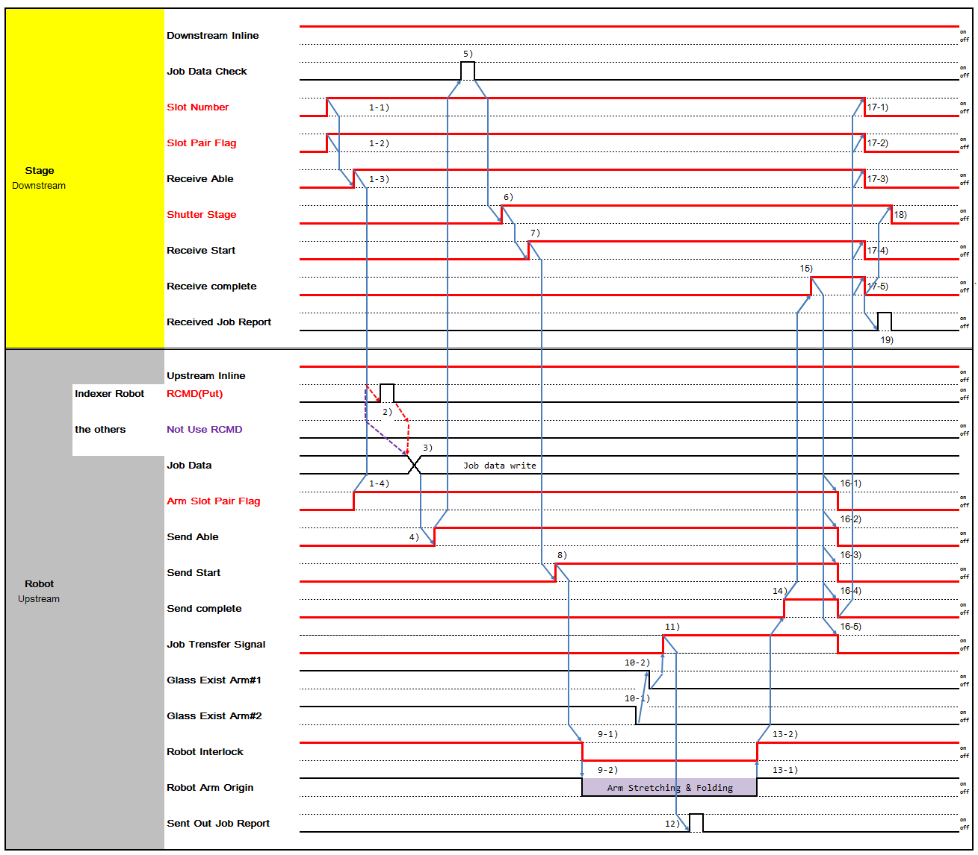

1-1) If Downstream is Multi Slot Stage and Robot transfers 2 Glass simultaneously, turn on 'Slot No' signal of lower Slot No.
1-2) If Robot transfers 2 Glass simultaneously, turn on 'Slot Pair Flag' which means to transfer Glass of Slot No and No+1 Slot.
1-3) When Downstream is ready to receive Panel, turn on 'Receive Able'. 1-4) Turn on 'Arm Slot Pair Flag' when Robot transfers 2 Panels.
- Robot Receives Put Command from Robot Controller.
- Write Job Data which will be send to Downstream.
- Turn on 'Send Able' when Upstream is ready to send Panel.
- Downstream checks Job Data of Panels to be received.
- If Job Data check is Ok, open Shutter and turn on 'Shutter State'.
- When Downstream is ready to receive Panel, turn on 'Receive Start'.
- Turn on 'Send Start' and Upstream start transferring.
9-1) After 'Send Start' is turned on, Robot moves and turns off Robot Interlock at the same time. Downstream doesn’t not perform any movement that interfere with Robot until Robot Interlock is turned on
9-2) Proceed with Robot Put Sequence.
- Glass existence is determined by Robot Fork Vacuum On/Off.
- When Glass Fork Vacuum is turn off, then turn on 'Job Transfer'.
- When 'Job Transfer' is on, Upstream reports 'Sent Out Report'. 13-1) Robot completes Put Sequence.
13-2) When Robot Arm returns to Original Position, remove Robot Interlock and turn on 'Robot Interlock' signal. Downstream can then Proceed with transfer-related activity.
- Turn on 'Send Complete' when Panel transfer to Downstream is completed.
- Turn on 'Receive Complete' after Panel Transfer is completed.
16-1,-2,-3,-4) Turn off 'Receive Start', 'Receive Able', 'Slot Number', 'Slot pair Flag' when 'Receive Complete' is turned on.
17-1,-2,-3,-4) Turn off 'Receive Complete' when 'Receive Start', 'Receive Able’, ‘Slot Number', 'Slot Pair Flag' is turned off.
18-1,-2,-3,-4,-5) When 'Receive Complete' is turned off, turn off 'Arm Slot pair Flag' 'Send Able', 'SendStart', 'Send Complete', 'Job transfer'.
19) After Upstream turns off 'Job Transfer' off, Downstream reports 'Received Job Report'.

Type 5 Time Chart (Single Stage-Robot)

Type | Glass-out | Glass-in | Action
Type 5 | Single Stage  (No Shutter, Self Controlled Shutter)  - PIN Stage  - Big Roller CV  - Gate CV  - Turn Stage | Robot | Unloading Robot ← Single Stage
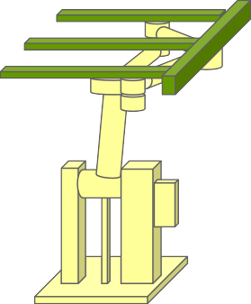
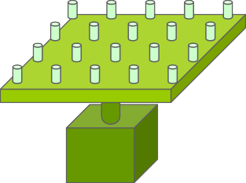
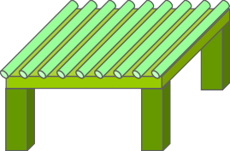

- Pin Exist
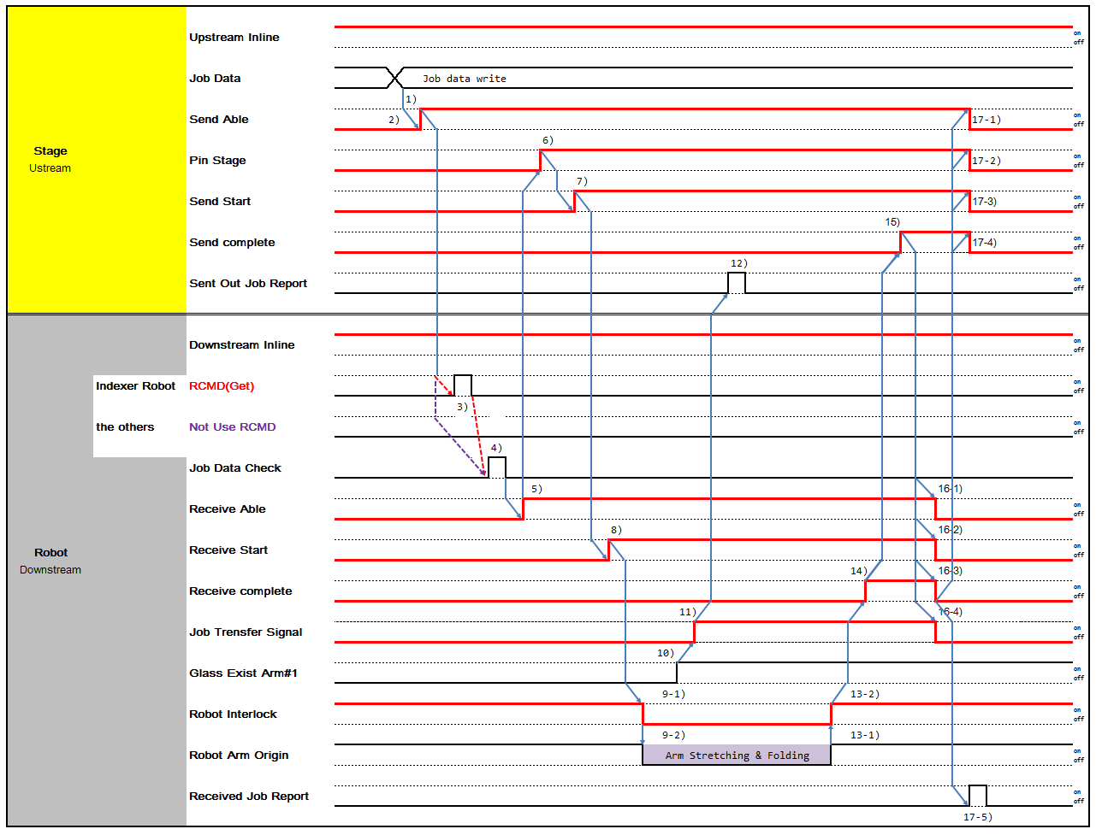

- No Pin Exist
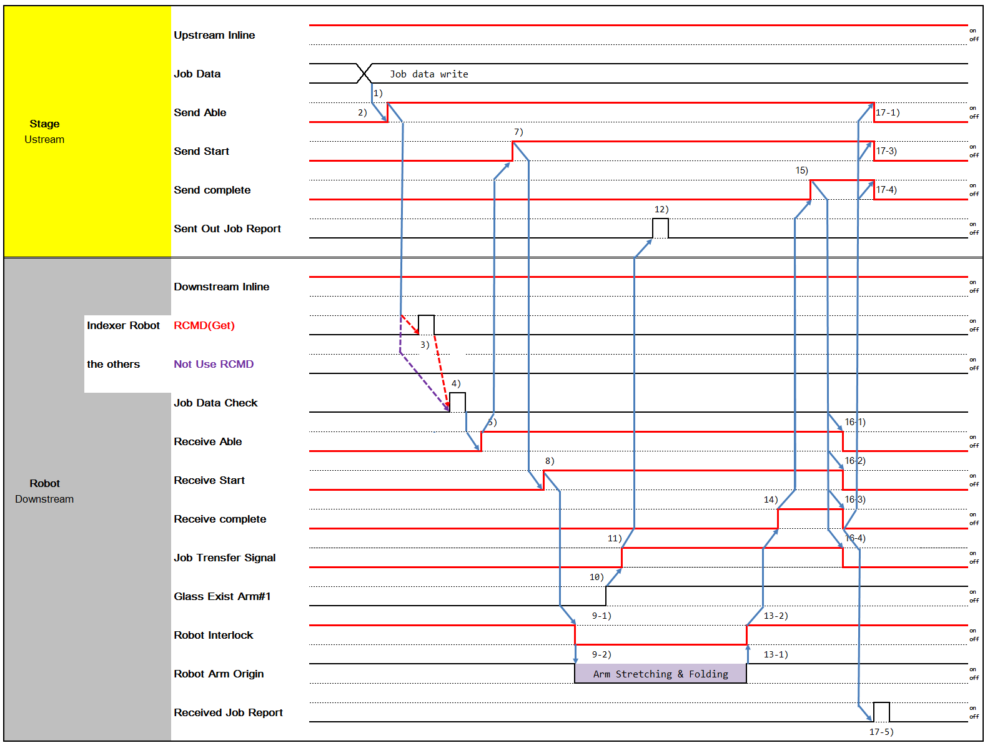

- Write Job Data which will be send to Downstream.
- When Upstream is ready to send Panel, turn on 'Send Able'.
- Robot Receives Put Command from Robot Controller. 4)Downstream check Job Data of Panel to be received
- If Job Data check is Ok and is ready to receive Panel, turn on 'Receive Able'.
- When Downstream turns on 'Receive able', Lift Pin Stage up and turn on 'Pin State'.
- Turn on 'Send Start' when Upstream is ready to send Panel.
- When Upstream turns on 'Send Start', Downstream Robot starts Get Sequence and turn on 'Receive Start'.
9-1) After 'Receive Start' is turned on, Robot moves and turns off Robot Interlock at the same time. Upstream doesn't not perform any movement that interfere with Robot until Robot Interlock is turned on
9-2) Proceed with Robot Get Sequence.
- Glass existence is determined by Robot Fork Vacuum On/Off.
- When Glass Fork Vacuum is turn off, then turn on 'Job Transfer'.
- When 'Job Transfer' is on, Upstream reports 'Sent Out Report'. 13-1) Robot completes Get Sequence.
13-2) When Robot Arm returns to Original Position, remove Robot Interlock and turn on 'Robot Interlock' signal. Downstream can then Proceed with transfer-related activity.
- Turn on 'Send Complete' when Panel transfer to Downstream is completed.
- Turn on 'Receive Complete' after Panel Transfer is completed.
16-1,-2) Turn off 'Send Start', 'Send Able' when 'Receive Complete' is turned on. 17-1,-2) Turn off 'Send Complete' when 'Send Start', 'Send Able' is turned off.
18-1,-2,-3,-4,-5) When 'Send Complete' is turned off, turn off 'Pin State', 'Receive Able', 'Receive Start', 'Receive Complete', 'Job transfer'.
19) When 'Job Transfer' is turned off, Downstream reports 'Received Job Report'.

Type 6 Time Chart (Single Stage/Shutter-Robot)

Type | Glass-out | Glass-in | Action
Type 6 | Single Stage  (Includes Shutter, Need to Control Shutter)  - PIN Stage  - Big Roller CV  - Gate CV  - Turn Stage | Robot | Unloading Robot ← Single Stage
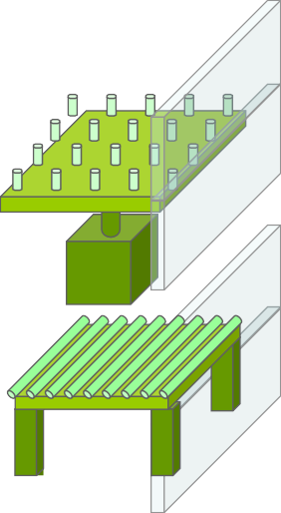

- Pin Exist
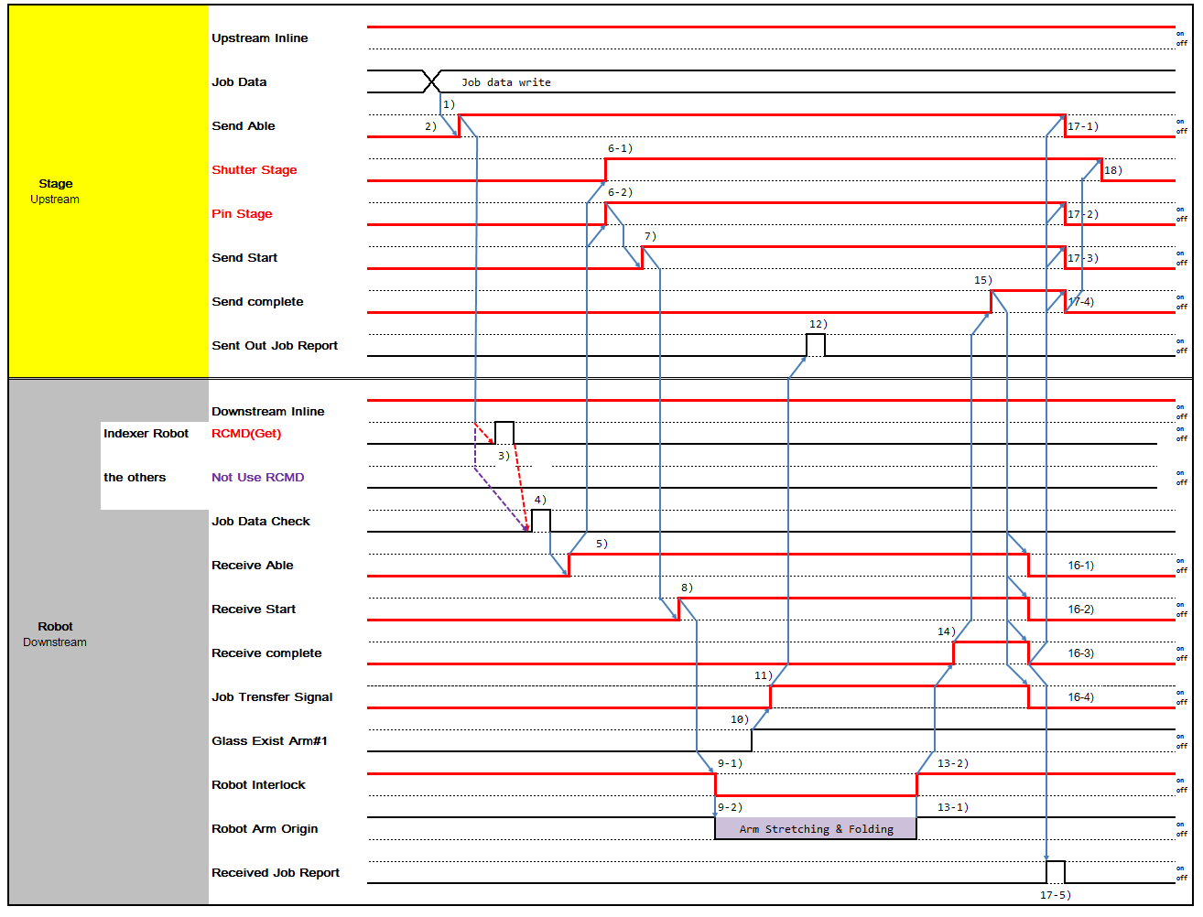

- No Pin Exist
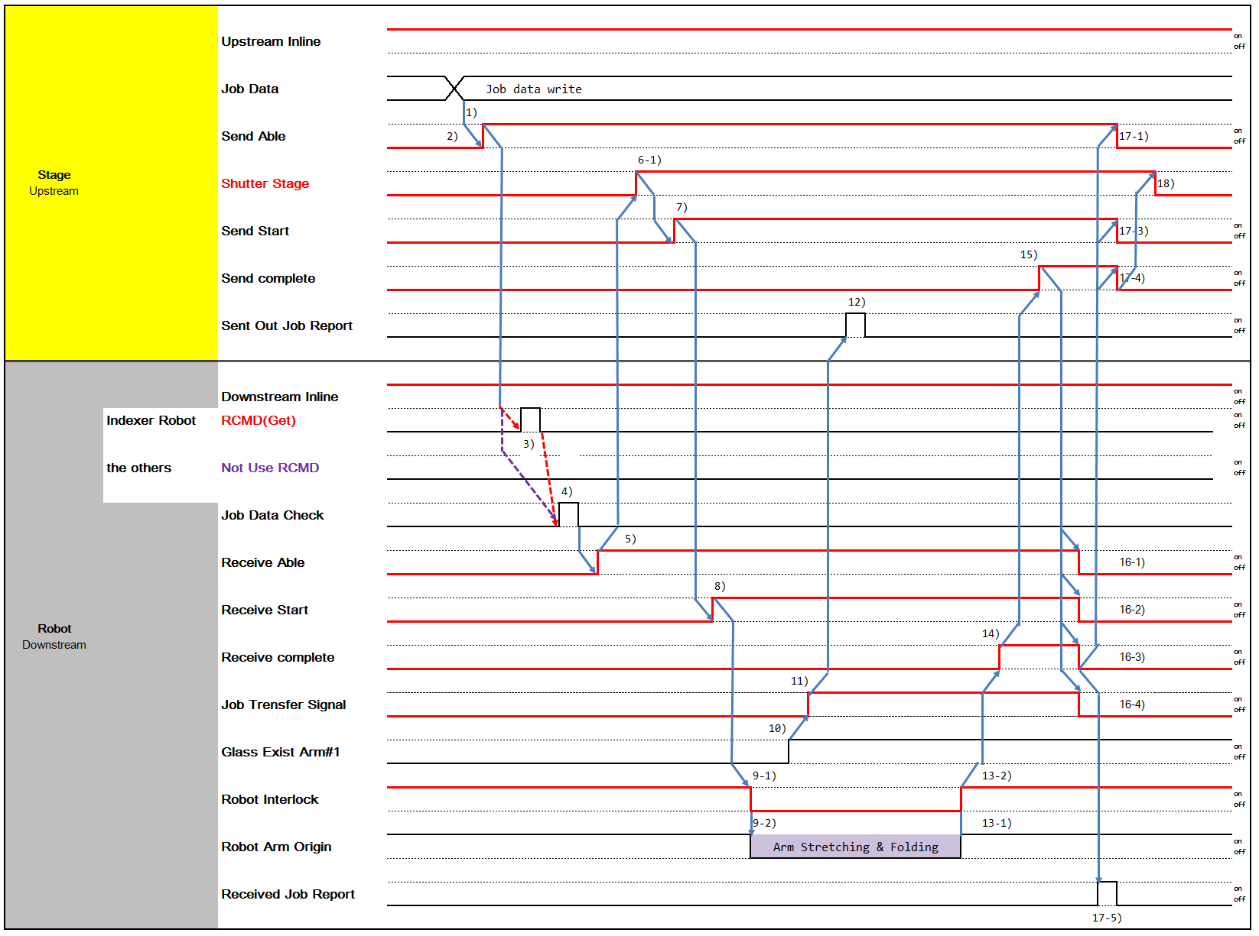

- Write Job Data which will be send to Downstream.
- When Upstream is ready to send Panel, turn on 'Send Able'.
- Robot Receives Put Command from Robot Controller. 4)Downstream check Job Data of Panel to be received
5) If Job Data check is Ok, turn on 'Receive Able'.
6-1,-2) when 'Receive Able' is turned on, turn on 'Pin State', 'Shutter State'. According to Equipment, Two may move simultaneously or one may move prior to another. It depends on Equipment's decision.
- Turn on 'Send Start' when Upstream is ready to send Panel.
- When Upstream turns on 'Send Start', Downstream Robot starts Get Sequence and turn on 'Receive Start'.
9-1) After 'Receive Start' is turned on, Robot moves and turns off Robot Interlock at the same time. Upstream doesn't not perform any movement that interfere with Robot until Robot Interlock is turned on
9-2) Proceed with Robot Get Sequence.
- Glass existence is determined by Robot Fork Vacuum On/Off.
- When Glass Fork Vacuum is turn off, then turn on 'Job Transfer'.
- When 'Job Transfer' is on, Upstream reports 'Sent Out Report'. 13-1) Robot completes Get Sequence.
13-2) When Robot Arm returns to Original Position, remove Robot Interlock and turn on 'Robot Interlock' signal. Upstream can then Proceed with transfer-related activity.
- Turn on 'Send Complete' when Panel transfer to Downstream is completed.
- Turn on 'Receive Complete' after Panel Transfer is completed.
16-1,-2) Turn off 'Send Start', 'Send Able' when 'Receive Complete' is turned on. 17-1,-2) Turn off 'Send Complete' when 'Send Start', 'Send Able' is turned off.
18-1,-2,-3,-4,-5,-6) When 'Send Complete' is turned off, turn off 'Pin State', 'Shutter State', 'Send Able', 'SendStart', 'Send Complete', 'Job transfer'.
18) When 'Job Transfer' is turned off, Downstream reports 'Received Job Report'.

Type 7 Time Chart (Multiple Stage-Robot)

Type | Glass-out | Glass-in | Action
Type 7 | Multiple Stage  (No Shutter, Self Controlled Shutter)  - Buffer  - Cassette | Robot | Unloading  Robot ← Multiple Stage
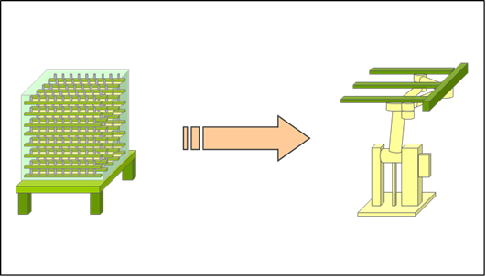

1 Slot Case
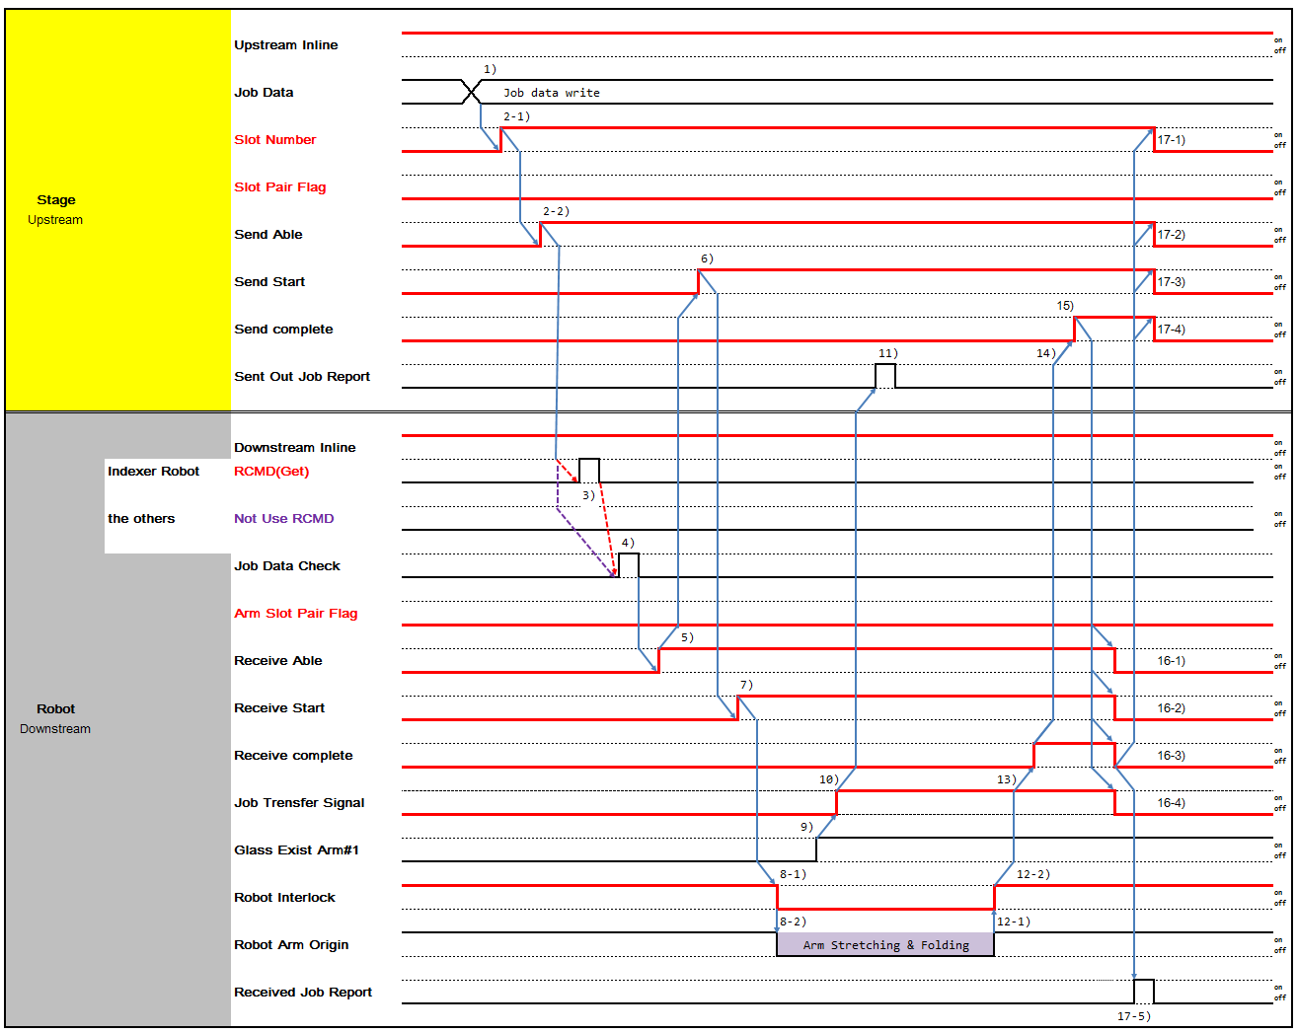

1) Write Job Data which will be send to Downstream.
2-1) If Downstream is Multi Slot Stage, turn on 'Slot No' signal of which Panel will be transferred 2-2) When Upstream is ready to receive Panel, turn on 'Send Able'.
3) Robot Receives Get Command from Robot Controller. 4)Downstream check Job Data of Panel to be received
- If Job Data check is Ok and Downstream is ready to receive panel, turn on 'Receive Able'.
- When Receive Able is turned on and Upstream is ready to send, turn on 'Send Start'
- When 'Send Start' is turned on, Downstream Robot starts Get sequence and turn on 'Receive Start'
8-1) After 'Receive Start' is turned on, Robot moves and turns off Robot Interlock at the same time. Upstream doesn't not perform any movement that interfere with Robot until Robot Interlock is turned on
8-2) Proceed with Robot Get Sequence.
- Glass existence is determined by Robot Fork Vacuum On/Off.
- When Glass Fork Vacuum is turn off, then turn on 'Job Transfer'.
- When 'Job Transfer' is on, Upstream reports 'Sent Out Report'. 12-1) Robot completes Get Sequence.
12-2) When Robot Arm returns to Original Position, remove Robot Interlock and turn on 'Robot Interlock' signal. Upstream can then Proceed with transfer-related activity.
- Turn on 'Receive Complete' after Panel Transfer is completed.
- Turn on 'Send Complete' when Panel transfer to Downstream is completed.
15-1,-2,-3) Turn off 'Send Start', 'Send Able', 'Slot Number' when 'Send Complete' is turned on. 16-1,-2,-3) Turn off 'Send Complete' when 'Send Start', 'Send Able', 'Slot Number' is turned off.
17-1,-2,-3,-4) When 'Send Complete' is turned off, turn off ‘Receive Able', ' Receive Start', ' Receive Complete', 'Job transfer'.
18) When 'Job Transfer' is turned off, Downstream reports 'Received Job Report'.

2 Slot Case
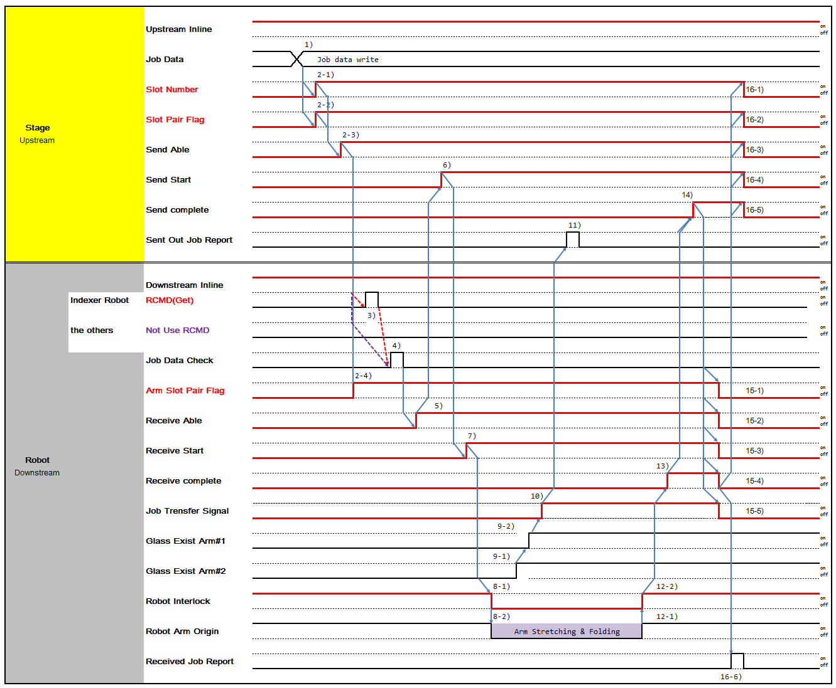

1) Write Job Data which will be send to Downstream.
2-1) If Downstream is Multi Slot Stage and Robot transfers 2 Glass simultaneously, turn on 'Slot No' signal of lower Slot No.
2-2) If Robot transfers 2 Glass simultaneously, turn on 'Slot Pair Flag' which means to transfer Glass of Slot No and No+1 Slot.
2-3) When Downstream is ready to receive Panel, turn on 'Receive Able'. 2-4) Turn on 'Arm Slot Pair Flag' when Robot transfers 2 Panels.
- Robot Receives Get Command from Robot Controller.
- Downstream check Job Data of Panel to be received
- If Job Data check is Ok and Downstream is ready to receive panel, turn on 'Receive Able'.
- When Receive Able is turned on and Upstream is ready to send, turn on 'Send Start'
- When 'Send Start' is turned on, Downstream Robot starts Get sequence and turn on 'Receive Start'
8-1) After 'Receive Start' is turned on, Robot moves and turns off Robot Interlock at the same time. Upstream doesn't not perform any movement that interfere with Robot until Robot Interlock is turned on
8-2) Proceed with Robot Get Sequence.
- Glass existence is determined by Robot Fork Vacuum On/Off.
- When Glass Fork Vacuum is turn off, then turn on 'Job Transfer'.
- When 'Job Transfer' is on, Upstream reports 'Sent Out Report'. 12-1) Robot completes Get Sequence.
12-2) When Robot Arm returns to Original Position, remove Robot Interlock and turn on 'Robot Interlock' signal. Upstream can then Proceed with transfer-related activity.
- Turn on 'Receive Complete' after Panel Transfer is completed.
- Turn on 'Send Complete' when Panel transfer to Downstream is completed.
15-1,-2,-3,-4) Turn off 'Send Start', 'Send Able', 'Slot Number', 'Slot Pair Flag' when 'Send Complete' is turned on. 16-1,-2,-3,-4) Turn off 'Send Complete' when 'Send Start', 'Send Able', 'Slot Number', 'Slot Pair Flag' is turned off. 17-1,-2,-3,-4,-5) When 'Send Complete' is turned off, turn off 'Arm Slot Pair Flag', 'Receive Able', ' Receive Start', ' Receive Complete', 'Job transfer'.
18) When 'Job Transfer' is turned off, Downstream reports 'Received Job Report'.

4 Slot Case
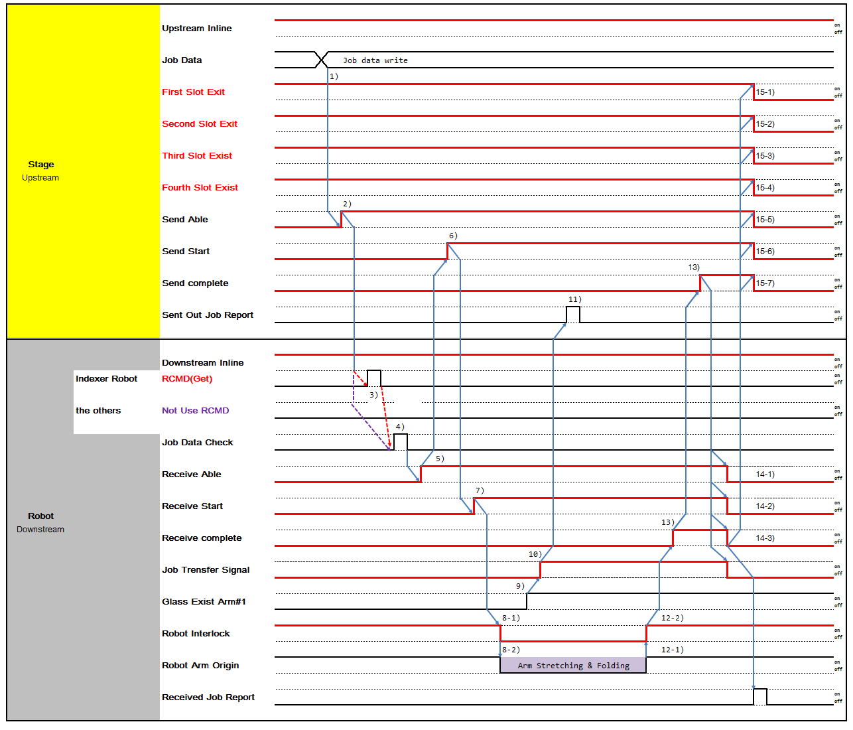

- Write Job Data which will be send to Downstream.
- Turn on 'Send Able' when Upstream is ready to send Panel.
- Robot Receives Get Command from Robot Controller.
- Downstream check Job Data of Panel to be received
- If Job Data check is Ok and Downstream is ready to receive panel, turn on 'Receive Able'.
- When Receive Able is turned on and Upstream is ready to send, turn on 'Send Start'
- When 'Send Start' is turned on, Downstream Robot starts Get sequence and turn on 'Receive Start'
8-1) After 'Receive Start' is turned on, Robot moves and turns off Robot Interlock at the same time. Upstream doesn't not perform any movement that interfere with Robot until Robot Interlock is turned on
8-2) Proceed with Robot Get Sequence.
- Glass existence is determined by Robot Fork Vacuum On/Off.
- When Glass Fork Vacuum is turn off, then turn on 'Job Transfer'.
- When 'Job Transfer' is on, Upstream reports 'Sent Out Report'. 12-1) Robot completes Get Sequence.
12-2) When Robot Arm returns to Original Position, remove Robot Interlock and turn on 'Robot Interlock' signal. Upstream can then Proceed with transfer-related activity.
- Turn on 'Receive Complete' after Panel Transfer is completed.
- Turn on 'Send Complete' when Panel transfer to Downstream is completed.
15-1,-2,-3,-4,-5,-6) Turn off 'Send Start', 'Send Able', 'First Slot Exist', 'Second Slot Exist', 'Third Slot Exist', 'Fourth Slot Exist' when 'Send Complete' is turned on.
16-1,-2,-3,-4,-5,-6) Turn off 'Send Complete' when 'Send Start', 'Send Able', 'First Slot Exist', 'Second Slot Exist', 'Third Slot Exist', 'Fourth Slot Exist' is turned off.
17-1,-2,-3,-4) When 'Send Complete' is turned off, turn off ‘Receive Able', ' Receive Start', ' Receive Complete', 'Job transfer'.
18) When 'Job Transfer' is turned off, Downstream reports 'Received Job Report'.

Type 8 Time Chart (Multiple Stage/Shutter-Robot)

Type | Glass-out | Glass-in | Action
Type 8 | Multiple Stage  (Includes Shutter, Need to Control Shutter)  - Buffer  - Cassette | Robot | Unloading  Robot ← Multiple Stage
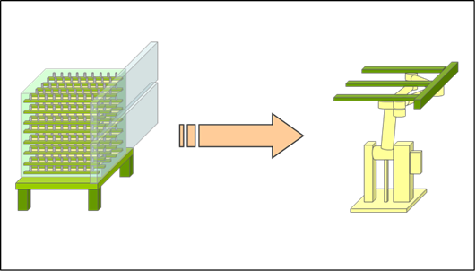

1 Slot Shutter Case
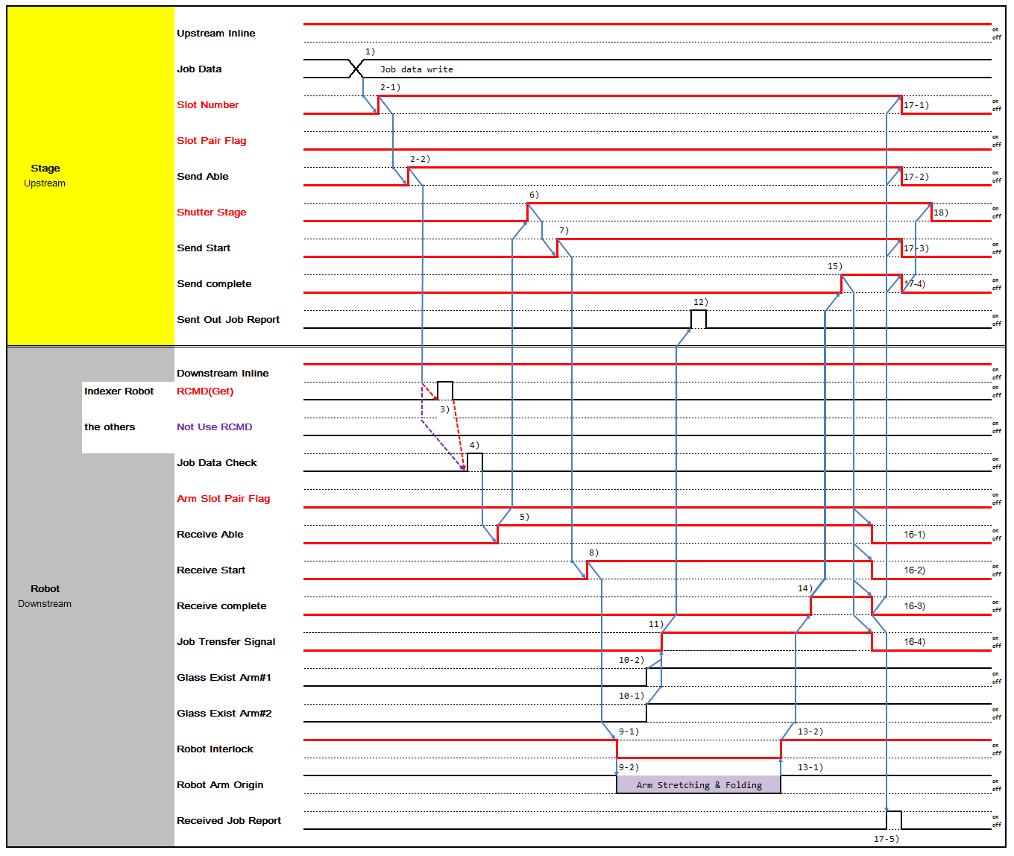

1) Write Job Data which will be send to Downstream
2-1) If Downstream is Multi Slot Stage, turn on 'Slot No' signal of which Panel will be transferred 2-2) When Upstream is ready to receive Panel, turn on 'Send Able'.
3) Robot Receives Get Command from Robot Controller. 4)Downstream check Job Data of Panel to be received
- If Job Data check is Ok and Downstream is ready to receive panel, turn on 'Receive Able'.
- If Job Data check is Ok, open Shutter and turn on 'Shutter State'.
- When Shutter is completely opened and Upstream is ready to send, turn on 'Send Start'.
- When 'Send Start' is turned on, Downstream Robot starts Get sequence and turn on 'Receive Start'
9-1) After 'Receive Start' is turned on, Robot moves and turns off Robot Interlock at the same time. Upstream doesn't not perform any movement that interfere with Robot until Robot Interlock is turned on
9-2) Proceed with Robot Get Sequence.
- Glass existence is determined by Robot Fork Vacuum On/Off.
- When Glass Fork Vacuum is turn off, then turn on 'Job Transfer'.
- When 'Job Transfer' is on, Upstream reports 'Sent Out Report'. 13-1) Robot completes Get Sequence.
13-2) When Robot Arm returns to Original Position, remove Robot Interlock and turn on 'Robot Interlock' signal. Upstream can then Proceed with transfer-related activity.
- Turn on 'Receive Complete' after Panel Transfer is completed.
- Turn on 'Send Complete' when Panel transfer to Downstream is completed.
16-1,-2,-3) Turn off 'Send Start', 'Send Able', 'Slot Number' when 'Send Complete' is turned on. 17-1,-2,-3) Turn off 'Send Complete' when 'Send Start', 'Send Able', 'Slot Number' is turned off.
18-1,-2,-3,-4,-5) When 'Send Complete' is turned off, turn off 'Shutter State', 'Receive Able', ' Receive Start', ' Receive Complete', 'Job transfer'.
- When 'Job Transfer' is turned off, Downstream reports 'Received Job Report'.

2 Slot Shutter Case
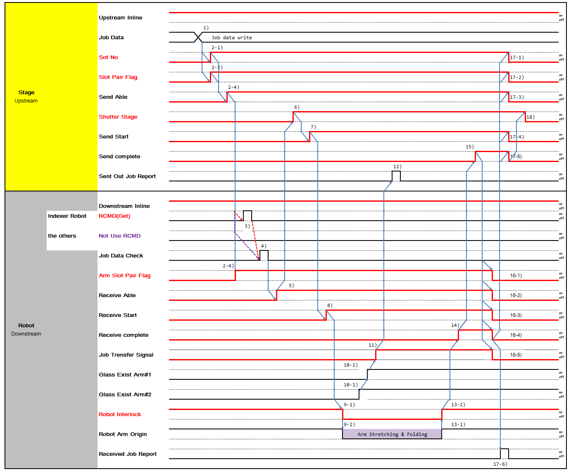

1) Write Job Data which will be send to Downstream
2-1) If Downstream is Multi Slot Stage and Robot transfers 2 Glass simultaneously, turn on 'Slot No' signal of lower Slot No.
2-2) If Robot transfers 2 Glass simultaneously, turn on 'Slot Pair Flag' which means to transfer Glass of Slot No and No+1 Slot.
2-3) When Downstream is ready to receive Panel, turn on 'Receive Able'. 2-4) Turn on 'Arm Slot Pair Flag' when Robot transfers 2 Panels.
3) Robot Receives Get Command from Robot Controller. 4)Downstream check Job Data of Panel to be received
- If Job Data check is Ok and Downstream is ready to receive panel, turn on 'Receive Able'.
- When 'Receive Able' is on, open Shutter and turn on 'Shutter State'.
- When Shutter is completely opened and Upstream is ready to send, turn on 'Send Start'.
- When 'Send Start' is turned on, Downstream Robot starts Get sequence and turn on 'Receive Start'
9-1) After 'Receive Start' is turned on, Robot moves and turns off Robot Interlock at the same time. Upstream doesn't not perform any movement that interfere with Robot until Robot Interlock is turned on
9-2) Proceed with Robot Get Sequence.
10-1,-2) Glass existence is determined by Robot Fork Vacuum On/Off.
- When Glass Fork Vacuum is turn off, then turn on 'Job Transfer'.
- When 'Job Transfer' is on, Upstream reports 'Sent Out Report'. 13-1) Robot completes Get Sequence.
13-2) When Robot Arm returns to Original Position, remove Robot Interlock and turn on 'Robot Interlock' signal. Upstream can then Proceed with transfer-related activity.
- Turn on 'Receive Complete' after Panel Transfer is completed.
- Turn on 'Send Complete' when Panel transfer to Downstream is completed.
16-1,-2,-3) Turn off 'Send Start', 'Send Able', 'Slot Number', 'Slot Pair Flag' when 'Send Complete' is turned on. 17-1,-2,-3) Turn off 'Send Complete' when 'Send Start', 'Send Able', 'Slot Number', 'Slot Pair Flag' is turned off.
18-1,-2,-3,-4,-5,-6) When 'Send Complete' is turned off, turn off 'Shutter State', 'Arm Slot Pair Flag', 'Receive Able', ' Receive Start', ' Receive Complete', 'Job transfer'.
- When 'Job Transfer' is turned off, Downstream reports 'Received Job Report'.

Type 9 Time Chart (Conveyor-Conveyor)

Type | Glass-out | Glass-in | Action
Type 9 | Conveyor | Conveyor | Send/Receive CV → CV
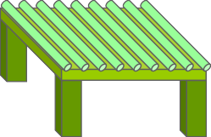
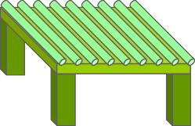

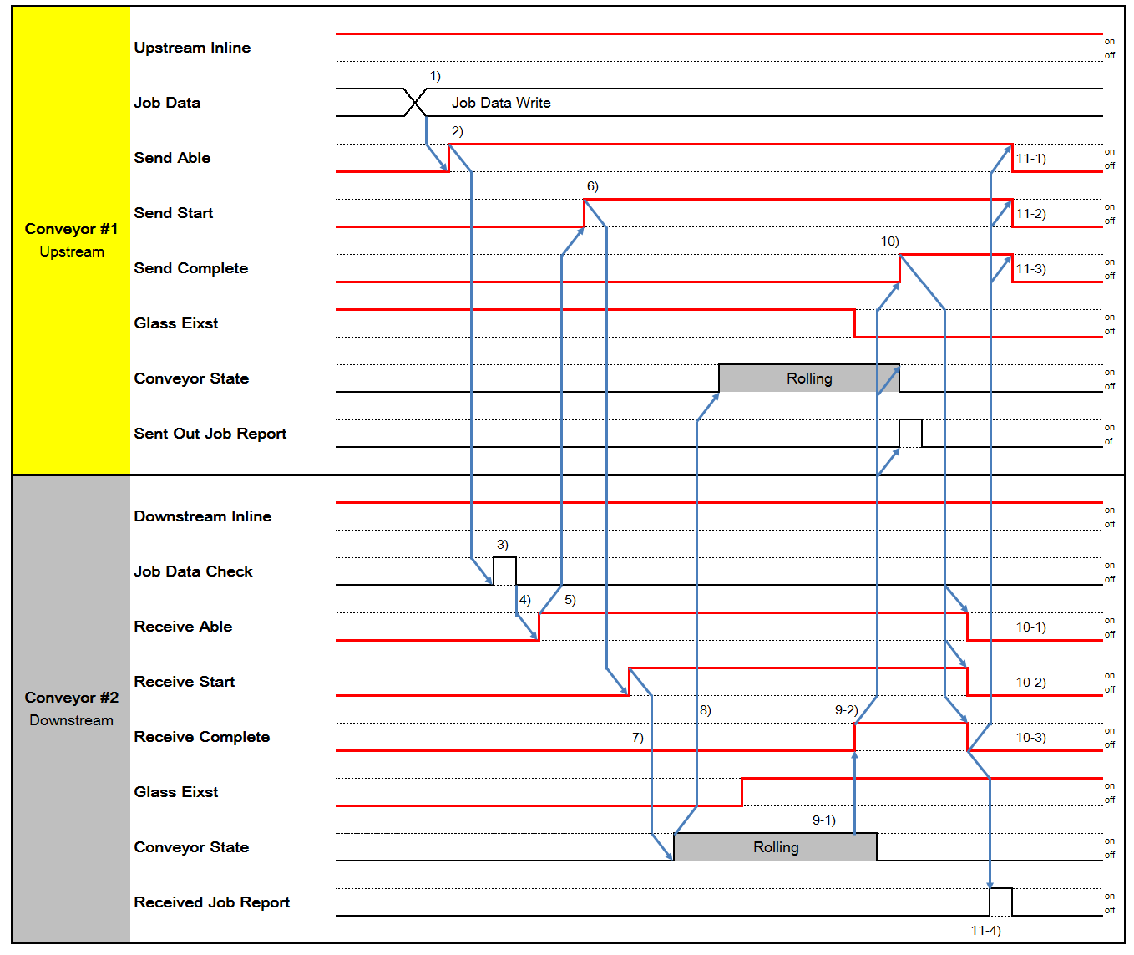

- Write Job Data which will be send to Downstream
- When Upstream is ready to receive Panel, turn on 'Send Able'.
- Downstream check Job Data of Panel to be received
- If Job Data check is Ok and Downstream is ready to receive panel, turn on 'Receive Able'.
- When 'Receive Able' is on, open Shutter and turn on 'Shutter State'.
- When 'Send Start' is turned on, turn on 'Receive Start'
- When 'Receive Start' is on, Downstream Conveyor starts moving
- After Downstream Conveyor moves, Upstream Conveyor starts moving
9-1) Downstream Conveyor completes Panel transfer when the complete detect sensor of conveyor is On 9-2) Turn on 'Receive Complete', when Panel transfer is completed.
10-1,-2,-3) When 'Receive Complete is turned on, Upstream reports 'Sent Out Job Report', completes Conveyor Panel Move and turns on 'Send Complete'.
11-1,-2) When 'Send Complete' is on, turn off 'Send Able', 'Send Start'. 12-1,-2) When 'Send Able', 'Send Start' is off, turn off 'Send Complete'.
13-1,-2,-3) When 'Send Complete' is off, turn off 'Receive Able', ' Receive Start', ' Receive Complete'.
14) Downstream reports 'Received Job Report' when 'Receive Complete' is off.

Type 10 Time Chart (Single Stage-Robot : Exchange/One Action)

Type | Glass-out | Glass-in | Action
Type 10 | Single Stage  (No Shutter, Self Controlled Shutter)  - PIN Stage  - Big Roller CV  - Gate CV  - Turn Stage | Robot | Combination of Type1 and 5 One Action Exchange  Robot ↔ Single Stage
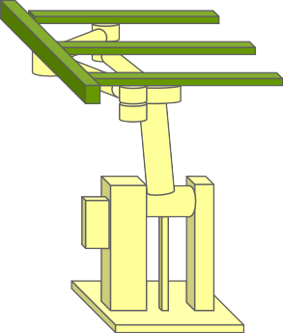
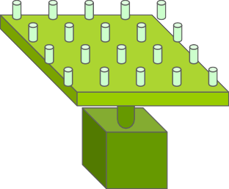

- Pin Exist
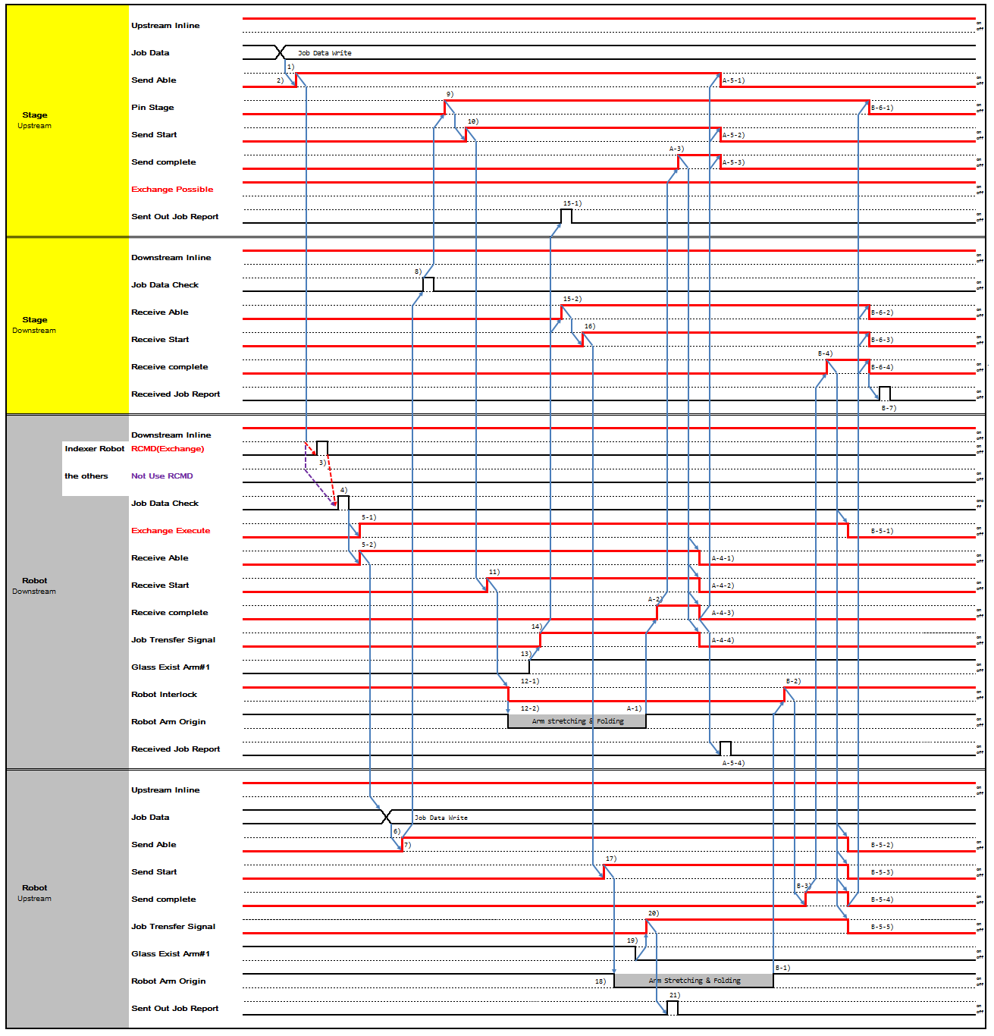

- No Pin Exist
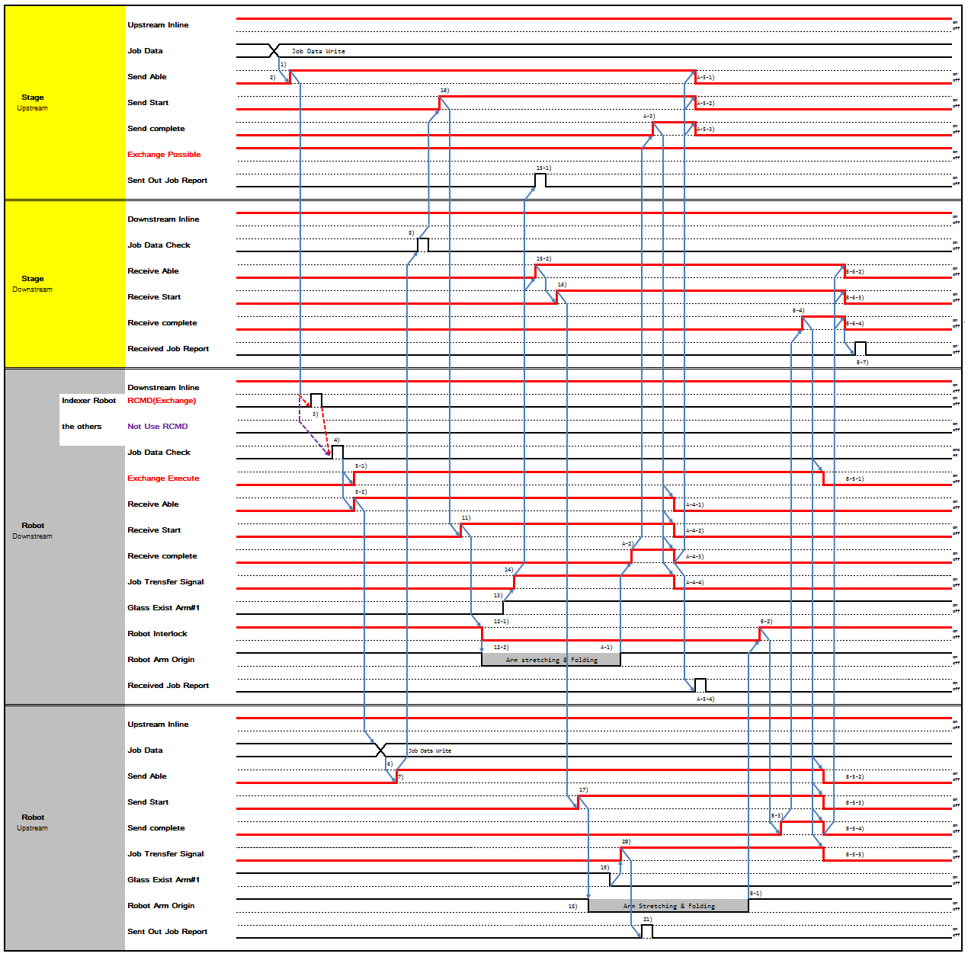

- Stage Upstream writes Job Data which will be send to Robot Downstream
- When Stage Upstream is ready to send Panel, turn on 'Send Able'.
- Robot Downstream receives Exchange Command from Robot Controller.
- Robot Downstream check Job Data of Panel to be received


5-1,-2) Robot Downstream, after checking, turns on 'Exchange Execute', 'Receive Able'. Upstream 'Exchange Possible': When upstream stage turns 'Exchange Possible' ON expecting exchange action, and then in case If downstream(robot) turns 'Receive Able' ON with 'Exchange Execute' OFF, upstream Stage should regards it as normal 'sending' action without exchange, and has to switch to conducting normal 'sending' process (refer to interface Type 5,6,7,8 ) automatically without any stops or trouble.

- Robot Upstream writes Job Data which will be send to Stage Downstream
- When Robot Upstream is ready to send Panel, turn on 'Send Able'.
- Stage Downstream check Job Data of Panel to be received
- Stage Upstream lifts Pin Stage up and turns on 'Pin State'.
- Stage Upstream turns on 'Send Start'.
- Robot Downstream turns on 'Receive Start'.
12-1) After Robot Downstream 'Receive Start' is turned on, Robot moves and turns off Robot Interlock at the same time. Stage Upstream doesn't not perform any movement that interfere with Robot until Robot Interlock is turned on
12-2) Robot Downstream proceed with Robot Get Sequence.
- Glass existence is determined by Robot Fork Vacuum On/Off.
- When Robot Downstream starts Transfer, turn on 'Job Transfer'.
15-1,-2) When Robot Downstream 'Job Transfer' is on, Stage Upstream reports 'Sent Out Job Report' and Stage Downstream turns on 'Receive Able'.
- When Stage Downstream turns on 'Receive Able', turn on 'Receive Start'.
- When Stage Downstream turns on 'Receive Start', turn on Robot Upstream 'Send Start'.
- When Robot Upstream 'Send Start' turns on, Robot proceeds with Put Sequence.
- Glass existence is determined by Robot Fork Vacuum On/Off.
- When Robot Upstream Glass Fork Vacuum is turn off, then turn on 'Job Transfer'.
- When 'Job Transfer' is on, Upstream reports 'Sent Out Report'. A-1) Robot Downstream completes Robot Get Sequence.
A-2) Robot Downstream turns on 'Receive Complete' after Panel Transfer is completed. A-3) Stage Upstream turns on 'Send Complete'
A-4-1,-2,-3,-4) When Stage Upstream turns on ‘Send Complete', turn off ‘Receive Able', ' Receive Start', ' Receive Complete', 'Job transfer'.
A-4-3) when Robot Downstream ‘Received Complete’ turn off, turn off ‘Send Able’, ‘Send Start’, ‘Send Complete’. A-4-4) When Robot Downstream turn off ‘Receive Complete’, turn on ‘Received Job Report’
B-1) Robot Upstream completes Put sequence.
B-2) Robot Downstream turns on 'Robot Interlock'. B-3) Robot Upstream turns on 'Send Complete'.
B-4) When Robot Upstream 'Send complete' is on, Stage Downstream turns on 'Receive Complete'.

B-5-1,-2,-3,-4,-5) When Stage Downstream 'Receive Complete' is on, 'Exchange Execute' at Robot Downstream is turn off and ‘Send Able’ , ‘Send Start’, ‘Send Complete’, ‘Job Transfer’ at Robot Upstream is turn off.
B-6-1,-2,-3,-4) When Robot Upstream turn off ‘Send Complete’, Stage Upstream turn off ‘Pin State’ and Stage Downstream turn off ‘Receive Able’ , Receive Start’, ‘Receive Complete’.
B-7) After State Downstream turn off ‘Receive Complete’, State Downstream turn on ‘Receive Job Report’

Type 11 Time Chart (Single Stage/Shuter-Robot : Exchange/One Action)

Type | Glass-out | Glass-in | Action
Type 11 | Single Stage  (Includes Shutter, Need to Control Shutter)  - PIN Stage  - Big Roller CV  - Gate CV  - Turn Stage | Robot | Combination of Type2 and 6 One Action Exchange  Robot ↔ Single Stage
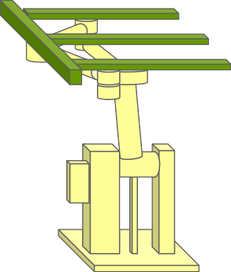
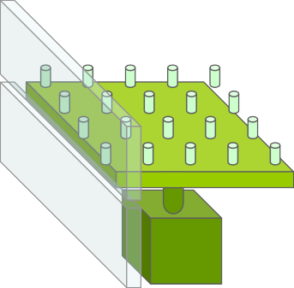

- Pin Exist
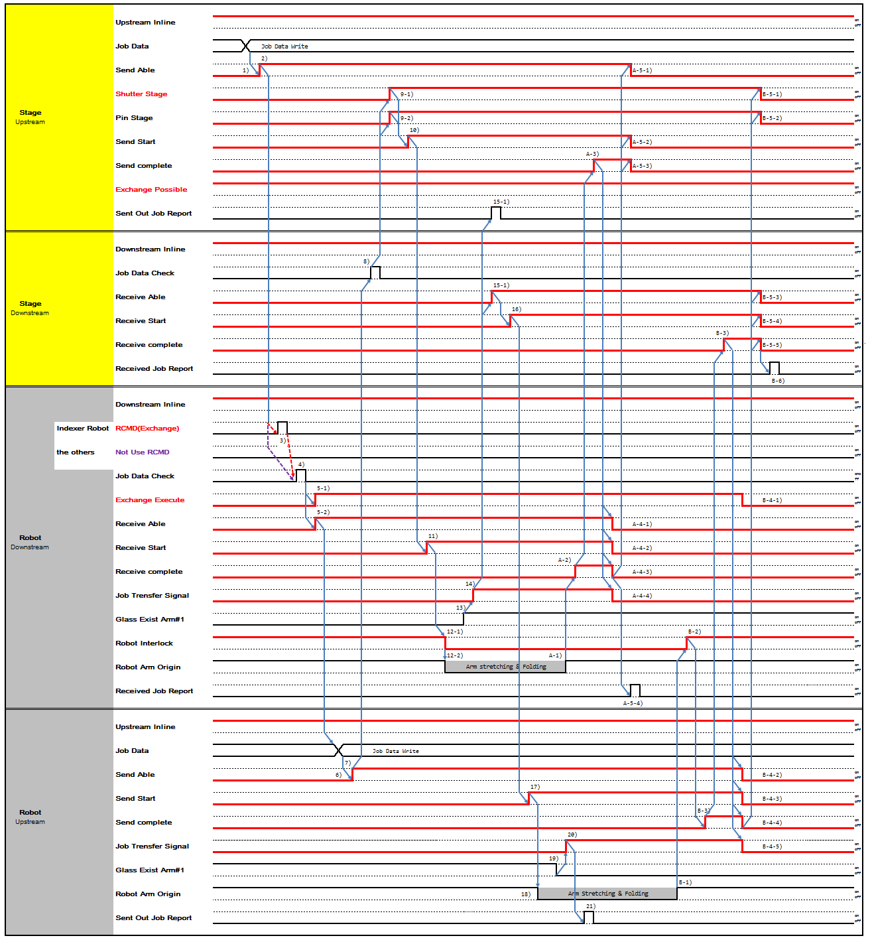

- No Pin Exist
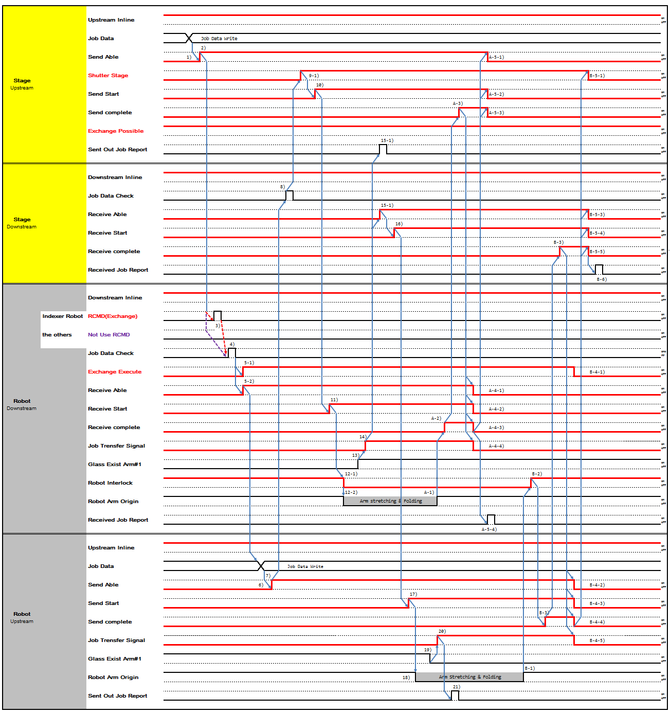

- Stage Upstream writes Job Data which will be send to Robot Downstream
- When Stage Upstream is ready to send Panel, turn on 'Send Able'.
- Robot Downstream receives Exchange Command from Robot Controller.
- Robot Downstream check Job Data of Panel to be received
5-1,-2) Robot Downstream, after checking, turns on 'Exchange Execute', 'Receive Able'. Upstream 'Exchange Possible': When upstream stage turns 'Exchange Possible' ON expecting exchange action, and then in case If downstream(robot) turns 'Receive Able' ON with 'Exchange Execute' OFF, upstream Stage should regards it as normal 'sending' action without exchange, and has to switch to conducting normal 'sending' process (refer to interface Type 5,6,7,8 ) automatically without any stops or trouble.

Robot Upstream writes Job Data which will be send to Stage Downstream
- When Robot Upstream is ready to send Panel, turn on 'Send Able'.
- Stage Downstream check Job Data of Panel to be received
9-1,-2) If Job Data check is Ok, Stage Upstream turns on 'Pin State', 'Shutter State'. According to Equipment, Two may move simultaneously or one may move prior to another. It depends on Equipment's decision.
- Stage Upstream turns on 'Send Start'.
- Robot Downstream turns on 'Receive Start'.
12-1) After Robot Downstream 'Receive Start' is turned on, Robot moves and turns off Robot Interlock at the same time. Stage Upstream doesn't not perform any movement that interfere with Robot until Robot Interlock is turned on
12-2) Robot Downstream proceed with Robot Get Sequence.
- Glass existence is determined by Robot Fork Vacuum On/Off.
- When Robot Downstream starts Transfer, turn on 'Job Transfer'.
15-1,-2) When Robot Downstream 'Job Transfer' is on, Stage Upstream reports 'Sent Out Job Report' and Stage Downstream turns on 'Receive Able'.
- When Stage Downstream turns on 'Receive Able', turn on 'Receive Start'.
- When Stage Downstream turns on 'Receive Start', turn on Robot Upstream 'Send Start'.
- When Robot Upstream 'Send Start' turns on, Robot proceeds with Put Sequence.
- Glass existence is determined by Robot Fork Vacuum On/Off.
- When Robot Upstream Glass Fork Vacuum is turn off, then turn on 'Job Transfer'.
- When 'Job Transfer' is on, Upstream reports 'Sent Out Report'. A-1) Robot Downstream completes Robot Get Sequence.
A-2) Robot Downstream turns on 'Receive Complete' after Panel Transfer is completed. A-3) Stage Upstream turns on 'Send Complete'
A-4-1,-2) When Stage Upstream turns on 'Send Complete', turn off 'Send Able', 'Send Start'. A-5-1,-2) When Stage Upstream turns off 'Send Able', 'Send Start', turn off 'Send Complete'.
A-6-1,-2,-3,-4) When Stage Upstream turns off 'Send Complete', turn off ‘Receive Able', ' Receive Start', ' Receive Complete', 'Job transfer'.
A-7) When Robot Downstream 'Job Transfer' is turned off, reports 'Received Job Report'. B-1) Robot Upstream completes Put sequence.

B-2) Robot Downstream turns on 'Robot Interlock'. B-3) Robot Upstream turns on 'Send Complete'
B-4) When Robot Upstream 'Send complete' is on, Stage Downstream turns on 'Receive Complete'.
B-5-1,-2,-3,-4) When Stage Downstream 'Receive Complete' is on, 'Receive Able', ' Receive Start' and Stage Upstream 'Pin State', 'Shutter State' is turned off.
B-6-1,-2,-3,-4) When 'Receive Able', ' Receive Start' and Stage Upstream 'Pin State', 'Shutter State' is turned off, Stage Downstream turns off 'Receive Complete'
B-7-1,-2,-3,-4,-5) When Stage Downstream 'Receive Complete' is turned off, turn off Robot Downstream 'Exchange Execute', Robot Upstream 'Send Able', 'Send Start', 'Send Complete', 'Job transfer'.
B-8) After Robot Upstream turns off 'Job Transfer' off, Stage Downstream reports 'Received Job Report'.

Type 12 Time Chart (Multiple Stage-Robot : Exchange/One Action)

Type | Glass-out | Glass-in | Action
Type 12 | Multiple Stage  (No Shutter, Self Controlled Shutter)  - Buffer  - Cassette | Robot | Combination of Type3 and 7 One Action Exchange  Robot ← Multiple Stage Robot → Multiple Stage
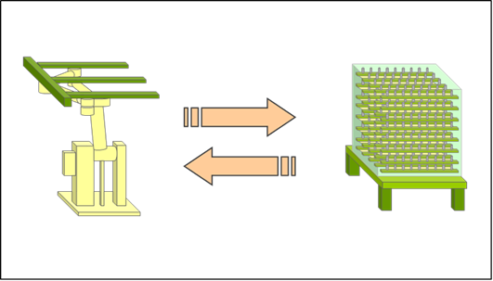

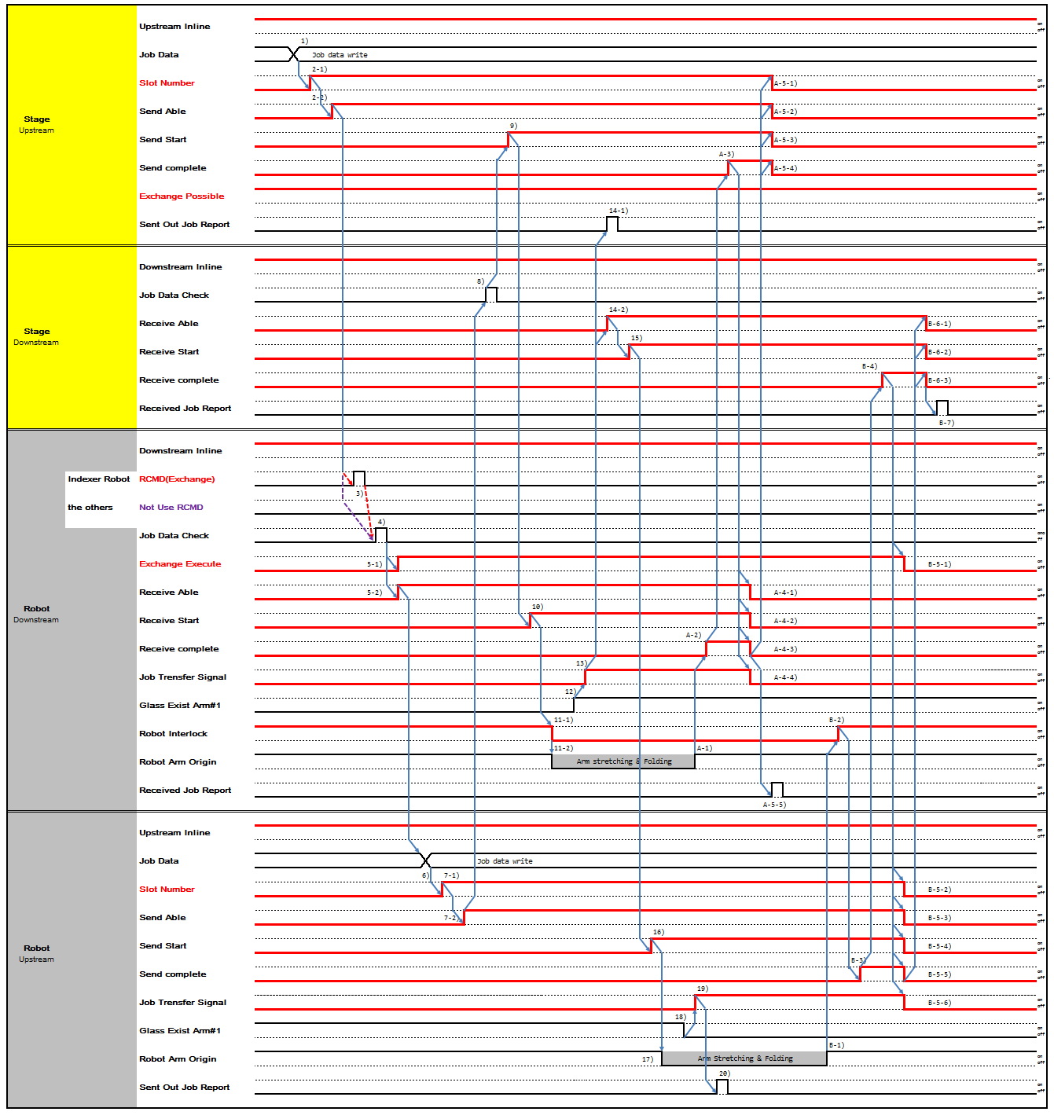

- Stage Upstream writes Job Data which will be send to Robot Downstream
- When Stage Upstream is ready to send Panel, turn on 'Send Able' and if Downstream is Multi Slot Stage, turn on 'Slot No' signal of lower Slot No.
- Robot Downstream receives Exchange Command from Robot Controller.
- Robot Downstream check Job Data of Panel to be received
5-1,-2) Robot Downstream, after checking, turns on 'Exchange Execute', 'Receive Able'. Upstream 'Exchange Possible': When upstream stage turns 'Exchange Possible' ON expecting exchange action, and then in case If downstream(robot) turns 'Receive Able' ON with 'Exchange Execute' OFF, upstream Stage should regards it as normal 'sending' action without exchange, and has to switch to conducting normal 'sending' process (refer to interface Type 5,6,7,8 ) automatically without any stops or trouble.

6) Robot Upstream writes Job Data which will be send to Stage Downstream
7-1,-2) When Robot Upstream is ready to send Panel, turn on 'Send Able' and if Downstream is Multi Slot Stage, turn on 'Slot No' signal of lower Slot No.
- Stage Downstream check Job Data of Panel to be received
- Stage Upstream turns on 'Send Start'.
- Robot Downstream turns on 'Receive Start'.
11-1) After Robot Downstream 'Receive Start' is turned on, Robot moves and turns off Robot Interlock at the same time. Stage Upstream doesn't not perform any movement that interfere with Robot until Robot Interlock is turned on
11-2) Robot Downstream proceed with Robot Get Sequence.
- Glass existence is determined by Robot Fork Vacuum On/Off.
- When Robot Downstream starts Transfer, turn on 'Job Transfer'.
14-1,-2) When Robot Downstream 'Job Transfer' is on, Stage Upstream reports 'Sent Out Job Report' and Stage Downstream turns on 'Receive Able'.
- When Stage Downstream turns on 'Receive Able', turn on 'Receive Start'.
- When Stage Downstream turns on 'Receive Start', turn on Robot Upstream 'Send Start'.
- When Robot Upstream 'Send Start' turns on, Robot proceeds with Put Sequence.
- Glass existence is determined by Robot Fork Vacuum On/Off.
- When Robot Upstream Glass Fork Vacuum is turn off, then turn on 'Job Transfer'.
- When 'Job Transfer' is on, Upstream reports 'Sent Out Report'. A-1) Robot Downstream completes Robot Get Sequence.
A-2) Robot Downstream turns on 'Receive Complete' after Panel Transfer is completed. A-3) Stage Upstream turns on 'Send Complete'
A-4-1,-2,-3) When Stage Upstream turns on 'Send Complete', turn off 'Send Able', 'Send Start', 'Slot No'. A-5-1,-2,-3) When Stage Upstream turns off 'Send Able', 'Send Start', 'Slot No', turn off 'Send Complete'.
A-6-1,-2,-3,-4) When Stage Upstream turns off 'Send Complete', turn off ‘Receive Able', ' Receive Start', ' Receive Complete', 'Job transfer'.
A-7) When Robot Downstream 'Job Transfer' is turned off, reports 'Received Job Report'. B-1) Robot Upstream completes Put sequence.
B-2) Robot Downstream turns on 'Robot Interlock'. B-3) Robot Upstream turns on 'Send Complete'
B-4) When Robot Upstream 'Send complete' is on, Stage Downstream turns on 'Receive Complete'.
B-5-1,-2) When Stage Downstream 'Receive Complete' is on, 'Receive Able', ' Receive Start' is turned off.
B-6-1,-2) When 'Receive Able', ' Receive Start' is turned off, Stage Downstream turns off 'Receive Complete'
B-7-1,-2,-3,-4,-5,-6) When Stage Downstream 'Receive Complete' is turned off, turn off Robot Downstream 'Exchange Execute', Robot Upstream 'Slot No', 'Send Able', 'Send Start', 'Send Complete', 'Job transfer'.
B-8) After Robot Upstream turns off 'Job Transfer' off, Stage Downstream reports 'Received Job Report'.

Type 13 Time Chart (Multiple Stage/Shutter-Robot : Exchange/One Action)

Type | Glass-out | Glass-in | Action
Type 13 | Multiple Stage  (Includes Shutter, Need to Control Shutter)  - Buffer  - Cassette | Robot | Combination of Type4 and 8 One Action Exchange  Robot ← Multiple Stage Robot → Multiple Stage
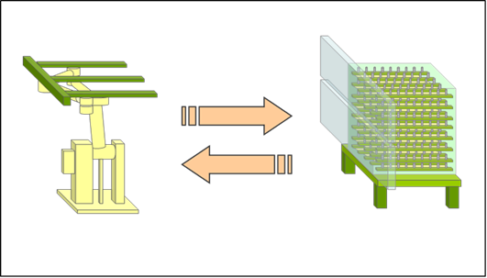

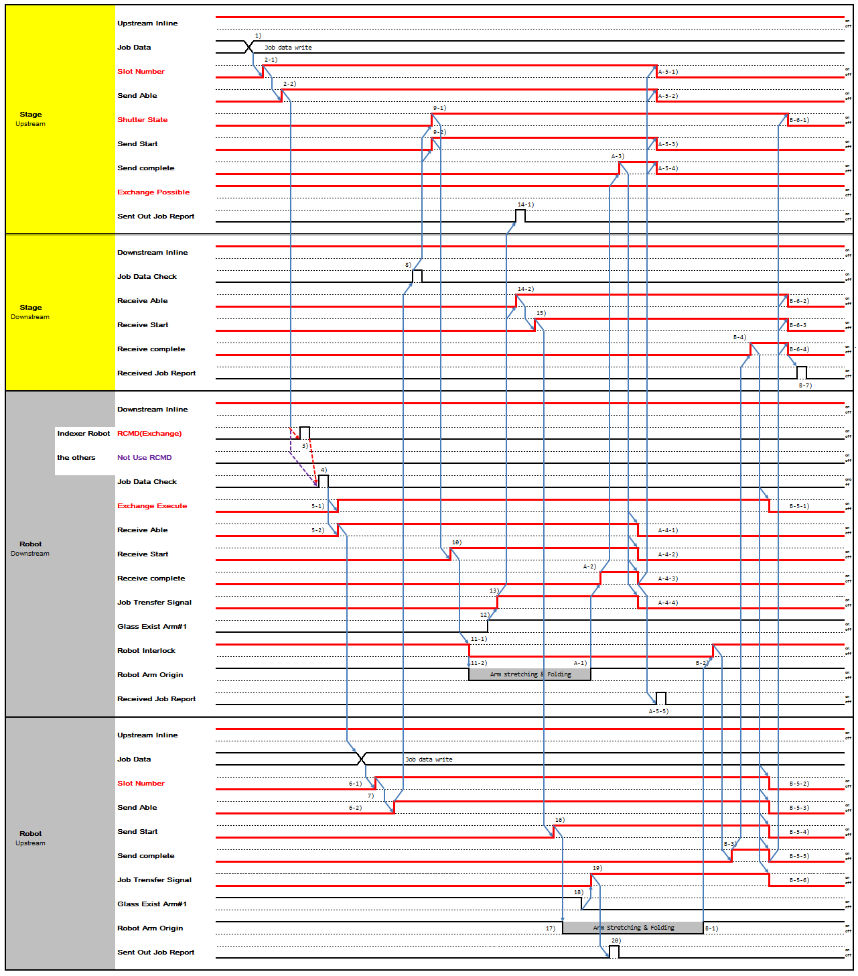

- Stage Upstream writes Job Data which will be send to Robot Downstream
- When Stage Upstream is ready to send Panel, turn on 'Send Able' and if Downstream is Multi Slot Stage, turn on 'Slot No' signal of lower Slot No.
- Robot Downstream receives Exchange Command from Robot Controller.
- Robot Downstream check Job Data of Panel to be received
5-1,-2) Robot Downstream, after checking, turns on 'Exchange Execute', 'Receive Able'. Upstream 'Exchange Possible': When upstream stage turns 'Exchange Possible' ON expecting exchange action, and then in case If downstream(robot) turns 'Receive Able' ON with 'Exchange Execute' OFF, upstream Stage should regards it as normal 'sending' action without exchange, and has to switch to conducting normal 'sending' process (refer to interface Type 5,6,7,8 ) automatically without any stops or trouble.

6) Robot Upstream writes Job Data which will be send to Stage Downstream
7-1,-2) When Robot Upstream is ready to send Panel, turn on 'Send Able' and if Downstream is Multi Slot Stage, turn on 'Slot No' signal of lower Slot No.
8) Stage Downstream check Job Data of Panel to be received
9-1,-2) Stage Upstream opens Shutter and turns on 'Send Start', 'Shutter State'.
10) Robot Downstream turns on 'Receive Start'.
11-1) After Robot Downstream 'Receive Start' is turned on, Robot moves and turns off Robot Interlock at the same time. Stage Upstream doesn't not perform any movement that interfere with Robot until Robot Interlock is turned on
11-2) Robot Downstream proceed with Robot Get Sequence.
- Glass existence is determined by Robot Fork Vacuum On/Off.
- When Robot Downstream starts Transfer, turn on 'Job Transfer'.
14-1,-2) When Robot Downstream 'Job Transfer' is on, Stage Upstream reports 'Sent Out Job Report' and Stage Downstream turns on 'Receive Able'.
- When Stage Downstream turns on 'Receive Able', turn on 'Receive Start'.
- When Stage Downstream turns on 'Receive Start', turn on Robot Upstream 'Send Start'.
- When Robot Upstream 'Send Start' turns on, Robot proceeds with Put Sequence.
- Glass existence is determined by Robot Fork Vacuum On/Off.
- When Robot Upstream Glass Fork Vacuum is turn off, then turn on 'Job Transfer'.
- When 'Job Transfer' is on, Upstream reports 'Sent Out Report'. A-1) Robot Downstream completes Robot Get Sequence.
A-2) Robot Downstream turns on 'Receive Complete' after Panel Transfer is completed. A-3) Stage Upstream turns on 'Send Complete'
A-4-1,-2,-3) When Stage Upstream turns on 'Send Complete', turn off 'Send Able', 'Send Start', 'Slot No'. A-5-1,-2,-3) When Stage Upstream turns off 'Send Able', 'Send Start', 'Slot No', turn off 'Send Complete'.
A-6-1,-2,-3,-4) When Stage Upstream turns off 'Send Complete', turn off ‘Receive Able', ' Receive Start', ' Receive Complete', 'Job transfer'.
A-7) When Robot Downstream 'Job Transfer' is turned off, reports 'Received Job Report'. B-1) Robot Upstream completes Put sequence.

B-2) Robot Downstream turns on 'Robot Interlock'. B-3) Robot Upstream turns on 'Send Complete'
B-4) When Robot Upstream 'Send complete' is on, Stage Downstream turns on 'Receive Complete'.
B-5-1,-2) When Stage Downstream 'Receive Complete' is on, 'Receive Able', ' Receive Start' is turned off.
B-6-1,-2) When 'Receive Able', ' Receive Start' is turned off, Stage Downstream turns off 'Receive Complete'
B-7-1,-2,-3,-4,-5,-6,-7) When Stage Downstream 'Receive Complete' is turned off, turn off Robot Downstream 'Exchange Execute', Stage Upstream 'Shutter State', Robot Upstream 'Slot No', 'Send Able', 'Send Start', 'Send Complete', 'Job transfer'.
B-8) After Robot Upstream turns off 'Job Transfer' off, Stage Downstream reports 'Received Job Report'.

Type 14 Time Chart (Single Stage-Robot : Exchange/Two Action)

Type | Glass-out | Glass-in | Action
Type 14 | Single Stage  (No Shutter, Self Controlled Shutter)  - PIN Stage  - Big Roller CV  - Gate CV  - Turn Stage | Robot | Combination of Type1 and 5 Two Action Exchange  Robot ← Single Stage Robot → Single Stage

- Pin Exist
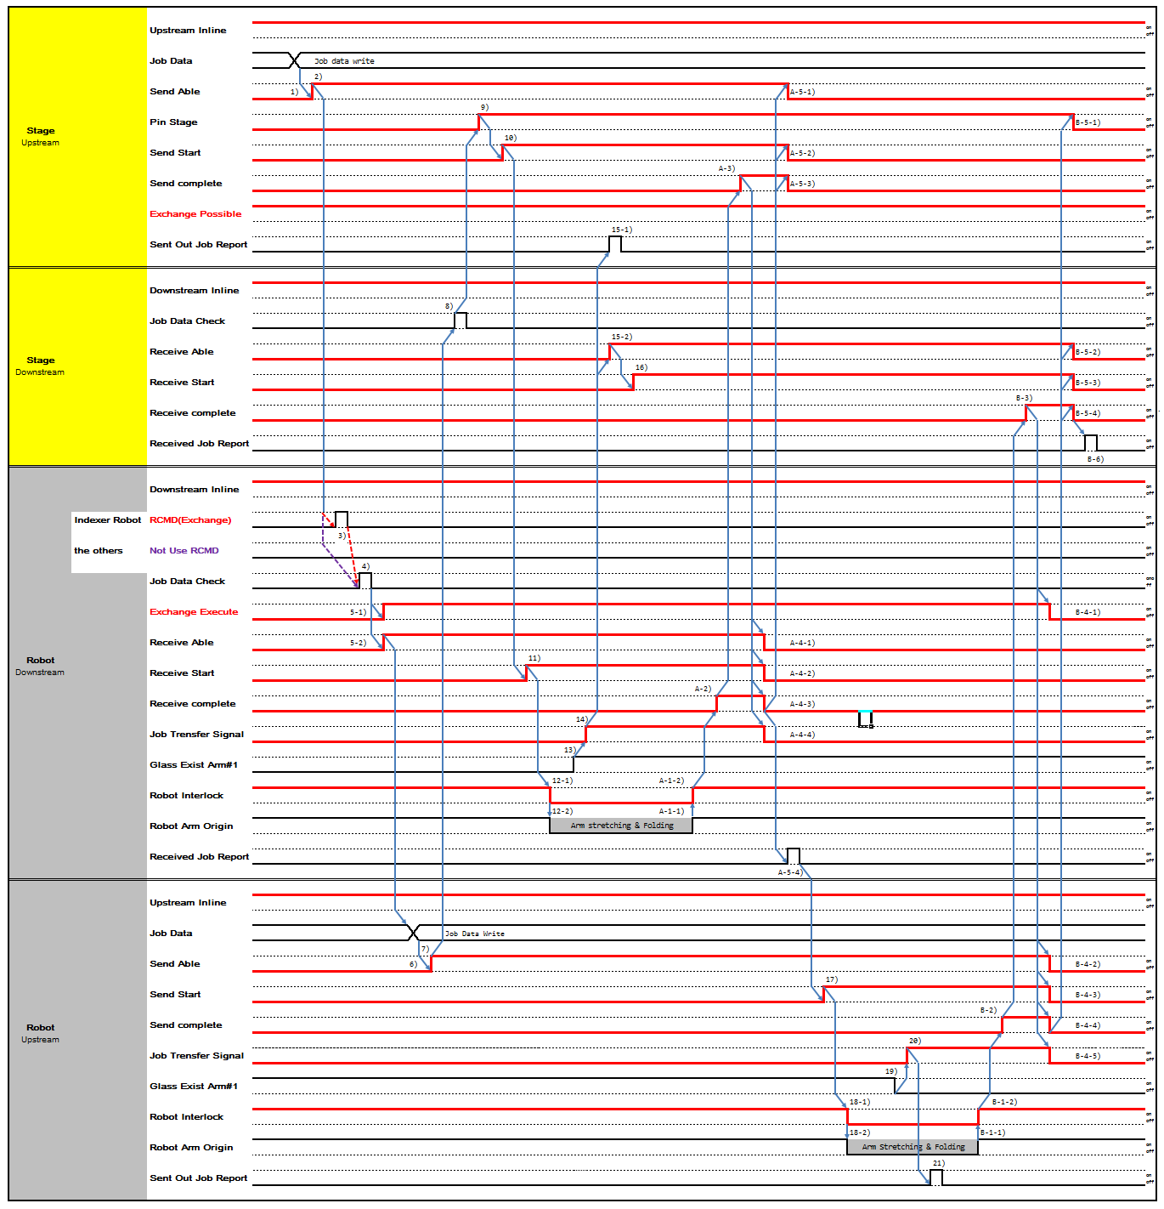

- No Pin Exist
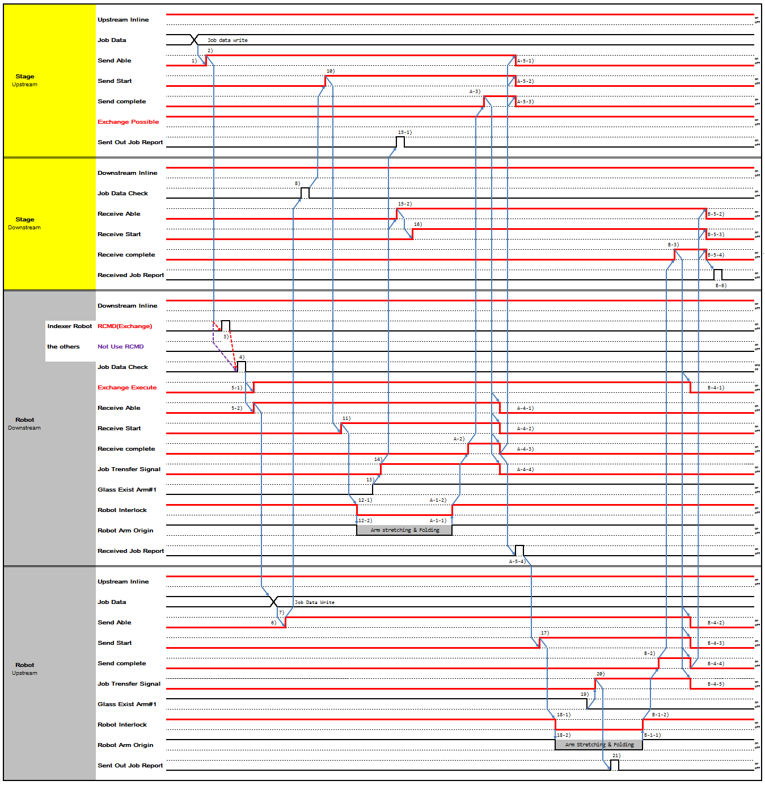

- Stage Upstream writes Job Data which will be send to Robot Downstream
- When Stage Upstream is ready to send Panel, turn on 'Send Able'.
- Robot Downstream receives Exchange Command from Robot Controller.
- Robot Downstream check Job Data of Panel to be received
5-1,-2) Robot Downstream, after checking, turns on 'Exchange Execute', 'Receive Able'. Upstream 'Exchange Possible': When upstream stage turns 'Exchange Possible' ON expecting exchange action, and then in case If downstream(robot) turns 'Receive Able' ON with 'Exchange Execute' OFF, upstream Stage should regards it as normal 'sending' action without exchange, and has to switch to conducting normal 'sending' process (refer to interface Type 5,6,7,8 ) automatically without any stops or trouble.

- Robot Upstream writes Job Data which will be send to Stage Downstream
- When Robot Upstream is ready to send Panel, turn on 'Send Able'.
- Stage Downstream check Job Data of Panel to be received
- Stage Upstream lifts Pin Stage up and turns on 'Pin State'.
- Stage Upstream turns on 'Send Start'.
- Robot Downstream turns on 'Receive Start'.
12-1) After Robot Downstream 'Receive Start' is turned on, Robot moves and turns off Robot Interlock at the same time. Stage Upstream doesn't not perform any movement that interfere with Robot until Robot Interlock is turned on
12-2) Robot Downstream proceed with Robot Get Sequence.
- Glass existence is determined by Robot Fork Vacuum On/Off.
- When Robot Downstream starts Transfer, turn on 'Job Transfer'.
15-1,-2) When Robot Downstream 'Job Transfer' is on, Stage Upstream reports 'Sent Out Job Report' and Stage Downstream turns on 'Receive Able'.
- When Stage Downstream turns on 'Receive Able', turn on 'Receive Start'. A-1-1) Robot Downstream completes Robot Get Sequence.
A-1-2) Robot Downstream turns on 'Robot Interlock'.
A-2) Robot Downstream turns on 'Receive Complete' after Panel Transfer is completed.
A-3) When Robot Downstream turns off 'Receive Complete', Stage Upstream turns on 'Send Complete' A-4-1,-2) When Stage Upstream turns on 'Send Complete', turn off 'Send Able', 'Send Start'.
A-5-1,-2) When Stage Upstream turns off 'Send Able', 'Send Start', turn off 'Send Complete'.
A-6-1,-2,-3,-4) When Stage Upstream turns off 'Send Complete', turn off ‘Receive Able', ' Receive Start', ' Receive Complete', 'Job transfer'.
A-7) When Robot Downstream 'Job Transfer' is turned off, reports 'Received Job Report'.
- When Robot Downstream completes Get transfer, Robot Upstream turns on 'Send Start' and proceed with Put sequence.
18-1) When Robot Upstream 'Send Start' turns on, Robot moves and turns off Robot Interlock at the same time. Stage Upstream doesn't not perform any movement that interfere with Robot until Robot Interlock is turned on
18-2) Robot Upstream proceeds with Put Sequence.
- Glass existence is determined by Robot Fork Vacuum On/Off.
- When Robot Upstream starts transferring, turn on 'Job Transfer'.

- When 'Job Transfer' is on, Upstream reports 'Sent Out Job Report'. B-1-2) Robot Upstream completes Put sequence.
B-1-2) Robot Downstream turns on 'Robot Interlock'.
B-2) When Robot Upstream completes transfer, turns on 'Send Complete' B-3) Stage Downstream turns on 'Receive Complete'.
B-4-1,-2,-3) When Stage Downstream 'Receive Complete' is on, 'Receive Able', ' Receive Start' and Stage Upstream 'Pin State' is turned off.
B-5-1,-2,-3) When 'Receive Able', ' Receive Start' and Stage Upstream 'Pin State' is turned off, Stage Downstream turns off 'Receive Complete'
B-6-1,-2,-3,-4,-5) When Stage Downstream 'Receive Complete' is turned off, turn off Robot Downstream 'Exchange Execute', Robot Upstream 'Send Able', 'Send Start', 'Send Complete', 'Job transfer'.
B-7) After Robot Upstream turns off 'Job Transfer' off, Stage Downstream reports 'Received Job Report'.

Type 15 Time Chart (Single Stage/Shutter-Robot : Exchange/Two Action)

Type | Glass-out | Glass-in | Action
Type 15 | Single Stage  (Includes Shutter, Need to Control Shutter)  - PIN Stage  - Big Roller CV  - Gate CV  - Turn Stage | Robot | Combination of Type2 and 6  Two Action Exchange  Robot ← Single Stage Robot → Single Stage
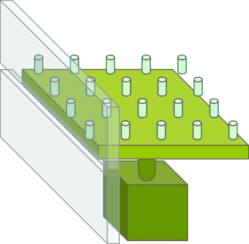

- Pin Exist
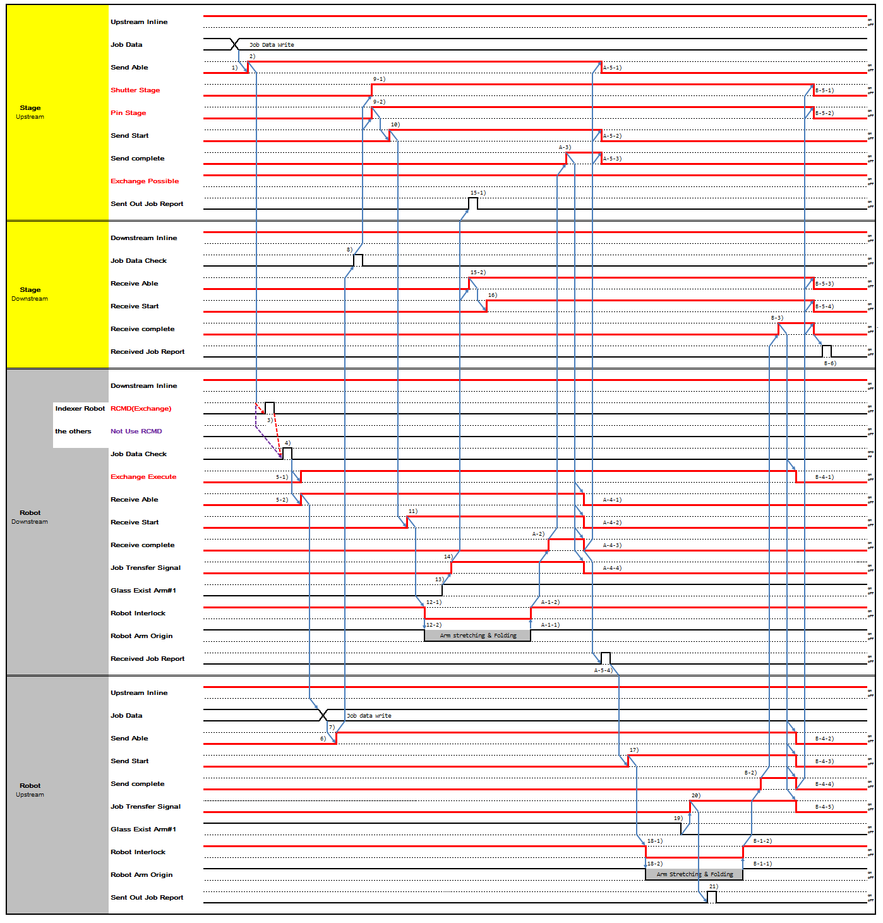

- No Pin Exist
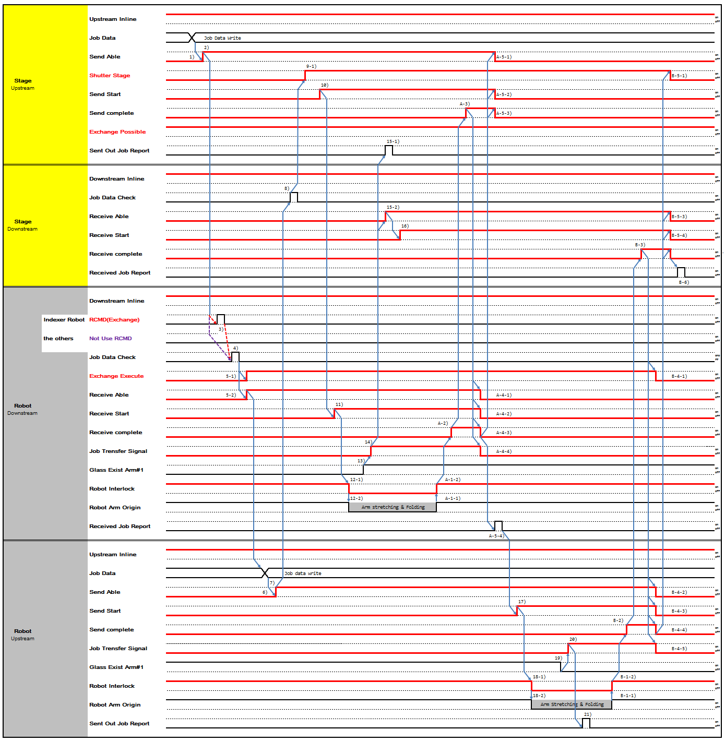

- Stage Upstream writes Job Data which will be send to Robot Downstream
- When Stage Upstream is ready to send Panel, turn on 'Send Able'.
- Robot Downstream receives Exchange Command from Robot Controller.
- Robot Downstream check Job Data of Panel to be received
5-1,-2) Robot Downstream, after checking, turns on 'Exchange Execute', 'Receive Able’. Upstream 'Exchange Possible': When upstream stage turns 'Exchange Possible' ON expecting exchange action, and then in case If downstream(robot) turns 'Receive Able' ON with 'Exchange Execute' OFF, upstream Stage should regards it as normal 'sending' action without exchange, and has to switch to conducting normal 'sending' process (refer to interface Type 5,6,7,8 ) automatically without any stops or trouble.
- Robot Upstream writes Job Data which will be send to Stage Downstream
- When Robot Upstream is ready to send Panel, turn on 'Send Able'.
- Stage Downstream check Job Data of Panel to be received
9-1,-2) If Job Data check is Ok, turn on 'Pin State', 'Shutter State'. According to Equipment, Two may move simultaneously or one may move prior to another. It depends on Equipment's decision. 10) Stage Upstream turns on 'Send Start'.
11) Robot Downstream turns on 'Receive Start'.
12-1) After Robot Downstream 'Receive Start' is turned on, Robot moves and turns off Robot Interlock at the same time. Stage Upstream doesn't not perform any movement that interfere with Robot until Robot Interlock is turned on
12-2) Robot Downstream proceed with Robot Get Sequence.
- Glass existence is determined by Robot Fork Vacuum On/Off.
- When Robot Downstream starts Transfer, turn on 'Job Transfer'.
15-1,-2) When Robot Downstream 'Job Transfer' is on, Stage Upstream reports 'Sent Out Job Report' and Stage Downstream turns on 'Receive Able'.
- When Stage Downstream turns on 'Receive Able', turn on 'Receive Start'. A-1-1) Robot Downstream completes Robot Get Sequence.
A-1-2) Robot Downstream turns on 'Robot Interlock'.
A-2) Robot Downstream turns on 'Receive Complete' after Panel Transfer is completed.
A-3) When Robot Downstream turns off 'Receive Complete', Stage Upstream turns on 'Send Complete' A-4-1,-2) When Stage Upstream turns on 'Send Complete', turn off 'Send Able', 'Send Start'.
A-5-1,-2) When Stage Upstream turns off 'Send Able', 'Send Start', turn off 'Send Complete'.
A-6-1,-2,-3,-4) When Stage Upstream turns off 'Send Complete', turn off ‘Receive Able', ' Receive Start', ' Receive Complete', 'Job transfer'.
A-7) When Robot Downstream 'Job Transfer' is turned off, reports 'Received Job Report'.
- When Robot Downstream completes Get transfer, Robot Upstream turns on 'Send Start' and proceed with Put sequence.
18-1) When Robot Upstream 'Send Start' turns on, Robot moves and turns off Robot Interlock at the same time. Stage Upstream doesn't not perform any movement that interfere with Robot until Robot Interlock is turned on
18-2) Robot Upstream proceeds with Put Sequence.
- Glass existence is determined by Robot Fork Vacuum On/Off.
- When Robot Upstream starts transferring, turn on 'Job Transfer'.

- When 'Job Transfer' is on, Upstream reports 'Sent Out Job Report'. B-1-2) Robot Upstream completes Put sequence.
B-1-2) Robot Downstream turns on 'Robot Interlock'.
B-2) When Robot Upstream completes transfer, turns on 'Send Complete' B-3) Stage Downstream turns on 'Receive Complete'.
B-4-1,-2,-3,-4) When Stage Downstream 'Receive Complete' is on, 'Receive Able', ' Receive Start' and Stage Upstream 'Pin State', 'Shutter State' is turned off.
B-5-1,-2,-3,-4) When 'Receive Able', ' Receive Start' and Stage Upstream 'Pin State', 'Shutter State' is turned off, Stage Downstream turns off 'Receive Complete'
B-6-1,-2,-3,-4,-5) When Stage Downstream 'Receive Complete' is turned off, turn off Robot Downstream 'Exchange Execute', Robot Upstream 'Send Able', 'Send Start', 'Send Complete', 'Job transfer'.
B-7) After Robot Upstream turns off 'Job Transfer' off, Stage Downstream reports 'Received Job Report'.

Type 16 Time Chart (Multiple Stage-Robot : Exchange/Two Action)

Type | Glass-out | Glass-in | Action
Type 16 | Multiple Stage  (No Shutter, Self Controlled Shutter)  - Buffer  - Cassette | Robot | Combination of Type3 and 7  Two Action Exchange  Robot ← Multiple Stage Robot → Multiple Stage
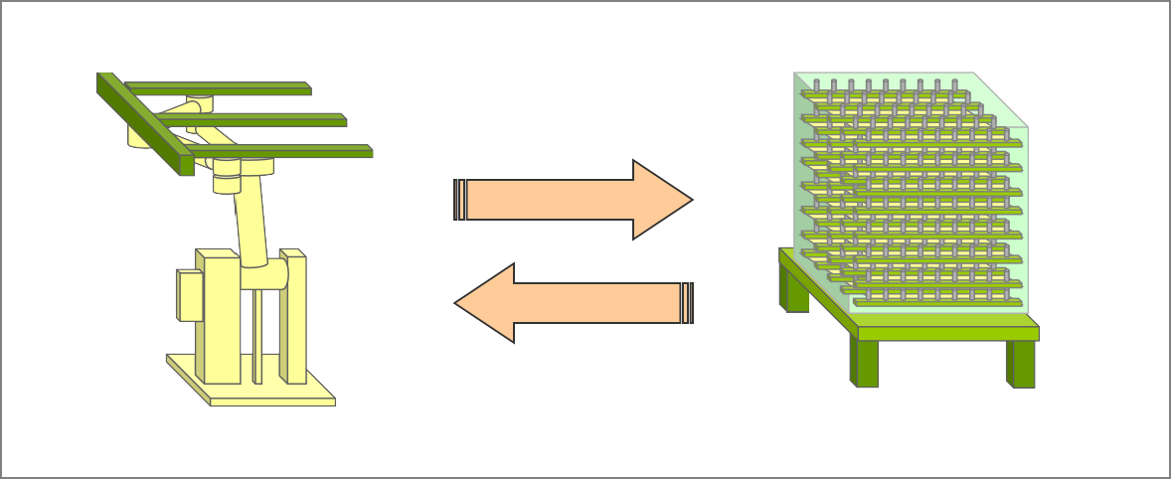

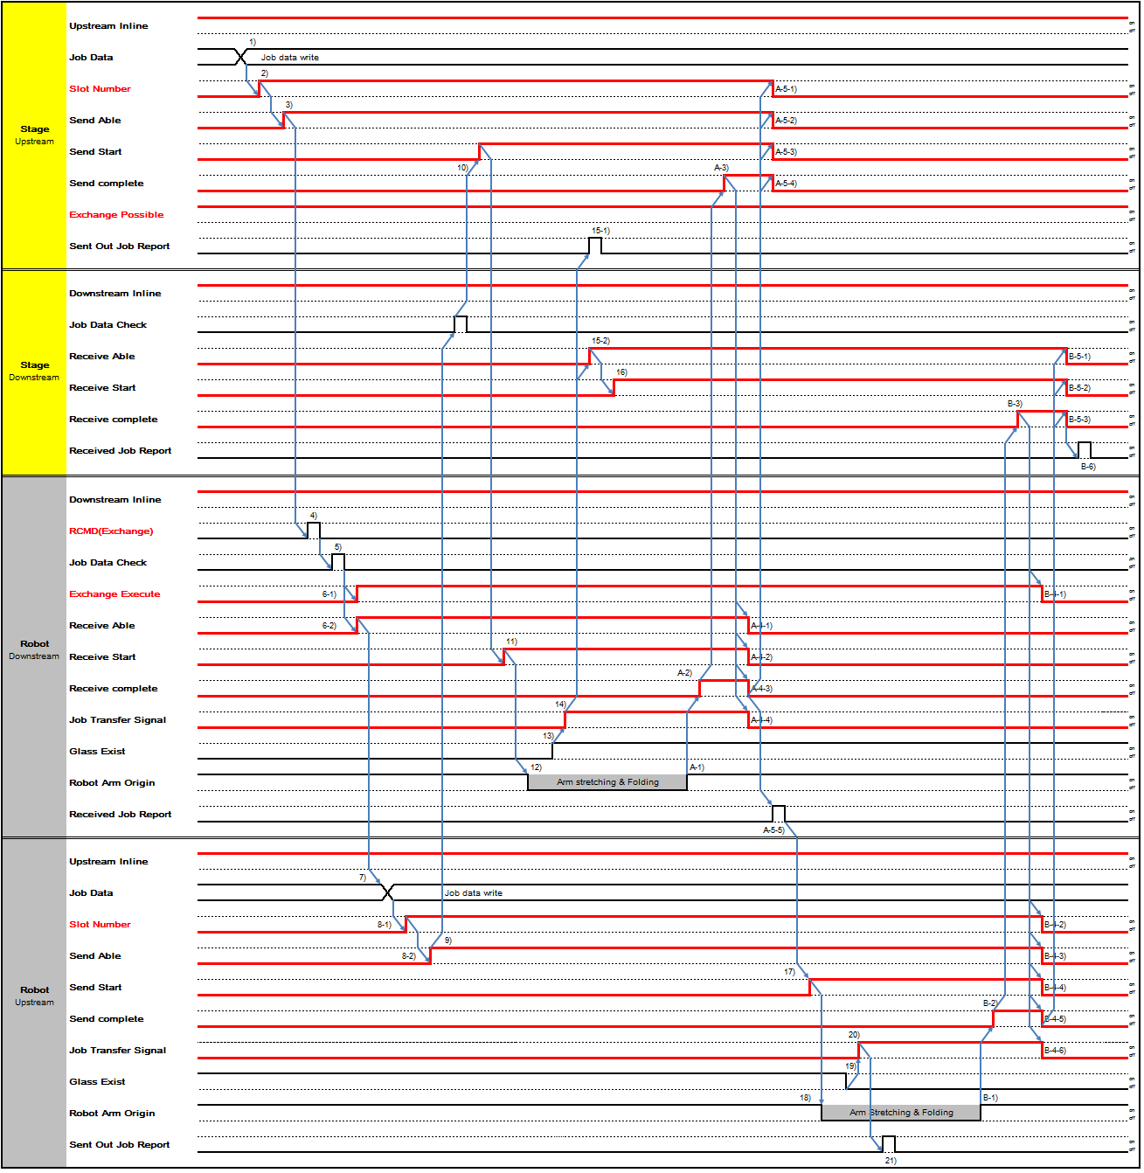

(Stage Upstream: SU, Stage Downstream: SD, Robot Upstream: RU, Robot Downstream: RD)
- SU: Send possible, Writes current job data on data area.
- SU: ‘Slot Number’ turns on.
- SU: ‘Send Able’ turns on.
- Robot is received ‘Exchange’ command from CIMPC.
- RD: Check job data.
- Robot turns on ‘Exchange Execute’ and ‘Receive Able’.(if do not turns on then Only SU→RD)
- RU: Send possible, Writes current job data on data area.
- RU: ‘Slot Number’ and ‘Send Able’ turns on.
- SD: ‘Job Data Check’ for receive job
- SU: Send start has processed job.
- RD: Receive start has processed job.
- RD: Robot Working.
- RD: 'Job Transfer Signal' turn on.
- RD: Get job at this time.
- SU: ‘Sent out job Report’ turns on and ‘Receive Able’ turns on.
- SD: ‘Receive Able’ turns on.
- SD: Receive start new job. A-1) RD: Get end.
A-2) RD: ‘Receive complete’ turns on. A-3) SU: ‘Send complete’ turns on.
A-4) SU: ‘Slot Number’, ‘Send able’ and ‘Send Start’ turns off. A-5) SU: ‘Send complete’ turn off.
A-6) RD: Turn off all signals.
A-7) RD: If 'Job transfer Signal' turn off. ‘Receive Job Report’ turns on.
- RU: Send start new job.
- RU: Robot put action.
- RU: 'Job Transfer Signal' turn on.
- RU: Put job at this time.
- RU: ‘Sent out job report’ turn on. B-1) RU: Put finish at this time.
B-2) RU: ‘Send complete’ turn on. B-3) SD: ‘Receive complete’
B-4) RU: ‘Slot Number’, ’Send able’, ‘Send Start’, ‘Send complete’ , ‘Job Transfer Signal’ turn off.
RD: ‘Exchange Execute’ turns off.
B-5) SD: ‘Receive able’, ‘Receive Start’, ‘Receive complete ‘turn off. B-6) SD: ‘Receive Job Report’ turns on.

Type 17 Time Chart (Multiple Stage/Shutter-Robot : Exchange/Two Action)

Type | Glass-out | Glass-in | Action
Type 17 | Multiple Stage  (Includes Shutter, Need to Control Shutter)  - Buffer  - Cassette | Robot | Combination of Type4 and 8  Two Action Exchange  Robot ← Multiple Stage Robot → Multiple Stage
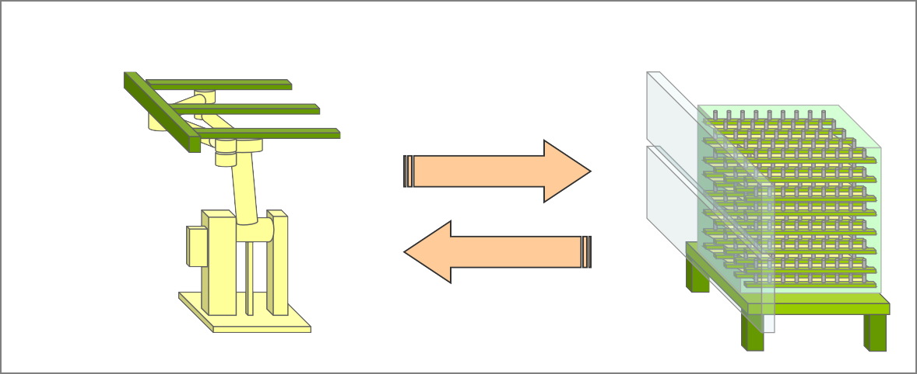

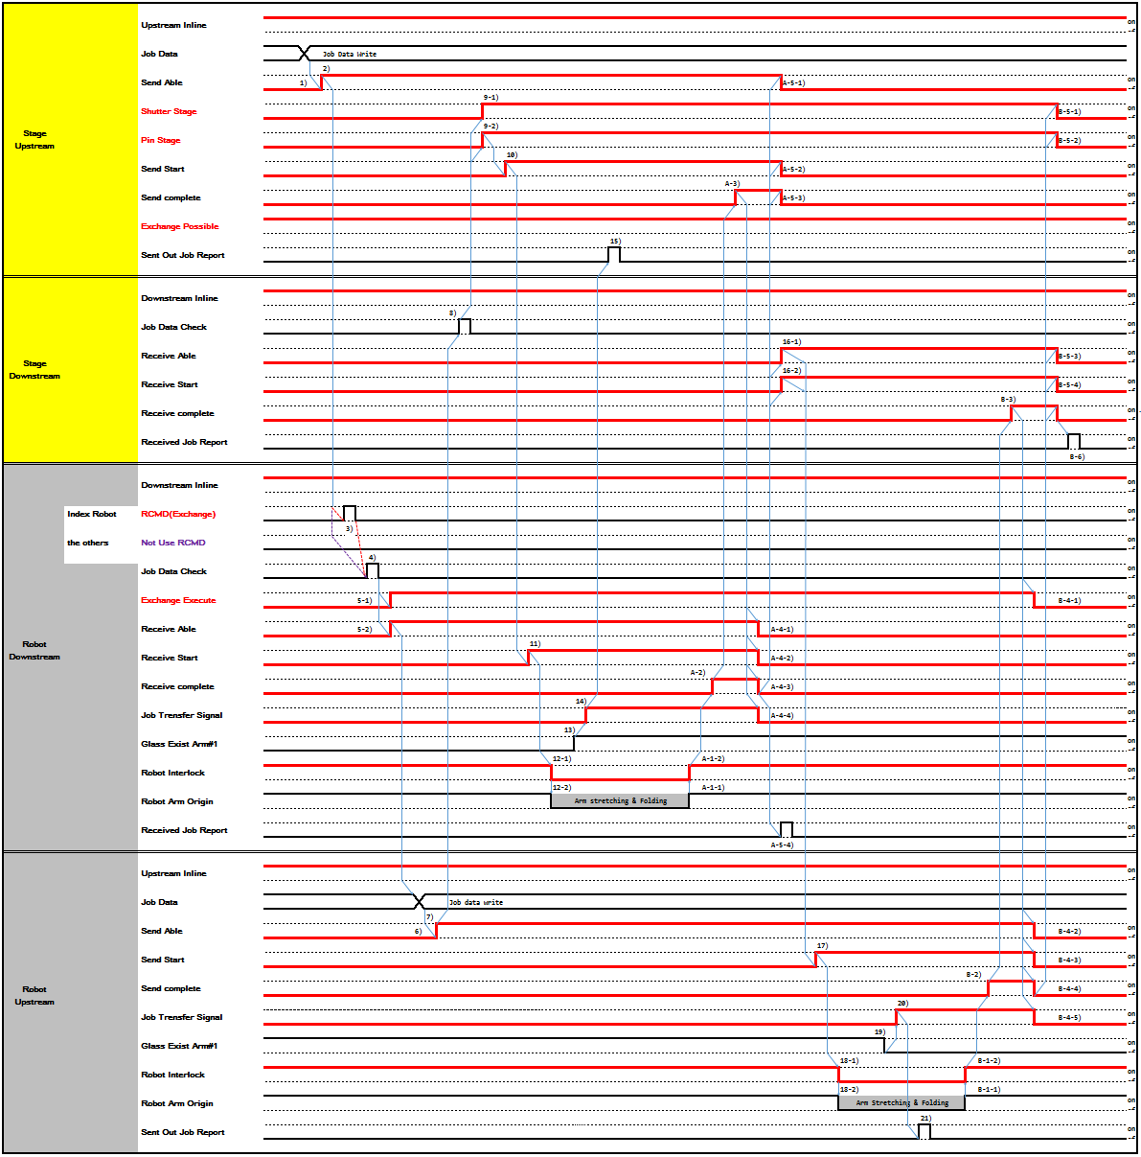

(Stage Upstream: SU, Stage Downstream: SD, Robot Upstream: RU, Robot Downstream: RD)
- SU: Send possible, Writes current job data on data area.
- SU: ‘Slot Number’ turns on.
- SU: ‘Send Able’ turns on.
- Robot is received ‘Exchange’ command from CIMPC.
- RD: Check job data.
- Robot turns on ‘Exchange Execute’ and ‘Receive Able’.(if do not turns on then Only SU→RD)

- RU: Send possible, Writes current job data on data area.
- RU: ‘Slot Number’ and ‘Send Able’ turns on.
- SD: ‘Job Data Check’ for receive job
- SU: Shutter Open.
- SU: Send start has processed job.
- RD: Receive start has processed job.
- RD: Robot Working.
- RD: 'Job Transfer Signal' turn on.
- RD: Get job at this time.
- SU: ‘Sent out job Report’ turns on and ‘Receive Able’ turns on.
- SD: Receive start new job. A-1) RD: Get end.
A-2) RD: ‘Receive complete’ turns on. A-3) SU: ‘Send complete’ turns on.
A-4) SU: ‘Send able’, ‘Send Start’ turns off. A-5) SU: ‘Send complete’ turn off.
A-6) RD: Turn off all signals.
A-7) RD: If 'Job transfer Signal' turn off. ‘Receive Job Report’ turns on.
- RU: Send start new job.
- RU: Robot put action.
- RU: 'Job Transfer Signal' turn on.
- RU: Put job at this time.
- RU: ‘Sent out job report’ turn on. B-1) RU: Put finish at this time.
B-2) RU: ‘Send complete’ turn on.
B-3) SD: ‘Receive complete’ turn on.
B-4) RU: ‘Slot Number’, ’Send able’, ‘Send Start’, ‘Send complete’ , ‘Job Transfer Signal’ turn off.
RD: ‘Exchange Execute’ turns off.
B-5) SU: ‘Shutter State’ turn off. SD: ‘Receive able’, ‘Receive Start’, ‘Receive complete ‘turn off. B-6) SD: ‘Receive Job Report’ turns on.

Recovery Timing Chart

Cancel Request(No handling glass from upstream to downstream)

Stage(Upstream) - Robot(Downstream)

      - Upstream Cancel Request Case(Include Exchange)

- Exchange Cancel Case follows this time chart(ref. 5.10~15 Type 10~15 Time Chart).
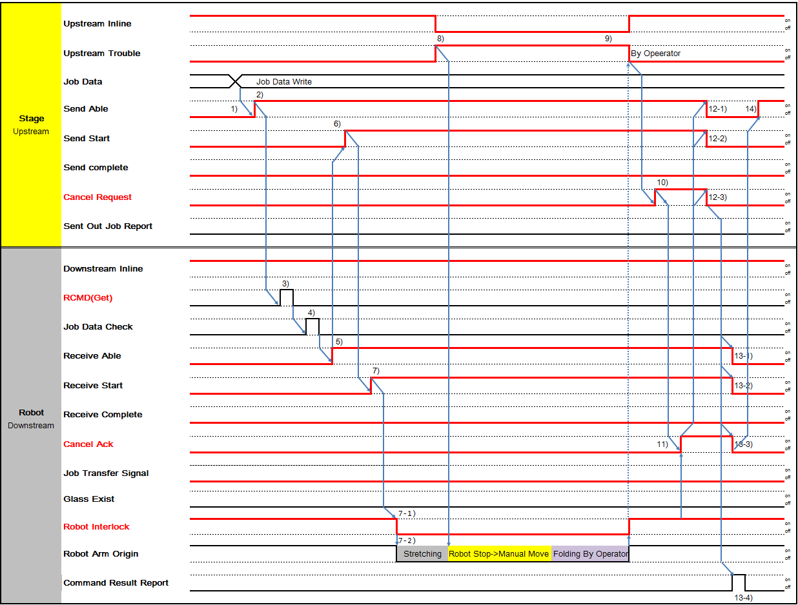
: If Job Transfer Signal is Off, then Put action(Stage Downstream - Robot Upstream) is not executed.

※ The Pin Stage signal is based on the normal chart.
※ For Local Dispatching Type Indexer, the RCMD signal is ignored.
※ Downstream Cancel Ack should be Robot Interlock On.
※ The dotted line indicates the Operator's operation sequence.

      - Downstream Cancel Request Case(Include Exchange)
- Exchange Cancel Case follows this time chart(ref. 5.10~15 Type 10~15 Time Chart).
: This is only Put action of Exchange(Stage Downstream - Robot Upstream)
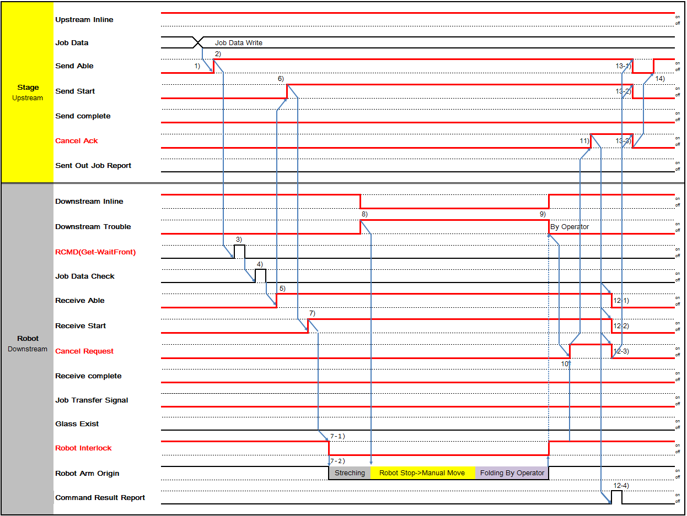
※ The Pin Stage signal is based on the normal chart.
※ For Local Dispatching Type Indexer, the RCMD signal is ignored.
※ Downstream Cancel Request should be Robot Interlock On.
※ The dotted line indicates the Operator's operation sequence.

Robot(Upstream) - Stage(Downstream)

      - Upstream Cancel Request Case(Include Exchange)
Exchange Cancel Case follows this time chart(ref. 5.10~15 Type 10~15 Time Chart).
: This is only Put action of Exchange(Stage Downstream - Robot Upstream)
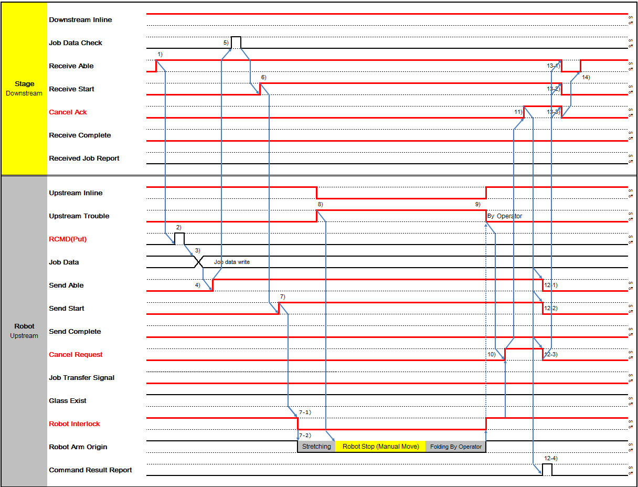

※ The Pin Stage signal is based on the normal chart.
※ For Local Dispatching Type Indexer, the RCMD signal is ignored.
※ Upstream Cancel Request should be Robot Interlock On.
※ The dotted line indicates the Operator's operation sequence.

      - Downstream Cancel Request Case(Include Exchange)

Exchange Cancel Case follows this time chart(ref. 5.10~15 Type 10~15 Time Chart).
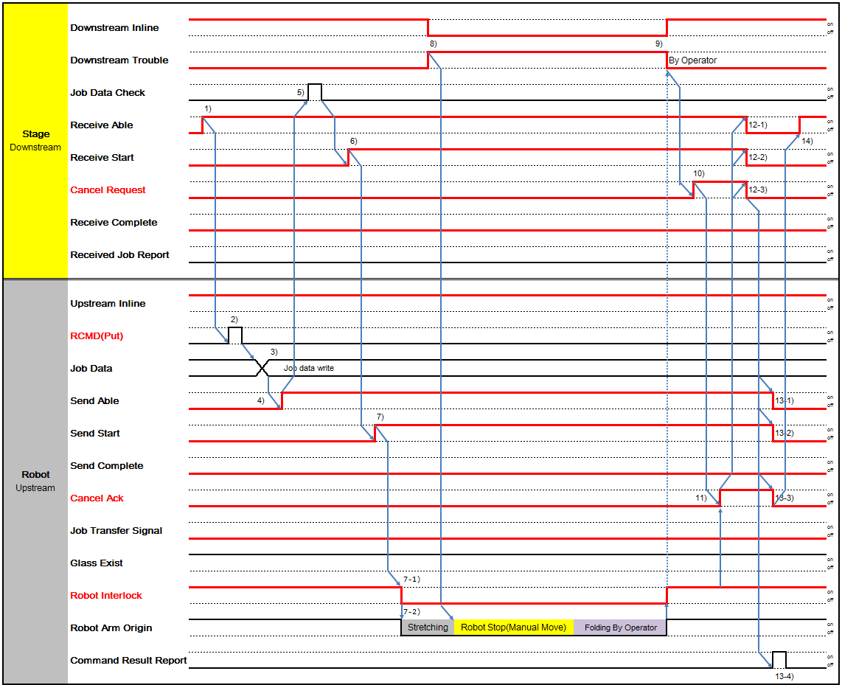
: This is only Put action of Exchange(Stage Downstream - Robot Upstream)

※ The Pin Stage signal is based on the normal chart.
※ For Local Dispatching Type Indexer, the RCMD signal is ignored.
※ Upstream Cancel Ack should be Robot Interlock On.
※ The dotted line indicates the Operator's operation sequence.

Conveyor

      - Upstream Cancel Request Case
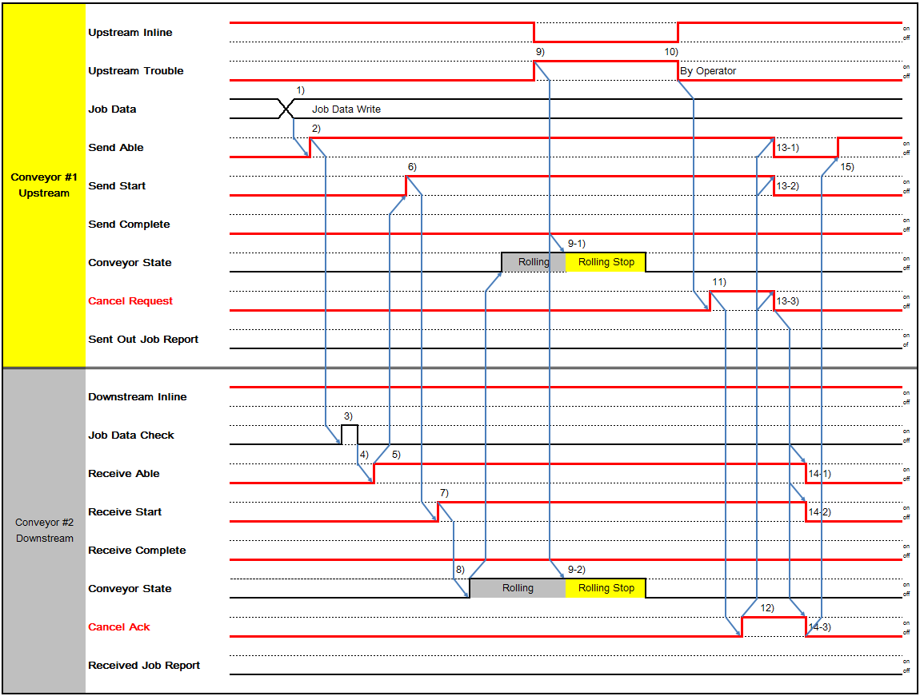

      - Downstream Cancel Request Case
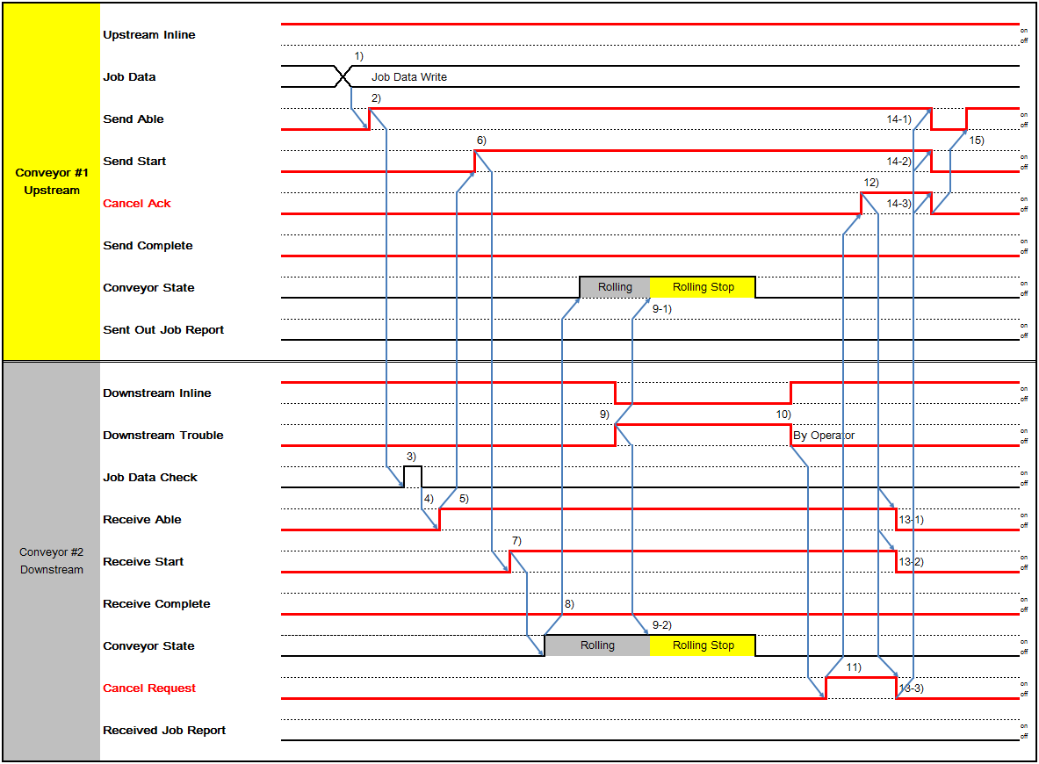

Abort Request(Handling glass from upstream to downstream)

Stage(Upstream) - Robot(Downstream)

      - Upstream Abort Request Case(Include Exchange)
Exchange Abort Case follows this time chart(ref. 5.10~15 Type 10~15 Time Chart).
: Put action(Stage Downstream - Robot Upstream) follows normal time chart. If a trouble occurs during the action, it follows a time chart of the trouble.
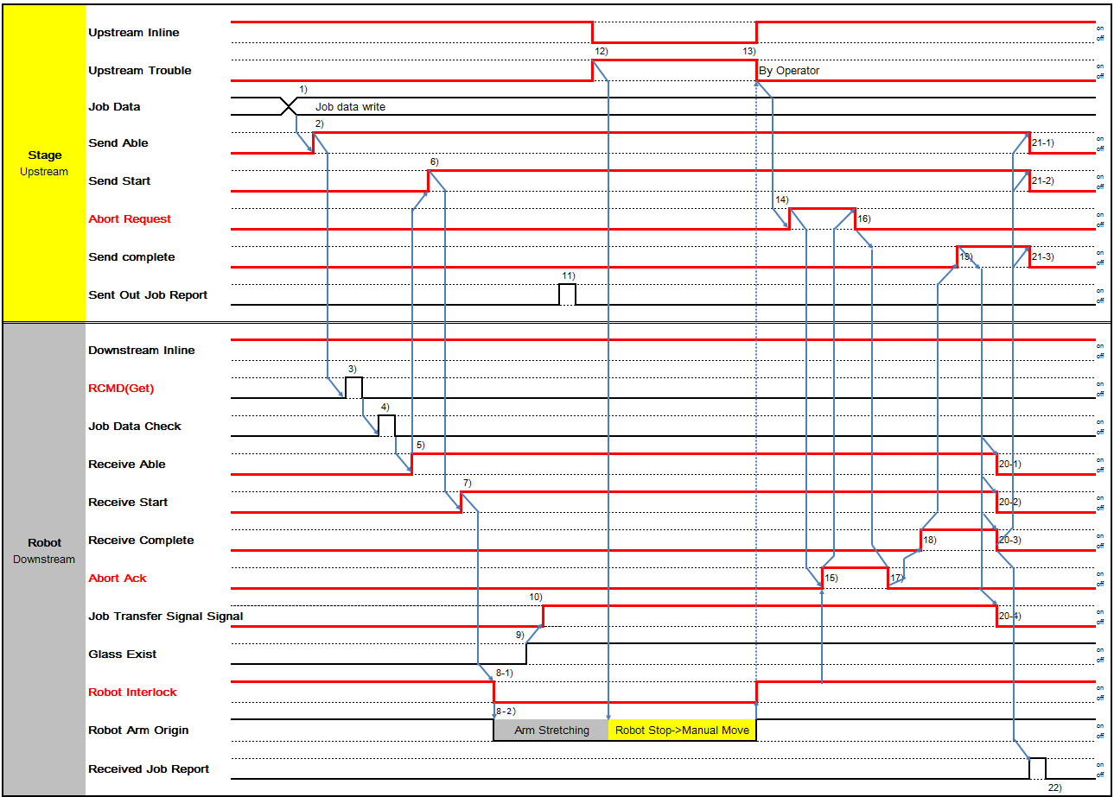
※ The Pin Stage signal is based on the normal chart.
※ For Local Dispatching Type Indexer, the RCMD signal is ignored.
※ Downstream Abort Ack should be Robot Interlock On.
※ The dotted line indicates the Operator's operation sequence.

      - Downstream Abort Request Case(Include Exchange)
Exchange Abort Case follows this time chart(ref. 5.10~15 Type 10~15 Time Chart).
: This is only Put action of Exchange(Stage Downstream - Robot Upstream)
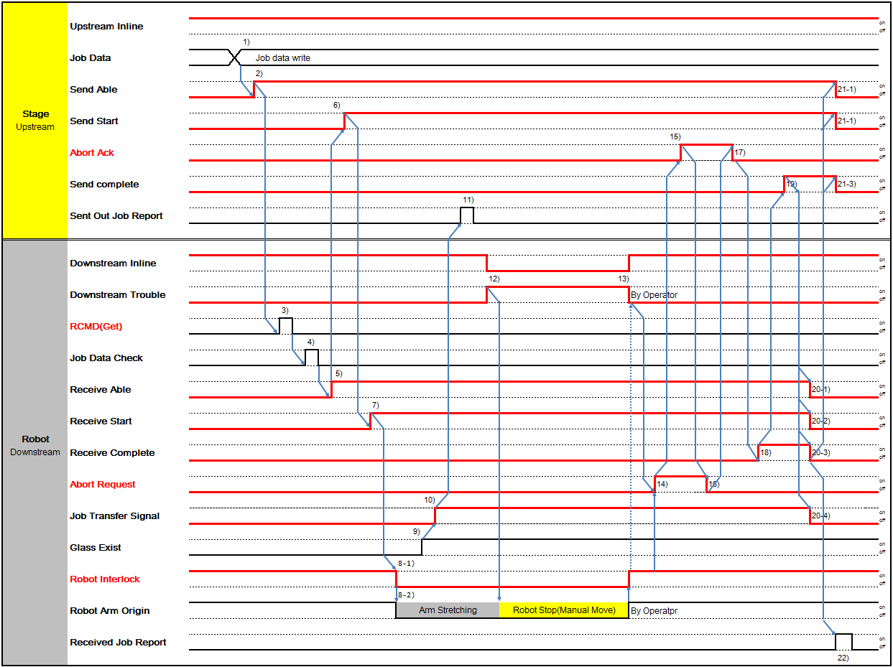
※ The Pin Stage signal is based on the normal chart.
※ For Local Dispatching Type Indexer, the RCMD signal is ignored.
※ Downstream Abort Request should be Robot Interlock On.
※ The dotted line indicates the Operator's operation sequence.

Robot(Upstream) - Stage(Downstream)

      - Upstream Abort Request Case(Include Exchange)
Exchange Abort Case follows this time chart(ref. 5.10~15 Type 10~15 Time Chart).
: This is only Put action of Exchange(Stage Downstream - Robot Upstream)
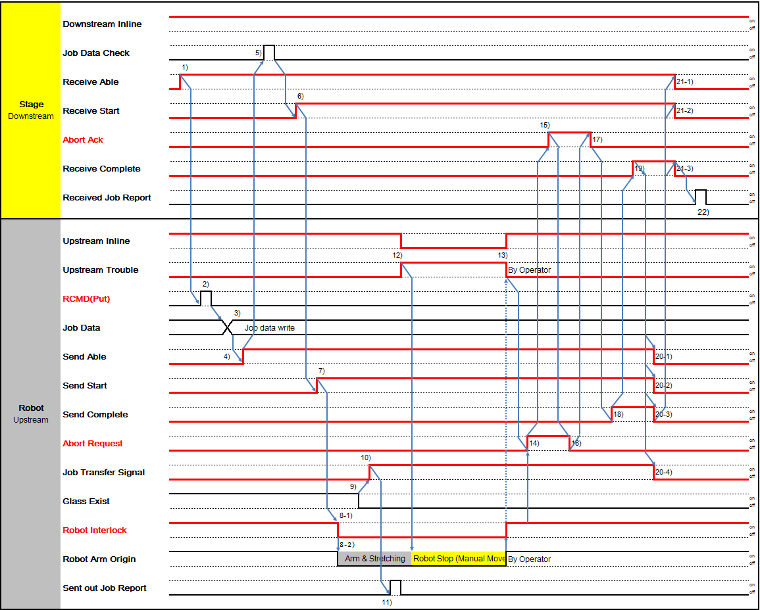
※ The Pin Stage signal is based on the normal chart.
※ For Local Dispatching Type Indexer, the RCMD signal is ignored.
※ Upstream Abort Request should be Robot Interlock On.
※ The dotted line indicates the Operator's operation sequence.

      - Downstream Abort Request Case(Include Exchange)
Exchange Abort Case follows this time chart(ref. 5.10~15 Type 10~15 Time Chart).
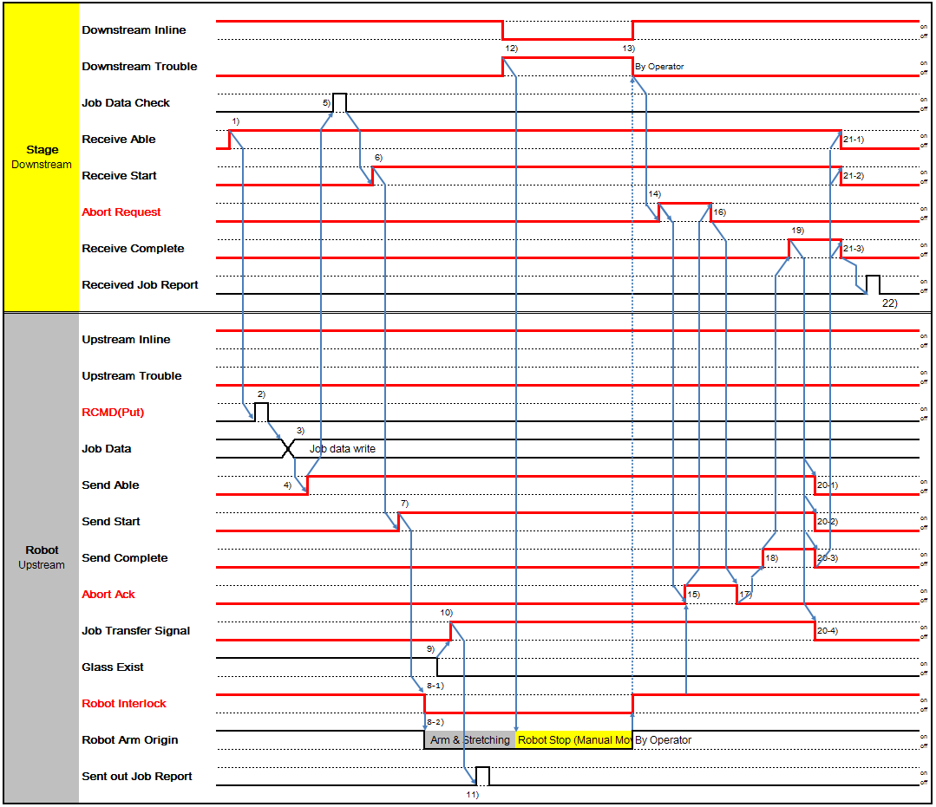
: Put action(Stage Downstream - Robot Upstream) follows normal time chart. If a trouble occurs during the action, it follows a time chart of the trouble.

※ The Pin Stage signal is based on the normal chart.
※ For Local Dispatching Type Indexer, the RCMD signal is ignored.
※ Upstream Abort Ack should be Robot Interlock On.
※ The dotted line indicates the Operator's operation sequence.

Conveyor

      - Upstream Abort Request Case
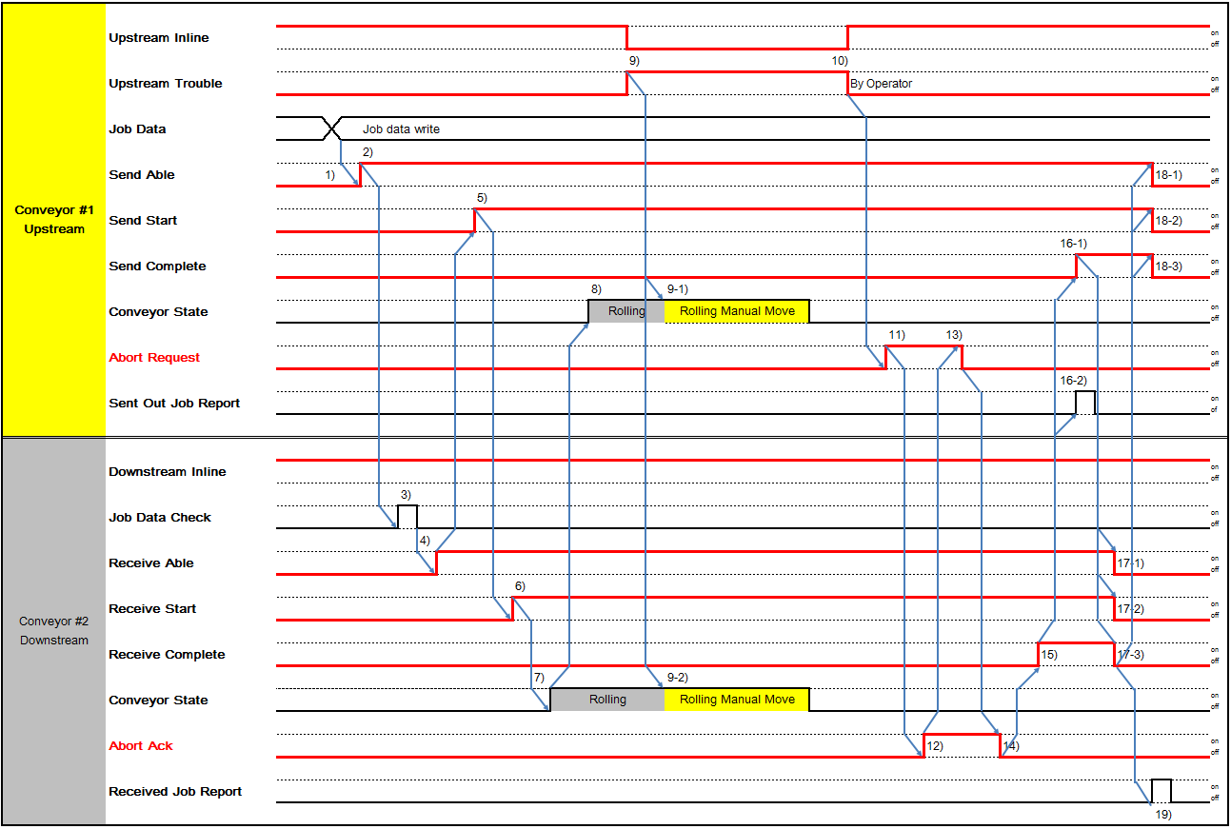

      - Downstream Abort Request Case
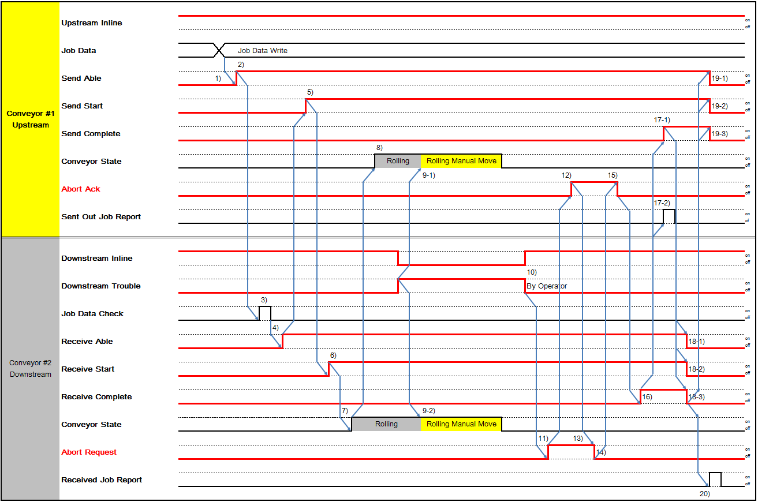

Resume Request

Stage(Upstream) - Robot(Downstream)

      - Upstream Resume Request Case(Include Exchange)
Exchange Resume Case follows this time chart(ref. 5.10~15 Type 10~15 Time Chart).
: Put action follows normal time chart.
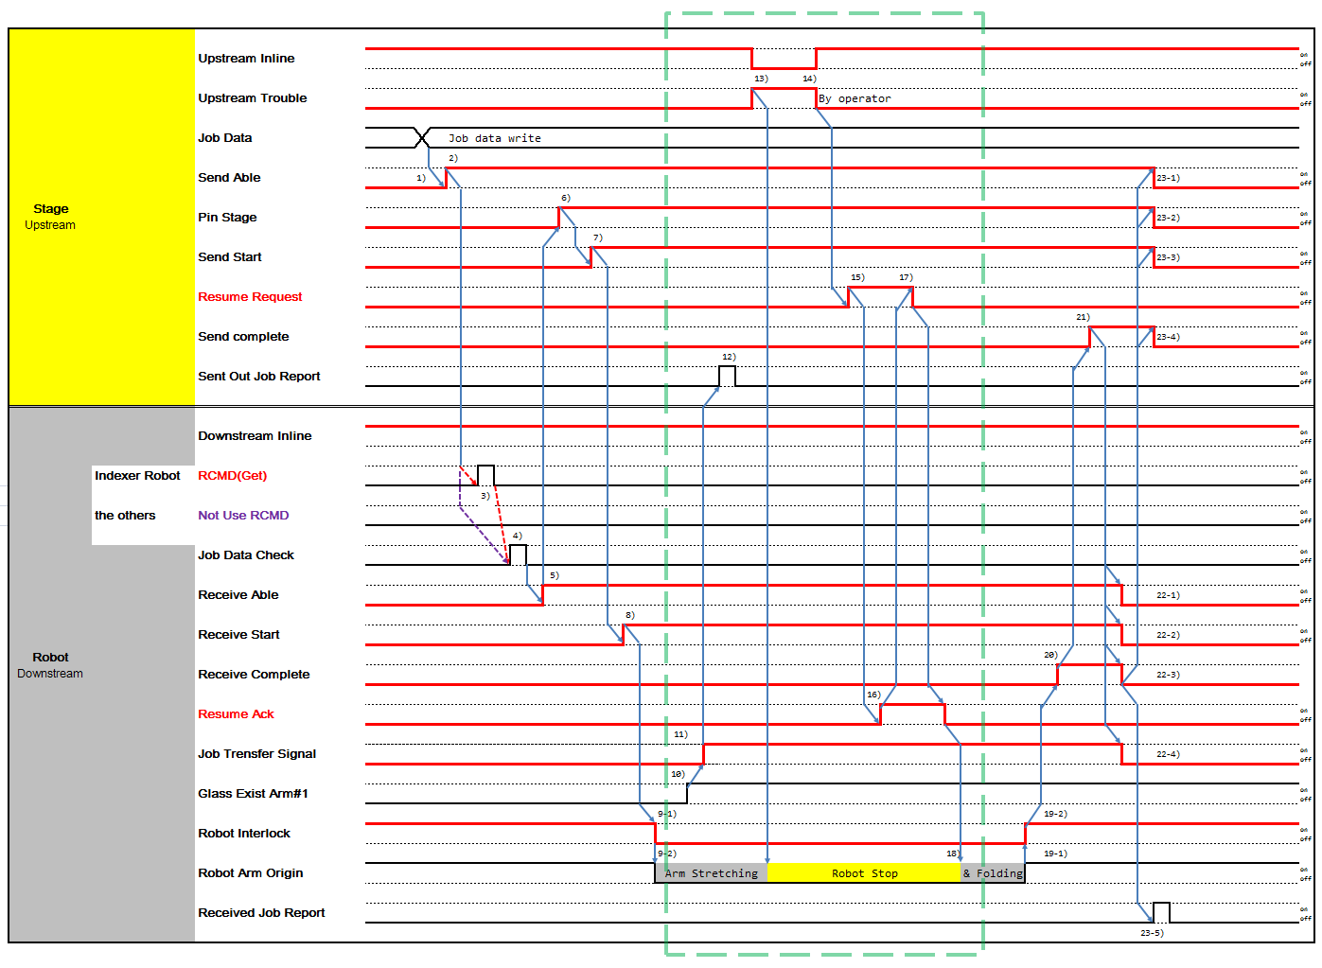

      - Downstream Resume Request Case(Include Exchange)
Exchange Resume Case follows this time chart(ref. 5.10~15 Type 10~15 Time Chart).
: Put action follows normal time chart.
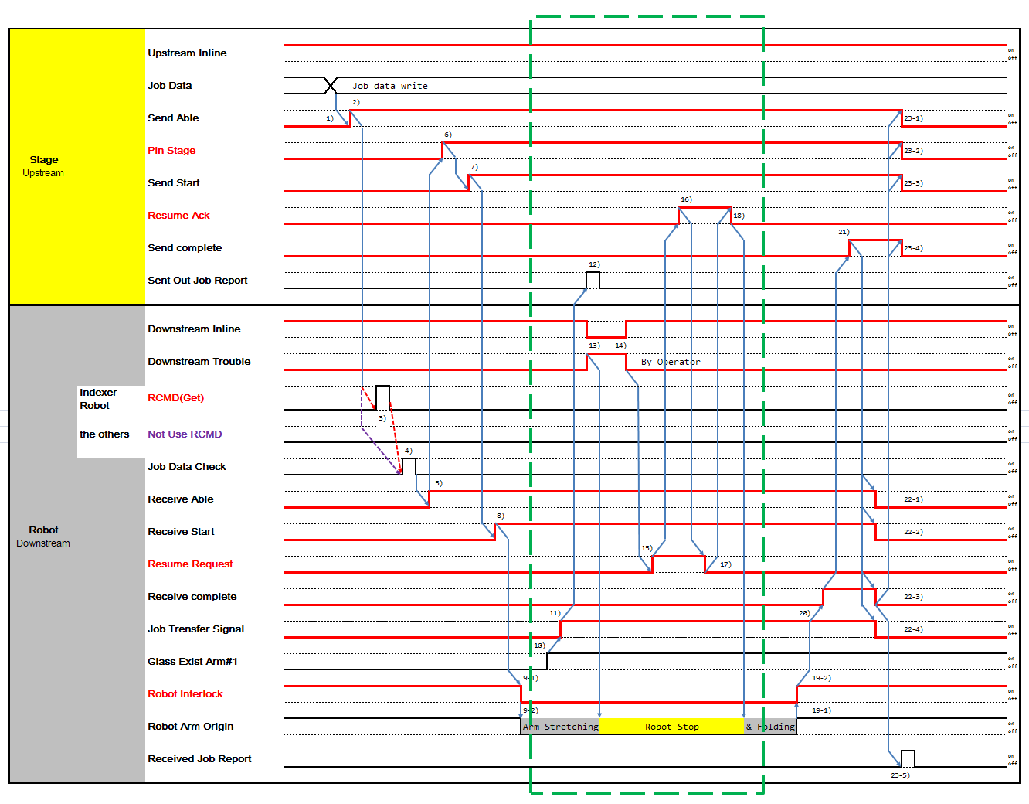

Robot(Upstream) - Stage(Downstream)

      - Upstream Resume Request Case(Include Exchange)
Exchange Resume Case follows this time chart(ref. 5.10~15 Type 10~15 Time Chart).
: This is only Put action of Exchange(Stage Downstream - Robot Upstream)
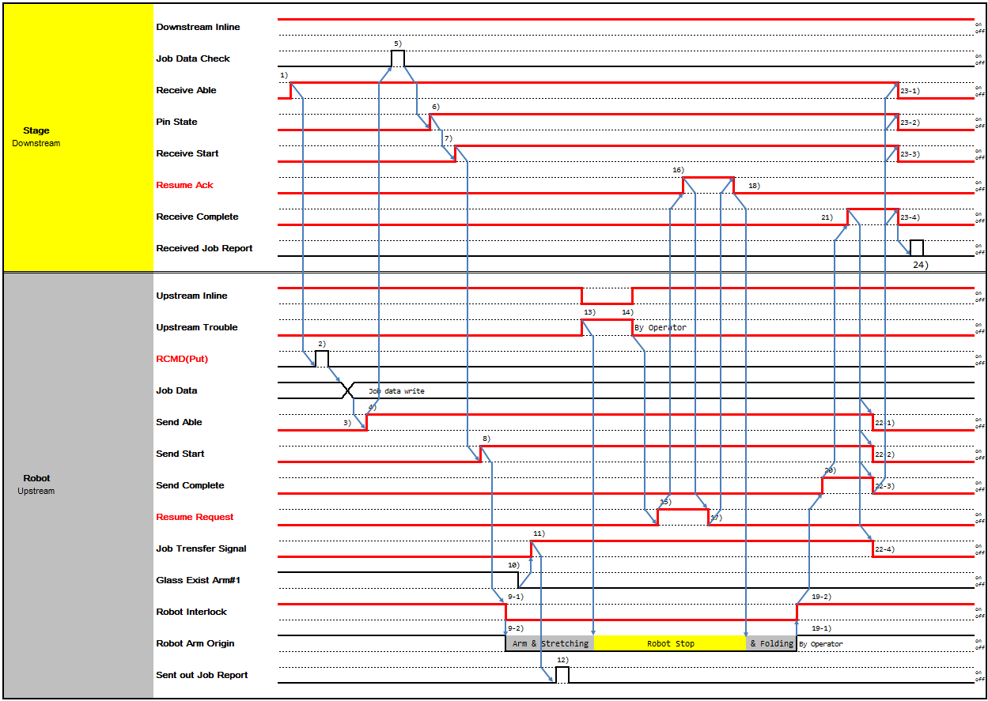

      - Downstream Resume Request Case(Include Exchange)
Exchange Resume Case follows this time chart(ref. 5.10~15 Type 10~15 Time Chart).
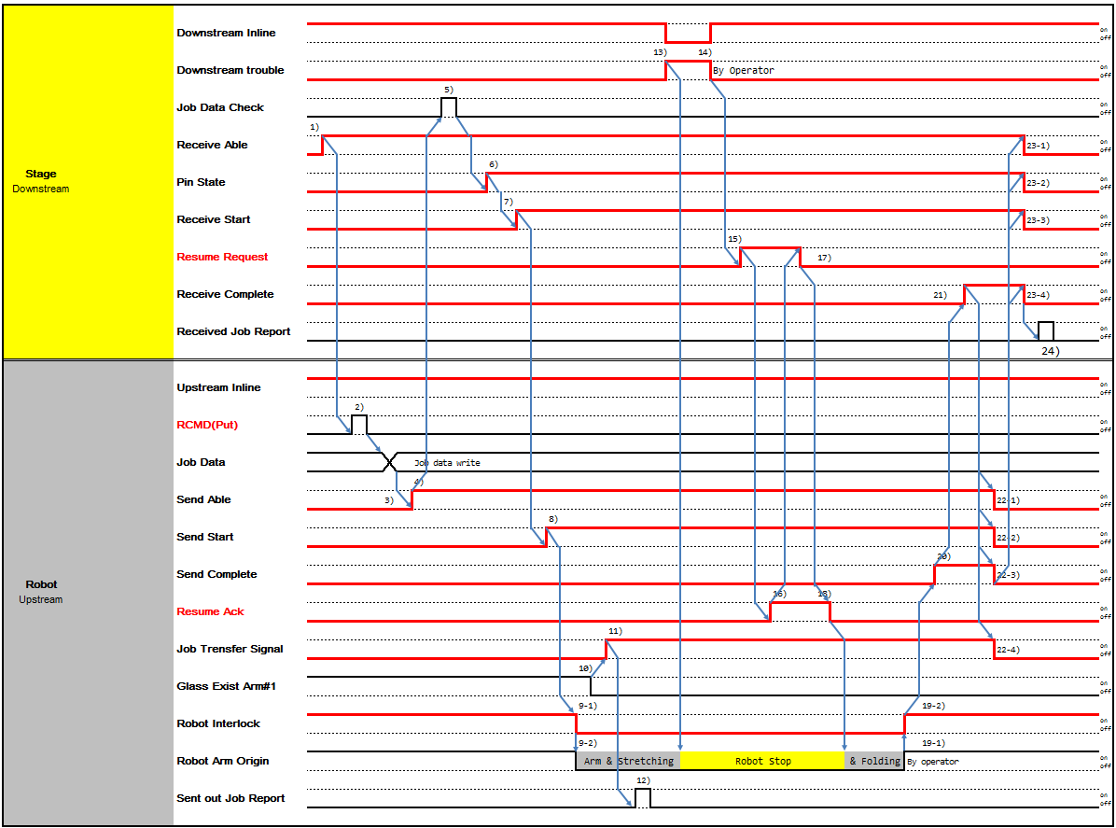
: This is only Put action of Exchange(Stage Downstream - Robot Upstr

Conveyor

      - Upstream Resume Request Case
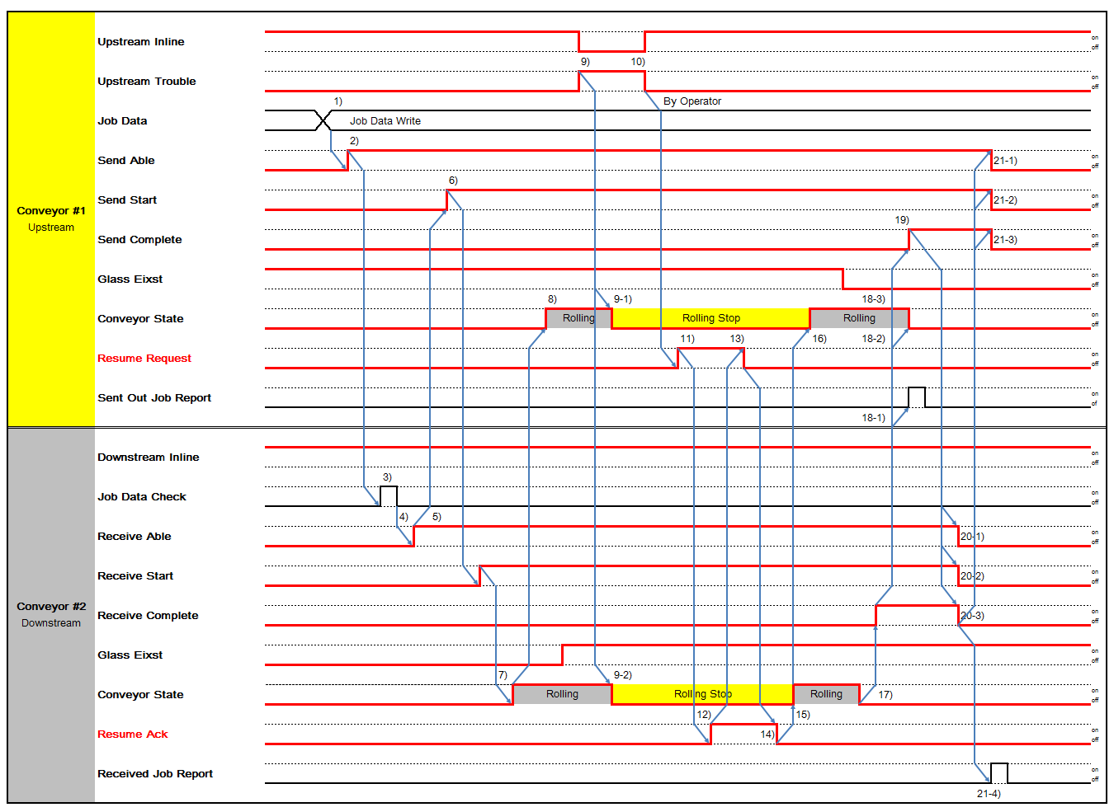

      - Downstream Resume Request Case
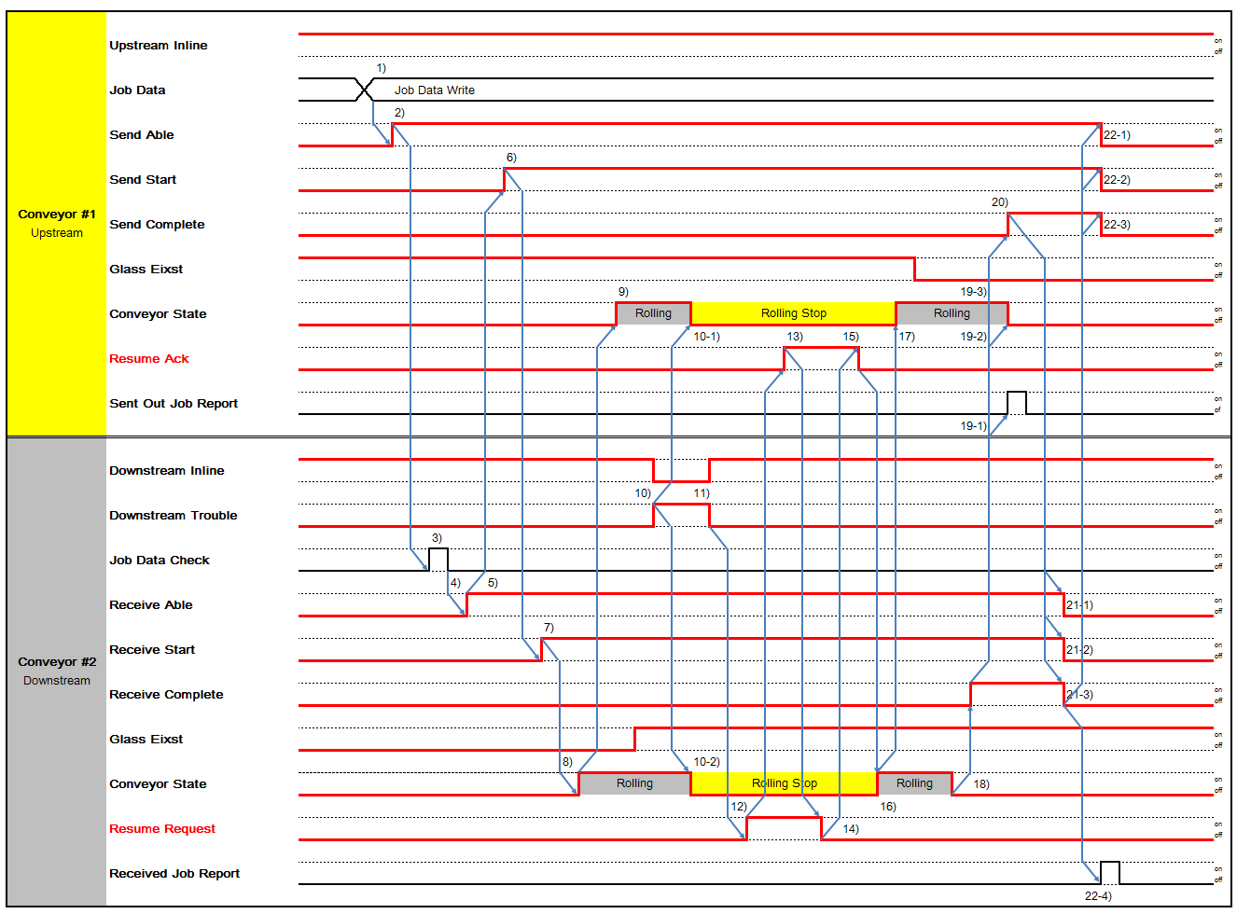

Time out
Time out input function should be set on the Equipment HMI.
- Between the upstream and downstream alarm occurred when timer should pause.
- The Equipment should report alarm report event by each timeout. And the Equipment should turn on upstream trouble / downstream trouble.

Time out Table

Timer | Section | Chart |  |  |  | Description | Default  Value
T1 | Upstream (Stage) |  |  |  |  | Between Downstream Receive Able turn on , and Upstream Send Start turn on  When T1 occurred then send Cancel Request or Resume Request for recovery | 30 Sec
T1 | Upstream (Stage) | Send Start |  |  |  |  | 30 Sec
T1 | Downstream (Robot) |  |  |  |  |  | 30 Sec
T1 | Downstream (Robot) | Receive Able |  |  |  |  | 30 Sec
T1 | Upstream (Robot) |  |  |  |  | Between Upstream Send Able turn on , and Downstream Receive Start turn on  When T1 occurred then send Cancel Request or Resume Request for recovery | 30 Sec
T1 | Upstream (Robot) | Send Able |  |  |  |  | 30 Sec
T1 | Downstream (Stage) | Receive Start |  |  |  |  | 30 Sec
T2 | Upstream (Stage) |  |  |  |  | Between Upstream Send Start turn on , and Downstream Receive Start turn on  When T2 occurred then send Cancel Request or Resume Request for recovery  Between Upstream Conveyer and Downstream Conveyer When T2 occurred then send Cancel Request for recovery if glass not exist on downstream But Send to Resume Request for recovery if glass exist on  downstream | 3 Sec
T2 | Upstream (Stage) | Send Start |  |  |  |  | 3 Sec
T2 | Downstream (Robot) |  |  |  |  |  | 3 Sec
T2 | Downstream (Robot) | Receive Start |  |  |  |  | 3 Sec
T2 | Upstream (Robot) |  |  |  |  | Between Downstream Receive Start turn on , and Upstream Send Start turn on  When T2 occurred then send Cancel request or Resume Request for recovery  Between Upstream Conveyer and Downstream Conveyer When T2 occurred then send Cancel Request for recovery if glass not exist on downstream But Send to Resume Request for  recovery if glass exist on downstream | 3 Sec
T2 | Upstream (Robot) | Send Start |  |  |  |  | 3 Sec
T2 | Downstream (Stage) |  |  |  |  |  | 3 Sec
T2 | Downstream (Stage) | Receive Start |  |  |  |  | 3 Sec
T3 | Downstream |  |  |  |  | Between Downstream Receive | 30 Sec

(Robot)

Downstream (Robot)
Receive Start

Receive Complete
Start turn on , and Downstream Receive Complete turn on When T3 occurred then send Cancel request or Abort Request or Resume Request for recovery

Upstream (Robot)

Upstream (Robot)

Send Start

Send Complete
Between Upstream Send Start turn on , and Upstream Send Complete turn on
When T3 occurred then send Cancel request or Abort Request or Resume Request for recovery

Upstream (Stage)

Downstream (Robot)
T4
Upstream (Robot)

Downstream (Stage)

Send Complete

Receive Complete

Send Complete

Receive Complete
Between Downstream Receive Complete turn on , and Upstream Send Complete turn on
When T4 occurred then send Abort Request or Resume Request for recovery
Between Upstream Send Complete turn on , and Downstream Receive Complete turn on
When T4 occurred then send Abort Request or Resume Request for recovery

3 Sec

Abnormal Case

Bit off on the Signal Handshake
When Signal Bit is off on the signal Handshake , timeout occurs T1 orT2 or T3 orT4 then inline Signal is off and trouble signal is On
It can reference timeout table

Conveyer to conveyer

Signal | Section | Chart | Description
Inline Signal Off  Or Trouble signal On | Upstream (Conveyer) | Inline | Between Downstream Inline Able turn off , and Upstream Inline turn off  Trouble signal is same  When trouble occurred then send Cancel Request for recovery if glass not exist at downstream  But Send to Resume Request or Abort Request for recovery if glass exist at downstream
Inline Signal Off  Or Trouble signal On | Downstream (Conveyer) | Trouble

- Line Special Function
Time out input function should be set on the Equipment HMI.
- Between the upstream and downstream alarm occurred when timer should pause.
- The Equipment should report alarm report event by each timeout. And the Equipment should turn on upstream trouble / downstream trouble.

Array Special Function

PECVD

Type 16 Normal
Single stage/Shutter-Robot : Exchange/Two Action (Robot <-> Single Stage) PECVD Special.

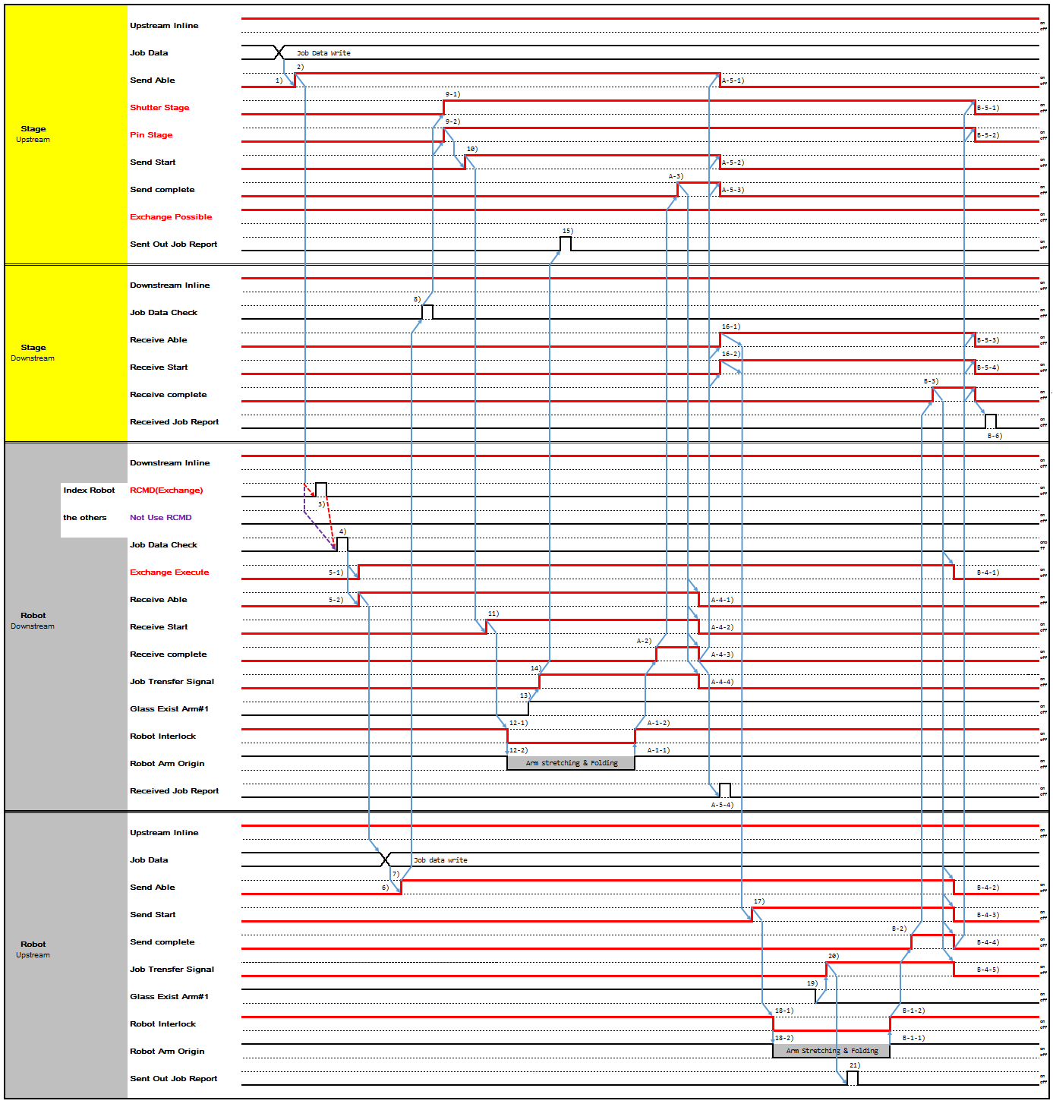

Type 16 Auto Send Cancel
Single stage/Shutter-Robot : Exchange/Two Action (Robot <-> Single Stage) Auto Send Cancel.
Tk Time Out: after Stage turned off "Send Complete", if Stage didn't turn ON "Receive Start" in Tk seconds, Robot need cancel the "PUT" command, clear "Send Able" and "Exchange Execute", send the processed glass back to cassette if the robot has two glass for get from stage , but if the robot has one glass for put to state, then the robot has to ready the front of stage with a glass.

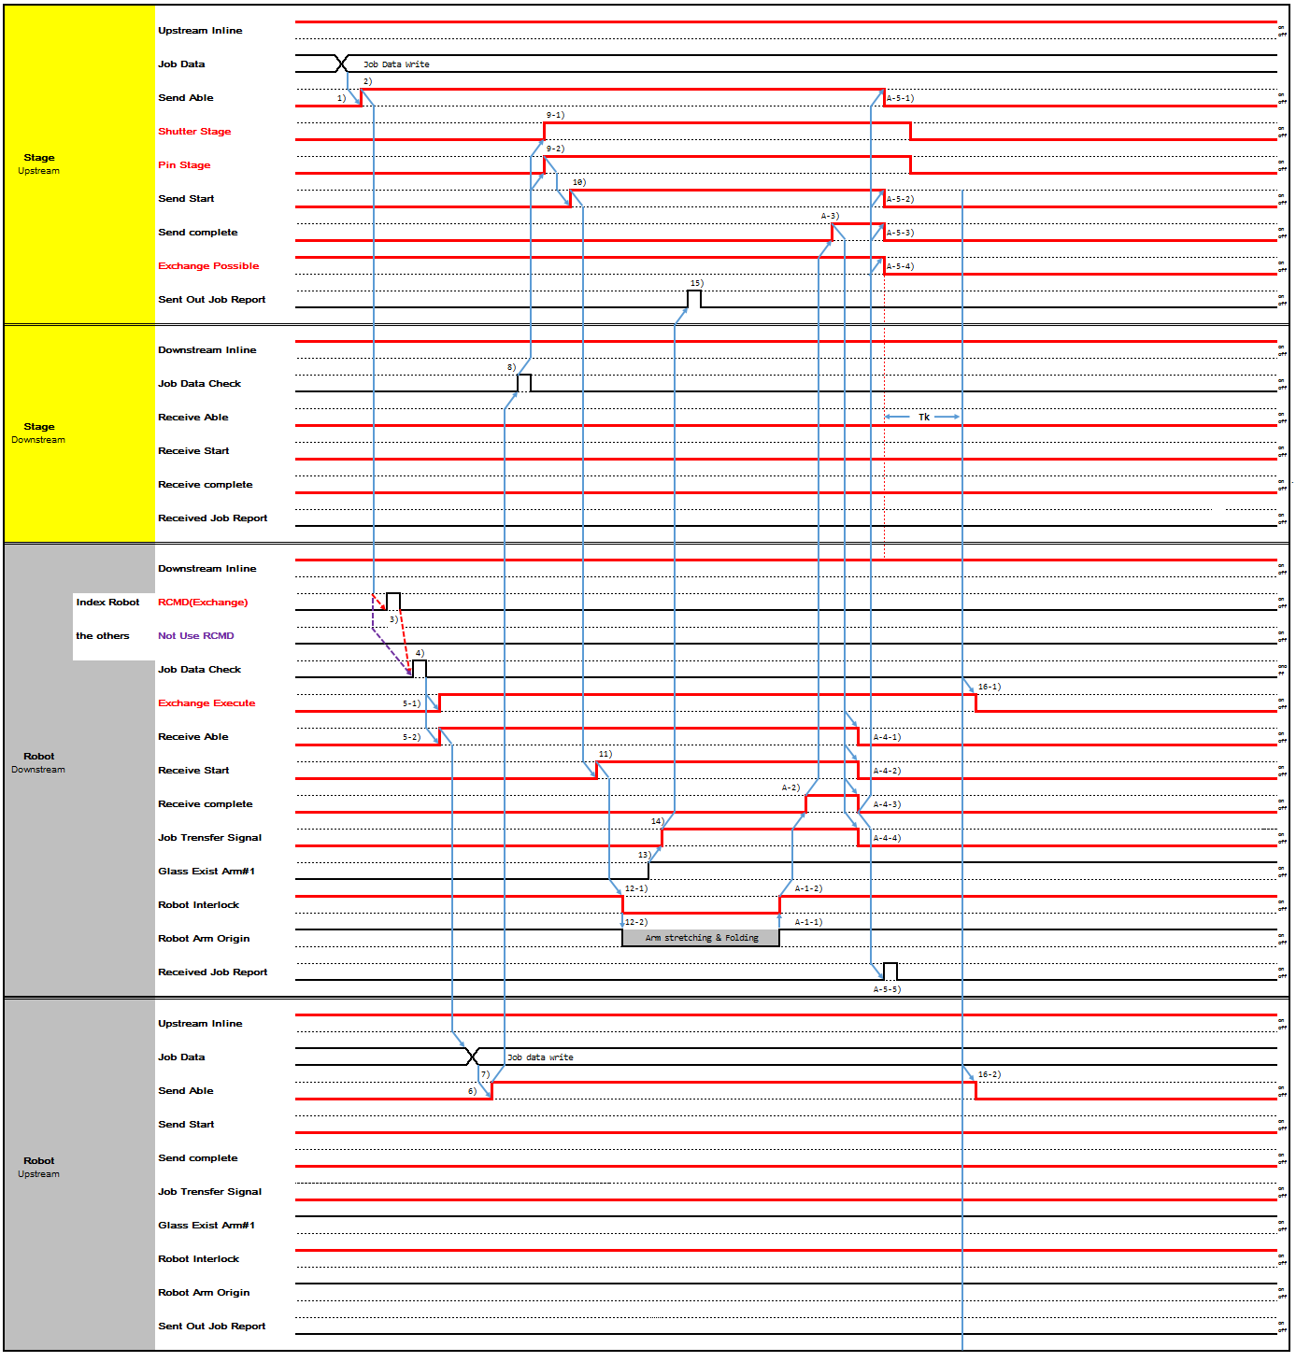

Cell Special Function

PI

      - Inkjet IN Only (TR IN - > Single Stage)
P-1) While Exchange Possible Signal is off, Inkjet turn on 'Receive Able'. In this case, Inkjet and TR-IN will provide glass with Flow Type 1, Robot to Single stage.

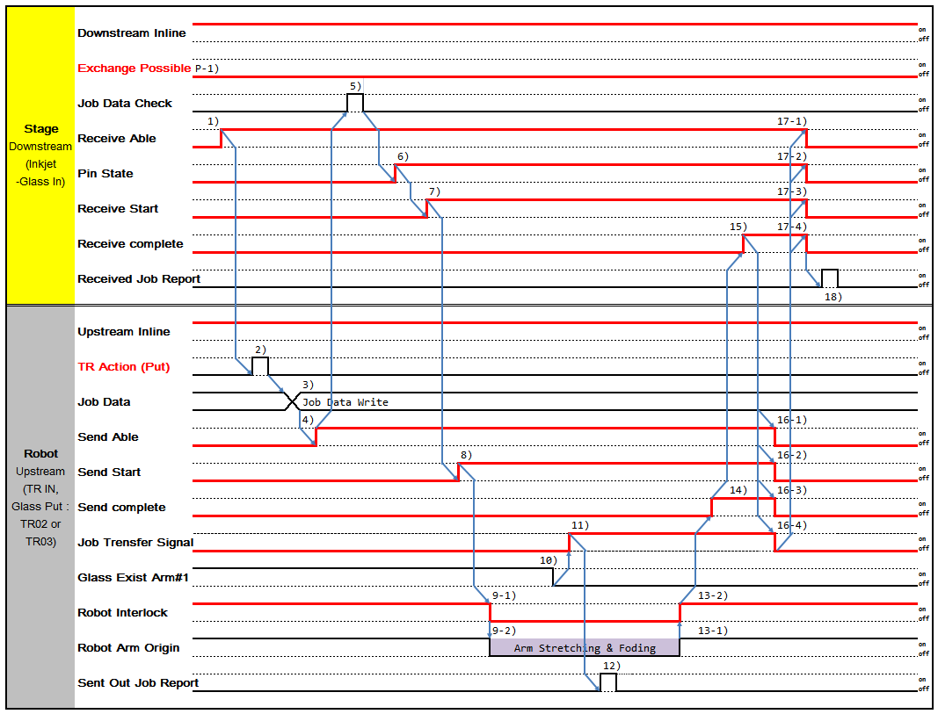

      - Inkjet OUT Only (Single Stage - > TR OUT)

P-1) While Exchange Possible Signal is off, Inkjet turn on 'Send Able'. In this case, Inkjet and TR-OUT will take glass with Flow Type 5, Robot to Single stage.

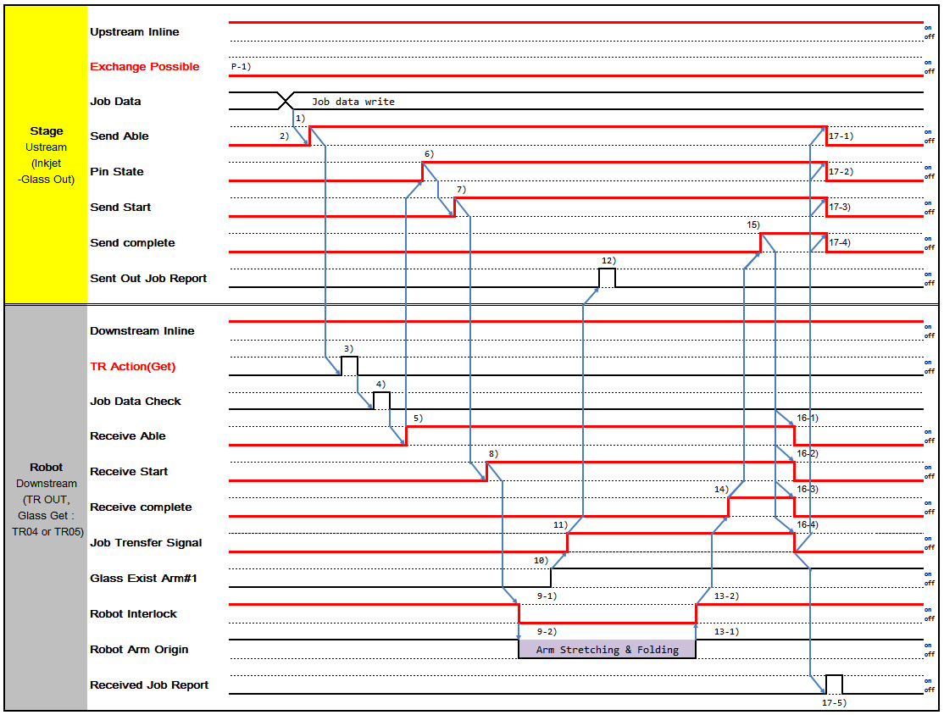

      - PI Inkjet Exchange /One Action (TR IN -> Single stage -> TR OUT)
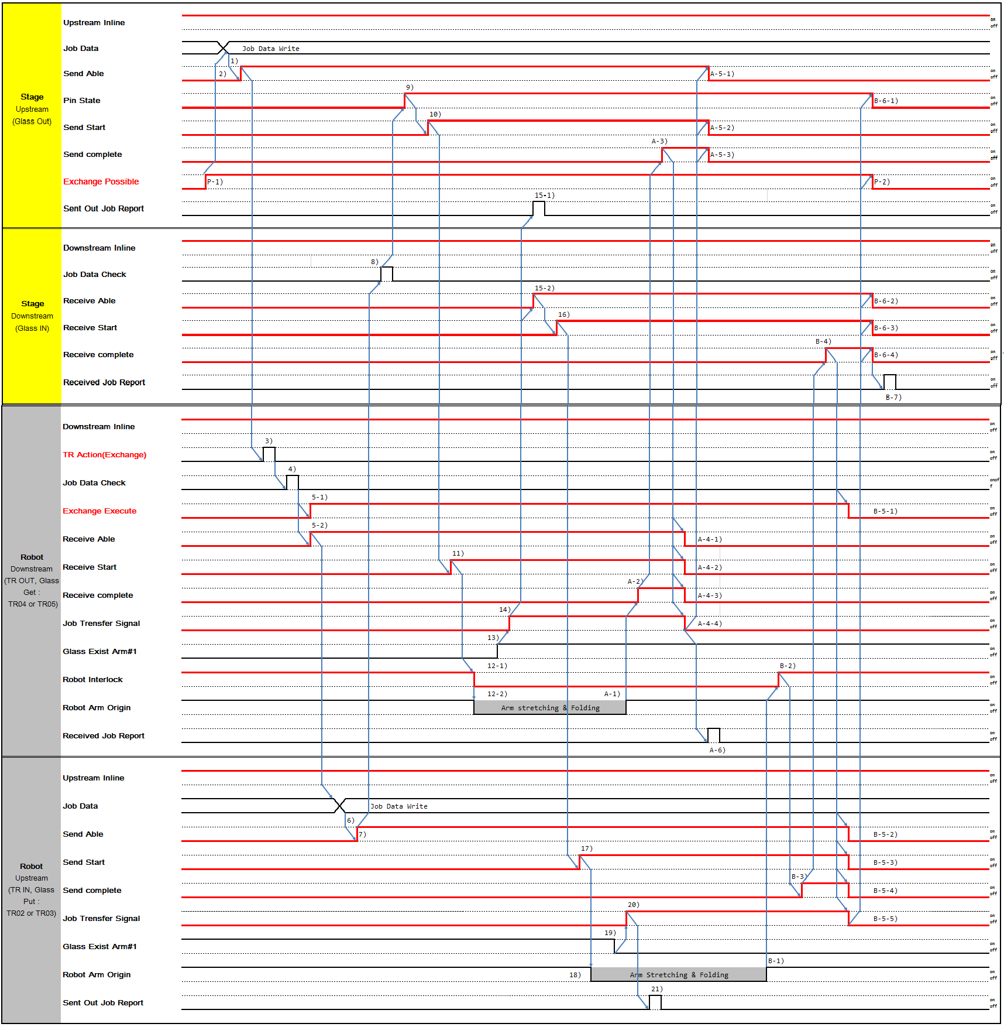

P-1) When Inkjet has process completed glass on its stage, It turn on 'Exchange Possible' and try to send glass to downstream and to receive glass from upstream.
P-1->5-1) If TR IN has no glass to send to Inkjet, Inkjet stage keep 'Execute Exchange' signal off, It run 'glass out procedure' by PI-Out only case.
- Inkjet Stage::Upstream writes Job Data, which will be sending to Robot (TR OUT)::Downstream
- When Inkjet Stage::Upstream is ready to send Glass, turn on 'Send Able'.
- Inkjet IN-OUT TR, Robot starts Robot-Action, Exchange.
- Robot::Downstream check Job Data of Glass to be received
5-1,-2) after 4, Robot::Downstream turns on 'Exchange Execute', 'Receive Able'.
- Robot::Upstream writes Job Data, which will be sending to Stage::Downstream
- When Robot(TR-IN)::Upstream is ready to send Glass, turn on 'Send Able'.

- Stage::Downstream check Job Data of Glass to be received
- Stage::Upstream lifts Pin Stage up and turns on 'Pin State'.
- Stage::Upstream turns on 'Send Start'.
- Robot::Downstream turns on 'Receive Start'.
12-1) After 11, Robot moves and turns off Robot Interlock at the same time. Stage::Upstream doesn't not perform any movement that interfere with Robot until Robot Interlock is turned on
12-2) Robot(TR OUT) proceed with Robot Get Sequence.
- Glass existence is determined by Robot Fork Vacuum On/Off.
- When Robot::Downstream starts Transfer, turn on 'Job Transfer'.
15-1,-2) When 14, Stage::Upstream reports 'Sent Out Job Report' and Stage::Downstream turns on 'Receive Able'.
- After 15-2, turn on 'Receive Start'.
- After 16, turn on Robot::Upstream 'Send Start'.
- After 17, Robot(TR IN) proceeds with Put Sequence.
- Glass existence is determined by Robot Fork Vacuum On/Off.
- When Robot::Upstream Glass Fork Vacuum is turn off, then turn on 'Job Transfer'.
- After 20, Upstream reports 'Sent Out Report'. A-1) Robot:(TR OUT) complete its 'Get Sequence'.
A-2) Robot::Downstream turns on 'Receive Complete' after Glass Transfer is completed. A-3) Stage::Upstream turns on 'Send Complete'
A-4-1,2,3,4) When A-3, turn off 'Receive Able', ' Receive Start', ' Receive Complete', 'Job transfer'. A-5-1,2,3) After A-4 Stage::Upstream turns off 'Send Able', 'Send Start', 'Send Complete'.
A-6) When Robot::Downstream 'Job Transfer' is turned off, reports 'Received Job Report'. B-1) Robot(TR IN) completes Put sequence.
B-2) Robot::Downstream turns on 'Robot Interlock'. B-3) Robot::Upstream turns on 'Send Complete'
B-4) When B-3, Stage::Downstream turns on 'Receive Complete'.
B-5-1,2,3,4,5) B-4, 'Receive Able', Robot::Downstream turn off 'Exchange Execute', Robot::Upstream turn off 'Send Able', 'Send Start', 'Send Complete', 'Job Transfer'
B-6-1,-2,-3,-4) After B-5, Stage::Downstream turn off 'Receive Able', 'Receive Start', 'Receive Complete', and Stage can make Pin down and turn off 'Pin State'.
B-7) After B-6-4, Stage::Downstream reports 'Received Job Report'.
P-2) If Inkjet has no glasses on its stage, and 'glass in-out procedure' end turn off 'Exchange Possible'

ODF

      - Robot <- Multiple Stage (TRF07 Get – from Pair Buffer)
TR07 request glasses form 'Pair Buffer' : Multiple stage-Robot (Robot <- Multiple Stage)
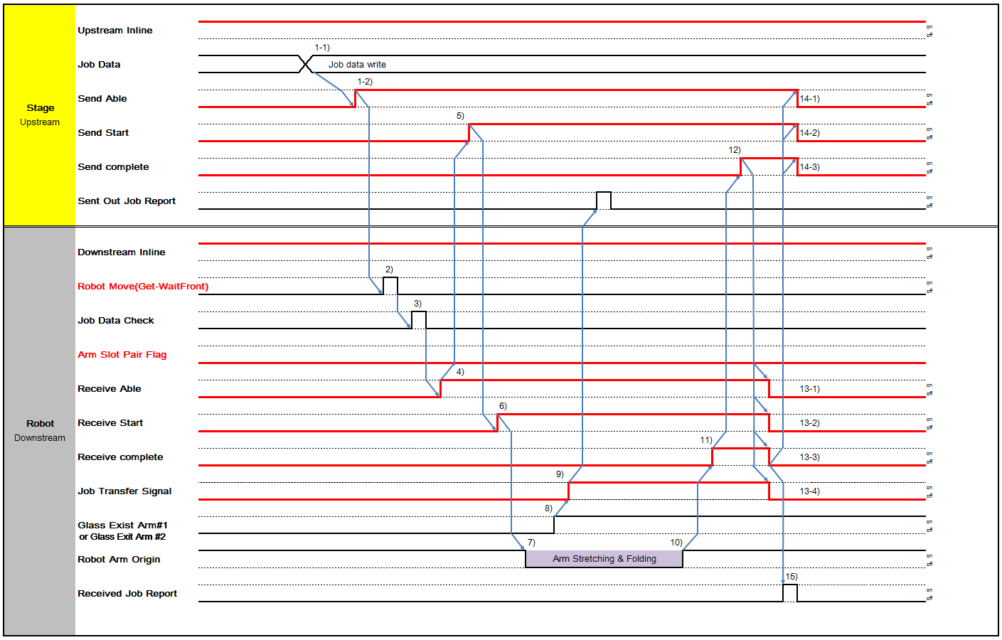

- Stage write Job data on data area. Then 'Send Able’ turns on.
- Robot is received ‘Get’ command from CIMPC and Other Device.
- Robot checks job data.
- If job data is OK. Robot turns on ‘Receive Able’.
- Stage turns on ‘Send Start’.
- Robot turns on ‘Receive Start’.
- ‘Robot Arm Origin’ turns off. That transfer (get) the glass at this time.
- When robot’s ‘Glass Exist#'1, 'Glass Exist#2' turn on. ‘Job Transfer Signal’ turns on.
- If ‘Job Transfer Signal’ turns on. 'Sent Out Job Report' turn on.
- Robot get action end. When ‘Robot Arm Origin’ turns on.
- Robot ‘Receive Complete’ turns on.
- Stage ‘Send Complete’ turn on.
- Robot ‘Receive Able’, ‘Receive Start’, ‘Receive complete’ and ‘Job Transfer Signal’ turn off.
- When Robot ‘Receive complete’ turn off, Stage’s all bit off.
- Robot ‘Received Job Report’ turns on.

      - VAS : Robot - > VAS Top Stage

Stage
Downstream
Downstream Inline
on
off
Job Data Check
5)
on
off
1-1)
Receive Able
20-1)
on
off
6)
Shutter State
22)
on
off
7)
Receive Start
20-2)
on
off
1-2)
11-1)
Pin Interlock
on
off
1-3)
H-Support Interlock
11-2)
on
off
Vaccum Complete
12)
on
off
Receive complete
18)
20-3)
on
off
Received Job Report
on
off
21)
Upstream
Upstream Inline
on
off
2)
RCMD(Batch-Put)
on
off
3)
Job Data
Job Data Write
19-1)
Send Able
4)
on
off
8)
19-2)
Send Start
on
off
17)
19-3)
Send complete
on
off
14)
19-4)
Job Trensfer Signal
on
off
19-5)
Robot Extend
10)
on
off
Glass Exist Arm#1
13)
on
off
9)
Robot Arm Origin
Arm Stretching & Folding
16)
on
off
Sent Out Job Report
15)
on
off

- If stage receive possible. That turns on the 'Receive Able', 'Pin Interlock', 'H-Support Interlock' signal.
- Robot is received ‘Put’ command from CIMPC and Other device.
- Robot writes current job data on data area.
- Turn on ‘Send Able’ signal.
- Stage checks job data.
- Turn on ‘Shutter State’ signal.
- If job data is OK. ‘Receive Start’ turns on.
- If turn on ‘Receive Start’. ‘Send Start’ turns on.
- ‘Robot Arm Origin’ turns off. That transfer (put) the glass at this time.
- Turn on 'Robot Extend’ signal.
- If turn on ‘Robot Extend’. 'Pin Interlock', 'H-Support Interlock' turns off.
- If turn on ‘Robot Extend’. 'Vaccum Complete' turns off.
- Glass existence is determined by Robot Fork Vacuum On/Off.
- When Glass Fork Vacuum is turn off, then turn on 'Job Transfer'.
- When 'Job Transfer' is on, Upstream reports 'Sent Out Report'.
- Robot completes Put Sequence. When Robot Arm returns to Original Position, remove Robot Interlock and turn on 'Robot Interlock' signal. Downstream can then Proceed with transfer-related activity.

- Turn on 'Send Complete' when Panel transfer to Downstream is completed.
- Turn on 'Receive Complete' after Panel Transfer is completed.
- Turn off 'Send Able', 'Send Start', 'Send complete', 'Job Transfer Signal', 'Robot Extend' when 'Receive Complete' is turned on.
- Turn off 'Receive Able', 'Receive Start', 'Receive Complete' when 'Send Able', 'Send Start', 'Send Complete' is turned off.
- After Upstream turns off 'Job Transfer' off, Downstream reports 'Received Job Report'.
- If turn off ‘Receive complete’. 'Shutter State' turns off.

VAS :Robot - > VAS Top Stage (Abnormal Case)
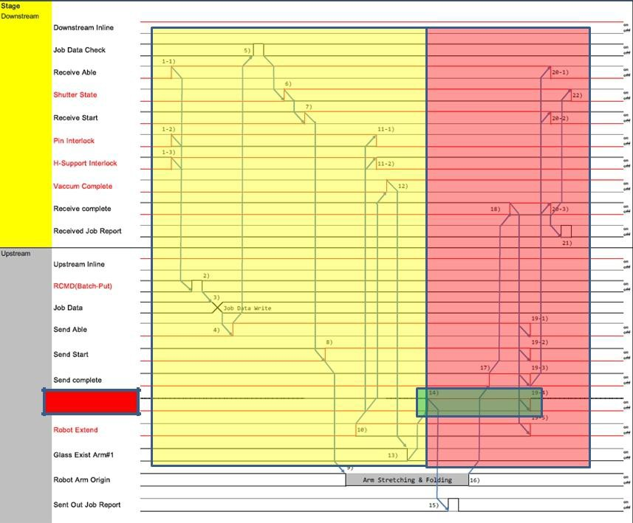
①
②
③
③

- Divide it into two situations according to 'Job Transfer Signal On'.

- Case ① :If all the signals are switched off during the interface, Return to home and start again from the beginning.

* Caution :When robot signal is 'Send Start = On', 'Robot Extend = On', 'Robot Interlock = Off', 'Job Transfer = Off', VAS return to Home Position First.adjust the position of the VAS and adjust the position of the pin without interference from the VAS.(In this state, Shutter Stat must remain on for extended periods - Shutter Open Status -, pin Interlock, and Hand Support Interlock signal remains on).Then return Robot to Home Position (return home).

- Case 2 :Robot follows VACUUM Complete On VAS, recovers Home returns (home returns), after returning home, and after the ROBOT Home (ROBOT ON, Send Start Off, Robot Extend Off)

Robot <->Seal Oven Stage
- Check the following signal before starting the interface.
- Oven Complete GLS Exist bit ‘On’ when one or more glasses are process finished.
- If the TR is Oven Complete GLS Exist ' On ' and it is in a cooling-enabled state, the TR Exchange Possible bit set ' On '.

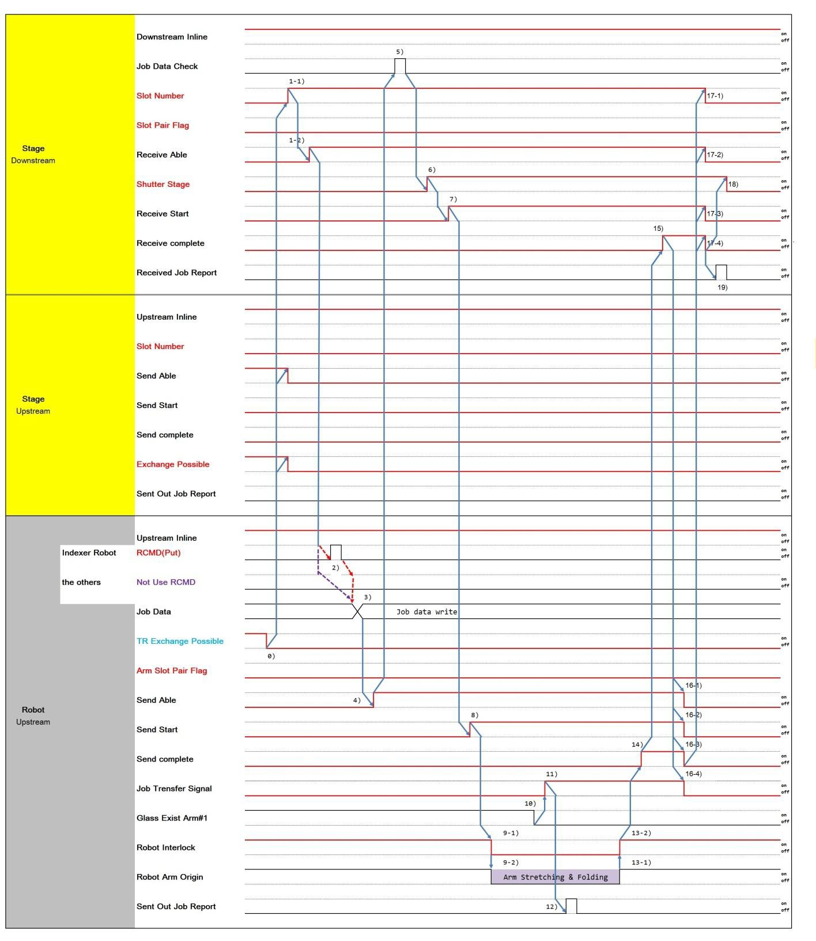
Oven Glass Receive Case

If the TR Exchange Possible ' On ' is performed during Send Able, TR stops and Opcall& Buzzer.

0) If the TR Exchange Possible is ' Off ', go to the Reverse Case.
1-1) If Downstream is Multi Slot Stage, turn on 'Slot No' signal of which Panel will be transferred 1-2) When Downstream is ready to receive Panel, turn on 'Receive Able'.
- Robot Receives Put Command from Robot Controller.
- Write Job Data which will be send to Downstream.
- Turn on 'Send Able' when Upstream is ready to send Panel.
- Downstream checks Job Data of Panels to be received.
- When Downstream is ready to receive Panel, turn on 'Receive Start'.
- Turn on 'Send Start' and Upstream start transferring.
8-1) After 'Send Start' is turned on, Robot moves and turns off Robot Interlock at the same time. Downstream doesn't not perform any movement that interfere with Robot until Robot Interlock is turned on
8-2) Proceed with Robot Put Sequence.
- Glass existence is determined by Robot Fork Vacuum On/Off.
- When Glass Fork Vacuum is turn off, then turn on 'Job Transfer'.
- When 'Job Transfer' is on, Upstream reports 'Sent Out Report'. 12-1) Robot completes Put Sequence.
12-2) When Robot Arm returns to Original Position, remove Robot Interlock and turn on 'Robot Interlock' signal. Downstream can then Proceed with transfer-related activity.
- Turn on 'Send Complete' when Panel transfer to Downstream is completed.
- Turn on 'Receive Complete' after Panel Transfer is completed.
15-1,-2,-3) Turn off 'Receive Start', 'Receive Able', 'Slot Number' when 'Receive Complete' is turned on. 16-1,-2,-3) Turn off 'Receive Complete' when 'Receive Start', 'Receive Able’, ‘Slot Number' is turned off.
17-1,-2,-3,-4) When 'Receive Complete' is turned off, turn off ‘Send Able', 'SendStart', 'Send Complete', 'Job transfer'.
18) After Upstream turns off 'Job Transfer' off, Downstream reports 'Received Job Report'.

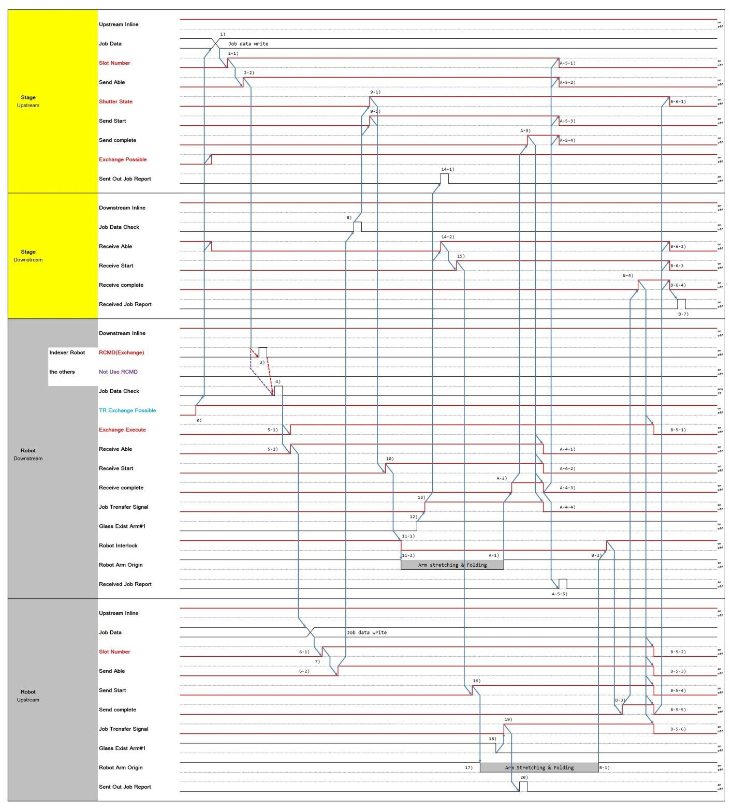
Oven Glass Exchange & Sending Case

If the TR Exchange Possible ' Off ' is performed during Exchange Execute(Receive Able), TR stops and Opcall& Buzzer.

0) If the TR Exchange Possible is ' On ', go to the Exchange & Sending Case.

1-1) If Downstream is Multi Slot Stage, turn on 'Slot No' signal of which Panel will be transferred 1-2) When Downstream is ready to receive Panel, turn on 'Receive Able'.
- Robot Receives Put Command from Robot Controller.
- Write Job Data which will be send to Downstream.
- Turn on 'Send Able' when Upstream is ready to send Panel.
- Downstream checks Job Data of Panels to be received.
- When Downstream is ready to receive Panel, turn on 'Receive Start'.
- Turn on 'Send Start' and Upstream start transferring.
8-1) After 'Send Start' is turned on, Robot moves and turns off Robot Interlock at the same time. Downstream doesn't not perform any movement that interfere with Robot until Robot Interlock is turned on
8-2) Proceed with Robot Put Sequence.
- Glass existence is determined by Robot Fork Vacuum On/Off.
- When Glass Fork Vacuum is turn off, then turn on 'Job Transfer'.
- When 'Job Transfer' is on, Upstream reports 'Sent Out Report'. 12-1) Robot completes Put Sequence.
12-2) When Robot Arm returns to Original Position, remove Robot Interlock and turn on 'Robot Interlock' signal. Downstream can then Proceed with transfer-related activity.
- Turn on 'Send Complete' when Panel transfer to Downstream is completed.
- Turn on 'Receive Complete' after Panel Transfer is completed.
15-1,-2,-3) Turn off 'Receive Start', 'Receive Able', 'Slot Number' when 'Receive Complete' is turned on. 16-1,-2,-3) Turn off 'Receive Complete' when 'Receive Start', 'Receive Able’, ‘Slot Number' is turned off.
17-1,-2,-3,-4) When 'Receive Complete' is turned off, turn off ‘Send Able', 'SendStart', 'Send Complete', 'Job transfer'.
18) After Upstream turns off 'Job Transfer' off, Downstream reports 'Received Job Report'.

Recovery Transfer (Cell Inline only)

Cancel , Abort , Resume
In case of abnormal transfer has to follow rule of indexer or Transfer Robot when Trouble occurred in transfer Unit(Robot or Stage) after Up/Downstream transfer has begun.
The Robot must turnoff ‘send complete’ bit and ‘received complete’ bit
In details, please refer to 3.4 Condition Check of Robot Complete bit(between PLC and Robot)

- Upstream down case
When Trouble(Robot Stop/Equipment Stop) occurs in Upstream, Upstream turn off 'Upstream Inline', 'Send Able', 'Send Start', 'Send Complete'.
And then Downstream turn off 'Downstream Inline', 'Receive Able', 'Pin State', 'Receive Start', 'Receive Complete'.

- Downstream down case
When Trouble(Robot Stop/Equipment Stop) occurs in Downstream, Downstream turn off 'Downstream Inline', 'Receive Able', 'Pin State', 'Receive Start', 'Receive Complete'.
And then Upstream turn off 'Upstream Inline', 'Send Able', 'Send Start', 'Send Complete'. If problem has been resolved, start the interface again from the beginning.

Manual Operation (Cell Inline only)

Manual Operation Interlock

No | Name | Direction | Comments
8 | Shutter State | Upstream ↔ Downstream | 1 : Shutter Opened 0 : Shutter Close
9 | Pin State | Upstream ↔ Downstream | 1 : Pin Up  0 : Pin Down
33 | Glass Exist | Upstream ↔ Downstream | 1 : Glass Exist  0 : Glass Not Exist
44 | Manual Operation | Upstream ↔ Downstream | 1 : Manual Operation 0 : Auto Operation

The Equipment must 'On’ or ’Off' current all Interlock status/sensor on all Upstream, Downstream Link Signal, which performs the interface in '1:Manual Operation'.

For example, All Interlock status/sensor is 'Shutter State', 'Pin State', 'Glass Exist', etc…

- End of document -

