ESWIN Equipment

PLC Communication Specification

DOCUMENT ID: | NUMBER OF PAGES: 254
REVISION NO: v1.1.0 | CREATED ON: 2025-01-01
FILENAME: Equipment Communication Specification(CC-LINK) | LAST REVISED:
STATUS:Release
PREPARED BY:  Signature Date | REVIEWED BY:  Signature Date
REVIEWED BY:  Signature Date | REVIEWED BY:  Signature Date
APPROVED BY  Signature Date | APPROVED AND ACCEPTED BY  Signature Date

Revision History
Item | Version | Page | Change Place | Writer | Date
1 | v0.1 | All | Initial |  | 2025.01.01

※Some details are subject to change.

This document contains confidential information provided by ESWIN. No part of this document may be copied, reproduced, disclosed, or transferred by any means without prior written consent of ESWIN.
ESWIN reserves the right to make updates to the information in this document without prior notice or approval from others. Please consult the author of this document to ensure that you have the latest revision.

Table of Contents

PLC Communication Specification 1
Revision History 2
Table of Contents 5
1 Scope &Basic Description 13
1.1 Scope 13
1.2 Basic Rule 13
1.3 Operation Specification 13
1.4 Equipment Operation Screen Specification 14
1.5 Inline Process 14
1.6 Equipment Type 14
1.7 Line Structure 15
2 System Architecture 16
2.1 CC-Link Communication 16
2.1.1 CC-Link Structure 16
2.1.2 Data Communication 16
2.1.3 MASTER PLC 16
1) PLC Module Base : 16
2) PC Board Base: 16
3) Common 17
* Data Link Configuration 17
2.1.7 PLC Network Number 18
3 Data Communication 19
3.1 Link Relay, Link Register Relation 19
3.2 EQP Event Report Timing chart 20
3.3 EAS Command Relay Time Chart 24
3.4 Timeout Error 24
3.4.1 T1 Timeout (Master ↔ Local) 24
3.4.2 T2 Timeout_Case1 (Master ↔ Local) 25
3.4.3 T2 Timeout_Case2 (Master ↔ Local) 25
3.4.4 Normal Timer Reset (Master ↔ Local) 26
3.5 Equipment Operations relating to the Timeout 26
3.5.1 Warning Alarm Case 26
3.5.1.1 T1 Timeout 26
3.5.1.2 T2 Timeout 27
3.5.2.1 T1 Timeout 27
3.5.2.2 Consecutive Event 27
3.6 Interface Signals and Data 27
3.6.1 Data Expression 27
3.6.1.1 ASC Type 27
3.6.1.2 Numeric Type 28
3.6.1.3 BCD Type 28
4 Terms Definition 30
4.1 Common 30
4.1.1 Job 30
4.1.2 Recipe ID 30
4.1.3 Master Recipe ID (PPID) 30
4.2 Equipment 30
4.2.1 Inline Mode 30
4.2.2 CIM Mode 30
4.2.3 Equipment Status 30
4.2.4 Unit/Sub-Unit Status 31
4.2.5 Processing Time 31
4.2.6 Upstream Path No 31
4.2.7 Downstream Path No 31
4.2.8 VCR No 31
4.3 Port 31
4.3.1 Port Type 31
4.3.2 Port Mode 31
4.3.3 Port Transfer Mode ( OTH / STK / AGV/ MGV) 31
4.3.4 Port Enable Mode (Port Down) 31
4.3.5 Port Status 32
4.3.6 Cassette ID 32
4.4 Job 32
4.4.1 Substrate Type 32
4.4.2 Glass ID 32
4.4.3 Cassette Sequence No (Lot index) 32
4.4.4 Job Sequence No (slot number) 32
4.4.5 Glass Code 33
4.4.6 Job Type 34
4.4.7 Dummy Type 35
4.4.10 Process Flag 37
4.4.11 Inspection Judge data 37
4.4.12 Skip Flag 37
4.4.13 Inspection Flag 38
4.4.14 Q-Time 38
4.5 Job Data 39
4.5.1 Job Data Items 39
4.5.1.1 Job Data A 39
4.5.1.3 Job Data C 41
4.5.1.4 Job Data S 42
5 Common Function 43
5.1 Equipment Main Mode Management 43
5.1.1 Equipment Alive 43
5.1.2 CIM Mode 43
5.1.3 CIM Mode Change By EAS 43
5.1.4 Inline Mode 43
5.1.5 Local Alarm State 44
5.1.6 PLC MAP 44
5.1.6.2 Local PLC – Link Relay (B Area) 44
5.1.7 Communication Scenarios 45
5.2 Equipment Mode Change 45
5.2.1 Equipment Mode Change Command 45
5) ETC.. 46
5.2.2 Equipment Mode Change Report 46
5.2.2.1 PLC MAP 46
5.3 Equipment Management 47
5.3.1 Equipment Status 47
5.3.3 Equipment Status Reason Code 49
5.3.5 PLC MAP 51
5.3.5.2 Local PLC – Link Relay (B Area) 53
5.4 Alarm Management 53
* Max alarm buffering : 5 count 53
5.4.1 Alarm State 54
5.4.2 Alarm Unit 54
5.4.3 Alarm ID 54
1 ~ 65500: Equipment can use 54
5.4.4 Alarm Code 54
5.4.5 Alarm Level 55
5.4.6 Alarm Text 55
5.4.7 Error Recovery and Remove Job 55
5.4.8 PLC MAP 56
5.4.8.2 Local PLC – Link Relay (B Area) 56
5.5 Job Management 57
5.5.1 Job Data Transfer 57
5.5.2 Job Count 57
5.5.3 Job Event 58
5.5.4 Job Event Report Timing Condition 59
■ Sent Out Job Event 59
5.5.5 Received Job Event 59
5.5.6 Sent Out Job Event 59
5.5.7 Stored Job Event 59
5.5.9 Removed Job Event 60
5.5.10 Removed Job Recovery Function 61
5.5.11 Process Start Report 61
5.5.12 Process End Report 61
5.5.13 PLC MAP 61
5.6 Process Data Management 65
5.6.1 Event Report Timing 65
5.6.2 DV and SV Naming Rule(recommend) 65
5.6.3 PLC MAP: By Glass(DV) 65
5.6.4 PLC MAP: By Glass(DV) – CF Only 66
5.6.4.2 Local PLC – Link Relay (B Area) 67
5.6.5 PLC MAP: By Time (SV) 68
5.6.6 Tact-Time DV Data 68
5.6.7 FAC Data Report 69
5.6.8 PLC MAP: By Time (SV) 69
5.7 Job Information Management 71
5.7.1 Job Data Request 72
5.7.2 Job Data Change 72
5.7.3 PLC Map 72
5.7.3.2 Local PLC – Link Relay (B Area) 72
5.8 Recipe Management 73
5.8.1 Auto Recipe Change Function 73
5.8.2 Current Recipe ID 73
5.8.3 Equipment Recipe Validation 74
2) Local Recipe setting 74
3) Local Recipe setting 75
4) Auto Recipe Change Disable Case 75
※ Master Recipe List Table 75
5.8.5 Master Recipe List Report 76
5.8.6 Current Recipe Change Report 77
5.8.7 Recipe Key Parameter Validation 77
5.8.7.1 Recipe Version Check 78
5.8.7.3 Recipe Parameter Report 78
5.8.9 Local Recipe Request (Array Only) 80
5.8.10 PLC MAP (Cell Only) 80
5.9 CIM Message Management 88
5.9.1 CIM Message 89
5.9.2 Touch Panel Number 89
5.9.3 CIM Message ID 89
5.9.4 CIM Message Set Command 89
5.9.5 CIM Message Clear Command 90
1) CIM Message Sample 90
5.9.6 CIM Message Confirm Event Report 90
5.9.7 CIM Message History Management 91
5.9.8 PLC MAP 91
5.9.8.2 Local PLC – Link Relay (B Area) 91
5.9.9 Signal Tower Management 92
5.10 Date Time Set Command 92
5.10.1 PLC MAP 93
5.10.1.1 Local PLC – Link Relay (B Area) 93
6 Port Management 94
6.1 Port Operation Mode Management 94
6.1.1 CST Operation Mode 94
2. Cold Run Mode 94
6.1.3 PLC Map 95
6.1.3.2 Local PLC – Link Relay (B Area) 97
6.2 Port Type & Mode Management 98
6.2.1 Port Type 98
6.2.2 Port Mode 99
6.2.4 Port Enable Mode 101
6.2.5 Port Type Auto Change Mode 101
6.2.6 Port Cassette Type 102
6.2.7 PLC MAP 102
6.3 Port Q-Time Check (except End Cell) 107
6.3.1 PLC MAP 108
6.4 Port and Cassette Control Management 109
6.4.1 Port State 109
Port States Transition Condition 110
4) Waiting for Processing 111
5) In Processing 111
6.4.3 Cassette Control Command 112
6.4.4 Return Code 113
6.4.5 Cassette Map Data 113
6.4.6 Cassette Mapping State 113
6.4.7 PLC MAP 114
6.4.8.1 Cassette Normal Scenario 120
6.4.8.2 Unclamp 122
6.4.8.3 Clamp/Unclamp 126
6.5 Port WIP Management 128
6.5.1 PLC MAP 128
6.5.1.1 Local PLC – File Register(R Area) 128
6.6 Port Cassette Size (only End Cell) 128
6.6.1 PLC MAP 129
7 Robot Management 130
7.1 Robot Control Command 130
7.1.1 Command format 130
■ RCMD : Robot Command 130
7.1.2 Data Description 131
7.1.4 PLC MAP 132
7.1.5 Robot Command Buffer 134
7.2 Command Fetch Report 135
7.2.1 PLC MAP 135
7.2.1.2 Local PLC – Link Relay (B Area) 136
7.3 Command Result Report 136
7.3.1 PLC MAP 136
7.3.1.2 Local PLC – Link Relay (B Area) 137
7.4 Robot Arm Event 137
■ Robot Arm Unload Report 137
7.4.1 PLC MAP 137
7.4.1.2 Local PLC – Link Relay (B Area) 137
7.5 Robot MonitoringBlock 138
7.5.1 PLC MAP 138
7.6 Dispatching Mode 138
7.6.1 Auto Dispatching 138
7.6.2 Robot Control Mode (Indexer Only). 139
7.6.3 PLC MAP 139
7.6.3.2 Local PLC – Link Relay (B Area) 139
7.7 Robot Position 140
8 Monitoring Block 141
8.1 C/V Monitoring 141
8.2 Buffer Monitoring 141
8.3 Indexer Monitoring 144
8.4 Position State Monitoring 145
8.4.1 PLC MAP 145
9 Signal Tower Lamp & Buzzer(provisional) 147
9.1 Signal Light Tower Specification for Process Equipment 147
9.2 Signal Light Tower Specification for Indexer or Feeder 147
9.3 Buzzer Specification 148
9.4 The Configuration of the Signal Tower 148
10 SPECIAL FUNCTION 149
10.1 VCR Management 149
10.1.1 PLC MAP 149
10.1.1.2 Local PLC – Link Relay (B Area) 149
10.1.2 Communication Scenario 151
10.2 Panel Data Request 151
10.2.1 PLC Map 151
10.2.1.2 Local PLC – Link Relay (B Area) 151
10.3 Panel Data Report 152
10.3.1 PLC Map 152
10.3.1.2 Local PLC – Link Relay (B Area) 152
10.4 Material Management 153
10.4.1 Material ID 153
10.4.2 Material Status 153
10.4.3 PLC Map: Material 154
10.4.3.4 Master PLC – Link Relay (B Area) 155
10.5 Loading Stop (EQ to EQ) 156
10.5.1 PLC Map 156
10.5.1.2 Local PLC – Link Relay (B Area) 156
10.6 Transfer Stop (EQ to EQ) 156
10.6.1 PLC Map 156
10.6.1.2 Local PLC – Link Relay (B Area) 156
10.7 Cancel Abort Request (EQ to EAS) 157
10.7.1 PLC MAP 157
10.7.1.2 Local PLC – Link Relay (B Area) 157
10.8 Lot End Glass Report (EQ to EQ) 158
10.8.1 PLC Map 158
10.9 Cassette Move In/Out Report 159
10.9.1 PLC MAP 159
10.9.1.2 Local PLC – Link Relay (B Area) 159
10.10 Oven Initial Heating 160
10.10.1 PLC MAP 161
10.11 Dummy Glass Request 161
10.11.1 PLC MAP 161
10.11.1.2 Local PLC – Link Relay (B Area) 161
10.12 Pre-action Signal (EQ to EQ) 162
10.12.1 Pre-action Signal Type 162
10.12.3 PLC Map 163
10.12.3.1 Local PLC – Link Relay (B Area) 163
10.13 Oven Over Bake 164
10.13.2 PLC MAP 164
10.13.2.2 Local PLC – Link Relay (B Area) 164
10.14 DFS 164
10.14.1 Cassette ID Request 164
10.14.1 PLC MAP 164
10.14.1.2 Local PLC – Link Relay (B Area) 165
10.15 Panel Repair Result Report 165
10.15.1 PLC Map 166
10.15.1.2 Local PLC – Link Relay (B Area) 166

Scope &Basic Description
This is a PLC Communication Specification for Equipment Automation, outlining detailed rules required for communicating and operation between Equipment Automation Software and Equipment.

For this specification, CUSTOMER reserves the right of final decision in any disputes. During the testing term, weather it is specification discrepancy or software bug, CUSTOMER can change the specification without any charge by vendor.

Equipment should provide all equipment function without big modification when start address changed. There would be separate specification regarding signals for hand-shaking between two different equipment.
There will be separate test specification based on the latest version of this specification. Each and every equipment supplier is obligated to comply with the latest version of test specification before obtaining Final Acceptance from Customer.

Scope
This specification specifies basic requirement for PLC and defines the communication specification between the equipment and EAS in Customer’s Company.
The contents of this have been determined through continuous discussion with Customer’s Company, and equipment venders are required to comply with this specification.

Basic Rule
- Equipment maker should provide the associated modules for CIM PLC and Network module.
- CIM cable clamp mechanism should be provided at both feed-in position and PLC connection position for preventing cable damage from unexpected physical force.
- Equipment maker should provide the layout about CIM PLC, lead-in opening, and cable path, including relative position and approximate length of the path after design.
- All interfaces between EAS and equipment must be fully tested by equipment maker and EAS engineer. These tests must be completed first prior to the equipment being shipped to the FAB.
- Equipment maker should supply final specification documents and the manual for operation regarding CIM.
- Equipment maker should provide the Ethernet module for interface with EAS.(Optional)

Operation Specification
- EAS can control each cassette and EAS can control each command (Process start, Process abort, Process pause, Process resume, etc.) by each port.
- If equipment has multiple chambers or similar units, partial down (cycle stop, etc.) should be controllable by engineer.
- Operation screen of equipment regarding CIM is required to follow the Customer’s Company standard.
- Basically, EAS can control and manage for the Recipe of each Glass.
- Glass movement trace is needed. Equipment should report the current situation or location of glass.
- EAS message (CIM Message) can be sent to equipment touch panel.
- Setting function for BCR/VCR/DCR is needed to enable or disable by operator.
- BCR usage field (function key) must be prepared according to the port number for each port if BCR exists at port. But VCR usage field also should prepared according to the VCR number.
- Help function (in GUI) for alarm or error is needed to recover the problem more easily.
- Raw material data should be reported to EAS automatically or manually by operator using touch panel on the Equipment.

Equipment Operation Screen Specification
- The equipment should support GUI (Graphic User Interface) in the basic operational display.
- Bar-Code ID (Cassette ID) & Veri-Code ID (Glass ID or Panel ID) input fields are necessary in the screen.
- The equipment should support monitoring screen for a job (glass/Panel). The screen should include Job Data.
- The equipment should support monitoring screen for the interface status, which must include interface with EAS, with upstream equipment, and with downstream equipment.

Inline Process
A cassette is loaded to a loader of a process line by AMHS System (OTH /STK/MGV/AGV/RGV), and glass/Panel is fetched out from the cassette and sent to downstream equipment to continue the process. Finally, un-loader receives each glass/Panel from upstream equipment, and stores it into cassette, and then the cassette is unloaded by AMHS System to continue the next process. This consecutive sequence of processes is defined as inline process, and the processing of each glass/Panel in the inline process is defined as job. Job transfer between equipment is controlled by interconnecting signals, and equipment sends or receives Job Data such as Recipe Number via MELSECNET/G.

Equipment Type
The equipment types are divided into 4 types according to function.
- Loader (LD): In charge of normal input of glasses into equipment. It is generally composed of ports and robot.
- Un-loader (ULD): In charge of normal output of glasses from equipment. It is generally composed of ports and robot.
- Process Equipment (PM): Denotes equipment to process glasses, etc., rather than handling the job transferring. It also includes inspection or measurement equipment. It is generally composed of process unit or inspection unit.
- Buffer Equipment (BM): In charge of interleaving and buffering Job between equipment’s. It is generally composed of buffer port and robots.

Line Structure
Line is equipment formed by the interconnection of one or more units of equipment. Line is composed of the following.

- Sub Unit: The lowest component.
- Unit : Types in this category are process unit, chamber, etc.
- Block : logical group of dispatching at operation of process flow in EAS
- Equipment: Equipment is composed of one or more units. Equipment can be controlled independently. General types of equipment are loader, un-loader, process Equipment and buffer Equipment.
- Line: Line is composed of more than one Indexer (Cassette loading/Unloading) and more than one process equipment. This Line is regarded as one equipment to Host CIM program, and its communication with Host is regarded as such.

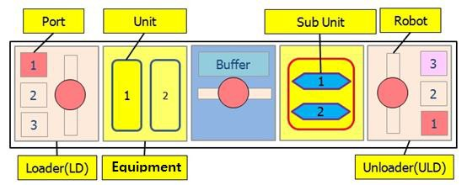

Figure 1-1 Line structure

System Architecture

CC-Link Communication

CC-Link Structure
The basis of communication between EAS and Equipment is MITSUBISHI PLC network.
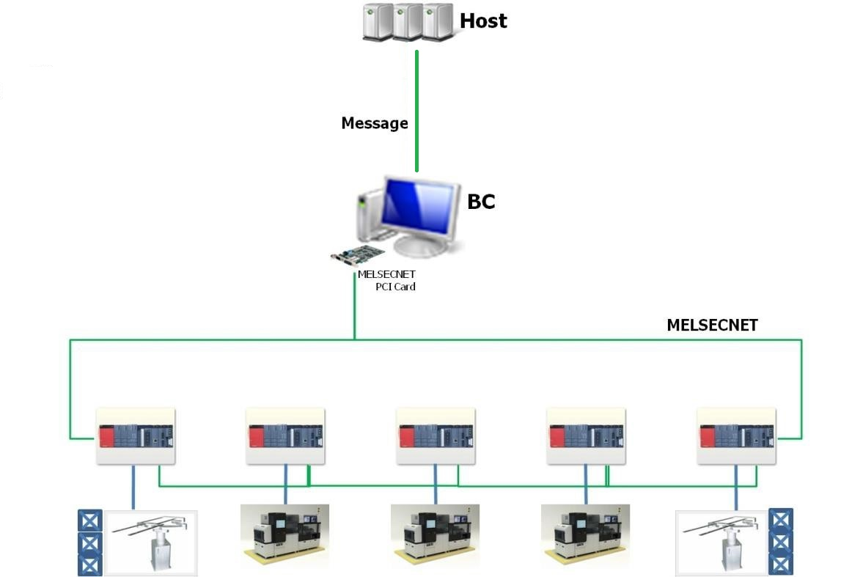

Figure 2-1 CC-Link IE Communication Structure

Data Communication
Equipment connects with upstream and downstream Equipment through link signal via MELSECNET/G Link Area. Link signal is used only to control job transferring. And Job Transfer Data is transferred via MELSECNET/G. Equipment connects with EAS via MELSECNET/G network of Mitsubishi to send/receive CIM data.

MASTER PLC
- PLC Module Base :
  - CPU Unit: MITSUBISHI Q03UDH, Q03UDV,R08CPU or above CPU
  - Base Unit: MELSEC Q35B , R38B
  - Power Unit: MELSEC Q62P , R61P
  - Ether Net Unit : QJ71E71-100 (100BASE-TX/10BASE-T)
  - MELSECNET/G Unit: MELSEC QJ71BR11 unit version D
- PC Board Base:
  - MELSECNET PCI Card: Q80BD-J71GP21(s)-SX (PCI) or Q81BD-J71GP21(s)-SX (PCI Express) or NZ81GP21-SX

- Common
  - Optical Cable: MELSECNET/G convertible type (1 set, more than 50 meters)
  - Optical Connector: MELSECNET/G convertible type (2 sets) (F connector 1 set) (unused)

LOCAL PLC (Provide by Equipment Supplier)
- CPU Unit : CC-Link IE Controller Network convertible
- MELSECNET/G Unit : QJ71GP21(s)-SX, RJ71GP21-SX or compatible PLC card for PC base
* PC Card reference model information : “MELSECNET PCI Card: Q80BD-J71GP21(s)-SX (PCI) or Q81BD- J71GP21(s)-SX (PCI Express)”
- Optical Connector : CC-Link IE Controller Network convertible type (Duplex LC connector 1set)
- Optical Cable prepared by each EQP. Vendor
- Upstream Equipment vendor prepare the optical cable for communication to downstream Equipment.
- If Equipment has port or buffer port that can be loaded or unloaded a cassette, the Equipment maker should provide File Register (R area). EAS can read or write the area for cassette map data.

Requirement of Cable Feed-in Hole & Path
- Equipment should reserve a path for optical cable from the lead-in opening to MELSECNET/G module and the path must be isolated from any electric noise source, like power supply, inverter, high voltage device and so on.
- Equipment vendor must supply layout information about MELSECNET module position in Equipment. End user must supply information about the length of optical cable between upstream Equipment and downstream Equipment.
- Around the connector of MELSECNET/G module, at least 90 mm must be reserved for connecting optical cable. It is to make sure that PLC connection and connector should be easily accessed for maintenance.
- Equipment must prepare a lead-in opening on the Equipment bottom plate.

* Data Link Configuration

Link Type | MELSEC PLC |  | Remarks
Unit | QJ71GP21(s)-SX | RJ71GP21-SX | ‘(s)’ option determine by maker
BPS | 1Gbps | 1Gbps
Cable | Optical Cable | Optical Cable
LX,LY | LX:8192 Points,LY:8192 Points | LX:8192 Points,LY:8192 Points | Use Device /1 Network
Link Device (B) | Max, 32768 Points (Bit) | Max, 65536 Points (Bit) | Use Device /1 Network
Link Device (W) | Max, 131072 Points (Word) | Max, 262144 Points (Word) | Use Device /1 Network
Link Device (B)/Local | Max, 16384 Points (Bit) | Max, 65536 Points (Bit) | Use Device /1 Unit (PLC)
Link Device (W)/Local | Max, 16384 Points (Word) | Max, 262144 Points (Word) | Use Device /1 Unit (PLC)

Equipment CC-Link IE Network Concept
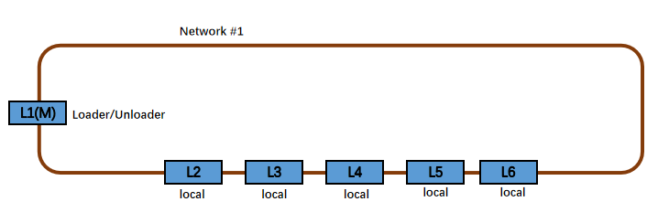

Figure 2-2 Communication Concept of Each Local PLC, Unit

PLC Network Number
Default Network Number is ‘1’

PLC Group Number
Default Group Number is ‘0’

Data Communication
Data Area of PLC memory is divided into two areas, namely Local Area and Master Area. The Local Area is used to send data from Local PLC to EAS, while the Master Area is used for data transfer from EAS to Local PLC. Items of each area are categorized into several types according to report or command characteristic, and the each item type is as below.
- Local Area
  - Status: Item that represents the current status of equipment, port, PLC.
  - Event: Item that represents events generated by equipment.
  - Request: Item that equipment requests a permission to do any action to EAS.
  - Command Reply: Item that equipment replies against the command from EAS.
- Master Area
  - Status: Item that represents the status of EAS.
  - Command: Item that can be sent to local PLC.
  - Event Reply: Item that is replied against the event from equipment.
  - Request Reply: Item that is replied against the request from equipment.

Link Relay, Link Register Relation
- When event occurs or some data are changed, local PLC must write the data to the specific link register (W Area) and then turn on the related local link relay for firing the event.
- When the data of link relay is changed, EAS should read the related link register area, and then turn on its own link relay for replying, which is corresponding to the local relay.
- When the response from EAS is OK, local PLC turns off its link relay.
- When the link relay of the local PLC is turn off, EAS turns off its link relay corresponding to the link relay of the local PLC.

EQP Event Report Timing chart

Event Report Timing Chart (Local to Master)
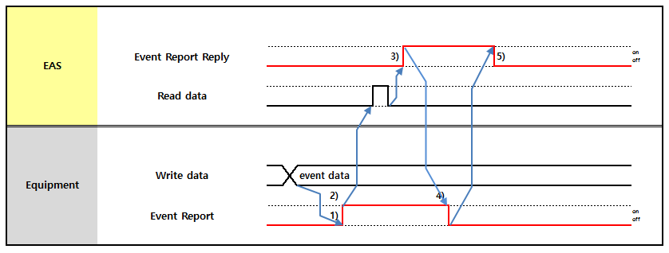

Figure 3-1 Diagram of Timing Chart for Normal Report Data

① After setting the data into link register (W Area), local PLC turns on the link relay (Event Bit).
② Local PLC loads the timer to check the Timeout. (T1 : 4 seconds) –Local PLC doesn’t report any same event using this link relay during this time.
③ Master PLC(EAS)reads the data, and then turn on the link relay (Event Reply Bit).
④ Local PLC turns off the link relay and continues the next action.
⑤ Master PLC (EAS) turns off link relay (Event Reply), after the timer reset. Master PLC (EAS) scans the link of the local PLC during T2 time. If timeout occurs, Master (EAS) processes error routine (T2 Timeout is 2 second)
- EQP vendor provide T1 timer value setting function. (Default value = 4 : 4 seconds)
- Local PLC preserves Report Data once set in link register until new Report Data is generated.
- When timeout occur , the EQ doesn’t have to stop signal wait then continue the next action

Request Timing Chart (Local to Master)
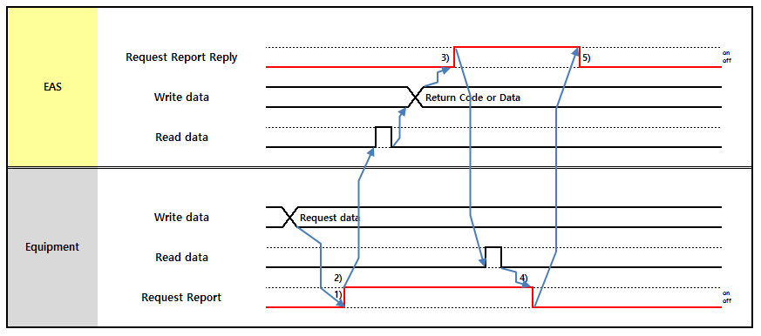

Figure 3-2 Diagram of Timing Chart for Request Report Data

① After setting the data into link register (W Area), local PLC turns on the link relay (Event Bit).
② Local PLC loads the timer to check the Timeout. (T1 : 4 seconds) – Local PLC doesn’t report any same event using this link relay during this time.
③ Master (EAS) reads the data, and then turn on the link relay (Event Reply Bit).
④ Local PLC reads the data of Master (EAS) and turns off the link relay (Event Bit), then continues the next action.
⑤ Master (EAS) turns off link relay (Event Reply), after the timer reset. Master (EAS) scans the link of the local PLC during T2 time. If timeout occurs, Master (EAS) processes error routine (T2 Timeout is 2 second)
- EQ vendor provide T1 timer value setting function. (Default value = 4 : 4 seconds)
- Local PLC preserves Report Data once set in link register until new Report Data is generated.
- When timeout occur , the EQ doesn’t have to stop signal wait then continue the next action

Consecutive Event Report Timing Chart (Local to Master)
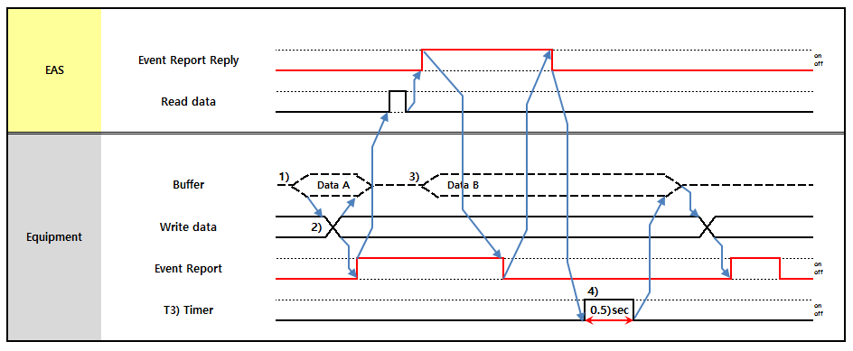

Figure 3-3 Diagram of Timing Chart for Normal Report Data – Consecutive Data Report

The above Timing Chart specifies data reporting procedure when Local PLC has more than one consecutive Data to report to Master (EAS) using one Event bit, such as Alarm or Job Event.

① If Local PLC has data (say, Data A) to report to Master (EAS), it sets the Data A in Buffer.
② If the Local PLC has no other previous data currently being reported to Master (EAS), moves Data A set in buffer to link register area and reports to Master (EAS).
③ If local PLC has new data (say, Data B) to report to Master (EAS), local PLC sets Data B in buffer. If, at this time, there is previous data (i.e. Data A) currently being reported to Master (EAS), local PLC waits until the Data A reporting process finishes.

④ After Master (EAS) turns off the link relay (Event Reply), the local PLC waits for 0.5 (T3: 0.5 second) second, and then the local PLC moves Data B to Link Word area and reports to Master (EAS).
- EQ vendor provide T3 timer value setting function. (Default value = 0.5 : 0.5 seconds)
- When timeout occur , the EQ doesn’t have to stop signal wait then continue the next action.

Event Report Timing Chart (Local to Local)
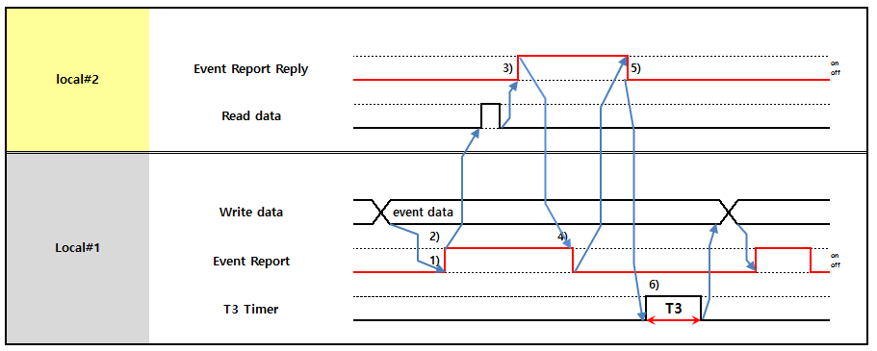

Figure 3-4 Diagram of Timing Chart for Normal Report Data

① After setting the data into link register (W Area), Local-1(send) PLC turns on the link relay (Event Bit).
② Local-1(send) PLC loads the timer to check the Timeout. (T1) – Local-1(send) PLC doesn’t report any same event using this link relay during this time.
③ Local-2(receive) reads the data, and then turn on the link relay (Event Reply Bit), and loads the timer to check the Timeout (T2).
④ Local-1(send) PLC turns off the link relay and continues the next action.
⑤ Local-2(receive) turns off link relay (Event Reply)
⑥ After Local-2(receive) turns off the link relay (Event Reply), the Local-1(send) PLC waits for 0.5 (T3) second before turns on the link relay (Event Bit) again for the next Event Report, if any.
- EQP vendor provide T1 timer value setting function. (Default value = 4 : 4 seconds)
- Local PLC preserves Report Data once set in link register until new Report Data is generated.
- When timeout occur , the EQP turns off the signal, and then continue the next action. EQP should generate timeout alarm to notify, but should not stop normal processing until required to do so.

EAS Command Relay Time Chart

EAS Command Timing Chart (Master to Local)
EAS Notice Area is related to Equipment Command Reply Area
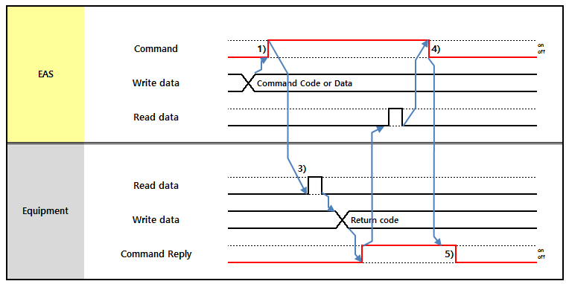

Figure 3-5 Diagram of Timing Chart for Normal Command Data

After setting data into the link register area of the Master (EAS), then mater PLC turns on the link relay (Command).

① Master (EAS) loads timer to check the Timeout. (T1 : 4 seconds)
② Local PLC reads the data of master area. After reading, local PLC turns on the link relay of local PLC (Command Reply).
③ Master (EAS) turns off the link relay (Command) upon Command Reply on. If local PLC does not turn on the reply bit within T1 timeout, Master (EAS) processes error routine.
④ Local PLC turns off the link relay (Command Reply), after the timer reset. Local PLC scans the link relay of Master (EAS) during T2 time. If timeout (T2) occurs, local PLC processes error routine.
- EQ vendor provide T2 timer value setting function. (Default value = 2 : 2 seconds)
- When timeout occur , the EQ doesn’t have to stop signal wait then continue the next action.

Timeout Error

T1 Timeout (Master ↔ Local)
T1 : duration to keep Event/Request/Command signal on without reply signal ,4sec
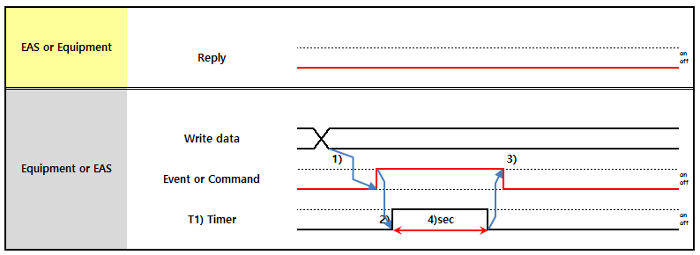

Figure 3-6 T1 Timeout Chart (Master (EAS) & Local PLC)

① After setting the data into link register, then Local or Master (EAS) turns on the link relay (Event or Command Bit).
② Local or Master (EAS) Loads timer to check Timeout. (T1 : 4 seconds) If the response of the partner does not exist, then Local or Master (EAS) makes Timeout.
③ Turn off the link relay (Event or Command Bit), after the timer reset.

T2 Timeout_Case1 (Master ↔ Local)
(Case 1)T2 : duration to wait Event/Request/Command signal off after reply signal on, 2sec
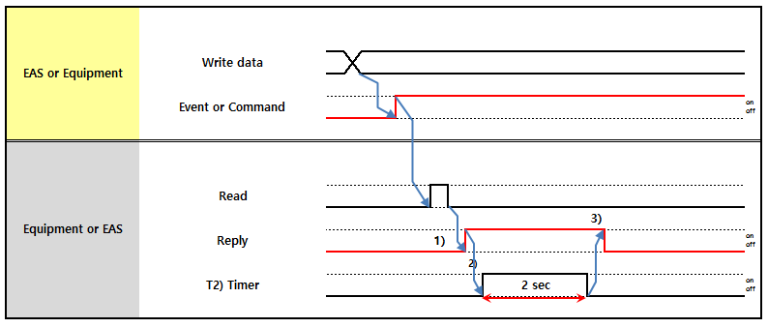

Figure 3-7 T2 Timeout Chart

① After reading the data into Link Word, then turn on the Link relay (Command or Event Reply Bit).
② Load the timer to check the Timeout. (T2: 2 second). If the response of the partner does not exist, then Local or Master (EAS) makes Timeout.
③ Turn off the Link relay (Event or Command Reply Bit), after the timer reset.

T2 Timeout_Case2 (Master ↔ Local)
(Case 2)T2 : duration to wait Event Reply signal off after Event or Command signal Off, 2sec.
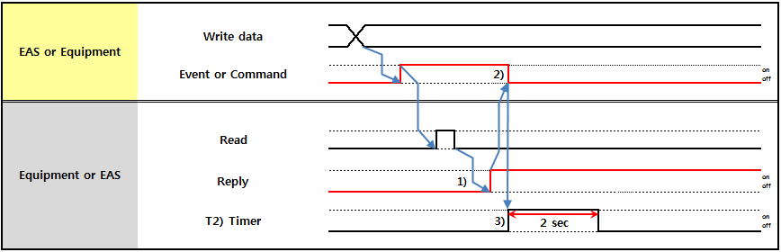

Figure 3-8 T2 Timeout Chart

① After reading the data into Link Word, then turn on the Link relay (Event Reply Bit).
② Turn off the Link relay (Event or Command Bit), after received Event or Command Reply.
③ Load the timer to check the Timeout. (T2: 2 second). If Reply BIT doesn't turn off,, then Local or Master (EAS) makes Timeout.

Normal Timer Reset (Master ↔ Local)
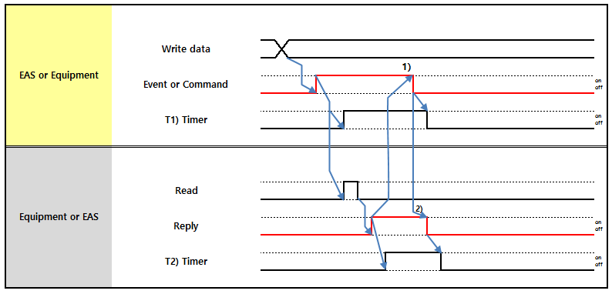

① When reply bit on , signal bit off then T1 timer reset
② When reply bit off, signal bit off then T2 timer reset

Equipment Operations relating to the Timeout

Warning Alarm Case
      - T1 Timeout
- When Equipment report event and EAS don’t set Reply bit ON, After set time over, Equipment set Warning Alarm and Equipment continue the processing
      - T2 Timeout
- When EAS send the Command or Request and Equipment set the Reply bit ON. Since then EAS don’t set Command or Request bit OFF, After set time over, Equipment set Warning Alarm and Equipment continue the processing

Error Alarm Case
      - T1 Timeout
- When Equipment request and EAS don’t set Reply bit ON. After set time over(T1 Timeout),
Equipment set Error Alarm and Equipment continue the processing (exception : special operation data, job data, the related processing data)
      - Consecutive Event
- When Equipment set Event, Equipment check the reply bit of EAS, If reply bit set ON, Equipment set the Error Alarm and stop processing

Interface Signals and Data
Interface between devices consist of:
- Transfer Interlock and Data
: This is mutual interlock signal required for transfer processing such as glass-in and glass-out between upstream and downstream devices. The Interlock Type depends on the configuration of the device and each has different Interlock signal system and its content.
- Signal and Data for Reporting Device Status
: These include device modes, anomaly and Glass hold state
- Glass Processing Signal and Data
: Scrap report and data report for Glass process.
- Signal and Data for Reporting Glass-in or Glass-out
: This is to report data on Glass carried upon glass-in from upstream or transmitted to downstream.
- Data Request Signal
: This requests data necessary for devices like Equipment Recipe ID request, Glass Data request to EAS.
- Special Signal and Data for other devices
: This allows exchange with other devices of data required for operation in such a case as special mode change.

Data Expression
      - ASC Type
- Use 8 bits ASC Code.
- Fill the empty value with Blank (H20) value at ASC type.
- Order of inter-character in word: Low byte → High byte order
- Order of inter-word: Low word → High word order
- Character and numeric data form: Standard Character form

‘A’ | ‘B’ | ‘C’ | ‘D’ | ‘1’ | ‘2’ | ‘3’ | ‘4’
H42 | H41 | H44 | H43 | H32 | H31 | H34 | H33 | H20 | H20 | H20 | H20
Word 1 (Low) |  | Word 2 |  | Word 3 |  | Word 4 |  | Word 5 |  | Word 6 (High)
Examples)
- Character data: (ex) ‘R’ → H2052
- Character data: (ex) ‘I1’ → H3149 (H4931 is an error)
- Character data: (ex) ‘123’ → H3231 2033
- Character data: (ex) ‘2AA00101 ‘ → H4132 3041 3130 3130 2020 2020
      - Numeric Type

Format | Abbreviati on | Size | Range | Sample Value | Expression in PLC
 |  |  |  |  | order | BIN | DEC | HEX
Unsigned Integer | INT | 1W | 0 ~ 65,535 | 324 | 0000 0001 0100 0100 |  | 324 | 0144
Signed Integer | SINT | 1W | -32,768~ 32,767 | - 90 | 1111 1111 1010 0110 |  | 65,446 | FFA6
 |  |  |  | 90 | 0000 0000 01011010 |  | 90 | 005A
Unsigned Long | LONG | 2W | 0 ~ 4,294,967,295 | 1234567 | 1st | 1101 0110 1000 0111 | 54,919 | D687
 |  |  |  |  | 2nd | 0000 0000 0001 0010 | 18 | 0012
Signed Long | SLONG | 2W | -2,147,483,648 ~  2,147,483,647 | -1234567 | 1st | 0010 1001 0111 1001 | 10,617 | 2979
 |  |  |  |  | 2nd | 1111 1111 1110 1101 | 65,517 | FFED
Float | F | 2W | sign : 1st bit exponent : next 8bit, fraction : next 23bit | 0.75 | 1st | 0011 1111 0100 0000 |  | 3F40
 |  |  |  |  | 2nd | 0000 0000 0000 0000 |  | 0000
- In case of signed format, negative value should be described with two’s complement.
- Float type complies with IEEE 754
      - BCD Type
- Use 4 bits BCD Code
- Character data is not used
- The below is BCD code Sample

1Word | F | E | D | C | B | A | 9 | 8 | 7 | 6 | 5 | 4 | 3 | 2 | 1 | 0
Binary | 0 | 0 | 1 | 0 | 1 | 0 | 0 | 0 | 0 | 0 | 1 | 1 | 0 | 0 | 0 | 0
BCD | 2 |  |  |  | 8 |  |  |  | 3 |  |  |  | 0

Terms Definition

Common

Job
The Job means specific processing works with a material such as glass, Panel. Glass is physical a unit and job logical a unit. And also, it is managed job data
There are glass job data, Panel job data, dispatching job data that distinguish for useful type

Recipe ID
Each job is to be processed in its desired process condition, called recipe. Equipment should give IDs to represent and manage these recipes, and the ID is called Recipe ID.
- Custom Specific:
Array : Recipe ID consists of ASC 20 characters. 0~9, A~Z, a~z (except : I, O, i, o). CF,CELL : Recipe ID consists of INT.

Master Recipe ID (PPID)
Master Recipe represent the group of each local Recipe ID. Master Recipe ID and Recipe ID relation rule refer to Equipment Operation Scenario.
(Ex. 1~999 or ABCD123)
- Custom Specific:
EQ: will use ASC type (ASC 20 characters. 0~9, A~Z, a~z (except : I, O, i, o)).

Equipment

Inline Mode
The inline mode is related only with job transferring and is necessary only between upstream equipment and downstream equipment.

CIM Mode
CIM Mode is to specify the communication relation between equipment and EAS. In general, a local PLC should ignore the command of the EAS at CIM OFF Mode. But, Equipment should be allow for the Command of the CIM Mode On Change.

Equipment Status
The Equipment Status shows the current operational state of the equipment. It consists of Setup, Stop, Pause, Idle and Run.

Unit/Sub-Unit Status
The Unit Status shows the current operation state of the unit. Types of Unit Status and the definitions are same as those of Equipment Status.

Processing Time
It is actual processing time of a job in equipment or unit. It does not include time spent for transferring between upstream equipment and downstream equipment. Equipment include this item in process data report.

Upstream Path No
There would be multiple upstream equipment’s for any specific equipment. Equipment should manage its upstream equipment’s’ identity by assigning unique number to all upstream equipment’s, and the number is called Upstream Path No. When receiving a Job from upstream equipment, the equipment can know from which upstream equipment the Job is received by checking the Upstream Path No. If there is only one upstream equipment, Upstream Path No is always set ‘1’.

Downstream Path No
There would be multiple downstream equipment’s for any specific equipment. Equipment manages its downstream equipment’s identity by assigning unique number to all downstream equipment’s, and the number is called Downstream Path No. When sending a Job to downstream equipment, the equipment should indicate to which downstream equipment the Job is sending to by checking the Downstream Path No.
If there is only one downstream equipment, Downstream Path No is always set ‘1’.

VCR No
VCR No is used to distinguish the unique VCR in the equipment. If there is only one VCR, VCR No is always ‘1’.

Port

Port Type
It is to classify a Port based on the expected operation of the Cassette currently loaded on the Port: Cassette loaded on the port is whether to input Job into Inline, or to output Job from Inline after Job that is finished its process in a line, or to buffer a Job in a line temporary. There are 4 types: Loading Port, Unloading Port, Buffer Port(There are 3 types for Buffer Port; Buffer Type, Loader in Buffer Type, Un-loader in Buffer Type), and Both Port.

Port Mode
It is to classify a port based on Judge of job that has been included or is going to be sorted in a cassette on the port. Port Mode is defined by a combination of Job Type, Production Type and Judge/Grade values.

Port Transfer Mode ( OTH / STK / AGV/ MGV)
It indicates the type of AMHS Equipment that connects with the port in transferring cassette to/from the port.

Port Enable Mode (Port Down)
It indicates that the port can be used or not. If this mode of a port is changed to ‘Disable Mode’, equipment does not process the cassette on the port. Operator can change its value in equipment screen.

Port Status
It is to indicate whether a Port is available for cassette loading, or a cassette loading is finished to a Port, or a Port is available for cassette unloading.

Cassette ID
Specific ID is assigned to individual cassettes, which is called Cassette ID. It can be read by Bar-Code Reader (BCR) or RFID.

Job

Substrate Type
The Substrate Type of job. It consists of 2 types: Glass, Panel.

Glass ID
A specific ID is assigned to a full size glass, which is called Glass ID. Veri Code is used to read the Glass ID of a job, and it consists of physical symbols.

Cassette Sequence No (Lot index)
The Cassette Sequence Number is a fictitious sequence number to represent a cassette. It should be increased when the Port Status of the port is changed to ‘In Use’. It is used to uniquely distinguish the cassette for the jobs. Regardless of CIM ON or CIM OFF, the Cassette Sequence Number is produced automatically by loader or un-loader. Buffer also produces Cassette Sequence Number as loader or un-loader. Equipment vendor should follow cassette sequence numbering rule specified in the equipment operation scenario.

Port No | CST Seq No. Range
1 | 1001 ~ 1999
2 | 2001 ~ 2999
3 | 3001 ~ 3999
4 | 4001 ~ 4999

Job Sequence No (slot number)
The Job Sequence Number is a fictitious sequence number. No matter it is in CIM ON or CIM OFF Mode, when a job is fetched out from a cassette on loader, Job Sequence Number should be produced by the loader/Un-loader/Buffer/Virtual Port automatically. Slot sequence of cassette is ordered from bottom to top, from Slot #1 to Slot #210. As same as slot order, the Job Sequence Number is numbered from bottom to top.
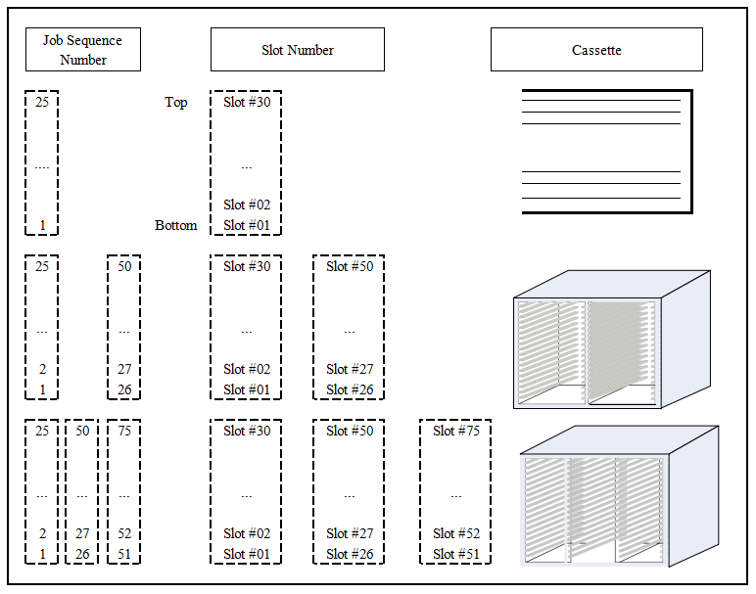

Figure 4-1 Relation between Job Sequence Number and Slot Number

This is Rule of Job Sequence No is in below
W | 5 | 4 | 3 | 2 | 1 | 0
Description | Unsigned Integer  Slot No(1~63)
*Slot No is Glass Job Sequence No.
*EQP don't change Slot No.

Glass Code
Glass Code is a combination of Cassette Sequence No. and Job Sequence No., and is used to identify a Job (Glass, Panel) instead of Glass ID or Panel ID. So, either Glass Code or Glass ID/Panel ID can be used to indicate a Glass/Panel.
Word | Word 01 (Glass Code #1) | Word 02(Glass Code #2)
Glass Code | CST Sequence Number (1~65535) | Job Sequence Number (1~65535)

For example) Data Expression
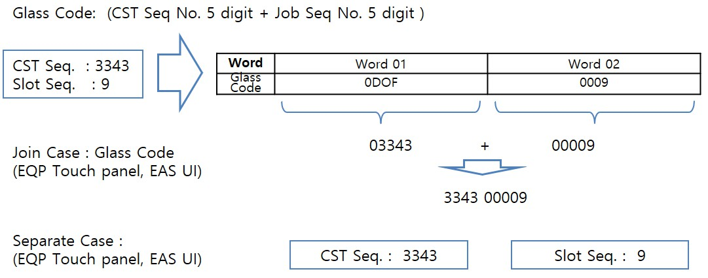

Figure 4-2 Data Expression of Glass Code

Job Type
Job Type is used to distinguish the kind of cassette or glass. It consists of Normal, Dummy and so on. Normally, glass is sorted to the cassette according to the Job Type of it.
Job type is distinguish by dispatching job type or Glass job type or Panel job type.

Dummy Type
There are various types of Dummy Glasses according to its purpose of exist. This is to indicates the type of Dummy for a specific Dummy Glass.
When ‘Job Type’ is ‘Dummy’, this value should be set by Host.

Dummy Type | Value | Format | EAS Map Down
General Dummy | 1 | INT | General
QC Dummy | 2 | INT
Through Dummy | 3 | INT
Mask Dummy | 4 | INT
Screen Dummy | 5 | INT
ODF Seal Dummy | 6 | INT | SD Dummy(ODF)
VAS Dummy | 7 | INT
Laser Seal Dummy | 8 | INT
ITO Dummy | 9 | INT
Photo Dummy | 10 | INT
TPCD Dummy | 11 | INT
Monitor Dummy | 12 | INT
Thickness Dummy | 13 | INT | Thickness
Rubbing ITO Dummy | 14 | INT | ITO(RubbingMonitor)
Rubbing Aging Dummy | 15 | INT | Rubbing Rubbing(Bare)  Aging(RubbingBare)
MM Dummy | 16 | INT
Bare Dummy | 17 | INT | Particle Count(Bare)
ODF UVMask Dummy | 18 | INT | UV Mask(ODF)
ODF Bare Dummy | 19 | INT
ODF LC Dummy | 20 | INT
Particle Bare Dummy | 21 | INT
Rubbing Bare Dummy | 22 | INT
General ITO Dummy | 23 | INT
Thickness ITO Dummy | 24 | INT
Rubbing NIP Dummy | 25 | INT
Etch Strip Dummy | 26 | INT | For Array EQP
Metal Dummy | 27 | INT | For Array EQP

Job Judge
It indicates the judgment of job. The value is to set by equipment automatically or by operator.

Job Judge
0 | Inspect Skip or No Judge | G | Good | R | Repair
N | NG | A | Need Mac | I | Need Mic
S | Scrap | W | R/W | K | Process Skip
T | Retest | M | Mac/Mic | P | Pending
F | Special Good (CF only) | C | Need CSI | V | Need CVD
E | Test(CF Only)
Each equipment may use different set of Judge codes – it will be determined by equipment engineer.

Job Grade
It indicates the grade of job. The value is to set by equipment automatically or by operator.
Job Grade
Judge | Transfer Grade | Grade
0 | 0 | 0 | Inspect Skip or No Judge or No Grade
G | G | AP | AP
G | G | AM | AM
G | G | AO | AO
G | G | AS | AS
G | G | AT | AT
G | G | AL | AL
G | G | AX | AX
G | G | AY | AY
G | G | AZ | AZ
G | G | AI | AI
G | T | TX | TX
G | T | TY | TY
G | T | TZ | TZ
G | T | TU | TU
G | Q | QS | QS
G | Q | QT | QT
G | Q | QQ | QQ
G | Q | QL | QL
G | Q | QV | QV
G | Q | QW | QW
G | Q | QU | QU
G | Q | QP | QP
G | Q | QR | QR
N | N | NW | NW
N | N | NU | NU
N | N | NR | NR
N | N | NP | NP
N | N | NV | NV
N | N | FL | FL
N | N | FO | FO
N | N | NI | NI
N | N | NS | NS
 |  | NT | NT
 |  | BR | BR
Each equipment may use different set of Judge codes – it will be determined by equipment engineer.

Process Flag
It is historical record of processing status, indicating that job has been processed or skipped in specific equipment. Each and every equipment should update this data after processing or skip.
Every Equipment should set its processed data value at its own designated write area, and should not overwrite data value recorded by other equipment. And also it has to be set “Skipped” when job has been aborted by OP or EQP. It can be recognized by Process Reason Code.

Process Flag | Value
Skipped | 0
Processed | 1

Inspection Judge data
It is historical judge data that job has been judged in specific inspections. The specific inspections should update this data after inspection.
<Example of use>

Inspection Jude Data
8bit | Equipment01 Inspection Jude Data  “0”= Inspect Skip or No Judge ,“G”=Good ,“R”=Repair ,“N”=NG “V”=Need CVD ,“C”=Need CSI ,“S”=Scrap ,“W”=R/W  “K”=Process Skip ,“T”=Retest ,“M”=Mac/Mic | 8bit | Equipment03 Inspection Jude Data “0”= Inspect Skip or No  Judge ,“G”=Good ,“R”=Repair,“N”=NG  “V”=Need CVD ,“C”=Need CSI ,“S”=Scrap ,“W”=R/W  “K”=Process Skip ,“T”=Retest ,“M”=Mac/Mic
8bis | Equipment02 Inspection Jude Data  “0”= Inspect Skip or No Judge ,“G”=Good ,“R”=Repair,“N”=NG “V”=Need CVD ,“C”=Need CSI ,“S”=Scrap ,“W”=R/W  “K”=Process Skip ,“T”=Retest ,“M”=Mac/Mic | 8bit | Equipment04 Inspection Jude Data “0”= Inspect Skip or No  Judge ,“G”=Good ,“R”=Repair,“N”=NG  “V”=Need CVD ,“C”=Need CSI ,“S”=Scrap ,“W”=R/W  “K”=Process Skip ,“T”=Retest ,“M”=Mac/Mic

Skip Flag
This is Host instruction to equipment whether to skip processing for a specific Job. If this flag is On, equipment should by pass the Job without processing.
Skip flag is composed of bits where each bit is assigned to each equipment. Therefore equipment should check its own Skip flag only.
Skip Flag | Value
To normal Process | 0 (OFF)
To Skip | 1(ON)

Inspection Flag
This flag indicate is to be set and be used within Equipment or Inline for inspection purpose.
While a Job is transferred or being processed in equipment, Operator or Equipment can set this flag to indicate that the specific Job is required inspection or measurement somewhere in downstream.
When receiving a Job with this flag is On, Transfer Unit is required to transfer the Job to designated Inspection Unit/Equipment, and the Inspection Unit/Equipment processes the inspection.
- Which equipment has to provide function to set this flag: To be determined by engineer, if need.
- Which equipment need to use this flag : To be determined by engineer, if need.
- After Inspection, whether to turn Off this flag after inspection : to be determined by engineer, if need.

Inspection Flag | Value
Default | 0
Inspection is required | 1

Q-Time
Q-Time is defined as duration of Job between two processing Equipment. It is calculated in time from the processing end of a Job in one equipment to the processing start of the same Job in target equipment.
- Equipment in Q-Time path : equipment records the in/out duration into Job Data before sending the Job to downstream. The in/out duration record should be cumulative so that it has to be added not overwritten.
- Q-Time Target Equipment : after receiving a Job, equipment checks the Q-Time of the Job before starting processing. If Q-Time is over, equipment raises alarm and set Q-Time over flag to the Job, and continues the next processing.
- Q-Time Target Equipment has to provide Q-Time validation setting function on touch panel.
- There are maximum three of Q-Time define points in equipment. Refer to Equipment Operation Scenario for each Q-Time Start and Target equipment.
- Time duration should be recorded in second.

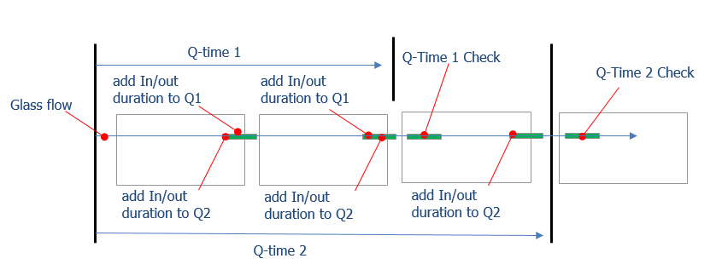

Figure 4-3 Process Q-Time

Job Data
Job Data is characteristics of a Job and should be managed and maintained in equipment.
- When Job is transferred between equipment, the Job Data also has to transferred along with the Job.
- Equipment has to maintain the Job Data as long as the Job is in equipment, even when equipment is down or power off.

Job Data Items
      - Job Data A
It has 96 word in default without optional Item. This Data is used for Job Data transferring between Equipment (Local) and is used to report Equipment-level Job Event Report to Host (Received Job Event, Sent Out Job Event)

Item Name | Format | Word Points | Bit Points | Sub Items | Writable |  |  | Description
 |  |  |  |  | EAS | LD | EQP | Description
Cassette Sequence No | INT | 1 |  | 1~65535 |  | W |  | It is mainly to distinguish which kind of job the job is  and from which cassette the job is fetched out
Job Sequence No | INT | 1 |  | 1~65535 |  | W |  | It indicates the position of the job in the cassette  that is Slot No
Lot ID | ASC | 10 |  |  | W | W
Product ID | ASC | 10 |  |  | W | W
Operation ID | ASC | 10 |  |  | W | W
GlassID or PanelID | ASC | 10 |  |  | W | W | VCR | The Glass ID or Panel ID (after Cut) of the Job
CST Operation Mode | INT | 1 |  | 0: Kind to Kind  1: CST to CST | W | W |  | It indicates the operation mode of cassette.
Substrate Type | INT | 1 |  | 0: Glass  1: Panel  2: Q-Panel | W | W | W | The Substrate Type of the job
Product Type | INT | 1 |  | 1:Production 2:Engineer 3:Dummy  4: Develop  5: Test  6~:Reserved | W | W |  | It indicates the type of product. Equipment can’t mix different product type in on local.
Job Type | INT | 1 |  | 1: TFT Glass  2: CF Glass  3: Dummy  4: Normal  5: UV Mask | W | W |  | It indicates the type of glass.

Item Name | Format | Word Points | Bit Points | Sub Items | Writable |  |  | Description
 |  |  |  |  | EAS | LD | EQP | Description
6: Pol
7 ~ : Reserved
Dummy Type | INT | 1 |  | Refer to 4.4.9 Dummy  Type | W | W |  | It indicates the type of dummy glass. It is valid when Job Type is Dummy.
Skip Flag | BIT | 2 | 1 | 1Bit/ Unit or Local 00: Processing  01: Skip | W | W |  | It indicates Host downloads a process or non process flag to EQ that to will be skip or process
Process Flag | BIT | 2 | 1 | 1Bits/Unit or Local 0: Skipped  1: Processed |  |  | W | It is historical Process Data that job has been processed or skipped in specific equipments. The specific equipments should update this data after  processing or skip.
Process Reason Code | INT | 1 | 1 | 0: no Error  1: stop by OP  2: material problem 3: abort by EQP  4: abort by OP  5: Mura Reprocess  6: Reserved  [need to define by  vender] |  |  | W | It is historical error code of process that reason code when job has been not processed or aborted in specific equipments
Last Glass Flag | INT | 1 |  | 0: Not Last Glass 1: Last Glass | W | W |  | Mark last glass of CST or LOT for FIFO operation
First Glass Flag | INT | 1 |  | 0: Not First Run 1: First Run | W | W |  | Mark first glass of CST or LOT for FIFO operation
Glass Thickness | INT | 1 |  | 1: 0.3t  2: 0.4t  3: 0.5t  4:0.7t  5 ~ : Reserved | W | W |  | It indicates the thickness of glass.
Glass Degree | INT | 1 |  | 0: 0°  1: 90°  2: -90°  3: 180°  8: Turn over 0°  9: Turn over 90°  10: Turn over -90°  11: Turn over 180° |  | W | W | Current degree of turn/turn over from normal position. If equipment turn/turn over glass, equipment should write this data (the value is the resultant degree from normal position, not the degree amount that equipment turned)
Inspection Flag | BIT | 1 | 1 | 0: No Inspection  1: Inspection | W | W | W | The Inspections unit of downstream with Inline has to process an reservation flag that is set manual by OP or automatically by EQP. Such as sampling or  by pass
Inspection Judge Data | ASC | 3(4) |  | 8bits/Equipment Max 6Equipment  *Referto Judge Value*  *CF Photo Special*  - 4word |  |  | W | It is historical judge data that job has been judged in specific inspections. The specific inspections should update this data after inspection.
Job Judge | ASC | 1 |  | [Common]  *refer to Judge Code | W | W | W | In case equipment makes Judge, the equipment should write this data.
Job Grade | ASC | 1 |  | Job Grade(2 Char)  *refer to Judge Grade | W | W | W | It indicates the grade of a job.  In case equipment makes Grade, the equipment  should write this data
Job Recovery Flag | INT | 1 |  | 0: default  1: from EQ  2: from EAS | W | W | W | It indicates job recovery state at No VCR Unit. Write this data if Job is recovered from Scrap.
Q-Time1 | INT | 1 |  | second |  |  | W | equipment add(not overwrite) the in/out duration into Job Data before sending the Job to  downstream
Q-Time2 | INT | 1 |  | second |  |  | W | equipment add(not overwrite) the in/out duration into Job Data before sending the Job to  downstream
Q-Time3 | INT | 1 |  | second |  |  | W | equipment add(not overwrite) the in/out duration into Job Data before sending the Job to  downstream

Item Name | Format | Word Points | Bit Points | Sub Items | Writable |  |  | Description
 |  |  |  |  | EAS | LD | EQP | Description
Q-Time Over Flag | Bit | 1 | 3 | 1st bit : Q-time 1 2nd bit : Q-time 2  3rd bit : Q-time 3 |  |  | W | This item is set by equipment of Q-time Check when Q-time is over.
Mode | INT | 1 |  | Ex)  1: Normal Mode 2: Cold Run Mod 3: Sorting Mode  4: Photo Dummy Mode 5: ITO Dummy Rework Mode  6: PR Rework Mode 7: Scraper Mode Refer to Indexer  Operation Mode Block | W |  |  | Line Operation Mode  This is the reference value when glass processing or glass flow.
Master Recipe | ASC or INT | 10 or  1[‘= |  |  | W | W |  | It indicates Master Recipe. (PPID)
Shop Special Item |  | 18 or 27 |  | Refer to below

      - Job Data B
This Data item is brief version of Job Data. When equipment reports Job Event to Host for Job transferring between Units (Stored Job Event, Fetched Out Job Event), Equipment should report Job Data B instead of Job Data A.

Item Name | Format | Word  Points | Bit Points | Sub Items | Writable |  |  | Description
 |  |  |  |  | EAS | LD | EQP | Description
Cassette Sequence No | INT | 1 |  | 1~65535 | W | W |  | It is mainly to distinguish which kind of job the job is  and from which cassette the job is fetched out
Job Sequence No | INT | 1 |  | 1~65535 | W | W |  | It indicates the position of the job in the cassette  that is Slot No
Glass ID or PanelID | ASC | 10 |  |  | W | W | VCR | The Glass ID or Panel ID of the Job
Job Judge | ASC | 1 |  | [Common]  *refer to Judge Code | W | W | W | It indicates the judgment of job. If operator changes it in inspection, its value should be changed.  (Total result flag of all Inspection Equipment in  Inline)
Job Grade | ASC | 1 |  | Job Grade(2 Char)  *refer to Judge Grade | W | W | W

      - Job Data C
This Data item is brief version of Job Data. When equipment reports Job Event to Host for Job transferring between Equipment ,Units by Cassette that is Cassette Cleaner or Multi Aging. Equipment should report Job Data C instead of Job Data A or B.

Item Name | Format | Word  Points | Bit Points | Sub Items | Writable |  |  | Description
 |  |  |  |  | EAS | LD | EQP | Description
Cassette Sequence No | INT | 1 |  | 1~65535 | W | W |  | It is mainly to distinguish which kind of job the job is  and from which cassette the job is fetched out
Cassette ID | ASC | 10 |  |  | W | W | VCR
Cassette Judge | ASC | 1 |  | [Common]  *refer to Judge Code | W | W | W | It indicates the judgment of CST. If operator changes it in inspection, its value should be changed.  (Total result flag of all Inspection Equipment in  Inline)
Cassette Process Flag | BIT | 1 | 1 | 1Bits/Unit of Local 0: Skipped  1: Processed |  |  | W | It is historical Process Data that job has been processed or skipped in specific equipments. The specific equipments should update this data after  processing or skip.

Item Name | Format | Word  Points | Bit Points | Sub Items | Writable |  |  | Description
 |  |  |  |  | EAS | LD | EQP | Description
Master Recipe | ASC or  INT | 10 |  |  | W | W |  | It indicates Master Recipe. (PPID)

      - Job Data S
This Data item is brief version of Job Data. When equipment reports Job Event to Host for Job transferring between Equipment ,Units by Cassette that is Cut Line. Equipment should report Job Data S with Job Data A that is 256 word.
※ This feature is used only devices needed.

Item Name | Format | Word  Points | Bit Points | Sub Items | Writable |  |  | Description
 |  |  |  |  | EAS | LD | EQP | Description
Job Data A | - | 96 |  |  | W | W | W
Panel Judge | ASC | 128 |  |  | W | W |  | this is to request information of Panels such as Risk of each Panel in a Glass (available only Glass –  before cut to Panel).
Risk Panel Flag | ASC | 10 |  |  | W | W |  | This data should be set in Parent Glass from MES  before Cutting
Reserved | - | 21

Common Function

Equipment Main Mode Management

Equipment Alive
Equipment Alive is the status that the equipment is in proper operation and can be controlled by PLC. Local PLC should periodically change Equipment Alive bit to be 60 seconds on and 60 seconds off. If Equipment Alive signal doesn’t change for 130 seconds, Master (EAS) should take it as communication disconnection and generate Operator Call.

- Equipment Alive Check between equipment
Besides Equipment Alive signal to Master (EAS), Equipment check Alive status of both upstream equipment and downstream equipment.
Equipment’s sends ‘Downstream Alive’ bit to its upstream equipment, and sends ‘Upstream Alive’ bit to its downstream equipment.
‘Upstream Alive’ and ‘Downstream Alive’ bit is to be set 60 seconds on and 60 seconds off, and periodically repeats this on/off set.
If equipment detects either ‘Upstream Alive’ or ‘Downstream Alive’ doesn’t change for 130 seconds, equipment raises and alarm and OP call.

CIM Mode
CIM Mode is to specify the communication relation between equipment and EAS. There are 2 kinds of modes, CIM ON Mode and CIM OFF Mode. Equipment should provide CIM Mode change button on touch panel.
- CIM ON Mode: The communication is normal between EAS and EQ. EQ can report all events to EAS. Also the EAS can send any command to EQ.
- CIM OFF Mode: The communication is somehow abnormal between EAS and EQ. EQ can update status data (Link Register Area), but has not to report the event to EAS (Link Relay Area). Also, equipment has not to accept any command from EAS. But, Equipment should be allow for the Command of the CIM Mode On Change.

CIM Mode Change By EAS
EAS can change CIM Mode by CIM Mode Change Command, for data collection.

Inline Mode
The inline mode is related only to job transferring and is necessary only between upstream equipment and downstream equipment. Equipment should provide inline mode change button on touch panel. The Inline Mode consists of 2 modes:
- Upstream Inline Mode On: EQ can receive a glass/Panel from upstream equipment.
- Upstream Inline Mode Off: EQ cannot receive a glass/Panel from upstream equipment.
- Downstream Inline Mode On: EQ can send a glass/Panel to downstream equipment.
- Downstream Inline Mode Off: EQ cannot send a glass/Panel to downstream equipment.

Local Alarm State
It shows that there is an alarm in entire equipment. If all alarms are cleared, it should be turned off.

PLC MAP
      - Local PLC – Link Register (W Area)

Block | Item | Points | Type | Format | Sub Items
CIM Mode Change  Command Reply Block | Return Code | 1 | Data | INT | 1: Accept  2: Already In Desired Status

      - Local PLC – Link Relay (B Area)

Block | Item | Points | Type | Sub Items | Related Word Items | Master (EAS) Action
 | Equipment Alive | 1 | Status
 | CIM Mode | 1 | Status | - On: CIM ON Mode  - Off: CIM OFF Mode
 |  |  |  | - On: Inline On Mode with
 | Upstream Inline Mode | 1 | Status | Upstream EQP  - Off: Inline Off Mode with
 |  |  |  | Upstream EQP
Equipment Status Event | Downstream Inline Mode | 1 | Status | - On: Inline On Mode with Downstream EQP  - Off: Inline Off Mode with
 |  |  |  | Downstream EQP
 |  |  |  | - On: There is an alarm that
 |  |  |  | is not cleared.
 | Local Alarm State | 1 | Status | - Off: There is no alarm. All
 |  |  |  | alarms have already been
 |  |  |  | cleared.
EASComman d Reply | CIM Mode Change Command Reply | 1 | Reply | - On: Reply  - Off: Reply End | Command Reply Block

      - Master (EAS) – Link Register (W Area)

Block | Item | Points | Type | Format | Sub Items
CIM Mode  Change Command Block | CIM Mode | 1 | Data | INT | 1: CIM On  2: CIM Off

      - Master (EAS) – Link Relay (B Area)

Block | Item | Points | Type | Sub Items | Related Word Items | Local PLC Action
EAS  Command | CIM Mode Change Command | 1 | CMD | - On: Fire Command  - Off: Command End/Timeout | CIM Mode Change Command Block

Communication Scenarios
      - Equipment Alive Scenario
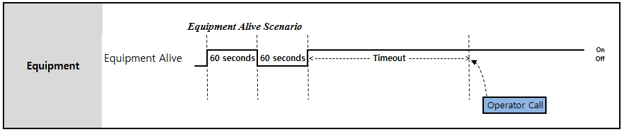
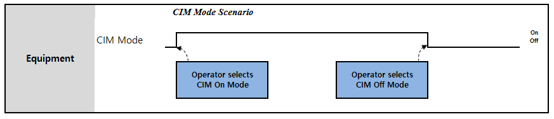
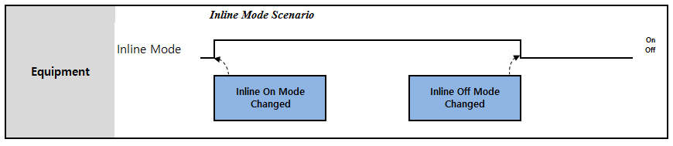
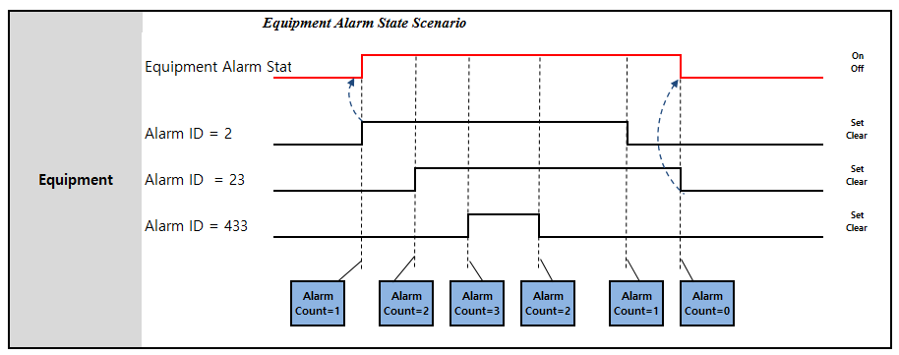

      - CIM Mode Scenario

      - Inline Mode Scenario

      - Local Alarm State Scenario

Equipment Mode Change

Equipment Mode Change Command
If EAS need to change equipment mode, EAS sends the “Equipment Mode Change Command” to equipment.
- Normal Mode : Normal processing
- Recovery(Force clean out) Mode : Executing force clean out function
- Skip Mode : Processing Skip(or By-pass)
- Cold Run Mode : Each equipment just transfer glass without processing
- ETC..
      - PLC MAP

        - Local PLC – Link Register (W Area)

Block | Item | Points | Type | Format | Sub Items
Equipment Mode Change Return Block | Return Code | 1 | Data | INT | 1: Accepted  2: Not Accepted (Already this mode )  3: Not Accepted (Equipment have no this mode)  4: Not Accepted (Other error)

        - Local PLC – Link Relay (B Area)

Block | Item | Points | Type | Sub Items | Related Word Items | Master (EAS)
EAS Command Reply Block | Equipment Mode Change Command Reply | 1 | Reply | - On: Reply  - Off: Reply End | Equipment Mode Change Return Block | Reply for Receiving

        - Master (EAS) – Link Register (W Area)

Block | Item | Points | Type | Format | Sub Items
Equipment Mode Change Block | Equipment Mode | 1 | Data | INT | 0: No Equipment Mode exist 1: Normal Mode  2: Recovery(Force Clean Out) Mode 3: Skip Mode  4: Cold Run Mode  5: ETC.

        - Master (EAS) – Link Relay (B Area)

Block | Item | Points | Type | Sub Items | Related Word Items | Local PLC Action
EAS Command | Equipment Mode Change  Command | 1 | CMD | - On: Fire Event  - Off: Event End | Equipment Mode Change Block

Equipment Mode Change Report
Equipment Mode can be change by operator at touch panel setting or by command from EAS. After Equipment Mode change, equipment reportsEquipment Mode Change Report

      - PLC MAP
        - Local PLC – Link Register (W Area)

Block | Item | Points | Type | Format | Sub Items
EquipmentModeBlock | Equipment Mode | 1 | Data | INT | 0: No Equipment Mode exist

1: Normal Mode
2: Recovery(Force Clean Out) Mode 3: Skip Mode
4: Cold Run
5: ETC..

        - Local PLC – Link Relay (B Area)

Block | Item | Points | Type | Sub Items | Related Word Items | Master (EAS)
EquipmentE vent | Equipment ModeChange Report | 1 | Event | - On: Fire Event  - Off: Event End | Equipment Mode Block

        - Master (EAS) – Link Register (W Area)
None

        - Master (EAS) – Link Relay (B Area)

Block | Item | Points | Type | Sub Items | Related Word Items | Local PLC Action
Equipment Event Reply | Equipment Mode Change Report Reply | 1 | Reply | - On: Reply  - Off: Reply End

Equipment Management

Equipment Status
If equipment status is changed, the corresponding events must be reported. And it has to be displayed at the touch panel of the equipment. There is no remote command that directly changes equipment status. In EAS, equipment status is defined as one of five of the following types: state
- Idle: Equipment does not execute a process that means not exist any glass, but it is ready to start a process. This is applicable whether there is a material related to the equipment or not.
- Run: Equipment is executing a process that means exist a glass If the process is completed and there is no job for processing, the equipment turns idle again.
- PM: Equipment is initializing the module and utilities. Equipment must manage PM code list
- Down(BM): Equipment process is stopped. The equipment has been stopped by alarm, or H/W problem or other causes. During this status, the equipment has to stop job transferring.
- Pause: Equipment process is paused. In this status, equipment can resume process immediately.
- Job Change: Special Customer Requirements.
- ETC: Special Customer Requirements.
- Priority (Job Change/ETC is the same priority to PM)
Serial Structure : PM(Job Change/ETC) > DOWN(BM) > RUN > IDLE Parallel Structure : RUN > IDLE > PM(Job Change/ETC) > Down(BM)

※ Equipment Status for Loader/Un-loader/Buffer/Both

Transfer EQ | Run | Idle

Transfer EQ | Run | Idle
Loader | Idle to Run: When robot or conveyor fetched out the first glass from a cassette.  As long as there is one or more cassette in processing state (Port state is InUse) then Loader keeps Run status. | There is no cassette in processing state (i.e. Port State is InUse)
Un-loader | Idle to Run: When robot or conveyor Received a glass from upstream. If there is one or more cassette in processing state (Port state is InUse) then Un-loader keeps Run status | Un-loader has no cassette in processing (i.e. Port State is InUse), but it is ready to start glass receiving.
Loader/ Un-loader (Both) | Idle to Run: When robot or conveyor fetched out the first glass from a cassette.  When robot or conveyor fetched out all glasses from the cassette, but if there is one or more cassette in processing state (Port state is InUse) then Loader/Un-loader keeps Running status. | There is no cassette in processing state (i.e. Port State is InUse)
Buffer | Idle to Run:  Loader in Buffer Type: When robot or conveyor fetched out the first glass from a cassette.  Buffer Type or Un-Loader in Buffer Type: When robot or conveyor Received the first glass from upstream. | Buffer has no cassette in processing (i.e. Port State is InUse), but it is ready to start glass transfer.  Buffer has no glass, but it is ready to start glass transfer.

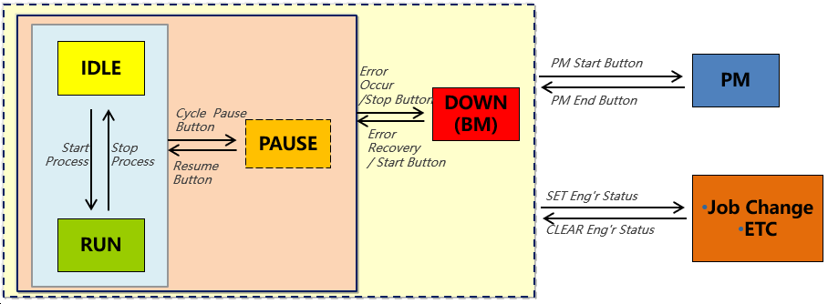

Equipment / Unit Status | Value | Format

PM | 1 | INT
DOWN | 2 | INT
PAUSE | 3 | INT
IDLE | 4 | INT
RUN | 5 | INT
JobChange | 6 | INT
ETC | 7 | INT

Unit/Sub-Unit Status
Unit Status is only used for the equipment with multi-units, and the maximum number of units is 15. If equipment has no unit, all data should be set to zero and will be ignored. Types of Unit Status and the definitions are the same as those of Equipment Status. Each Unit statuses are independent, but Equipment status may be dependent on the statuses of units within the equipment. It is the sole responsibility of equipment to report correct Equipment Status based on the Status of its Units.
The same rule is also applied to Sub-Unit.

Equipment Status Reason Code
It is to classify the status based on reason code of equipment status. Reason Code is used to indicate that why the status is changed.
Reason Code is represented by 5 digit numbers that are consists of 3 different properties of code to distinguish.
Equipment has to report the current status after report the previous status when operator executes the function on touch panel which is “Recovery”, because operator should decide the reason code of status by manual if equipment reports the reason code of wrong status

Property | Type | Category | Sub Item
Reason Code | XXXXX(Combination of each value , INT: 10000~29999)
Data Format | 1Digit  (1 ~ 2) | 2 ~ 3 Digit  (00~ 99) | 4 ~ 5 Digit  (00~ 99)
Data Format | By who | Category | Sub Item
Value Description | 1 : EQP  2 : Operator | Refer to the table In below | Refer to the table In below
 | * For example, Reason Code of 12001 indicates, HW Trouble happens with Sensor by EQP.
- Common Reason Code is reserved that category : 00 ~ 85.
- Equipment Special Code is reserved that category : 86 ~ 95.
Equipment vender must use to Equipment Special Code if the reason code for vender special want to add as reason code.
Priority is related with Category that means priority must be decided order by category.
For example, when priority of EN Run is 2, if category of Dummy run is 01 and EN Run is 02, it is wrong because category code is different by order with priority.

Status |  |  | Priority | Category |  |  |  | Sub Item |  |  |  | Format |  |  | How To Report | Description
 |  |  | Priority | name | Code |  |  | name | Code |  |  |  |  |  | How To Report | Description
 |  |  | Priority | name | (2~3  digit) |  |  | name | (4~5  digit) |  |  |  |  |  | How To Report | Description
Run |  |  | 1 | Production Run |  | 00 |  | Production Run |  | 01 |  |  | INT |  | EQ Auto | MES Decision
 |  |  | 2 | EN Run |  | 01 |  | EN Run |  | 01 |  |  | INT |  | EQ Auto | MES Decision
 |  |  | 3 | DV Run |  | 02 |  | DV Run |  | 01 |  |  | INT |  | EQ Auto | MES Decision
 |  |  | 4 | Dummy Run |  | 03 |  | Dummy Run |  | 01 |  |  | INT |  | EQ Manual | MES Decision
Idle |  |  | 1 | No WIP | 10 |  |  | No WIP |  | 01 |  |  | INT |  | EQ Auto | MES Decision
 |  |  |  |  |  |  |  | No plan |  | 02 |  |  | INT |  | EQ Manual | Manual operation
 |  |  | 2 | No Material |  | 12 |  | No Material |  | 01 |  |  | INT |  | EQ Manual | Manual operation
 |  |  | 3 | No CST |  | 13 |  | No CST |  | 01 |  |  | INT |  | EQ Auto | MES Decision
 |  |  | 4 | AMHS Down |  | 14 |  | AMHS Down |  | 01 |  |  | INT |  | EQ Auto | MES Decision
Down |  |  | 1 | HW Failure | 20 |  |  | Equipment Hardware Error |  | 01 |  |  | INT |  | EQ Auto | Manual operation is possible, and operator change is possible
 |  |  |  |  |  |  |  | Cannot recover trouble |  | 02 |  |  | INT |  | EQ Auto
 |  |  |  |  |  |  |  | Robot Trouble |  | 03 |  |  | INT |  | EQ Auto
 |  |  | 2 | SW Failure | 21 |  |  | Equipment Software Error |  | 01 |  | INT |  |  | EQ Auto
 |  |  |  |  |  |  |  | Equipment Communication Error | 02 |  |  | INT |  |  | EQ Auto
 |  |  |  |  |  |  |  | Glass or Panel information error | 03 |  |  | INT |  |  | EQ Auto
 |  |  | 3 | Facilities  Failure | 22 |  |  | Utility Error | 01 |  |  | INT |  |  | EQ Auto
 |  |  | 4 | Quality Failure | 23 |  |  | Danger for human |  | 01 |  |  | INT |  | EQ Auto
 |  |  |  |  |  |  |  | Glass or Panel Trouble |  | 02 |  |  | INT |  | EQ Auto
 |  |  |  |  |  |  |  | Parameter overflow caused  process error | 03 |  |  | INT |  |  | EQ Auto
 |  |  |  |  |  |  |  | Parameter overflow caused equipment can‘t work | 04 |  |  | INT |  |  | EQ Auto
 |  |  |  |  |  |  |  | Material Error | 05 |  |  | INT |  |  | EQ Auto
 |  |  |  |  |  |  |  | Parameter configuration error | 06 |  |  | INT |  |  | EQ Auto
 |  |  |  |  |  |  |  | other categories |  | 07 |  |  | INT |  | EQ Auto
 | PM |  | 1 | PM | 30 |  |  | PM |  | 01 |  |  | INT |  | EQ Manual | Manual operation
 | J/C |  | 1 | Job Change |  | 40 |  | Job Change |  | 01 |  |  | INT |  | EQ Manual | Manual operation
ETC |  |  | 1 | Material Change |  | 50 |  | Material Change |  | 01 |  |  | INT |  | EQ Manual | Manual operation
 |  |  | 2 | Others | 51 |  |  | Set up |  | 01 |  |  | INT |  | EQ Manual | Manual operation
 |  |  |  |  |  |  |  | Others |  | 02 |  |  | INT |  | EQ Manual | Manual operation

No Processing Time
Equipment should provide “No Processing Time” timer setting function on touch panel for each equipment.
If unit/equipment has sent out all Jobs (status of no Job), then equipment checks “No Processing Time” timer. If “No Processing Time” is over and there still is no Job, then equipment reports Idle.

(No Processing Time =0 : Don’t check no processing time) (Default : tact time *2)
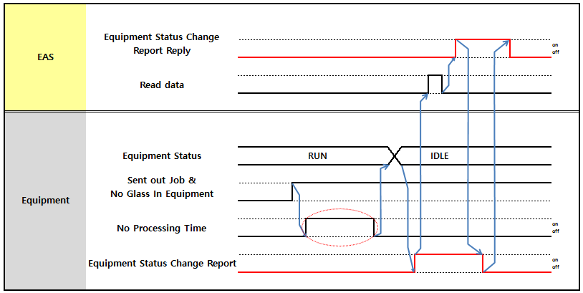
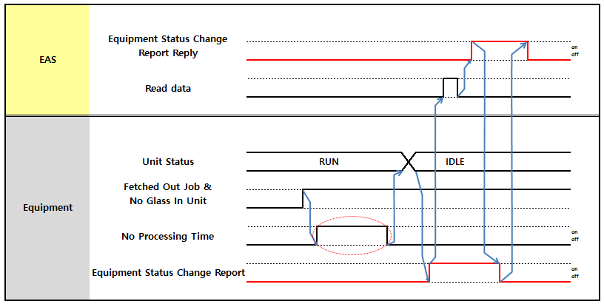

Figure 5-1 No Process Time in case one unit in equipment

Figure 5-2 No Process Time in case upper two unit

PLC MAP
      - Local PLC – Link Register (W Area)

Block | Item | Points | Type | Format | Sub Items
Equipment Status Block | Equipment Status | 1 | Data | INT | Status  - : PM  - : Down(BM)  - : Pause  - : Idle  5: Run  6: Job Change

Block | Item | Points | Type | Format | Sub Items
 |  |  |  |  | 7 : ETC
 | Equipment Reason Code | 1 | Data | INT | Refer to the Equipment Status Reason Code
 | Reserve | 4 | Data | INT
 | Unit Status#01 | 1 | Data | INT | Status  1 : PM  2 : Down(BM)  3 : Pause  4 : Idle  5: Run  6: Job Change  7 : ETC
 | Unit Reason Code#01 | 1 | Data | INT | Refer to the Equipment Status Reason Code
 | Unit Status#02 | 1 | Data | INT | Same as Unit Status#01
 | Unit Reason Code#02 | 1 | Data | INT | Same as Unit Reason Code#01
 | Unit Status#03 | 1 | Data | INT | Same as Unit Status#01
 | Unit Reason Code#03 | 1 | Data | INT | Same as Unit Reason Code#01
 | Unit Status#04 | 1 | Data | INT | Same as Unit Status#01
 | Unit Reason Code#04 | 1 | Data | INT | Same as Unit Reason Code#01
 | Unit Status#05 | 1 | Data | INT | Same as Unit Status#01
 | Unit Reason Code#05 | 1 | Data | INT | Same as Unit Reason Code#01
 | Unit Status#06 | 1 | Data | INT | Same as Unit Status#01
 | Unit Reason Code#06 | 1 | Data | INT | Same as Unit Reason Code#01
 | Unit Status#07 | 1 | Data | INT | Same as Unit Status#01
 | Unit Reason Code#07 | 1 | Data | INT | Same as Unit Reason Code#01
 | Unit Status#08 | 1 | Data | INT | Same as Unit Status#01
 | Unit Reason Code#08 | 1 | Data | INT | Same as Unit Reason Code#01
 | Unit Status#09 | 1 | Data | INT | Same as Unit Status#01
 | Unit Reason Code#09 | 1 | Data | INT | Same as Unit Reason Code#01
 | Unit Status#10 | 1 | Data | INT | Same as Unit Status#01
 | Unit Reason Code#10 | 1 | Data | INT | Same as Unit Reason Code#01
 | Unit Status#11 | 1 | Data | INT | Same as Unit Status#01
 | Unit Reason Code#11 | 1 | Data | INT | Same as Unit Reason Code#01
 | Unit Status#12 | 1 | Data | INT | Same as Unit Status#01
 | Unit Reason Code#12 | 1 | Data | INT | Same as Unit Reason Code#01
 | Unit Status#13 | 1 | Data | INT | Same as Unit Status#01
 | Unit Reason Code#13 | 1 | Data | INT | Same as Unit Reason Code#01
 | Unit Status#14 | 1 | Data | INT | Same as Unit Status#01
 | Unit Reason Code#14 | 1 | Data | INT | Same as Unit Reason Code#01
 | Unit Status#15 | 1 | Data | INT | Same as Unit Status#01
 | Unit Reason Code#15 | 1 | Data | INT | Same as Unit Reason Code#01

      - Local PLC – Link Relay (B Area)

Block | Item | Points | Type | Sub Items | Related Word Items | Master (EAS) Action
Equipment Event | Equipment Status Change Report | 1 | Event | - On: Fire Event  - Off: Event End | Equipment Status Block  ※ EQ should report the event for each equipment status or unit status change | Reply for Receiving

      - Master (EAS) – Link Relay (B Area)

Block | Item | Points | Type | Sub Items | Related Word Items | Local PLC Action
Equipment Event Reply | Equipment Status Change Report Reply | 1 | Reply | - On: Reply  - Off: Reply End

Alarm Management
Operator should confirm all alarm when alarm is occurred even if several alarm .

* Max alarm buffering : 5 count
When reporting alarm occurrence, every Alarm Report (Set or Clear) should be reported in separate Link Area (5 report block) in ‘Round Robin’ manner.
Set and Clear state of each alarm should be reported in separate report.
Equipment should provide function to clear all alarms in equipment touch panel, and even this case each Alarm clear report should be reported separately.

When 5 report block is full, if a next alarm occurs then equipment has to keep by buffering alarms. When an alarm of within 5 block has been reported which turn off the event bit , the next alarm should be able to report with ‘Round Robin’ manner on the offed event block after get from buffering alarm.
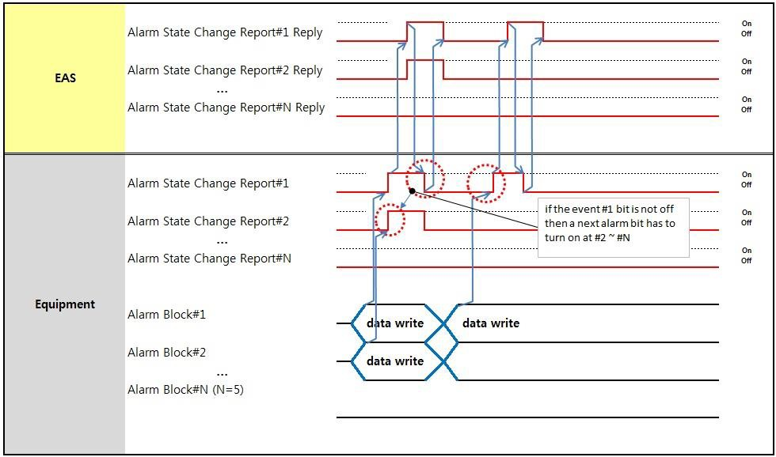

Figure 5-3Alarm State Change Report

Alarm State
It is the state of the alarm that is reported.
- Alarm Set: An alarm is detected.
- Alarm Clear: An alarm is cleared.

Alarm Unit
When equipment reports an alarm event, it shows that which unit in the equipment the alarm is related to.

Alarm ID
All equipment makers must submit Alarm ID list per unit. A unit must have a unique Alarm ID regardless of error or warning alarm.
0: reserved (never used)

1 ~ 65500: Equipment can use
65501 ~ 65535: EAS Reserved

Alarm Code
Alarm has an associated severity code (ALCD) that is alarm type.
- 0: Danger for human
- 1: Equipment Hardware Error
- 2: Equipment Software Error
- 3: Equipment Communication Error
- 4: Glass or Panel information error
- 5: Glass or Panel Trouble
- 6: Material or Utility Error
- 7: Parameter overflow caused process error
- 8: Parameter overflow caused equipment can’t work
- 9: Parameter configuration error
- 10: Cannot recover trouble
- 11: Equipment status warning
- 12: Robot Trouble
- 13: EAS Caused
- 14: other categories

Alarm Level
It shows the level of the alarm. It consists of Warning and Error.
- Warning: Warning represents a light error. For warnings, the equipment should keep on processing, buzz operator, and display the message on the touch panel.
- Error: Alarm represents a serious error. When alarm is occurred, the equipment must stop the processing (For some equipments, it may cause only process pause), buzz operator to check the equipment, and display a message on the touch panel.

Alarm Text
It contains a brief textual description of an alarm.All the text character should in the scope of ASCII (H20-H7E, except H22,( “ ) and H27(‘)).

Error Recovery and Remove Job
When an alarm is occurred, or discrepancy between job existence and Job Data is found, and in consequence the data needs to be changed or removed, equipment should provide functions as below.
- Alarm to notify operator to correct it.
- Provide “job removal procedure” and “job position display” to recover the above discrepancy trouble or alarm situation.
Job removal procedure should contain at least three items.
- Physical glass/Panel removal
- Report removed Job Data to EAS
- Job deletion from equipment on touch panel
Detail error recovery scenario should be provided by equipment vender.

PLC MAP
      - Local PLC – Link Register (W Area)

Block | Item | Points | Type | Format | Sub Items
Alarm Block#1 | Alarm State | 1 | Data | INT | 0: Alarm Clear  1: Alarm Set
Alarm Block#1 | Alarm Unit | 1 | Data | INT | 0: Equipment Level Alarm  1~: Alarm Occurred Unit Number
Alarm Block#1 | Alarm ID | 1 | Data | INT | 1~65535
Alarm Block#1 | Alarm Code | 1 | Data | INT | Refer to “5.4.4 Alarm Code”
Alarm Block#1 | Alarm Level | 1 | Data | INT | - : Warning  - : Error
Alarm Block#1 | Alarm Text | 40 | Data | ASC
…
Alarm Block#n  [n : 5] | Same as Alarm #1 Event Block | 45

      - Local PLC – Link Relay (B Area)

Block | Item | Points | Type | Sub Items | Related Word Items | Master (EAS) Action
Equipment Event | Alarm State Change Report#1 | 1 | Event | - On: Fire Event  - Off: Event End | Alarm Block#1 | Reply for Receiving
Equipment Event | …
Equipment Event | Alarm State Change Report#n  [n=5] | 1 | Event | - On: Fire Event  - Off: Event End | Alarm Block#n | Reply for Receiving
      - Master (EAS) – Link Register (W Area)
None
      - Master (EAS) – Link Relay (B Area)

Block | Item | Points | Type | Sub Items | Related Word Items | Local PLC Action
Equipment Event Reply | Alarm State Change Report#1Reply | 1 | Reply | - On: Reply  - Off: Reply End
Equipment Event Reply | Alarm State Change Report #n Reply  [n=5] | 1 | Reply | - On: Reply  - Off: Reply End

Job Management
The job means some processing works with a material such as glass, Panel. Each job has its own unique data for processing, which is called Job Data, including Master Recipe, cassette sequence number, job sequence number and the like. The Job Data is received from upstream equipment, as main equipment is ready to receive a job, and should be sent to downstream equipment as main equipment is ready to send out a job.
Equipment should keep and manage Job Data of each job even if the job is moved between internal zones. At the same time, equipment should provide Job Data information of each job on touch panel.

Job Data Transfer
If equipment sends a Job to other equipment, the equipment sending a Job is called Upstream Equipment. If equipment receives a Job from other equipment, the equipment receiving a Job is called Downstream Equipment. Equipment can have more than one Upstream Equipment and Downstream equipment. In order to distinguish which equipment is Upstream Equipment or Downstream Equipment for specific equipment, Upstream Path No. is used and managed.
When sending out a Job to a Downstream Equipment, Job Data is transferred to Downstream Equipment along with the Job, via MELSECHNET/G. For the Job Data transferring, equipment should write the data in the corresponding ‘Job Data Downstream Block’, according to downstream Equipment the Job is transferring to.
When Upstream Equipment is about to send a Job to Downstream Equipment, the Downstream Equipment first validates Job Data of the Job. In case no error is detected in the Job Data, Downstream Equipment starts Job receiving. The Job Data validation items are as below.
Glass Flow

Upstream Equipment #1

Job Data for Downstream 1 Block
Main Equipment

Job Data for Downstream 1 Block
Job Data for Downstream 2 Block
Downstream Equipment #1

Downstream Equipment #2

Figure 5-4 job Transfer

      - Local PLC – Link Register (W Area)

Block | Item | Points | Type | Format | Sub Items
Job Data for Downstream Block 1 | Job Data  [Sent Out Job Event Downstream 1] | 96 or  256 | Data | - | Refer to 4.5 Job Data A or S Items or M(Only CF Mask Cleaner) Items
Job Data for Downstream Block 2 | Job Data  [Sent Out Job Event Downstream 2] | 96 or  256 | Data | - | Refer to 4.5 Job Data A or S Items or M(Only CF Mask Cleaner)
.. | ..
Job Data for Downstream Block #N  (N = 6) | Job Data  [Sent Out Job Event Downstream N] | 96 or  256 | Data | - | Refer to 4.5 Job Data A or S Items or M(Only CF Mask Cleaner)

Job Count
The Job Count is to report the count of the job in the entire equipment. According to the job type, equipment should distinguish whether the job is product job or dummy job. Normally, the product job means mass

product processing, but in the assembly line where there are two product jobs, TFT and CF, the product job means TFT glass processing.
Equipment should write job count before report job event to EAS.
- TFT(Array) Product Job Count: It is the current count of the TFT(Array) glasses is in the equipment.
- CF Product Job Count: It is the current count of the CF glasses is in the equipment.
- Dummy Job Count: It is the count of the dummy glasses is in the equipment.
- Total Available Count(Array Initial Cleaner Only) : The total amount of Glass Available for Unload.
- Total Glass Count(Array Initial Cleaner Only) :
L2 – Quantity of glass on conveyor out of wire cassette. L3 – The total amount of glass in the initial cleaner.

Job Event
The Job Data has to be reported to EAS at special time, such as received job from upstream equipment, sent out job to downstream equipment, fetched out job from a cassette or unit, stored job into a cassette or unit, and removed job from equipment.
Etch event in Details can refer operation scenario of equipment by type.
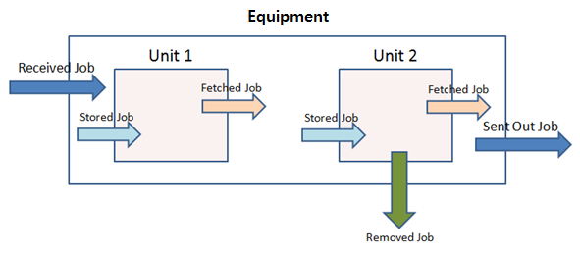
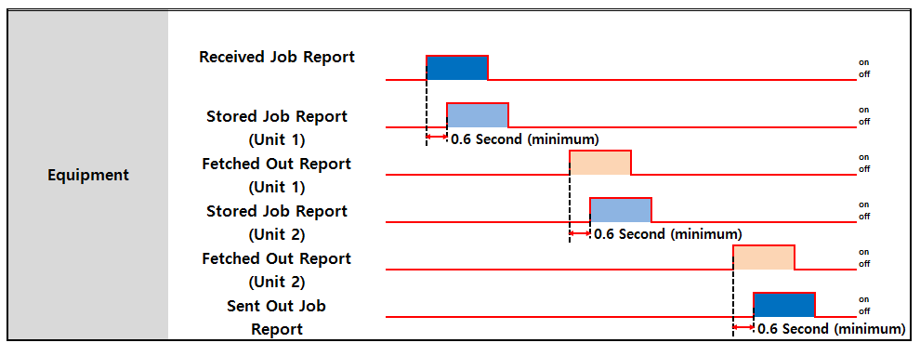

Figure 5-5 Job Data Event Report Point

Figure 5-6 Job Event Timing Chart

Job Event Report Timing Condition
- Sent Out Job Event
  - On the rise of Link Signal Job Transfer signal
  - Job should be completely transferred to downstream equipment.
- Received Job Event
  - After Receive Complete Signal turns off.
  - Job should be completely received by downstream equipment.
Between upstream and downstream equipment, report sequence of Sent Out Job Event from upstream equipment and Received Job Event from downstream equipment should follow physical Job transfer sequence. Exact report timing will be adjusted during and after test, if required.

Received Job Event
When equipment receives a job from upstream equipment, this event should be reported. The below items are included when equipment reports the Received Job event.
- Received Job: The Job Data of the job that is received from the upstream equipment.
- Upstream Path No: The Upstream Path Number of the upstream equipment

Sent Out Job Event
When the equipment sends out a job to downstream equipment, this event should be reported. The below items should be included when equipment reports the Sent Out Job event.
- Sent Out Job: The Job Data of the job that is sent to the downstream equipment.
- Downstream Path No: The Downstream Path Number of the downstream equipment

Stored Job Event
When the equipment stored a job to a unit or cassette, this event should be reported with the port number and unit number that is occurred by unit. If there are some slots, slot no should be reported.

- Stored Job: The Job Data of the job that is stored
- Unit or Port: it is used to distinguish the product stored in Unit from Port.
- Unit No: The Unit No of the Unit or Sub Unit. If the (Sub)Unit has some slots, equipment should update the Slot No.
- Sub Unit No : The level of the unit. 0 is Unit, 1~15 is Sub Unit No
- Port No: The port no of the cassette that the job is stored. Equipment should update the Slot No.
- Slot No: Slot No. If unit has no slot, this item should be cleared.

Stored Job Event should be reported in separate Link Area for each Unit/Port. Basic Link Area usage rule:
Indexer – first priority is Port , second priority is Unit
Example:

Stored Job Event Report Area | Indexer of two Ports and one Units | Process Equipment with three Units
Stored Job Report #1 | Port 1 | Unit 5
Stored Job Report #2 | Port 3 | Unit 2
Stored Job Report #3 | Unit 1 | Unit 4
…
Stored Job Report #15

Fetched Out Job Event
When the equipment fetched out a job from a unit or cassette, this event should be reported with the port number and unit number that is occurred by unit. If there are some slots, slot no should be reported.
The Job Data of fetched job is reported while a job is being fetched out from a cassette or unit. In this case, the port number and unit number must be reported

- Fetched Out Job: The Job Data of the job that is fetched out
- Unit or Port: it is used to distinguish the product stored in Unit from Port.
- Unit No: The Unit No of the Unit or Sub Unit. If the (Sub)Unit has some slots, equipment should update the Slot No.
- Sub Unit No : The level of the unit. 0 is Unit, 1~ is Sub Unit No
- Port No: The port no of the cassette that the job is fetched. Equipment should update the Slot No.
- Slot No: Slot No. If unit has no slot, this item should be cleared.

Fetched Out Job Event should be reported in separate Link Area for each Unit/Port. Basic Link Area usage rule:
Indexer – first priority is Port , second priority is Unit Example :
Fetched Out Job Event Report Area | Indexer of two Ports and one Units | Process Equipment with three Units
Fetched Out Job Report #1 | Port 1 | Unit 5
Fetched Out Job Report #2 | Port 3 | Unit 2
Fetched Out Job Report #3 | Unit 1 | Unit 4
…
Fetched Out Job Report #15

Removed Job Event
The Job Data of removed job is reported when a job has just been removed from equipment.
- Removed Job: The Job Data of the job that is removed by operator.
- Unit or Port: it is used to distinguish the product stored in Unit from Port.
- Unit No: The Unit No of the unit. If the unit has some slots, equipment should update the Slot No.
- Sub Unit No : The level of the unit. 0 is Unit, 1~ is Sub Unit No
- Port No: The port no of the cassette that the job is removed. Equipment should update the Slot No.
- Slot No: Slot No. If unit has no slot, this item should be cleared.
- Removed Flag : Removed type. And this is updated on touch panel
- Remove Reason Code : Removed job was happened why and this is updated on touch panel

Removed Job Recovery Function
Equipment should provide removed job data keeping function that stores at least the latest 20 job data removed. And function to support operator can select which Job to recovery.
Takeout Job can recovery before end of Lot processing. If Operator take out the glass after end of Lot processing, it must be took manual out tracking in Host.

Process Start Report
Principal unit of equipment should report when processing of a Job is started. The report timing should be comply with the ‘Process Start Time’ in Process Data Report.
ESWIN engineer will decide which Unit is required to report Process Start.

Process End Report
Principal unit of equipment reports the Process End Event. The report timing should be comply with the ‘Process End Time’ in Process Data Report.
ESWIN engineer will decide whether or not an important unit.

PLC MAP
      - Local PLC – Link Register (W Area)

Block | Item | Points | Type | Format | Sub Items
Job Count Block | TFT(Array) Product Job Count | 1 | Data | INT
Job Count Block | CF Product Job Count | 1 | Data | INT
Job Count Block | Dummy Job Count | 1 | Data | INT
Job Count Block | Total Available Count | 1 | Data | INT | Array Initial Cleaner Only
Job Count Block | Total Glass Count | 1 | Data | INT | Array Initial Cleaner Only
Received Job Data Block | Job Data for Upstream Block 1~6 | 96 or  256 | Data | - | Refer to Job Data A or S
Received Job Data Sub Block 1~6 | Upstream Path No | 1 | Data | INT | 1~6
Sent Out Job Data Block | Job Data For Downstream Block 1~6 | 96 or  256 | Data | - | Refer to Job Data A or S
Sent Out Job Data Sub Block 1~6 | Downstream Path No | 1 | Data | INT | 1~6
Stored Job Data | Stored Job Data | 14 | Data | - | Refer to Job Data B

Block | Item | Points | Type | Format | Sub Items
Block #1
Stored Job Data Sub Block #1 | Unit or Port | 1 | Data | INT | 1: Unit  2: Port
Stored Job Data Sub Block #1 | Unit No or Port No | 1 | Data | INT | 0: No Unit Event  1~: Unit No or Port No
Stored Job Data Sub Block #1 | Sub Unit No | 1 | Data | INT | 0 : Unit
Stored Job Data Sub Block #1 | Slot No | 1 | Data | INT | 0: No Slot  1~ : Slot No of Cassette/Unit
Stored Job Data Block #N  (N: 2~15) | Stored Job Data | 14 | Data | - | Refer to Job Data B
Stored Job Data Sub Block #N(N: 2~15) | Unit or Port | 1 | Data | INT | 1: Unit  2: Port
Stored Job Data Sub Block #N(N: 2~15) | Unit No or Port No | 1 | Data | INT | 0: No Unit Event
Stored Job Data Sub Block #N(N: 2~15) | Sub Unit No | 1 | Data | INT | 0 : Unit
Stored Job Data Sub Block #N(N: 2~15) | Slot No | 1 | Data | INT | 0: No Slot  1~ : Slot No of Cassette/Unit
Fetched Out Job Data Block #1 | Job Data B | 14 | Data | - | Refer to Job Data B
Fetched Out Job Data Sub Block#1 | Unit or Port | 1 | Data | INT | 1: Unit  2: Port
Fetched Out Job Data Sub Block#1 | Unit No or Port No | 1 | Data | INT | 0: No Unit Event  1~: Unit No or Port No
Fetched Out Job Data Sub Block#1 | Sub Unit No | 1 | Data | INT | 0 : Unit
Fetched Out Job Data Sub Block#1 | Slot No | 1 | Data | INT | 0: No Slot  1~ : Slot No of Cassette/Unit
Fetched Out Job Data Block #N(N: 2~15) | Job Data B | 14 | Data | - | Refer to Job Data B
Fetched Out Job Data Sub Block #N  (N: 2~15) | Unit or Port | 1 | Data | INT | 1: Unit  2: Port
Fetched Out Job Data Sub Block #N  (N: 2~15) | Unit No or Port No | 1 | Data | INT | 0: No Unit Event  1~ : Unit No or Port No
Fetched Out Job Data Sub Block #N  (N: 2~15) | Sub Unit No | 1 | Data | INT | 0 : Unit
Fetched Out Job Data Sub Block #N  (N: 2~15) | Slot No | 1 | Data | INT | 0: No Slot  1~ : Slot No of Cassette/Unit
Removed Job Data Block | Removed Job Data | 96 or  256 | Data | - | Refer to Job Data A or C (glass code, glass ID)
Removed Job Data Sub Block | Unit or Port | 1 | Data | INT | 0: Others  1: Unit  2: Port
Removed Job Data Sub Block | Unit No or Port No | 1 | Data | INT | 0: No Unit Event  1~: Unit No or Port No

Block | Item | Points | Type | Format | Sub Items
 | Sub Unit No | 1 | Data | INT | 0 : Unit
 | Slot No | 1 | Data | INT | 0: No Slot  1~ : Slot No of Cassette/Unit
 | Removed Flag | 1 | Data | INT | 1: Scrap (broken)  2: Take out 3~: Reserved.
Job  Process Start Report Block | Cassette Sequence No | 1 | Data | INT | CST Sequence Number (1~65535)
Job  Process Start Report Block | Job Sequence No | 1 | Data | INT | Job Sequence Number (1~65535)
Job  Process Start Report Block | Unit No | 1 | Data | INT | 0: No Unit Event 1~: Unit No
Job  Process Start Report Block | Sub Unit No | 1 | Data | INT | 0 : Unit
Job  Process Start Report Block | Slot No | 1 | Data | INT | 0: No Slot  1~ : Slot No of Cassette/Unit
Job  Process Start Report Block | Process Start Time | 3 | Data | BCD | 00 ~ 07 Bit :A.D Year(00~99)  08 ~ 15 Bit :Month(01~12)  00 ~ 07 Bit :Day(01~31)  08 ~ 15 Bit :Hour(00~23)  00 ~ 07 Bit :Minute(00~59)  08 ~ 15 Bit :Second(00~59)
Job  Process End Report Block | Cassette Sequence No | 1 | Data | INT | CST Sequence Number (1~65535)
Job  Process End Report Block | Job Sequence No | 1 | Data | INT | Job Sequence Number (1~65535)
Job  Process End Report Block | Unit No | 1 | Data | INT | 0: No Unit Event  1~: Unit No
Job  Process End Report Block | Sub Unit No | 1 | Data | INT | 0 : Unit
Job  Process End Report Block | Slot No | 1 | Data | INT | 0: No Slot  1~ : Slot No of Cassette/Unit
Job  Process End Report Block | Process End Time | 3 | Data | BCD | 00 ~ 07 Bit :A.D Year(00~99)  08 ~ 15 Bit :Month(01~12)  00 ~ 07 Bit :Day(01~31)  08 ~ 15 Bit :Hour(00~23)  00 ~ 07 Bit :Minute(00~59)  08 ~ 15 Bit :Second(00~59)

      - Local PLC – Link Relay (B Area)

Block | Item | Points | Type | Sub Items | Related Word Items | Master (EAS) Action
Job Event | Received Job Report Upstream #1 | 1 | Event | - On: Fire Event  - Off: Event End | Received Job Data Block Received Job Data Sub Block Job Count Block | Reply for Receiving
Job Event | Received Job Report Upstream #N | 1 | Event | - On: Fire Event  - Off: Event End | Received Job Data Block Received Job Data Sub Block Job Count Block | Reply for Receiving
Job Event | Sent Out Job Report Downstream #1 | 1 | Event | - On: Fire Event  - Off: Event End | Sent Out Job Data Block Sent Out Job Data Sub Block Job Count Block | Reply for Receiving
Job Event | Sent Out Job Report Downstream #N | 1 | Event | - On: Fire Event  - Off: Event End | Sent Out Job Data Block Sent Out Job Data Sub Block Job Count Block | Reply for Receiving

Block | Item | Points | Type | Sub Items | Related Word Items | Master (EAS) Action
 | Stored Job Report #1 | 1 | Event | - On: Fire Event  - Off: Event End | Stored Job Block#1  Stored Job Data Sub Block#1 Job Count Block | Reply for Receiving
 | Stored Job Report #n (2~15) | 1 | Event | - On: Fire Event  - Off: Event End | Stored Job Block#N  Stored Job Data Sub Block#N Job Count Block | Reply for Receiving
 | Fetched Out Job Report #1 | 1 | Event | - On: Fire Event  - Off: Event End | Fetched Out Job Data Block#1  Fetched Out Job Data Sub Block#1  Job Count Block | Reply for Receiving
 | Fetched Out Job Report #N(2~15) | 1 | Event | - On: Fire Event  - Off: Event End | Fetched Out Job Data Block#N  Fetched Out Job Data Sub Block#N  Job Count Block | Reply for Receiving
 | Removed Job Report | 1 | Event | - On: Fire Event  - Off: Event End | Removed Job Data Block Removed Job Data Sub Block  Job Count Block | Reply for Receiving
 | Job Process Start Report | 1 | Event | - On: Fire Event  - Off: Event End | Job Process Start Block | Reply for Receiving
 | Job Process End Report | 1 | Event | - On: Fire Event  - Off: Event End | Job Process End Block | Reply for Receiving

      - Master (EAS) – Link Relay (B Area)

Block | Item | Points | Type | Sub Items | Related Word Items | Local PLC Action
Job Event Reply | Received Job Report Reply Upstream #1 | 1 | Event | - On: Fire Event  - Off: Event End
Job Event Reply | Received Job Report Reply Upstream #N ( 1~ 6) | 1 | Event | - On: Fire Event  - Off: Event End
Job Event Reply | Sent Out Job Report Reply Downstream #1 | 1 | Event | - On: Fire Event  - Off: Event End
Job Event Reply | Sent Out Job Report Reply Downstream #N (1~6) | 1 | Event | - On: Fire Event  - Off: Event End
Job Event Reply | Stored Job Report Reply #1 | 1 | Reply | - On: Reply  - Off: Reply End
Job Event Reply | Stored Job Report Reply #N (1~6) | 1 | Reply | - On: Reply  - Off: Reply End
Job Event Reply | Fetched Out Job Report Reply #1 | 1 | Reply | - On: Reply  - Off: Reply End
Job Event Reply | Fetched Out Job Report Reply #N (1~6) | 1 | Reply | - On: Reply  - Off: Reply End

Block | Item | Points | Type | Sub Items | Related Word Items | Local PLC Action
 | Removed Job Report Reply | 1 | Reply | - On: Reply  - Off: Reply End
 | Job Process Start Report Reply | 1 | Reply | - On: Reply  - Off: Reply End
 | Job Process End Report Reply | 1 | Reply | - On: Reply  - Off: Reply End

Process Data Management
This function is only for process equipment, which has process data such as processed parameter values or inspection result. The data should be related to individual jobs, and reported with glass/Panel ID.
The process data item should be determined by ESWIN engineer.
- Job Data: The Job Data should be same as Job Data of Sent out Job
- Processing Time: It is actual processing time for a job in the equipment.
- Kind or Process Data: There are 2 kinds of process data. By Glass, By Time.

Event Report Timing
- By Glass: The Process Data(DV) of each Glass/Panel should be reported after job sent to downstream equipment, if equipment has process data. One local equipment should report process data one time per glass to EAS.
- By Time (Trace Data::SV): Equipment write current Process Data into the word area by specified time cycle. Equipment provide the function for the cycle time setting. (minimum value = 500ms)

DV and SV Naming Rule(recommend)
- Each equipment vendor should summit its SV and DV name with the equipment data file(EAS-equipment Data Collection.xlsx) following the standard naming rule

Order of digit | Item
1 | Layer – 1 : Equipment, 2: unit, 3: sub unit
2 | Unit no. (00: if no Unit)
Example) 1_00_MGNT-Speed : Equipment-level data
2_03_MGNT-Speed : Unit-level data, collected from Unit No. 3

PLC MAP: By Glass(DV)
This data should report after Sent Out Report.
      - Local PLC – Link Register (W or R Area)

Block | Item | Points | Type | Format | Sub Items
 | GlassID or PanelID or MaterialID | 10 | Data | ASC
 | Process Start Time | 3 | Data | BCD | 00 ~ 07 Bit :A.D Year(00~99)
Process  Data Block |  |  |  |  | 08 ~ 15 Bit :Month(01~12)
 | Process End Time | 3 | Data | BCD | 00 ~ 07 Bit :Day(01~31)
 |  |  |  |  | 08 ~ 15 Bit :Hour(00~23)

Block | Item | Points | Type | Format | Sub Items
 |  |  |  |  | 00 ~ 07 Bit :Minute(00~59)
 |  |  |  |  | 08 ~ 15 Bit :Second(00~59)
 |  |  |  |  | Process Data Items
 |  |  |  |  | Default = 512 word
 | Process Data Items | 512 | Data | -
 |  |  |  |  | Each equipment vendor need to discuss with
 |  |  |  |  | customer for the size.
      - Local PLC – Link Relay (B Area)

Block | Item | Points | Type | Sub Items | Related Word Items | Master (EAS) Action
Equipment Event | Process Data Report | 1 | Event | - On: Fire Event  - Off: Event End/Timeout | Process Data Block | Reply for Receiving

      - Master (EAS) – Link Register (W Area)
None

      - Master (EAS) – Link Relay (B Area)

Block | Item | Points | Type | Sub Items | Related Word Items | Local PLC Action
Equipment Event Reply Block | Process Data Report Reply | 1 | Reply | - On: Reply  - Off: Reply End

PLC MAP: By Glass(DV) – CF Only
This data should report after Sent Out Report.
The data of DV Item List should request or reply with group by other because there is limit to memory size for gathering a lot of DV Item List.
Equipment should report the data with Total DV Item List Count ,Total Group Count , Current Group Count that the data is continually transferred until all data is transferred.
The condition of complete the transfer of all data is when Total Group Count and Current Group Count is same.

Total DV Item List Count | It is total count of DV Item Lists
Total Group Count | It is total count of group
Current Group Count | It is current group count by event

For example, if Total Group Count is 3 when Process Data Report of first is happened, then Current Group Count is 1. Equipment writes next data after EAS reads its memory map .
and when Process Data Report of next is happened, Current Group Count is 2. It will report the DV Item List until Current Group Count is 3. Equipment terminate the transition of data if Total Group Count is same with Current Group Count and then it doesn’t report next event.

      - Local PLC – Link Register (W or R Area)

Block | Item | Points | Type | Format | Sub Items
 | GlassID or PanelID or MaterialID | 10 | Data | ASC
 | Process Start Time | 3 | Data | BCD | 00 ~ 07 Bit :A.D Year(00~99)
 |  |  |  |  | 08 ~ 15 Bit :Month(01~12)
 |  |  |  |  | 00 ~ 07 Bit :Day(01~31)
 | Process End Time | 3 | Data | BCD | 08 ~ 15 Bit :Hour(00~23)
Process Data Block |  |  |  |  | 00 ~ 07 Bit :Minute(00~59)  08 ~ 15 Bit :Second(00~59)
 |  |  |  |  | Process Data Items
 |  |  |  |  | Default = 512 word
 | Process Data Items | 512 | Data | -
 |  |  |  |  | Each equipment vendor need to discuss with customer for the size.

Block | Item | Points | Type | Format | Sub Items
Process Data Sub Block | Total DV Item List Count | 1 | Data | INT
Process Data Sub Block | Total Group Count | 1 | Data | INT
Process Data Sub Block | Current Group Count | 1 | Data | INT

      - Local PLC – Link Relay (B Area)

Block | Item | Points | Type | Sub Items | Related Word Items | Master (EAS) Action
Process Data Report Event | Process Data Report#1~#26 | 1 | Event | - On: Fire Event  - Off: Event End/Timeout | - Process Data Block  - Process Data Sub Block | Reply for Receiving

      - Master (EAS) – Link Register (W Area)

Block | Item | Points | Type | Format | Sub Items
Process Data Report Reply Block | Return Code | 1 | Data | INT | - : OK  - : NG  - : continue  - : DV Item List Count NG  - : Group Count NG  6: Duplication Group Count NG 7 : Order by Group Count NG

      - Master (EAS) – Link Relay (B Area)

Block | Item | Points | Type | Sub Items | Related Word Items | Local PLC Action
Equipment Event Reply Block | Process Data Report Reply | 1 | Reply | - On: Reply  - Off: Reply End

      - Process Data report Sequence.
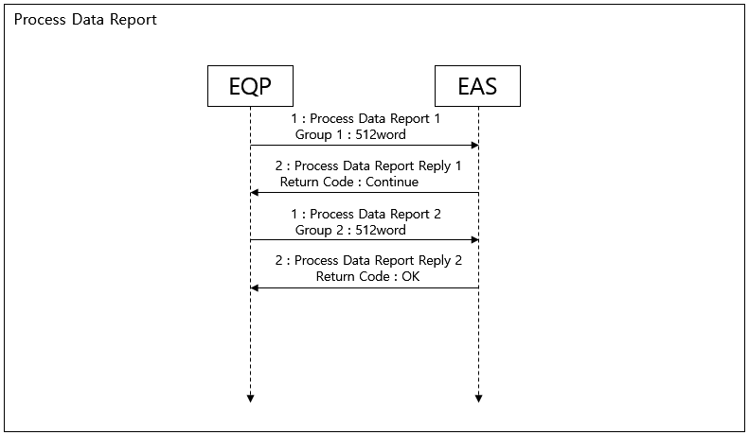

PLC MAP: By Time (SV)
      - Local PLC – Link Register (W or R Area)

Block | Item | Points | Type | Format | Sub Items
 |  |  |  |  | 00 ~ 07 Bit :A.D Year(00~99)
 |  |  |  |  | 08 ~ 15 Bit :Month(01~12)
 | SV Time Record | 3 | Data | BCD | 00 ~ 07 Bit :Day(01~31)
 |  |  |  |  | 08 ~ 15 Bit :Hour(00~23)
Trace Data Block |  |  |  |  | 00 ~ 07 Bit :Minute(00~59)  08 ~ 15 Bit :Second(00~59)
 |  |  |  |  | Trace Data Items
 | SV Data | 640 | Data | - | Default = 640 word
Each equipment vendor need to discuss with
customer for the size.

Tact-Time DV Data
Equipment has to write all signal of action for tact time when glass in or out between Unit, Equipment. And When glass in or out between Robot and PLC, Transfer Robot has to write all signal of action.
When the event of Process Data Report arises from Equipment, the Tact-Time DV Data should report to Host.

It will be define by ESWIN after receives DV List by type of Equipment. The Data Format is Float type that complies with IEEE 754
For example,

Tact-time Data | description
1 | One second
0.1 | 100 millisecond
0.01 | 10 millisecond

FAC Data Report
Equipment should report the facility data with FAC Data Report that is method of event driven.
And also, the event has to raise by cycle of event which is set by operator on touch panel of equipment. The cycle of event is five second.
Equipment must have to write on one block of memory that is FAC Data Block#0, if the data has to be wrote by every five second, but if the data has to be wrote by every one second, equipment must have to write on etch block of memory that is from FAC Data Block#1 to FAC Data Block#5, that mean’s the etch block should have an area which is happened by every one second.
So, the five block from #1 to #5 are data to gathering during five second.

The FAC Data have to discuss by engineer of ESWIN with Vender of equipment how to use the blocks.

PLC MAP: By Time (SV)
      - Local PLC – Link Register (W or R Area)

Block | Item | Points | Type | Format | Sub Items
 |  |  |  |  | 00 ~ 07 Bit :A.D Year(00~99)
 |  |  |  |  | 08 ~ 15 Bit :Month(01~12)
 | SV Time Record | 3 | Data | BCD | 00 ~ 07 Bit :Day(01~31)  08 ~ 15 Bit :Hour(00~23)
 |  |  |  |  | 00 ~ 07 Bit :Minute(00~59)
 |  |  |  |  | 08 ~ 15 Bit :Second(00~59)
 |  |  |  |  | Trace Data Items
FAC Data Block#0 |  |  |  |  | Default = 100 word  Each equipment vendor need to discuss with customer for the size.
 | SV Data | 125 | Data | - | Here must be write by every five second.
 |  |  |  |  | *For example(ItemName=electricity)
 |  |  |  |  | 1.Total electricity usage(1s+2s+3s+4s+5s)
 |  |  |  |  | And
 |  |  |  |  | 2.electricity usage(5s)
 |  |  |  |  | 00 ~ 07 Bit :A.D Year(00~99)
 |  |  |  |  | 08 ~ 15 Bit :Month(01~12)
 | SV Time Record | 3 | Data | BCD | 00 ~ 07 Bit :Day(01~31)
 |  |  |  |  | 08 ~ 15 Bit :Hour(00~23)
 |  |  |  |  | 00 ~ 07 Bit :Minute(00~59)
 |  |  |  |  | 08 ~ 15 Bit :Second(00~59)
FAC Data Block#1 |  |  |  |  | Trace Data Items  Default = 100 word
 |  |  |  |  | Each equipment vendor need to discuss with customer for the size.
 | SV Data | 100 | Data | -
 |  |  |  |  | Here must be write by every 1 second.
 |  |  |  |  | 1 second electricity usage or
 |  |  |  |  | 1 second water usage or
 |  |  |  |  | 1 second gas usage.

Block | Item | Points | Type | Format | Sub Items
 |  |  |  |  | 00 ~ 07 Bit :A.D Year(00~99)
 |  |  |  |  | 08 ~ 15 Bit :Month(01~12)
 | SV Time Record | 3 | Data | BCD | 00 ~ 07 Bit :Day(01~31)
 |  |  |  |  | 08 ~ 15 Bit :Hour(00~23)
 |  |  |  |  | 00 ~ 07 Bit :Minute(00~59)
 |  |  |  |  | 08 ~ 15 Bit :Second(00~59)
FAC Data Block#2 |  |  |  |  | Trace Data Items  Default = 100 word
 |  |  |  |  | Each equipment vendor need to discuss with customer for the size.
 | SV Data | 100 | Data | -
 |  |  |  |  | Here must be write by every 1 second.
 |  |  |  |  | 1 second electricity usage or
 |  |  |  |  | 1 second water usage or
 |  |  |  |  | 1 second gas usage..
 |  |  |  |  | 00 ~ 07 Bit :A.D Year(00~99)
 |  |  |  |  | 08 ~ 15 Bit :Month(01~12)
 | SV Time Record | 3 | Data | BCD | 00 ~ 07 Bit :Day(01~31)
 |  |  |  |  | 08 ~ 15 Bit :Hour(00~23)
 |  |  |  |  | 00 ~ 07 Bit :Minute(00~59)
 |  |  |  |  | 08 ~ 15 Bit :Second(00~59)
FAC Data Block#3 |  |  |  |  | Trace Data Items  Default = 100 word
 |  |  |  |  | Each equipment vendor need to discuss with customer for the size.
 | SV Data | 100 | Data | -
 |  |  |  |  | Here must be write by every 1 second.
 |  |  |  |  | 1 second electricity usage or
 |  |  |  |  | 1 second water usage or
 |  |  |  |  | 1 second gas usage..
 |  |  |  |  | 00 ~ 07 Bit :A.D Year(00~99)
 |  |  |  |  | 08 ~ 15 Bit :Month(01~12)
 | SV Time Record | 3 | Data | BCD | 00 ~ 07 Bit :Day(01~31)
 |  |  |  |  | 08 ~ 15 Bit :Hour(00~23)
 |  |  |  |  | 00 ~ 07 Bit :Minute(00~59)
 |  |  |  |  | 08 ~ 15 Bit :Second(00~59)
FAC Data Block#4 |  |  |  |  | Trace Data Items  Default = 100 word
 |  |  |  |  | Each equipment vendor need to discuss with customer for the size.
 | SV Data | 100 | Data | -
 |  |  |  |  | Here must be write by every 1 second.
 |  |  |  |  | 1 second electricity usage or
 |  |  |  |  | 1 second water usage or
 |  |  |  |  | 1 second gas usage.

Block | Item | Points | Type | Format | Sub Items
 |  |  |  |  | 00 ~ 07 Bit :A.D Year(00~99)
 |  |  |  |  | 08 ~ 15 Bit :Month(01~12)
 | SV Time Record | 3 | Data | BCD | 00 ~ 07 Bit :Day(01~31)
 |  |  |  |  | 08 ~ 15 Bit :Hour(00~23)
 |  |  |  |  | 00 ~ 07 Bit :Minute(00~59)
 |  |  |  |  | 08 ~ 15 Bit :Second(00~59)
FAC Data Block#5 |  |  |  |  | Trace Data Items  Default = 100 word
 |  |  |  |  | Each equipment vendor need to discuss with customer for the size.
 | SV Data | 100 | Data | -
 |  |  |  |  | Here must be write by every 1 second.
 |  |  |  |  | 1 second electricity usage or
 |  |  |  |  | 1 second water usage or
 |  |  |  |  | 1 second gas usage..

      - Local PLC – Link Relay (B Area)

Block | Item | Points | Type | Sub Items | Related Word Items | Master (EAS) Action
Equipment Event | FAC Data Report | 1 | Event | - On: Fire Event  - Off: Event End/Timeout | FAC Data Block#0  …  FAC Data Block#5 | Reply for Receiving

      - Master (EAS) – Link Relay (B Area)

Block | Item | Points | Type | Sub Items | Related Word Items | Local PLC Action
Equipment Event Reply Block | FAC Data Report Reply | 1 | Reply | - On: Reply  - Off: Reply End

Job Information Management
The EAS provide Job information download function.

Job Data Request
If equipment has lost Job Data or needs to update from Host, equipment can request Job Data to EAS. This Job Data could be available for Glass, Panel, or a type of material that is specifically managed, such as Mask.
Upon the Job Data request from equipment, EAS will download the latest updated data for the Job.
Where required, equipment should provide function for operator to enter a Job ID or select a specific Job when requesting Job Data to EAS.
Regardless of this function, all equipment should also provide function for manual entering and revision of data by operator for a specific glass being held in the equipment.

Job Data Change
When glass data is changed by workers from the device, it needs to be reported to EAS Equipment vender provide the data input screen in touch panel

PLC Map
      - Local PLC – Link Register (W Area)

Block | Item | Points | Type | Format | Sub Items
 |  |  |  |  | 1: Glass ID
 |  |  |  |  | 2: Material ID(Mask)
 | Job(Glass or Material) Data Request  Option | 1 | Data | INT | 3: Glass CST Seq /job Seq No
 |  |  |  |  | 4: Reserved
Job Data |  |  |  |  | 5: Glass ID for VCR Mismatch
Request Block | Request Job (Glass or  Material) ID | 10 | Data | ASC | Job ID (Glass or Material)
 | Request Job  CST Sequence Number | 1 | Data | INT | CST Sequence Number (1~65535)
 | Request Job  Job Sequence Number | 1 | Data | INT | Job Sequence Number (1~65535)
Job Data Request Sub Block | Reserved | 20 | Data | - | It is used for line special if the special items must be not changed in job data.  It will be decided by ESWIN Engineer.
Job Data Change Block | Changed Job Data | 96 or 23  or 256 | Data | - | Refer to Job Data A or C or S
      - Local PLC – Link Relay (B Area)

Block | Item | Points | Type | Sub Items | Related Word Items | Master (EAS) Action
Job Event | Job (Glass or Material) Data Request | 1 | Event | - On: Fire Event  - Off: Event End | - Job Data Request Block  - Job Data Request Sub Block
Job Event | Job Data Change Report | 1 | Event | - On: Fire Event  - Off: Event End | Job Data Change Block

      - Master (EAS) – Link Register (W Area)

Block | Item | Points | Type | Format | Sub Items
Job Data Request Reply Block | Job Data Send | 96 or 23  or 256 | Data | - | Refer to Job Data A or C or S  **E.Cell(not Cutting)  : Not including Master Recipe
Job Data Request Reply Block | Job Data Request Ack | 1 | Data | INT | 1: Job Data Exist  2: Job Data no Exist
      - Master (EAS) – Link Relay (B Area)

Block | Item | Points | Type | Sub Items | Related Word Items | Local PLC Action
Job Event Reply | Job Data Request reply | 1 | Reply | - On: Reply  - Off: Reply  End | Job Data  Request Reply Block
Job Event Reply | Job Data  Change Report reply | 1 | Reply | - On: Reply  - Off: Reply  End

Recipe Management
EAS download job data in Cassette Map to Loader/Un-loader/Buffer at Indexer. This job data include Master Recipe (PPID). When job is sent to downstream equipment, Maser Recipe is also sent to downstream equipment as in Job Data. For other equipment, it is received from upstream equipment and should be sent to downstream equipment without any modification.
0) Master Recipe (PPID) Sample Format: Refer to Equipment Operation Scenario. Master Recipe (PPID) = ABDC123.. or 999

* Master Recipe (PPID) represent a set of Local Recipe IDs of each Equipment, which are to be used for processing according to a specific Host Recipe instruction..

Auto Recipe Change Function
All equipment should provide auto recipe change function. Equipment should provide auto recipe change enable / disable change function on equipment touch panel.
Enable: Equipment should change Recipe ID by automatic. Disable: Equipment should change Recipe ID by manual.

Current Recipe ID
Current recipe is the equipment setting Recipe ID that currently being used.
When current recipe is changed, equipment should report to EAS with corresponding Recipe ID. Current Recipe change at equipment should be allowed only when there is no Glass in equipment. Equipment should not allow to change Current Recipe that is not found in Recipe Register Table in the equipment.

Equipment Recipe Validation
When cassette is loaded on port , on CIM On status , EAS has to request Master Recipe (PPID) to MES and validate with the Master Recipe (PPID) in EAS , if current Master Recipe (PPID) not exist then EAS send the OP Call to EQ
if the registration of master recipe is OK then EAS download to Indexer the Cassette Map for processing but if master recipe is not exist in equipment then EAS doesn’t have to send the Cassette Map to indexer.
Master Recipe (PPID) is transferred from Loader to downstream equipment, and the equipment should validate Master Recipe (PPID) and corresponding Recipe ID before receiving Glass from upstream equipment

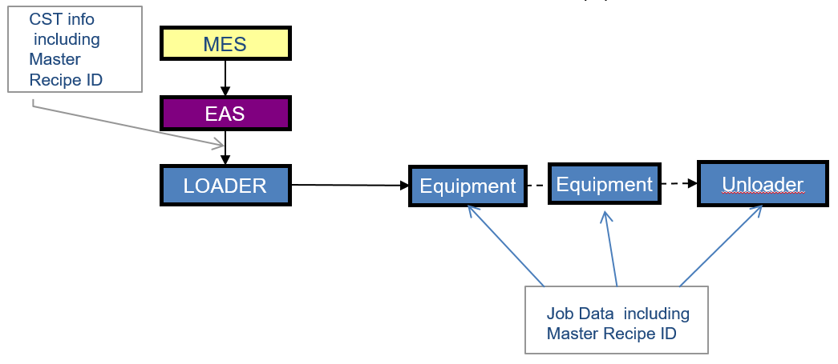
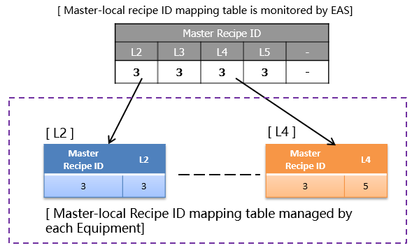

Figure 5-7 Equipment Master Recipe ID

- Master Recipe (PPID) transferring
  - EAS downloads “Master Recipe (PPID)” for each Job to Indexer when downloading Cassette information
  - Indexer sends Job data including Master Recipe (PPID) to next Equipments

Figure 5-8 Master Recipe Structure
Recipe table has to synchronize between EAS & each Equipments

- Local Recipe setting
  - EAS should provide function for setting Master-local recipe table, and should maintain the recipe table.
  - Equipment should provide function for setting Master-local recipe table, and should maintain the recipe table.
  - When receiving Job from upstream, Equipment gets Master Recipe ID from Job Data, and look into Master-Local Recipe table to identify the required Local Recipe to use to process the Job.

- Local Recipe setting
  - If Master Recipe (PPID) received from upstream equipment is match with Current Recipe ID then equipment can receive glass from upstream.
  - If Master Recipe (PPID) received from upstream equipment is not match with Current Recipe ID but found in Recipe Register Table then equipment should change recipe by automatic and receive glass from upstream equipment.
  - If Master Recipe (PPID) received from upstream equipment is not match with Current Recipe ID and not found in Recipe Register Table then equipment should raise an alarm and don’t receive glass.
After Recipe Register by operator in equipment then equipment should check Master Recipe (PPID) one more time and change recipe by automatic. If Master Recipe (PPID) received from upstream equipment is match with Current Recipe ID then receive glass from upstream equipment.
- Auto Recipe Change Disable Case
  - If PPID received from upstream Equipment matches with Current Recipe ID then Equipment can receive glass from upstream.
  - If PPID received from upstream Equipment does not match with Current Recipe ID then Equipment should generate an alarm and don’t receive glass.
After Current Recipe ID change by operator, Equipment should check PPID one more time. If PPID received from upstream Equipment matches with Current Recipe ID then receive glass from upstream Equipment.

Master Recipe List (auto change only)
Equipment should send to EAS the master recipe list for validate of register or Viewing of EAS
Equipment reports the list of all Equipment Recipe (Master Recipe) registered at the equipment according to request from EAS.
Equipment reports the list of all registered Equipment Recipe also when a change has been made to the list (addition/deletion revision of Equipment Recipe, etc.).
Equipment always should be set registered Equipment Recipe Number with index number.(See below) When Recipe ID is String type, it has to use the data structure in below which is ASC 10 word.

※ Master Recipe List Table

Index number (INT) | Master Recipe (ASC 10 Word or INT 1 Word)
1 | Master Recipe ID
2 | …
3 | …
.. | …
N | Master Recipe ID

For example)
If the PPID is empty then the index number and PPID doesn’t report to EAS.

Index number (INT) | Master Recipe (ASC 10 Word or INT 1 Word)
1 | 3
2 | 2
3 | 5
4
5 | 1

6 | 8
7
8 | 4

Here is the map that is Master Recipe List.

 | Index number | Master recipe | Index number | Master recipe | Index number | Master recipe | Index number | Master recipe | Index number | Master recipe | Index number | Master recipe | Index number | Master recipe | Index number | Master recipe
W | +0 | +1 | +2 | +3 | +4 | +5 | +6 | +7 | +8 | +9 | +A | +B | +C | +D | +E | +F
Master Recipe List | 1 | 3 | 2 | 2 | 3 | 5 | 5 | 1 | 6 | 8 | 8 | 4

Master Recipe List Report
Equipmentshould report to EAS when Master Recipe ID is changed, such like Create, Delete, Modify or when equipment receives a request of master recipe list from EAS that is Master Recipe List Request Command.
EAS should send the result of validation to Equipment with Return Code in below.

Master Recipe List Return Code Block | Description
1 | OK : Recipe List Received Result is all ok
2 | Continue : Equipment still has to send the master recipe list to EAS because EAS is not yet received all master recipe list.
3 | Master Recipe list Count NG : Total Group Count is same as Current Group Count but it’s different with Total Master Recipe List Count.
4 | Group Count NG : Total Group Count is different with Current Group Count but it’s same with Total Master Recipe Count.
5 | Duplication Group Count NG : Current Group Count is duplicate with previous group count. Equipment has to send the next group count to EAS.
6 | Order by Group Count NG : Group Count is not sent order by next group count to EAS. Group Count has to send by order the next group count

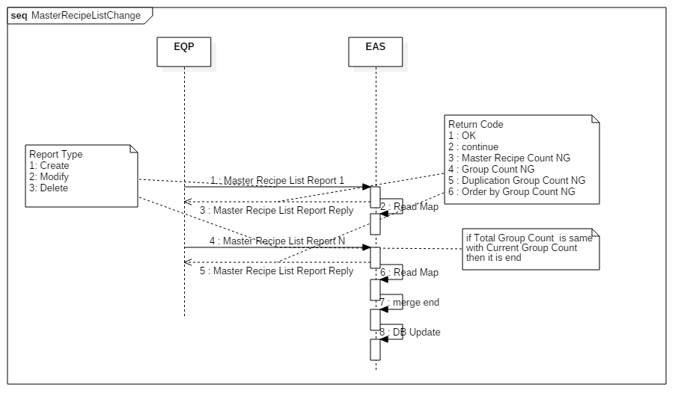
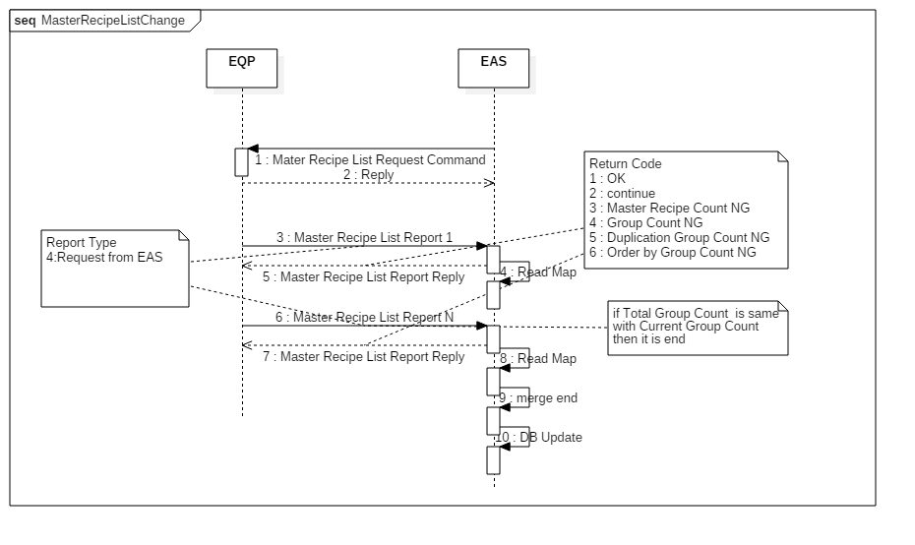

Figure 5-9 Mater Recipe List Change by Equipment

Figure 5-10 Master Recipe List Request Command

Current Recipe Change Report
Equipment should report with Current Recipe ID to EAS when the recipe is changed by auto or manual. In this time , Recipe parameters are able to validate by RMS

Recipe Key Parameter Validation
Equipment has to report the key parameters to EAS when it’s reached in condition by validation type. The key parameters should be determined by ESWIN engineer.

      - Recipe Version Check
When auto recipe is changed and before Cassette is loaded , if equipment missed a report of its change or if operator changes to wrong recipe then can be problem. To prevent changing a wrong recipe, Equipment send a version to EAS when Cassette is loaded. RMS should check the version before Process Start.
Any recipe parameter changed, the recipe version number should be updated. The recipe version number format☹e.g.: 20181127132826)
      - Key-Parameter Synchronization
The data of parameters should request or reply with group by other because there is limit to memory size for gathering a lot of parameter.
Equipment should report the data with Total Parameter Count ,Total Group Count , Current Group Count that the data is continually transferred until all data is transferred.
The condition of complete the transfer of all data is when Total Group Count and Current Group Count is same.

Total Parameter Count | It is total count of parameters
Total Group Count | It is total count of group
Current Group Count | It is current group count by event
For example, if Total Group Count is 3 when Recipe Parameter Report of first is happened, then Current Group Count is 1. Equipment writes next data after EAS reads its memory map .
and when Recipe Parameter Report of next is happened, Current Group Count is 2. It will report the key- parameters until Current Group Count is 3. Equipment terminate the transition of data if Total Group Count is same with Current Group Count and then it doesn’t report next event.

Report Type | Description
1 | Create
2 | Modify
3 | Delete
4 | Request from EAS

Equipment should send Report Type 1 ~ 3 to EAS when key-parameters are changed.
Equipment should send Report Type 4 to EAS when receives a request from EAS that’s Recipe Key- Parameters.
      - Recipe Parameter Report
Equipment should report to the EAS when the recipe parameter is changed, such like Create, Delete , Modify or when equipment receives a request of recipe parameter from Host.
Engineer should manage the parameters in equipment and RMS when change recipe parameter. The recipe parameter has to upload to RMS when recipe parameter of equipment is changed.

EAS should send the result of validation to Equipment with Return Code in below.

Recipe Parameter Report Return Code | Description
1 | OK : Recipe validation result by RMS is all ok
2 | NG : Recipe validation result by RMS is NG, Equipment has to recovery to previous parameter.

3 | Continue : Equipment still has to send parameter to EAS because EAS is not yet received all parameter.
4 | Parameter Count NG : Total Group Count is same as Current Group Count but it’s different with Total Parameter Count.
5 | Group Count NG : Total Group Count is different with Current Group Count but it’s same with Total Parameter Count.
6 | Duplication Group Count NG : Current Group Count is duplicate with previous group count. Equipment has to send the next group count to EAS.
7 | Order by Group Count NG : Group Count is not sent order by next group count to EAS. Group Count has to send by order the next group count

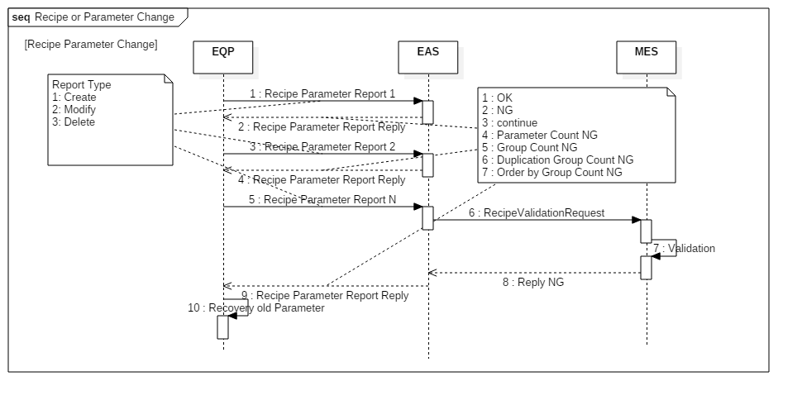
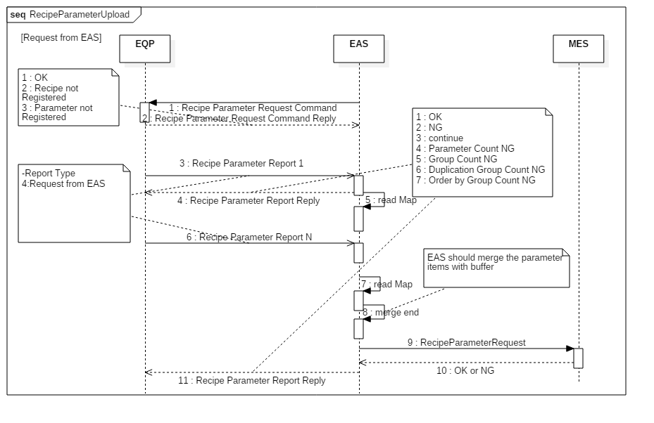

Figure 5-11 Recipe Parameter Change Sequence

Figure 5-12 Recipe Parameter Request sequence by EAS

Recipe Key Parameter or Master Recipe List at abnormal
Equipment should re-send the Recipe Parameter Report or the Mater Recipe List Report to EAS that is cause by operator after OP Call when T1 or T2 Timeout occurs that the event from the first start.
And also Equipment should restart all Event from the first group count that is cause by operator after OP Call, if the Return Code is NG.
Case of Master Recipe List is same as the abnormal sequence in below.
Time out of the Event should can be changed on touch panel by operator because the message of reply can be received after time over that is able to depend on network traffic and message handshake.
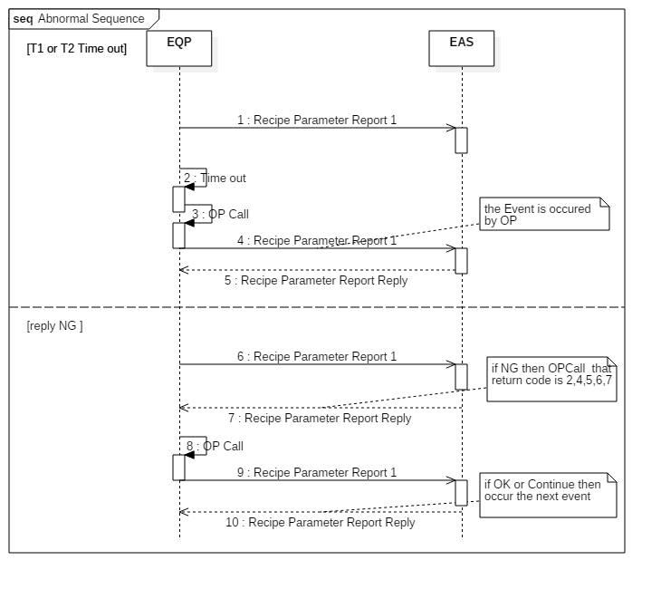

Figure 5-13 abnormal scenario at recipe parameter report

Local Recipe Request (Array Only)
This is used for the Equipment requiring Local Recipe. This is the signal requesting Local Recipe to EAS. It is used with Local Recipe request ‘Master Recipe ID’, ‘Unit ID’in the W area.
The timing of requesting Local Recipe is basically conducted when confirming ‘Glass data is being displayed’ from the upstream side before receiving glass from the upstream.
If there is no response against Local Recipe request for a certain time, it should be available for manual input on the operation screen.
The Local Recipe request is basically done when receiving new PPID glass from the upstream, when receiving glass of new LOT, and when the auto-starting is started again(when CIM Mode Off -> On).

Index number (INT) | Local Recipe (ASCII 10W)
1 | Local Recipe ID #1
2 | Local Recipe ID #2
3 | Local Recipe ID #3
…
N | Local Recipe ID #N

PLC MAP (Cell Only)
      - Local PLC – Link Register (W or R Area)

Block | Item | Points | Type | Format | Sub Items

Block | Item | Points | Type | Format | Sub Items
Current Recipe Block | Unit No or Local No | 1 | Data | INT | 0 : Local  Others : Unit No
Current Recipe Block | Current Master Recipe ID | 1 | Data | INT
Current Recipe Block | Local Recipe ID | 1 | Data | INT
Recipe Parameter Return Code Block | Return Code | 1 | Data | INT | 1 : OK  2 : Recipe not Registered  3 : Parameter not Registered
Recipe Key Parameter Block | Master Recipe ID | 1 | Data | INT
Recipe Key Parameter Block | Local Recipe ID | 1 | Data | INT
Recipe Key Parameter Block | Unit No or Local No | 1 | Data | INT | 0 : Local  Others : Unit No
Recipe Key Parameter Block | Report Type | 1 | Data | INT | 1: Create  2: Modify  3: Delete  4: Request from EAS
Recipe Key Parameter Block | Total Parameter Count | 1 | Data | INT
Recipe Key Parameter Block | Total Group Count | 1 | Data | INT
Recipe Key Parameter Block | Current Group Count | 1 | Data | INT
Recipe Key Parameter Block | Request Recipe Parameter Items | 250 | Data | ASC
Master Recipe Block | Unit No or Local No | 1 | Data | INT | 0 : Local  Others : Unit No
Master Recipe Block | Master Recipe List | 250 | Data | INT
Master Recipe Block | Report Type | 1 | Data | INT | 1: Create  2: Modify  3: Delete  4: Request from EAS
Master Recipe Block | Total Master Recipe Count | 1 | Data | INT
Master Recipe Block | Total Group Count | 1 | Data | INT | It is total count of group of Master Recipe
Master Recipe Block | Current Group Count | 1 | Data | INT | It is current group count of Master Recipe by event
Recipe Parameter Monitoring Block | Master Recipe ID | 1 | Data | INT
Recipe Parameter Monitoring Block | Local Recipe ID | 1 | Data | INT
Recipe Parameter Monitoring Block | Unit No or Local No | 1 | Data | INT | 0 : Local  Others : Unit No
Recipe Parameter Monitoring Block | Current Recipe Parameter Items | 250 | Data | ASC | Cell only

      - Local PLC – Link Relay (B Area)

Block | Item | Points | Type | Sub Items | Related Word Items | Master (EAS)
Equipment Status Event | Auto Recipe Change Mode | 1 | Status | - On: Enable  - Off: Disable
Equipment Event | Current Recipe Change Report | 1 | Event | - On: Fire Event  - Off: Event End | Current Recipe Block | Reply for Receiving

Block | Item | Points | Type | Sub Items | Related Word Items | Master (EAS)
 | Master Recipe List Report | 1 | Event | - On: Fire Event  - Off: Event End | Master Recipe Block | Reply for Receiving
 | Recipe Parameter Report | 1 | Event | - On: Fire Event  - Off: Event End | -Recipe Key Parameter Block  *it has to be wrote by Recipe Parameter Request Command | Reply for Receiving
EAS  Command Reply | Master Recipe List Request Command Reply | 1 | Reply | - On: Reply  - Off: Reply End
EAS  Command Reply | Recipe Parameter Request Command Reply | 1 | Reply | - On: Reply  - Off: Reply End | Recipe Parameter Return Code Block

      - Master (EAS) – Link Register (W Area)

Block | Item | Points | Type | Format | Sub Items
Master
Recipe List Request | Unit No or Local No | 1 | Data | INT | 0 : Local  Others : Unit No
Block
Recipe | Master Recipe ID | 1 | Data | INT
Recipe | Local Recipe ID | 1 | Data | INT
Parameter
Request |  |  |  |  | 0 : Local
Block | Unit No or Local No | 1 | Data | INT | Others : Unit No
 |  |  |  |  | 1 : OK
Recipe Parameter |  |  |  |  | 2 : NG  3 : continue
Report | Return Code | 1 | Data | INT | 4 : Parameter Count NG
Return Code  Block |  |  |  |  | 5: Group Count NG
 |  |  |  |  | 6 : Duplication Group Count NG
 |  |  |  |  | 7 : Order by Group Count NG
 |  |  |  |  | 1 : OK
Master Recipe List Return Code Block | Return Code | 1 | Data | INT | - : continue  - : Master Recipe Count NG  - : Group Count NG  - : Duplication Group Count NG
 |  |  |  |  | 6 : Order by Group Count NG
      - Master (EAS) – Link Relay (B Area)

Block | Item | Points | Type | Sub Items | Related Word Items | Local PLC Action
Equipment Event  Reply | Current Recipe Change Report Reply | 1 | Reply | - On: Reply  - Off: Reply End
Equipment Event  Reply | Master Recipe List Report Reply | 1 | Reply | - On: Reply  - Off: Reply End | Master Recipe List Return Code Block

Block | Item | Points | Type | Sub Items | Related Word Items | Local PLC Action
 | Recipe Parameter Report Reply | 1 | Reply | - On: Reply  - Off: Reply End | Recipe Parameter Report Return Code Block
EAS  Command | Master Recipe List Request Command | 1 | CMD | - On: Fire Command  - Off: Command End | Master Recipe List Request Block | Reply for Receiving
EAS  Command | Recipe Parameter Request Command | 1 | CMD | - On: Fire Command  - Off: Command End | Recipe Parameter  Request Block | Reply for Receiving

PLC MAP (Array Only)
      - Local PLC – Link Register (W or R Area)

Block | Item | Points | Type | Format | Sub Items
Current Recipe Block | Unit No or Local No | 1 | Data | INT | 0 : Local  Others : Unit No
Current Recipe Block | Current Master Recipe ID | 10 | Data | ASC
Current Recipe Block | Local Recipe ID | 10 | Data | ASC
Recipe Parameter Return Code Block | Return Code | 1 | Data | INT | 1 : OK  2 : Recipe not Registered  3 : Parameter not Registered
Recipe Key Parameter Block | Local Recipe ID | 10 | Data | ASC
Recipe Key Parameter Block | Local Recipe ID | 10 | Data | INT
Recipe Key Parameter Block | Unit No or Local No | 1 | Data | INT | 0 : Local  Others : Unit No
Recipe Key Parameter Block | Report Type | 1 | Data | INT | 1: Create  2: Modify  3: Delete  4: Request from EAS
Recipe Key Parameter Block | Total Parameter Count | 1 | Data | INT
Recipe Key Parameter Block | Total Group Count | 1 | Data | INT
Recipe Key Parameter Block | Current Group Count | 1 | Data | INT
Recipe Key Parameter Block | Request Recipe Parameter Items | 250 | Data | ASC
Local Recipe Request Block | Master Recipe ID | 10 | Data | ASC
Local Recipe Request Block | Unit No | 1 | Data | INT | 0: Local
Local Recipe Block | Unit No or Local No | 1 | Data | INT | 0 : Local  Others : Unit No
Local Recipe Block | Local Recipe List | 250 | Data | ASC
Local Recipe Block | Report Type | 1 | Data | INT | 1: Create  2: Modify  3: Delete  4: Request from EAS
Local Recipe Block | Total LocalRecipe Count | 1 | Data | INT
Local Recipe Block | Total Group Count | 1 | Data | INT | It is total count of group of Master Recipe
Local Recipe Block | Current Group Count | 1 | Data | INT | It is current group count of Master Recipe by event
Recipe | Master Recipe ID | 10 | Data | ASC

Block | Item | Points | Type | Format | Sub Items
Version Block | Local Recipe ID | 10 | Data | ASC
Version Block | Recipe Version | 3 | Data | BCD | 00 ~ 07 Bit :A.D Year(00~99)  08 ~ 15 Bit :Month(01~12)
Version Block | Recipe Version | 3 | Data | BCD | 00 ~ 07 Bit :Day(01~31)  08 ~ 15 Bit :Hour(00~23)
Version Block | Recipe Version | 3 | Data | BCD | 00 ~ 07 Bit :Minute(00~59)  08 ~ 15 Bit :Second(00~59)

      - Local PLC – Link Relay (B Area)

Block | Item | Points | Type | Sub Items | Related Word Items | Master (EAS)
Equipment Status Event | Auto Recipe Change Mode | 1 | Status | - On: Enable  - Off: Disable
Equipment Event | Current Recipe Change Report | 1 | Event | - On: Fire Event  - Off: Event End | Current Recipe Block | Reply for Receiving
Equipment Event | Local Recipe List Report | 1 | Event | - On: Fire Event  - Off: Event End | Local Recipe Block | Reply for Receiving
Equipment Event | Recipe Parameter Report | 1 | Event | - On: Fire Event  - Off: Event End | Recipe Parameter Block | Reply for Receiving
EAS  Command Reply | Local Recipe List Request Command Reply | 1 | Reply | - On: Reply  - Off: Reply End
EAS  Command Reply | Recipe Parameter Request Command Reply | 1 | Reply | - On: Reply  - Off: Reply End | Recipe Parameter Return Code Block
EAS  Command Reply | Recipe Version Request Command Reply | 1 | Reply | - On: Reply  - Off: Reply End | Recipe Version Block
Equipment Special Event | LocalRecipeRequest | 1 | Event | - On: Fire Event  - Off: Event End | Recipe Request Block | Reply for Receiving

      - Master (EAS) – Link Register (W Area)

Block | Item | Points | Type | Format | Sub Items
Local Recipe List Request Block | Unit No or Local No | 1 | Data | INT | 0 : Local  Others : Unit No
Recipe Parameter Request Block | Master Recipe ID | 10 | Data | ASC
Recipe Parameter Request Block | LocalRecipe ID | 10 | Data | ASC
Recipe Parameter Request Block | Unit No or Local No | 1 | Data | INT | 0 : Local  Others : Unit No
Recipe Version Request Block | Master Recipe ID | 10 | Data | ASC
Recipe Version Request Block | Local Recipe ID | 10 | Data | ASC

Block | Item | Points | Type | Format | Sub Items
Recipe Parameter Report Return Code Block | Return Code | 1 | Data | INT | 1 : OK  2 : NG  3 : continue  4 : Parameter Count NG 5: Group Count NG  6: Duplication Group Count NG  7 : Order by Group Count NG
Local Recipe List Return Code Block | Return Code | 1 | Data | INT | 1 : OK  2 : continue  3 : LocalRecipe Count NG  4 : Group Count NG  5: Duplication Group Count NG 6 : Order by Group Count NG
      - Master (EAS) – Link Relay (B Area)

Block | Item | Points | Type | Sub Items | Related Word Items | Local PLC Action
Equipment EventReply | Current Recipe Change Report Reply | 1 | Reply | - On: Reply  - Off: Reply End
Equipment EventReply | Local Recipe List Report Reply | 1 | Reply | - On: Reply  - Off: Reply End | Local Recipe List Return Code Block
Equipment EventReply | Recipe Parameter Report Reply | 1 | Reply | - On: Reply  - Off: Reply End | Recipe Parameter Report Return Code Block
EAS  Command | Local Recipe List Request Command | 1 | CMD | - On: Fire Command  - Off: Command End | Local Recipe List Request Block | Reply for Receiving
EAS  Command | Recipe Parameter Request Command | 1 | CMD | - On: Fire Command  - Off: Command End | Recipe Parameter Request Block | Reply for Receiving
EAS  Command | Recipe Version Request Command | 1 | CMD | - On: Fire Command  - Off: Command End | Recipe Version Request Block | Reply for Receiving
Equipment Special Event Reply | LocalRecipeRequest Reply | 1 | Reply | - On: Reply  - Off: Reply End | Recipe Request Confirm Block

CIM Message Management
CIM Message is used to notify specific information to operator of specific equipment. When receiving CIM Message, equipment has to display it to operator and save the history data locally.
Equipment should support that EAS can send one or more CIM Messages to a specific touch panel of a specific equipment using touch panel number. When equipment receives a CIM Message from EAS, the equipment should display the CIM Message in a pop-up window on touch panel. The CIM Message pop-up window should provide “Confirmation” button so that, if operator confirms, the CIM Message is cleared and at that time equipment should report the confirm event (refer to CIM Message Confirm Report Area).
Equipment clears only the CIM Message that has been confirmed by operator or indicated by CIM Message Clear command from EAS. When CIM Messages are received then display like below.

CIM Message Display (T/P=1)

No | ID | Received Time | CIM Message | Confirm
1 | 1000 | 2010/12/01 05:00:00 | Display the newest (latest) CIM Message | Confirm
2 | 2000 | 2010/12/01 04:00:00 |  | Confirm
3 | 3000 | 2010/12/01 03:00:00 |  | Confirm
4 | 4000 | 2010/12/01 02:00:00 |  | Confirm
5 | 5000 | 2010/12/01 01:00:00 | Display the earliest CIM Message | Confirm

If Equipment has received more than one CIM Messages before confirming by Engineer or Operator, then Equipment should do buffering of CIM Message on the screen up to five CIM Messages. And if the count of CIM Message buffered is over five, then Equipment should change the buffering of CIM Message by newest (latest) 5 CIM Messages.

CIM Message
Equipment should reserve enough space to display some CIM messages. Equipment displays the CIM message on equipment touch panel with CIM Message ID and Touch panel number.

Touch Panel Number
Equipment should provide screens to display a CIM message on touch panel. Each screen has its screen number. If equipment receives the CIM Message Set, it must read this data first and display on the corresponding screen. If touch panel number does not match then equipment doesn’t display this CIM message.

CIM Message ID
CIM Message ID is a unique identification of message, while message contents indicate more detail information to operator. If CIM Message ID has no value, equipment should display space. According to the CIM Message ID, equipment should display the message and do some actions such as buzzing to operator and turning on a signal tower lamp.

 | CIM Message ID
Signal Light Tower | 1xxxx
Buzzer | 2xxxx
Signal Light Tower + Buzzer | 3xxxx
Normal | 4xxxx
Reserved | 5xxxx

CIM Message Set Command
This is Command from EAS to equipment, instructing CIM Message display on equipment Touch Panel. When received, equipment displays the message on Popup window. Every CIM Message has its unique ID, and equipment manages CIM Messages based on the CIM Message ID.

CIM Message Clear Command
This is command from Master to equipment, instructing clear CIM Message being displayed on touch panel. Equipment clears from CIM Message Popup window the CIM Message indicated by Master based on CIM Message ID, regardless whether the CIM Message has been confirmed by operator or not. If there is no not- confirmed CIM message in Popup window, equipment closes the Popup window. The history of CIM Message has to be preserved.
Equipment should support that EAS can clear one or more CIM Messages from a specific touch panel of a specific equipment using touch panel number and CIM Message ID. If equipment receives this command, equipment should clear only the CIM Message indicated by CIM Message ID from the touch panel indicated by Touch Panel Number.
If CIM Message are all cleared or confirmed then equipment should close CIM Message popup display, buzzer and signal tower should change to original status.
After CIM Message clear command or confirm, equipment should re-arrange popup display like below.

- CIM Message Sample
CIM Message Display (T/P=1)

No | ID | Received Time | CIM Message | Confirm
1 | 1000 | 2010/12/01 05:00:00 | Port#1 Canceled By Host | Confirm
2 | 2000 | 2010/12/01 04:00:00 | Port#2 Canceled By Host | Confirm
3 | 3000 | 2010/12/01 03:00:00 | Port#3 Canceled By Host | Confirm
4 |  |  |  | Confirm
5 |  |  |  | Confirm

- After receive CIM Message Clear Command from BC CIM Message ID = 2000
CIM Message Display (T/P=1)

No | ID | Received Time | CIM Message | Confirm
1 | 1000 | 2010/12/01 05:00:00 | Port#1 Canceled By Host | Confirm
2 | 3000 | 2010/12/01 03:00:00 | Port#3 Canceled By Host | Confirm
3 |  |  |  | Confirm
4 |  |  |  | Confirm
5 |  |  |  | Confirm

CIM Message Confirm Event Report
This is to indicate that operator confirmed CIM Message on the equipment touch panel. Upon confirmation from operator, equipment reports the ID of the CIM Message to Master.
If CIM Message are all cleared or confirmed then equipment should close CIM Message popup display, buzzer and signal tower should change to original status.
After CIM Message clear command or confirm, equipment should re-arrange popup display like below.

- CIM Message Sample
CIM Message Display (T/P=1)

No | ID | Received Time | CIM Message | Confirm
1 | 1000 | 2010/12/01 05:00:00 | Port#1 Canceled By Host | Confirm
2 | 2000 | 2010/12/01 04:00:00 | Port#2 Canceled By Host | Confirm
3 | 3000 | 2010/12/01 03:00:00 | Port#3 Canceled By Host | Confirm
4 |  |  |  | Confirm
5 |  |  |  | Confirm

- After confirm CIM Message on Touch Panel CIM Message ID = 2000
CIM Message Display (T/P=1)

No | ID | Received Time | CIM Message | Confirm
1 | 1000 | 2010/12/01 05:00:00 | Port#1 Canceled By Host | Confirm
2 | 3000 | 2010/12/01 03:00:00 | Port#3 Canceled By Host | Confirm
3 |  |  |  | Confirm
4 |  |  |  | Confirm
5 |  |  |  | Confirm

CIM Message History Management
Equipment should display on the equipment Touch Panel the history of at least 20 CIM Messages most recently received from EAS.

No | Received Time | CIM Message ID | CIM Message
1 | 2010/10/07 13:20:57 | 0113 | ➔ Display the newest (latest) CIM Message
2 | … | … | …
: | … | … | …
20 | 2010/10/07 10:20:01 | 3333 | ➔ Display the earliest CIM Message
Figure5-14CIM Message History Table

PLC MAP
      - Local PLC – Link Register (W Area)

Block | Item | Points | Type | Format | Sub Items
CIM Message Confirm Block | CIM Message ID | 1 | Data | INT
CIM Message Confirm Block | Touch Panel No | 1 | Data | INT | 1~65535

      - Local PLC – Link Relay (B Area)

Block | Item | Points | Type | Sub Items | Related Word Items | Master (EAS)
Equipment Event | CIM Message Confirm Report | 1 | Event | - On: Fire Event  - Off: Event End | CIM Message Confirm Block
EAS  Command | CIM Message Set Command Reply | 1 | Reply | - On: Reply  - Off: Reply End

Block | Item | Points | Type | Sub Items | Related Word Items | Master (EAS)
Reply | CIM Message Clear Command Reply | 1 | Reply | - On: Reply  - Off: Reply End

      - Master (EAS) – Link Register (W Area)

Block | Item | Points | Type | Format | Sub Items
CIM Message Set CMD Block | CIM Message | 16 | Data | ASC
CIM Message Set CMD Block | CIM Message ID | 1 | Data | INT | 1~65535
CIM Message Set CMD Block | Touch Panel No | 1 | Data | INT | 0 : All  1~65535
CIM Message Clear CMD  Block | CIM Message ID | 1 | Data | INT | 1~65535
CIM Message Clear CMD  Block | Touch Panel No | 1 | Data | INT | 0 : All  1~65535

      - Master (EAS) – Link Relay (B Area)

Block | Item | Points | Type | Sub Items | Related Word Items | Local PLC Action
Equipment Event Reply | CIM Message Confirm Report Reply | 1 | Reply | - On: Reply  - Off: Reply End
EAS  Command | CIM Message Set Command | 1 | CMD | - On: Fire Command  - Off: Command End/Timeout | CIM Message Set CMD Block
EAS  Command | CIM Message Clear Command | 1 | CMD | - On: Fire Command  - Off: Command End/Timeout | CIM Message Clear CMD Block

Signal Tower Management

Type | O | Δ | X
Lamp | Light On | Light Flash | Light Off
Buzzer | Long Beep | Short Interval Beep | No Sound

No | Type of CIM Message | Touch Panel | Tower Lamp |  |  |  | Buzzer
No | Type of CIM Message | Touch Panel | Rd | Yw | Gn | Bl | Buzzer
1 | CIM Message & Tower Lamp & Buzzer (ID : 1~65535) | Display CIM Message. | Keep current status | Δ | Keep current status | Δ | ο

Date Time Set Command
When equipment receives this command, equipment adjusts its local system time according to the time sent by this command.
EAS will set date time to equipment when receive date time from MES or equipment CIM mode changed to on.

PLC MAP
      - Local PLC – Link Relay (B Area)

Block | Item | Points | Type | Sub Items | Related Word Items | Master (EAS)
EAS  Command Reply | Date Time Set Command Reply | 1 | Reply | - On: Reply  - Off: Reply End

      - Master (EAS) – Link Register (W Area)

Block | Item | Points | Type | Format | Sub Items
Date Time  Set CMDBlock | Date Time | 3 | Data | BCD | 00 ~ 07 Bit :A.D Year(00~99)  08 ~ 15 Bit :Month(01~12)
Date Time  Set CMDBlock | Date Time | 3 | Data | BCD | 00 ~ 07 Bit :Day(01~31)  08 ~ 15 Bit :Hour(00~23)
Date Time  Set CMDBlock | Date Time | 3 | Data | BCD | 00 ~ 07 Bit :Minute(00~59)  08 ~ 15 Bit :Second(00~59)

      - Master (EAS) – Link Relay (B Area)

Block | Item | Points | Type | Sub Items | Related Word Items | Local PLC Action
EAS  Command | Date Time Set Command | 1 | CMD | - On: Fire Command  - Off: Command End/Timeout | Date Time Set CMD Block | Local PLC replies and should change the time of itself.

Port Management

Port Operation Mode Management

CST Operation Mode
It indicates the current operation mode of Loader based on Glass type. CST Operation Mode is applicable for specific equipment’s only.
- Kind to Kind Mode (Default): Glass/Panel is stored into a cassette according to product (kind) type. It does not consider FIFO sequence of glasses. Un-loader reports Unload Request event when unloading cassette is full.
- Cassette To Cassette Mode: Glass/Panel will be stored into the same slot of unloading cassette as loading cassette. If un-loader has wire cassette then glass/Panel can be stored into the another slot of unloading cassette.

Indexer Operation Mode(Line Operation Mode)
In a Line, there could be multiple job transfer routes between Indexer and Equipment’s according to specific manufacturing purpose. Each of a specific job transfer route is defined as an Indexer Operation Mode; one or more Indexer Operation Mode can be assigned for one Line if there exist one or more than one specific job transfer routes
Indexer Operation Mode defines job transfer routes mainly between Indexer and Process Equipment’s, and therefore is to be used by Indexer Job dispatching controller.

The below is examples of Indexer Operation Mode.
- Mode that is required for each Equipment Types will be defined in separate Equipment Operation Scenario document.

  - Sort Mode : This mode is used for sorting function (Job exchange between Cassettes). In this Mode, Job in one Cassette (source Cassette) is transferred to another Cassette (target Cassette) directly without delivering to Process Equipment’s. Source and target cassette can be determined automatically or by user-defined Sorting Plan.
  - Cold Run Mode
    - This mode is used for the purpose of the transfer test.
    - The indexer should provide Cold Run Mode function on touch screen.
    - The operator set the glass count to touch screen of the indexer and the indexer reports to the EAS.
    - The EAS control the robot for the glass transfer test and the indexer not unload the cassette, automatically change the Port Mode until glass count set.

Indexer is required to transfer Job according to Indexer Operation Mode either when Indexer is in Local Dispatching Mode or Indexer is independent type (i.e. no EAS dispatching control).
Therefore Indexer has to provide function of
- Indexer Operation Mode management (glass transfer route definition, mode change, etc.)
- Control Job transfer according to current Indexer Operation Mode..

PLC Map
      - Local PLC – Link Register (W Area)

Block | Item | Points | Type | Format | Sub Items
Indexer Operation Mode Block | Indexer Operation Mode | 1 | Data | INT | *common (1~9999)  - : Normal  - : Clean_Out 4 : Cold Run  ~9999 : Etc  *Array (10000~19999) 10000 : AOI_Only  10001 : Mix_Sorting  10002 : Return  10003 : Wet_Stripper_Only  10004 : Anneal_Only  10005 : Anneal_Skip  10006 : Re_Input  10007 : USC_Only  10008 : Mix_Run  10009 : HDC_Only  10010 : PECVD_Only  10011 : Reverse  10012 : Sputter_Only  10013 : Dummy_Glass  10014 : Tray_Gap_Test  10015 : Dry_Etch_Only  10016 : Normal_Independent  10017 : Sorting  10018 : Cassette_Change  10019 : TC_Bypass  10020 : Align  10021 : To_Normal_Sort  10022 : To_Wire_Sort  10023 : Turn  10024 : Cutting  10025 : Scrap  10026 : ByPass AOI Only(Photo) 10027 : HDC_SUPTTER_HDC  10028 : Normal Matching Sorter 10029 : Wire Matching Sorter  ~19999 : Etc  *CF (20000~29999) 20001 : BM  20002 : Blue  20003 : Green  20004 : Red  20005 : PS  20006 : OC

Block | Item | Points | Type | Format | Sub Items
20007 : White
20008 : ITO_Dummy_Rework
20009 : COA_Only_PR_Rework
20010 : Scraper_Cutting
20011 : Stand_Alone_Sorting
*F.Cell(30000~39999) 30001 : MERGE
30002 : PAIR
30003 : AF_CV_INPUT
30004 : CLN_CIRCULATION_START
30005 : CLN_CIRCULATION_END
30006 : PARTICLE_TEST1
30007 : PARTICLE_TEST2
30008 : PARTICLE_TEST3
30009 : UV_MASK_DUMMY
30010 : LC_SD_DUMMY
30021: WIRE_BUFF_STORED_GLASS_BACK
30031 : CLN_TURN
30032 : REVERSE_REPROCESS1
30033 : REVERSE_REPROCESS2
30034 : TC_GLASS1
30035 : TC_GLASS2
30036 : TC_GLASS3
30041 : USC_PATH1
30042 : USC_PATH2
30043 : USC_PATH3
30044 : USC_PATH4
30045 : RUBBING_SAME_RECIPE
30046 : RUBBING_DIFFERENT_RECIPE
30047 : STEAM_ONLY
30048 : MMG_MODE
30049 : TC_MMG_MODE
30050 : TTCC_USC_PATH1
30100 : SORTING
30101 : INSPECTION_SKIP
30102 : AGING_OVEN
30103 : CELL_GAP
30104 : SAMPLING
30105 : FULL_INSPECTION_GM
30106 : FULL_INSPECTION_CG
30107 : FULL_INSPECTION_GM_CG
30108 : AOI
30109 : MACRO
30110 : AOI_MACRO
30111 : ODF_EV_GLASS_TURN
30112 : MOVING_WIRE_TO_NORMAL
30113 : MOVING_NORMAL_TO_WIRE

Block | Item | Points | Type | Format | Sub Items
30114 : MOVING_NORMAL_TO_NORMAL
30115 : SAMPLING_ONLY_ONE
30116 : SAMPLING_MORE_THEN_TWO
30117 : FULL_INSPECTION
30118 : INSPECTION_1
30119 : INSPECTION_2
30125 : PARTICLE_COUNT_ONLY
30126 : THICKNESS_MEASURE_ONLY
30127 : BOTH
30128 : PARTICLE_ONLY_TURN
30129 : BOTH_TURN
30133 : REWORK_COUNT_CHECK
30138 : AOI_ONLY
30139 : AOI_STEAM_INSPECTION
30140 : MAIN_UNIT_ONLY
30141 : BOTH_UNIT
30145 : SLOC_PRODUCT_CF_TO_CELL
30146 : SLOC_PRODUCT_CELL_TO_CF
*E.Cell(40000~59999) 40000 : TFT_UP
40001 : CF_UP
40002 : POL_LOAD
40003 : POL_UNLOAD
40004 : POL_EXCHANGE
40005 : PALLET_OUT_MODE
40006 : BOX_OUT_MODE
40007 : SCRAP_MODE
40008 : UNPACKER_MODE
40009 : SINGLE_PANEL_OUT
40010 : SINGLE_PANEL_IN
40011 : NO_VCR
40012 : POL_INPUT
40013 : BYPASS_CELLTEST
 | Cold Run Count | 1 | Data | INT | Cold Run only
Indexer Operation Mode Return Block | Return Code | 1 | Data | INT | - : OK  - : NG
CST  Operation Mode Block | CST Operation Mode | 1 | Data | INT | - : Kind To Kind mode  - : Cassette To Cassette mode

      - Local PLC – Link Relay (B Area)

Block | Item | Points | Type | Sub Items | Related Word Items | Master (EAS) Action
Indexer Event | Indexer Operation Mode Change Report | 1 | Event | - On: Fire Event  - Off: Event End | Indexer Operation Mode Block | Reply for Receiving

Block | Item | Points | Type | Sub Items | Related Word Items | Master (EAS) Action
 | CST Operation Mode Change Report | 1 | Event | - On: Fire Event  - Off: Event End | CST Operation Mode Block | Reply for Receiving
Indexer Command Reply | Indexer Operation Mode Command Reply | 1 | Reply | - On: Reply  - Off: Reply End | Indexer Operation Mode Return Block

      - Master (EAS) – Link Register (W Area)

Block | Item | Points | Type | Format | Sub Items
Indexer Operation Mode Command Block | Indexer Operation Mode | 1 | CMD | INT

      - Master (EAS) – Link Relay (B Area)

Block | Item | Points | Type | Sub Items | Related Word Items | Local PLC Action
Indexer Event Reply | Indexer Operation Mode Change Report Reply | 1 | Reply | - On: Reply  - Off: Reply End
Indexer Event Reply | CST Operation Mode Change Report Reply | 1 | Reply | - On: Reply  - Off: Reply End
Indexer Command | Indexer Operation Mode Change Command | 1 | CMD | - On: Fire Command  - Off: Command End | Indexer Operation Mode Command Block.

Port Type & Mode Management

Port Type
It is to classify a Port based on the expected operation of the Cassette currently loaded on the Port: Cassette loaded on the port is whether to input Job into Inline, or to output Job from Inline after Job has been finished its process in a line, or to buffer a Job in a line temporary.
If there is a cassette on a port, the port type of the port cannot be changed. Equipment makers should provide this function. If port type is changed, equipment should report the ‘Load Ready’ event for the port.
There are 5 kinds of port types, loader, un-loader, both and buffer, un-loader partial. Port mode is related to port type, according to the type of the port.
- Loading Port: To be used to fetch out Job from cassette loaded on the port and input into Inline.
- Unloading Port: To be used to store into Cassette the Job that finished its process, and take out the Cassette out of Inline.
- Both Port: To be used to fetch out Job from cassette loaded on the port and input into Inline and also used to store into Cassette the Job that finished its process, and take out the Cassette out of Inline
- Buffer Port: To be used to buffer Job in Inline.
  - Buffer Type : Indicates this Port is for buffering purpose only. Available for mixing of multiple types of Glasses.
  - Loader in Buffer Type : Indicates that this Buffer Port can be used for Glass Inline input, like Loading Port.
  - Un-Loader in Buffer Type : Indicates that this Buffer Port can be used for Glass Inline output, like Unloading Port.
- Unloading Partial Port : To be used to store into Cassette the Job that finished its process, and take out the Cassette out of Inline. But a Cassette with processed the job will be loaded at Unloading Port, Then the Cassette will be unloaded when it is full.

Port Mode
It is to classify a Port based on operational mode of Glasses to be stored in the Cassette on Port. Port Mode is used to indicate that a Port with specific Port Mode can store only a Job of specific properties.
Port Mode is represented by 5 digit numbers that are consists of 3 different properties of Job to distinguish.

Property | Glass Type | Production Type | Use Type(without End Cell)
Port Mode Value | XXXXX(Combination of each value , INT: 10000~59999)
Data Format | 1 Digit  (1~5) | 2~3 Digit  (00~99) | 4~5 Digit  (00~99)
Data Format | Glass Type | Production Type | Use Type
Value Description | 5: Not Specific  1: TFT  2: CF  3: Both  .. | 00: Not Specific  01: Production  02: Engineer  03: General Dummy  04: QC Dummy  05: Through Dummy  06: Mask Dummy  07: Screen Dummy 08: ODF Seal Dummy 09: VAS Dummy  10: Laser Seal Dummy 11: ITO Dummy  12 :Photo Dummy  13: TPCD Dummy  14: Monitor Dummy  15: Thickness Dummy  16: Rubbing Monitor Dummy 17: Rubbing Aging Dummy 18 :MM Dummy  19: Bare Dummy  20: ODF UVMask Dummy 21: ODF Bare Dummy 22: ODF LC Dummy  23: PI Inkjet Dummy | 00: Not Specific  01: G (Good)  02: N (NG)  03: T (Retest)  04: R (Repair)  05: W (Rework)  06: S (Scrap)  07: K (Process Skip)  08: P (Pending, Need PS Laser)  09: M (Mac/Mic)  10: A (Need Mac, Need Tape Repair)  11: I (Need Mic) 12: C (Need CSI)  13: V (Need CVD)  14: K (Ink Repair :CF only) 15: D (Visible NG)  ..  70: AX  71: A1  72: A2  73: A3  74: A4  75: A5  76: A6

Property | Glass Type | Production Type | Use Type(without End Cell)
 |  | … | 77: A7
 |  |  | 78: A8
 |  |  | 79: A9
 |  |  | ..
 |  |  | 81: AOI
 |  |  | 82: SI(Steam Inspection)
 |  |  | ..
 |  |  | 90: OK
 |  |  | 91: SN
 |  |  | 92: MN
 |  |  | 93: VN(VN Rate)
 |  |  | 94: NP(Non Pair)
 |  |  | 95: SC
 |  |  | 96: PA(Pair)
 |  |  | 97: 2N
 |  |  | 98: RT
 |  |  | 99: RD
 |  |  | …
* For example, Port Mode of 10101 indicates, the Port is to be stored TFT glass/panel of normal Production whose Judge value is Good only.

Port Mode is mainly used by Indexer Dispatching Controller in order to find matching Port of each Job to transfer.
In case Equipment (includes Indexer) needs to have Port Mode property management, the Equipment has to provide functions of
- Provide Port Mode change function (at Touch Panel or other type of instrument) for each Port, and report to Host when Port Mode gets changed.
- Receive Port Mode change command from Host, and set the Port Mode accordingly.
If there is a cassette on a port and clamped, the port mode of the port cannot be changed. Equipment makers should provide this function.

This is End Cell Only in below
End Cell Grade Use Type should be define by modeling that means can be flexibly set by operator. When Port Mode is changed, Indexer should report Use Type and Grades for End Cell.
- Use type indicates that to modeling dispatching rule with a lot of grade
- Priority can be use when the Use Type exists with same grade, if Operator want to dispatch the panels in other to work with priority before processing start with Cassette Loading
- Grades indicates that panel want to dispatch by grade at port which should can set on touch panel by modeling.
It will be provide by ESWIN Engineer. For example,

 | Use Type
W | +0

Use Type | GQ

 | Priority
W | +0
Priority | 2

 | Grade | Grade | Grade | Grade | Grade | Grade
W | +0 | +1 | +2 | +3 | +4 | +5 | …
Grades | QL | QV | QW | QU | QP | QR

Port Transfer Mode
It indicates the mode for transferring of cassette between port and AMHS. There are 3 modes: AGV Mode, MGV Mode and STK Inline Mode. The AGV mode includes RGV mode. AGV mode should be switch able to MGV mode via a button press by operator.
If there is a cassette on a port, the port transfer mode of the port cannot be changed. Equipment makers should provide this function. If port transfer mode is changed, equipment should report the ‘Load Request’ event for the port.
- MGV Mode : Port interfaces with MGV.
- AGV Mode : Port interfaces with AGV.
- Stocker Inline Mode: Port interfaces with Stocker directly.

Port Enable Mode
Port Enable Mode means the port will be used. Port Enabled/Disabled change should be available only when there is no cassette on the Port (i.e. Load Ready status). Once Port status is set to be disabled, no Port mode or Cassette status change related with the Port should be allowed or made.
If there is a cassette on a port, the port enable mode of the port cannot be changed. Equipment makers should provide this function. If port enable mode is changed from disabled mode to enable mode, equipment should report the ‘Load Ready’ event for the port.
- Enabled Mode: This port can be used.
- Disabled Mode: This port cannot be used. Operator or other prevents to use this port

Port Type Auto Change Mode
In this mode, The Indexer must be automatically changing the port type.
If actual cassette is changed empty cassette then the port type should be automatically changed from loading port type to unloading port type.
If empty cassette is changed actual cassette then do unload the cassette. And, after cassette is completely unloaded, then the indexer must be automatically changed from the unloading port type to the loading port type.

- Enable Mode : This mode can automatically change the port type.
- Disable Mode : This mode cannot automatically change the port type.

Port Cassette Type
A specific Cassette Type can be assigned to a Port in order to indicate that only the Cassette with matching specific properties can be loaded on the Port.
In case Equipment (Indexer) needs to have Cassette Type property management, the Equipment has to provide functions of
- Providing Cassette Type change function (at Touch Panel or other type of instrument) for each Port, and report to Host when Cassette Type gets changed.
- Receiving Cassette Type change command from Host, and set the Cassette Type accordingly
- Validating a loaded Cassette ; when received Cassette data from Host, validates the Cassette property from Host data against Cassette Type set to the Port.

Property | Not Use | Partial | Glass Type | CST Capacity | Thickness | CST Model | Reserved
Word
Port Cassette Type
Data Format | 1Digit  (1~3) | 2 Digit  (0~9) | 3 Digit  (0~9) | 4 Digit  (0~9) | 5 Digit  (0~9) | 6 Digit  (0~9) | 7~10 Digit
Value Description | Not Use | 0: Not Specific  1: Full  2: Empty  3: Partial | 0: Not specific  1: TFT  2 : CF  3 : Panel  4 : POL | 0: Not Specific  1: 20  2: 30  3: 50  4: 80  5: 40 | Example)  0: Not Specific  1: 0.1t  2: 0.2t  3: 0.9t | 0: Not specific  1: W  2: N  3: V  4: A  5: B | 0: Not Specific
Port Cassette Type is represented by 5 digit numbers that are consists of 5 different properties of Job to distinguish. Thickness or size is optional and 2nd word is reserved

PLC MAP
      - Local PLC – Link Register (W Area)

Block | Item | Points | Type | Format | Sub Items
Port#1 Block | Port Type | 1 | Data | INT | - : Loading Port  - : Unloading Port  - : Both Port  - : Buffer Port – Buffer Type  - : Buffer Port – Loader in Buffer Type  - : Buffer Port – Un-loader in Buffer Type  - : Unloading Partial Port
Port#1 Block | Port Mode | 1 | Data | INT | 10100 : TFT, normal Product  * Details are to be defined later

Block | Item | Points | Type | Format | Sub Items
 | Port Cassette Type | 2 | Data | INT | * it might be updated if special item need to discuss.
 | Port Transfer Mode | 1 | Data | INT | - : MGV Mode  - : AGV Mode  - : Stocker Inline Mode
 | Port Enable Mode | 1 | Data | INT | - : Port Enabled  - : Port Disabled
 | Port Type Auto Change Mode | 1 | Data | INT | - : Auto Change Enable  - : Auto Change Disable
 | Port Type Change Return Code | 1 | Data | INT | - : OK  - : NG
 | Port Mode Change Return Code | 1 | Data | INT | - : OK  - : NG
 | Port Transfer Mode Change Return Code | 1 | Data | INT | - : OK  - : NG
 | Port Enable Mode Change Return Code | 1 | Data | INT | - : OK  - : NG
 | Port Type Auto Change Mode Return Code | 1 | Data | INT | - : OK  - : NG
 | Port Cassette Type Change Return Code | 1 | Data | INT | - : OK  - : NG
Port#2 Block | Port#2 Event Report Area | 13 |  | - | Sub Items are same as Port#1 Block
Port#3 Block | Port#3 Event Report Area | 13 |  | - | Sub Items are same as Port#1 Block
Port#4 Block | Port#4 Event Report Area | 13 |  | - | Sub Items are same as Port#1 Block
Port#5 Block | Port#5 Event Report Area | 13 |  | - | Sub Items are same as Port#1 Block
Port#6 Block | Port#6 Event Report Area | 13 |  | - | Sub Items are same as Port#1 Block
Port#7 Block | Port#7 Event Report Area | 13 |  | - | Sub Items are same as Port#1 Block
Port#8 Block | Port#8 Event Report Area | 13 |  | - | Sub Items are same as Port#1 Block
Port#9 Block | Port#9 Event Report Area | 13 |  | - | Sub Items are same as Port#1 Block
Port#10 Block | Port#10 Event Report Area | 13 |  | - | Sub Items are same as Port#1 Block
Port#1 Grade Use Type Block | Use Type | 1 | Data | ASC | *Refer to Port Mode for End Cell
Port#1 Grade Use Type Block | Priority | 1 | Data | INT | *Refer to Port Mode for End Cell
Port#1 Grade Use Type Block | Grades | 62 | Data | ASC | *Refer to Port Mode for End Cell
…
Port#N Grade Use Type Block | Port#N Event Report Area | 64 |  | - | Sub Items are same as Port#1 Grade Use Type Block

      - Local PLC – Link Relay (B Area)

Block | Item | Points | Type | Sub Items | Related Word Items | Master (EAS)
Port Event | Port#1 Port Type Change Report | 1 | Event | - On: Fire Event  - Off: Event End/Timeout | Port#1 Block  - Port Type | Reply for Receiving
Port Event | Port#1 Port Mode Change Report | 1 | Event | - On: Fire Event  - Off: Event End/Timeout | Port#1 Block  Port#1 Grade Use Type Block  - Port Mode | Reply for Receiving

Block | Item | Points | Type | Sub Items | Related Word Items | Master (EAS)
 | Port#1 Port Cassette Type Change Report | 1 | Event | - On: Fire Event  - Off: Event End/Timeout | Port#1 Block  -Port Cassette Type | Reply for Receiving
 | Port#1 Port Transfer Mode Change Report | 1 | Event | - On: Fire Event  - Off: Event End/Timeout | Port#1 Block  - Port Transfer Mode | Reply for Receiving
 | Port#1 Port Enable Mode Change Report | 1 | Event | - On: Fire Event  - Off: Event End/Timeout | Port#1 Block  - Port Enable Mode | Reply for Receiving
 | Port#1 Port Type Auto Change Mode Report | 1 | Reply | - On: Reply  - Off: Reply End | Port#1 Block  - Port Type Auto Change Mode | Reply for Receiving
Port Command Reply | Port#1 Port Type Change Command Reply | 1 | Reply | - On: Reply  - Off: Reply End | Port#1 Block  - Port Type  Change Return Code
Port Command Reply | Port#1 Port Mode Change Command Reply | 1 | Reply | - On: Reply  - Off: Reply End | Port#1 Block  - Port Mode Change Return Code
Port Command Reply | Port#1 Port Transfer Mode Change Command Reply | 1 | Reply | - On: Reply  - Off: Reply End | Port#1 Block  - Port Transfer Mode Change Return Code
Port Command Reply | Port#1 Port Enable Mode Change Command Reply | 1 | Reply | - On: Reply  - Off: Reply End | Port#1 Block  - Port Enable Mode Change Return Code
Port Command Reply | Port#1 Port Type Auto Change Mode Command Reply | 1 | Reply | - On: Reply  - Off: Reply End | Port#1 Block  - Port Type Auto Change Mode Return Code
Port Command Reply | Port#1 Port Cassette Type Change Command Reply | 1 | Reply | - On: Reply  - Off: Reply End | Port#1 Block  - Port Cassette Type Change Return Code
Port Event & Port Command Reply | Port#2 Port Event & Command Reply  Same as Port#1 Event & Command Reply | 12 | Event | - On: Fire Event  - Off: Event End/Timeout
Port Event & Port Command Reply | Port#3 Port Event & Command Reply  Same as Port#1 Event & Command Reply | 12 | Event | - On: Fire Event  - Off: Event End/Timeout
Port Event & Port Command Reply | Port#4 Port Event & Command Reply  Same as Port#1 Event & Command Reply | 12 | Event | - On: Fire Event  - Off: Event End/Timeout
Port Event & Port Command Reply | Port#5 Port Event & Command Reply  Same as Port#1 Event & Command Reply | 12 | Event | - On: Fire Event  - Off: Event End/Timeout
Port Event & Port Command Reply | Port#6 Port Event & Command Reply  Same as Port#1 Event & Command Reply | 12 | Event | - On: Fire Event  - Off: Event End/Timeout
Port Event & Port Command Reply | Port#7 Port Event & Command Reply | 12 | Event | - On: Fire Event  - Off: Event

Block | Item | Points | Type | Sub Items | Related Word Items | Master (EAS)
 | Same as Port#1 Event & Command Reply |  |  | End/Timeout
 | Port#8 Port Event & Command Reply  Same as Port#1 Event & Command Reply | 12 | Event | - On: Fire Event  - Off: Event End/Timeout
 | Port#9 Port Event & Command Reply  Same as Port#1 Event & Command Reply | 12 | Event | - On: Fire Event  - Off: Event End/Timeout
 | Port#10 Port Event & Command Reply  Same as Port#1 Event & Command Reply | 12 | Event | - On: Fire Event  - Off: Event End/Timeout

      - Master (EAS) – Link Register (W Area)

Block | Item | Points | Type | Format | Sub Items
Port#1 Command Block | Port Type | 1 | Data | INT | Same as Port Type Change Report
Port#1 Command Block | Port Mode | 1 | Data | INT | Same as Port Mode Change Report
Port#1 Command Block | Port Cassette Type | 2 | Data | INT | * it might be updated if special item need to discuss.
Port#1 Command Block | Port Transfer Mode | 1 | Data | INT | - : MGV Mode  - : AGV Mode  - : Stocker Inline Mode
Port#1 Command Block | Port Enable Mode | 1 | Data | INT | - : Port Enabled  - : Port Disabled
Port#1 Command Block | Port Type Auto Change Mode | 1 | Data | INT | - : Auto Change Enable  - : Auto Change Disable
Port#2 Command Block | Same as Port #1 | 7 | Data | INT
Port#3 Command Block | Same as Port #1 | 7 | Data | INT
Port#4 Command Block | Same as Port #1 | 7 | Data | INT
Port#5 Command Block | Same as Port #1 | 7 | Data | INT
Port#6 Command Block | Same as Port #1 | 7 | Data | INT
Port#7 Command Block | Same as Port #1 | 7 | Data | INT
Port#8 Command Block | Same as Port #1 | 7 | Data | INT
Port#9 Command Block | Same as Port #1 | 7 | Data | INT
Port#10 | Same as Port #1 | 7 | Data | INT

Command Block

      - Master (EAS) – Link Relay (B Area)

Block | Item | Points | Type | Sub Items | Related Word Items | Local PLC Action
Port Event Reply | Port#1 Port Type Change Report Reply | 1 | Reply | - On: Reply  - Off: Reply End
Port Event Reply | Port#1 Port Mode Change Report Reply | 1 | Reply | - On: Reply  - Off: Reply End
Port Event Reply | Port#1 Port Cassette Type Change Report Reply | 1 | Reply | - On: Reply  - Off: Reply End
Port Event Reply | Port#1 Port Transfer Mode Change Report Reply | 1 | Reply | - On: Reply  - Off: Reply End
Port Event Reply | Port#1 Port Enable Mode Change Report Reply | 1 | Reply | - On: Reply  - Off: Reply End
Port Event Reply | Port#1 Port Type Auto Change Mode Report Reply | 1 | Reply | - On: Reply  - Off: Reply End
Port Command | Port#1 Port Type Change Command | 1 | CMD | - On: Fire Command  - Off: Command End | Port#1 Command Block  - Port Type
Port Command | Port#1 Port Mode Change Command | 1 | CMD | - On: Fire Command  - Off: Command End | Port#1 Command Block  - Port Mode
Port Command | Port#1 Port Transfer Mode Change Command | 1 | CMD | - On: Fire Command  - Off: Command End | Port#1 Command Block  - Port Transfer Mode
Port Command | Port#1 Port Enable Mode Change Command | 1 | CMD | - On: Fire Command  - Off: Command End | Port#1 Command Block  - Port Enable Mode
Port Command | Port#1 Port Type Auto Change Mode Command | 1 | CMD | - On: Fire Command  - Off: Command End | Port#1 Command Block  - Port Type Auto Change Mode
Port Command | Port#1 Port Cassette Type Change Command | 1 | CMD | - On: Fire Command  - Off: Command End | Port#1 Command Block  - Port Cassette Type
Port Command & Port Event Reply | Port#2 Port Command & Event Reply  Same as Port#1 Event & Command Reply | 12 | Reply | - On: Reply  - Off: Reply End
Port Command & Port Event Reply | Port#3 Port Command & Event Reply  Same as Port#1 Event & Command Reply | 12 | Reply | - On: Reply  - Off: Reply End
Port Command & Port Event Reply | Port#4 Port Command & Event Reply  Same as Port#1 Event & Command Reply | 12 | Reply | - On: Reply  - Off: Reply End
Port Command & Port Event Reply | Port#5 Port Command & Event Reply  Same as Port#1 Event & Command Reply | 12 | Reply | - On: Reply  - Off: Reply End

Block | Item | Points | Type | Sub Items | Related Word Items | Local PLC Action
 | Port#6 Port Command & Event Reply  Same as Port#1 Event & Command Reply | 12 | Reply | - On: Reply  - Off: Reply End
 | Port#7 Port Command & Event Reply  Same as Port#1 Event & Command Reply | 12 | Reply | - On: Reply  - Off: Reply End
 | Port#8 Port Command & Event Reply  Same as Port#1 Event & Command Reply | 12 | Reply | - On: Reply  - Off: Reply End
 | Port#9 Port Command & Event Reply  Same as Port#1 Event & Command Reply | 12 | Reply | - On: Reply  - Off: Reply End
 | Port#10 Port Command & Event Reply  Same as Port#1 Event & Command Reply | 12 | Reply | - On: Reply  - Off: Reply End

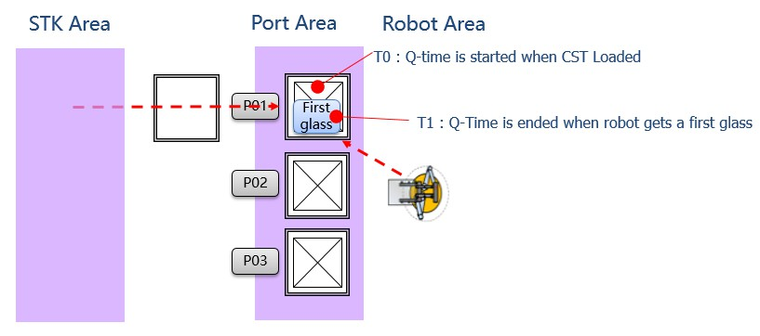

Port Q-Time Check (except End Cell)
Indexer has to manage Q-Time in Port after Cassette is loaded until get a first glass with robot.
Q-time check is started when Cassette is Loaded and Q-time check is ended when robot gets a first glass. Indexer can set the Q-time value on touch screen.
If Q-Time is over for a cassette, then Equipment occurs OP Call. Equipment should report Q-Time Timeout Report to EAS, Unload Cassette.

Figure 6-1 Port Q-Time

PLC MAP
      - Local PLC – Link Register (W Area)

Block | Item | Points | Type | Format | Sub Items
Port#1 Block | Port Q-Time | 1 | Data | INT | 1~65535 minutes
Port#1 Block | Port Q-Time Setting Time | 1 | Data | INT | 1~65535 minutes
… | …
Port#N Block | Port Q-Time | 1 | Data | INT | 1~65535 minutes
Port#N Block | Port Q-Time Setting Time | 1 | Data | INT | 1~65535 minutes

      - Local PLC – Link Relay (B Area)

Block | Item | Points | Type | Sub Items | Related Word Items | Master (EAS)
Port Event | Port #1 Port Q-Time Change Report | 1 | Event | - On: Fire Event  - Off: Event End/Timeout | Port#1 Block  *That Item : Port Q-Time Setting Time | Reply for Receiving
Port Event | …
Port Event | Port #N Port Q-Time Change Report | 1 | Event | - On: Fire Event  - Off: Event End/Timeout | Port#N Block | Reply for Receiving
Port Event | Port#1 Port Q- TimeTimeout Report | 1 | Event | - On: Fire Event  - Off: Event End/Timeout | Port#1 Block  *That Item : Port Q-Time | Reply for Receiving
Port Event | …
Port Event | Port#N Port Q- TimeTimeout Report | 1 | Event | - On: Fire Event  - Off: Event End/Timeout | Port#N Block | Reply for Receiving
Port Command Reply | Port#1 Port Q-Time Change Command Reply | 1 | Reply | - On: Reply  - Off: Reply End
Port Command Reply | …
Port Command Reply | Port#N Port Q-Time Change Command Reply | 1 | Reply | - On: Reply  - Off: Reply End

      - Master (EAS) – Link Register (W Area)

Block | Item | Points | Type | Format | Sub Items
Port#1 Command Block | Port Q-Time | 1 | Data | INT | 1~65535 minutes
… | …
Port#N Command Block | Port Q-Time | 1 | Data | INT | 1~65535 minutes

      - Master (EAS) – Link Relay (B Area)

Block | Item | Points | Type | Sub Items | Related Word Items | Local PLC Action
Port Event Reply | Port #1 Port Q-Time Change Report Reply | 1 | Reply | - On: Reply  - Off: Reply End
Port Event Reply | …
Port Event Reply | Port #N Port Q-Time | 1 | Reply | - On: Reply

 | Change Report Reply |  |  | - Off: Reply End
 | Port#1 Port Q- TimeTimeout Report Reply | 1 | Reply | - On: Reply  - Off: Reply End
 | …
 | Port#N Port Q- TimeTimeoutReport Reply | 1 | Reply | - On: Reply  - Off: Reply End
Port Command | Port#1 Port Q-Time Change Command | 1 | CMD | - On: Fire Command  - Off: Command End | Port#1 Command Block
Port Command | …
Port Command | Port#N Port Q-Time Change Command | 1 | CMD | - On: Fire Command  - Off: Command End | Port#N Command Block

Port and Cassette Control Management

Port State
There are 6 types of port state; Empty, Load Ready, Loaded, In Use, Unload Ready, Blocked
- Load Ready: Port can receive a cassette and is waiting for cassette loading.
- Loaded : Cassette is loaded but net yet clamped.
- In Use: a cassette has been loaded on the port, and ready to use for production. On firing the event, the Cassette Sequence Number of the port should be increased automatically
- Unload Ready: a cassette is ready to unload from the port.
- Empty: cassette is removed from the port. This is the state when cassette removal from Port is detected.
- Blocked: the port is temporarily not allowed to use (pausing); for example, accessing to a cassette in the port is not allowed. Port can be changed to this state automatically if the port is out of normal functional status. This state is controlled by Indexer by its own judgment, and in this state, Robot Command for the Port will not be downloaded.
In this time, Equipment Status depends on state of the transfer unit, if all transfer unit is down then equipment status is Down, otherwise, when the transfer unit is dispatching, its status is Run.
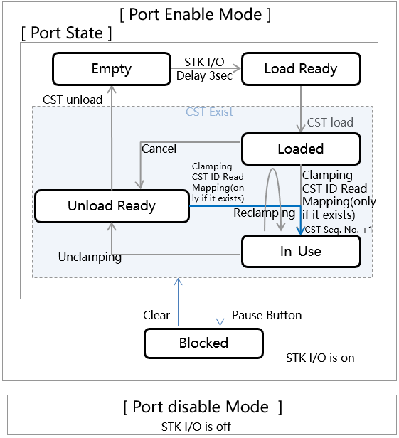

Figure 6-2Port State Change Diagram

Port States Transition Condition

Current State | New State | Condition / Trigger
Empty | Load Ready | Port is ready to receive a cassette. When this state, the port has completed I/O hand-shaking process with Cassette Transfer Equipment for Cassette transfer out, and all I/O should be ready to start a Cassette receiving hand-shaking (I/O hand shaking process definition with Cassette Transfer Equipment is out of this specification scope. Any hand shaking process agreed between Indexer Vendor and Storage/Transfer Vendor could be used)
Load Ready | Loaded | Cassette is loaded but not yet clamped.
Loaded | In Use | The all following requirement has to be completed.  - Cassette is loaded and clamping is completed  - Cassette ID read is completed.  - Cassette glass count(slot existence) mapping is completed, if Port is equipped with slot mapping sensor.  - Cassette is ready to be accessed for fetching out/storing of Job; all internal processes have to be completed, if any.
Loaded | Unload Ready | Unclamping is completed.  When Port is occurred error or need to control to unload  by receiving ‘Unclamp’ command (EAS , equipment touch panel).
In Use | Unload Ready | Unclamping is completed.  Unclamping action can be performed by receiving ‘Unclamp’ command from Host, or user operation at equipment touch panel.
In Use | Loaded | This state change is applied only when there was a command for re-clamping(ReClamp).  But when Cassette Status is changed to Waiting for Processing or In Processing, the command never can conduct.  Operator has to cancel or abort or end of lot process for re-clamp.  For ‘ReClamp’ command, Unclamping action and Clamping action should be conducted automatically and consecutively.
Unload Ready | Empty | Cassette is removed from Port (such as sensor detects no Cassette on Port)
Loaded In Use  Unload Ready | Blocked | If Equipment opts to decide pausing from normal processing according to pre-defined program condition (like Port is temporary out of normal functioning), or operator manually trigger process pause on Equipment (like touch panel)
Blocked | Loaded  In Use  Unload Ready | If Equipment opts to decide resume processing according to pre-defined program condition or operator manually trigger on Equipment (like touch panel) in order to be out of Blocked state.  The new state should be the same as previous state before ‘Blocked’ state (i.e. In Use > Blocked > In Use, Unload Ready > Blocked > Unload Ready)

Cassette Status (Feeder Type & Independent Type Indexer Only)
The Cassette Status is related to processing status of Cassette. Indexer of Feeder Type cassette operation and Indexer of Independent Type (i.e. Robot dispatching from/to cassette is controlled by Indexer) should manage this data items.
- No Cassette: There is no cassette on the port.
- Waiting for Cassette Data: A cassette is currently loaded in a port and waiting for Cassette Map Data from Master (EAS) or Operator. Equipment should report this event, after clamping the cassette and (if port has BCR) reading the cassette ID and (if port has mapping unit) sensing the existence of job for each slot.
* i.e. Report this event after Port State turns in to ‘In Use’.
- Waiting for Start Command: Cassette Map has been received successfully, and waiting for Start Command from Master (EAS) or Operator.
- Waiting for Processing
  - Loading Port: Process Start Command has been received successfully, and waiting for Job fetching out start.
  - Unloading Port: Process Start Command has been received successfully, and waiting for Job inserting into Cassette.
- In Processing
  - Loading Port: The first Job has been fetched out from Cassette.
  - Unloading Port: The first Job has been stored into Cassette.
  - Buffer Port: Received Start Command.
- Process Completed: Process of Cassette has been finish, or cancel, or abort.
  - Loading Port: equipment reports when all Job has been fetched out from Cassette is empty.
  - Unloading Port: equipment reports when all Job has been stored into Cassette.
  - Equipment reports when equipment decides cancel or abort.

- Process Paused: Process of Cassette has been pause by EAS or operator.
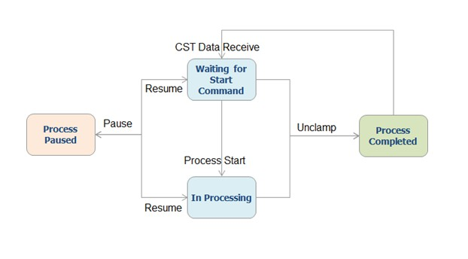

Figure 6-3Diagram of Timing Chart for Cassette State Change

Cassette Control Command
The cassette control command is used to control equipment how to process the cassette on port.
- Cassette Map Download: When equipment requests the cassette map data for a port, EAS should download the data to the equipment. EAS writes the cassette map data in the local PLC of the equipment which has requested the data. And that time, EAS sends this command to the equipment. Equipment can process the cassette using the cassette map data. When Port state is ‘In Use’, Host can write the cassette map data for the cassette on the Port. Equipment has to validate the Cassette ID and Job existence of slot, and has to reply to Host.
- Clamp: this is to request to Port to conduct ‘clamping’ actions for the cassette on the Port. After ‘clamping’, the Port should follow the normal cassette loading sequence.
- Unclamp: this is to request to Port to conduct ‘unclamping’ actions for the cassette on the Port. After ‘unclamping’, the Port should follow the normal cassette loading sequence.
- ReClamp: this is to request to Port to conduct the sequential actions of ‘unclamping’ and ‘clamping’ again. After ‘clamping’, the Port should follow the normal cassette loading sequence.

The below is additional Cassette Control Command that is required for Feeder Type, Independent Type Indexer (and, all Indexer when Auto Dispatching mode is ‘Local Mode’) and operation by Cassette.
- Cassette Process Start: If the cassette map data that received from the EAS is normal, Equipment should request a cassette process start command to EAS. When receives this command from EAS, Equipment can start the cassette.
- Cassette Process Start By Count : Some Equipment need specific glass quantity to be started. This command is used for these types and includes the glass quantity to by started. Operation is same as Cassette Process Start Command. This command only is used that operator start processing manually in Equipment touch panel.
- Cassette Process Pause: EAS can give pause to a cassette. If receives this command, Equipment must pause the process. If robot (or conveyor) is currently fetching or storing a job to the cassette, the fetching or storing operation should be completed before Equipment switches the cassette status to pause.
- Cassette Process Resume: If process of a cassette is paused, Equipment can restart the process by this command.
- Cassette Process Cancel: If a cassette is not being processed, EAS can cancel the process. EAS uses this command. Equipment unclamps the cassette on the port.
- Cassette Process Abort: If a cassette is being processed, EAS can abort the process using this command. If robot (or conveyor) is currently fetching or storing a job to the cassette, the fetching or storing operation should be completed before Equipment switches the cassette status to abort.
- Cassette Process End : If a cassette is being processed, EAS can end the process using this command. Equipment unclamps the cassette on the port.
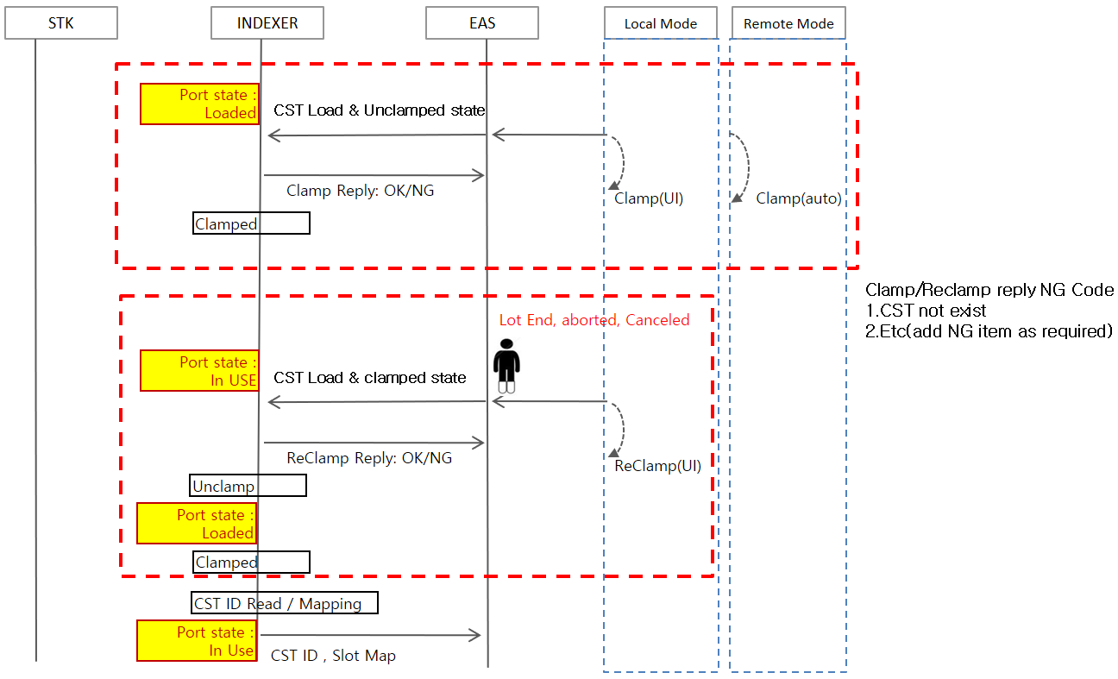

Figure 6-4Clamp/Reclamp Sequence

Return Code
It is a Return Code for the Cassette Control Command from Host. Equipment has to reply with Return Code against the following command.
- Cassette Map Download.
- Clamp, Unclamp, Reclamp.

Cassette Map Data
It is the Job Data of each slot in a cassette. EAS can write the data to local PLC of the equipment after cassette loading process has been completed.

Cassette Mapping State
It is state that has to skip of mapping or mapping in Port. This can set on touch panel of equipment before loading the cassette.
If mapping state is skip then equipment is not mapping.

PLC MAP
      - Local PLC – Link Register (W Area)

Block | Item | Points | Type | Format | Sub Items
Port#1 Port Status Block | Port Status | 1 | Data | INT | - : Load Ready(Load Request)  - : Loaded  - : In Use (Load Complete)  - : Unload Ready (Unload Request)  - : Empty (Unload Complete)  - : Blocked
Port#1 Port Status Block | Cassette Sequence No | 1 | Data | INT | 1~65535  * Include this item only when cassette exists
Port#1 Port Status Block | Cassette ID (Box ID) | 10 | Data | ASC | H20 ~ H7E  (except : H22( “ ), H27(‘)  * Include this item only when cassette exists
Port#1 Port Status Block | Job(glass) Existence Slot | 5 | Data | Bit | On: Job Exist Off: No Job Exist  [1st Word ]  00 ~ 15 Bit : Job Existence Slot 1 ~ 16  00 bit: Job Existence Slot 1  01 bit: Job Existence Slot 2  ….  15 bit: Job Existence Slot 16 [2nd Word]  00 ~ 15 Bit : Job Existence Slot 17 ~ 32 [3rd Word]  00 ~ 15 Bit : Job Existence Slot 33 ~ 48 [4th Word]  00 ~ 15 Bit : Job Existence Slot 49 ~ 64 [5h Word]  00 ~ 15it : Job Existence Slot 65 ~ 80  * Include this item only when Port Status is ‘In Use’
Port#1 Port Status Block | Loading Cassette Type | 1 | Data | INT | 1: Actual Cassette  2: Empty Cassette  * Include this item only when cassette exists
Port#1 Port Status Block | Q-Time Flag | 1 | Data | INT | 1: Normal Un-loading  2: Q-Time Over & Un-loading  * Include this item only when Port Status is ‘Unload Ready’
Port#1 Port Status Block | Cassette Mapping State | 1 | Data | INT | 1: mapping use  2: mapping not use
Port#1 Port Status Block | Cassette Status  (Feeder, Independent Type only, or Local dispatching Mode) | 1 | Data | INT | - : No Cassette Exist  - : Waiting for Cassette Data  - : Waiting for Start Command  - : Waiting for Processing  - : In Processing

Block | Item | Points | Type | Format | Sub Items
- : Process Paused
- : Process Completed
 | Cassette Control Command Return Code | 1 | Data | INT | [Cassette Control Command Return Code]  - : Command OK  - : CSTID is Invalid (Include Dense Box ID) 3: Cassette not exist  - Already received  - Other Error  [Cassette Map Download Return Code]  1 : Command OK  2 : CSTID is Invalid (Include Dense Box ID) 4 : Already Received  5. Other Error  - : Slot Information Mismatch  (If no mapping sensor then don’t check)  - : Job Type Mismatch  - : Dummy Type Mismatch
 | Reserved | 9
Port#2 Port Status Block | Same as Port#1 | 31 |  | -
Port#3 Port Status Block | Same as Port#1 | 31 |  | -
Port#4 Port Status Block | Same as Port#1 | 31 |  | -
Port#5 Port Status Block | Same as Port#1 | 31 |  | -
Port#6 Port Status Block | Same as Port#1 | 31 |  | -
Port#7 Port Status Block | Same as Port#1 | 31 |  | -
Port#8 Port Status Block | Same as Port#1 | 31
Port#9 Port Status Block | Same as Port#1 | 31
Port#10 Port Status Block | Same as Port#1 | 31
      - Local PLC – Link Relay (B Area)

Block | Item | Points | Type | Sub Items | Related Word Items | Master (EAS)
Port Event | Port#1 Empty Change Report | 1 | Event | - On: Fire Event  - Off: Event End/Timeout | Port#1 Status Block
Port Event | Port#1 Load Ready Change Report | 1 | Event | - On: Fire Event  - Off: Event End/Timeout | Port#1 Status Block
Port Event | Port#1 Loaded Change Report | 1 | Event | - On: Fire Event  - Off: Event End/Timeout | Port#1 Status Block

Block | Item | Points | Type | Sub Items | Related Word Items | Master (EAS)
 | Port#1 InUse Change Report | 1 | Event | - On: Fire Event  - Off: Event End/Timeout | Port#1 Status Block
 | Port#1 Unload Ready Change Report | 1 | Event | - On: Fire Event  - Off: Event End/Timeout | Port#1 Status Block
 | Port#1 Blocked Change Report | 1 | Event | - On: Fire Event  - Off: Event End/Timeout | Port#1 Status Block
 | Port#1 Cassette Status Change Report  (Feeder, Independent Type, or local dispatching Mode) | 1 | Event | - On: Fire Event  - Off: Event End/Timeout | Port#1 Port Status Block  - Cassette Status
Port Command Reply | Port#1 Cassette Control  Command Reply | 1 | Reply | - On: Reply  - Off: Reply End | Port#1 Port Status Block  - Cassette Control Command Return Code
Port Event & Command Reply | Port#2 Port Event & Command ReplySame as Port#1 | 8 | Event
Port Event & Command Reply | Port#3 Port Event & Command Reply Same as Port#1 | 8 | Event
Port Event & Command Reply | Port#4 Port Event & Command Reply Same as Port#1 | 8 | Event
Port Event & Command Reply | Port#5 Port Event & Command Reply Same as Port#1 | 8 | Event
Port Event & Command Reply | Port#6 Port Event & Command Reply Same as Port#1 | 8 | Event
Port Event & Command Reply | Port#7 Port Event & Command Reply Same as Port#1 | 8 | Event
Port Event & Command Reply | Port#8 Port Event & Command Reply Same as Port#1 | 8 | Event
Port Event & Command Reply | Port#9 Port Event & Command Reply Same as Port#1 | 8 | Event
Port Event & Command Reply | Port#10 Port Event & Command Reply Same as Port#1 | 8 | Event

      - Master (EAS) – Link Register (W Area)

Block | Item | Points | Type | Format | Sub Items
Port#1 Cassette Control Block | Cassette Control Command | 1 | Data | INT | 1: Cassette Map Download  - : Clamp  - : Unclamp  - : Reclamp  - : Cassette Process Start  - : Cassette Process Start By Count

Block | Item | Points | Type | Format | Sub Items
- : Cassette Process Pause
- : Cassette Process Resume
- : Cassette Process Abort
- : Cassette Process Cancel
- : Cassette Process End
 | Job Existence | 5 | Data | BIT | ※ This item write when cassette map download.  On: Job Exist Off: No Job Exist  [1st Word ]  00 ~ 15 Bit : Job Existence Slot 1 ~ 16  00 Bit: Job Existence Slot 1  01 Bit: Job Existence Slot 2  ….  15 Bit: Job Existence Slot 16 [2nd Word]  00 ~ 15 Bit : Job Existence Slot 17 ~ 32 [3rd Word]  00 ~ 15 Bit : Job Existence Slot 33 ~ 48 [4th Word]  00 ~ 07 Bit : Job Existence Slot 49 ~ 56 [5h Word]  00 ~ 15it : Job Existence Slot 65 ~ 80  ※ Mismatch case EQ function  EQ has mapping unit: Return Command Error  EQ has no mapping unit: When fetch out a glass, If mismatch then fire alarm and operator call.
 | Slot To Process | 5 | Data | BIT | Slot Map to process 1: to process  0: not to process  Example ) 000011100110000
 | Job Count | 1 | Data | INT | ※ This item write when Cassette Process Start By Count.  [This function use special line only] 1~128  0: Process All Glass  1: Empty Cassette
Port#2  Cassette Control Block | Same as Port#1 | 12 | Data | INT
Port#3 Cassette Control Block | Same as Port#1 | 12 | Data | INT
Port#4 Cassette  Control | Same as Port#1 | 12 | Data | INT

Block | Item | Points | Type | Format | Sub Items
Block
Port#5 Cassette Control Block | Same as Port#1 | 12 | Data | INT
Port#6 Cassette Control Block | Same as Port#1 | 12 | Data | INT
Port#7 Cassette Control Block | Same as Port#1 | 12 | Data | INT
Port#8 Cassette Control Block | Same as Port#1 | 12 | Data | INT
Port#9 Cassette Control Block | Same as Port#1 | 12 | Data | INT
Port#10 Cassette Control Block | Same as Port#1 | 12 | Data | INT

      - Master (EAS) – Link Relay (B Area)

Block | Item | Points | Type | Sub Items | Related Word Items | Local PLC Action
Port Event Reply | Port#1 Empty Change Report Reply | 1 | Reply | - On: Reply  - Off: Reply End
Port Event Reply | Port#1 Load Ready Change Report Reply | 1 | Reply | - On: Reply  - Off: Reply End
Port Event Reply | Port#1 Loaded Change Report Reply | 1 | Reply | - On: Reply  - Off: Reply End
Port Event Reply | Port#1 InUse Change Report Reply | 1 | Reply | - On: Reply  - Off: Reply End
Port Event Reply | Port#1 Unload Ready Change Report Reply | 1 | Reply | - On: Reply  - Off: Reply End
Port Event Reply | Port#1 Blocked Change Report Reply | 1 | Reply | - On: Reply  - Off: Reply End
Port Event Reply | Cassette Status Change Report Reply (Feeder, Independent Type only) | 1 | Reply | - On: Reply  - Off: Reply End
Port Command | Cassette Control Command | 1 | CMD | - On: Fire Command  - Off: Command End/Timeout | Port#1 Control Block  - Cassette Control Command  - Job Existence  - Job Count | Local PLC should analyze the cassette control command of the Master (EAS) and reply with return code.
Port Event Reply & Command | Port#2 Event Reply & CommandSame as Port#1 | 8 | Reply | - On: Reply  - Off: Reply End

Block | Item | Points | Type | Sub Items | Related Word Items | Local PLC Action
 | Port#3 Event Reply & Command Same as Port#1 | 8 | Reply | - On: Reply  - Off: Reply End
 | Port#4 Event Reply & Command Same as Port#1 | 8 | Reply | - On: Reply  - Off: Reply End
 | Port#5 Event Reply & Command Same as Port#1 | 8 | Reply | - On: Reply  - Off: Reply End
 | Port#6 Event Reply & Command Same as Port#1 | 8 | Reply | - On: Reply  - Off: Reply End
 | Port#7 Event Reply & Command Same as Port#1 | 8 | Reply | - On: Reply  - Off: Reply End
 | Port#8 Event Reply & Command Same as Port#1 | 8 | Reply | - On: Reply  - Off: Reply End
 | Port#9 Event Reply & Command Same as Port#1 | 8 | Reply | - On: Reply  - Off: Reply End
 | Port#10 Event Reply & Command Same as Port#1 | 8 | Reply | - On: Reply  - Off: Reply End

      - Local PLC – File Register (R Area)
This standard cassette map data for 20 slot cassette, other type of cassette refer to PLC Address Map.

        - Standard Cassette Map Data (25 slot)

Standard Cassette Map Data
Port 1 |  |  | Port 2 |  |  | Port 3 |  |  | Port 4
Add |  | Slot No | Add |  | Slot No | Add |  | Slot No | Add |  | Slot No
R | 0000 | Slot#01 Job Data | R | 3600 | Slot#01 Job Data | R | 7200 | Slot#01 Job Data | R | 10800 | Slot#01 Job Data
R | 0064 | Slot#02 Job Data | R | 3664 | Slot#02 Job Data | R | 7264 | Slot#02 Job Data | R | 10864 | Slot#02 Job Data
R | 0128 | Slot#03 Job Data | R | 3728 | Slot#03 Job Data | R | 7328 | Slot#03 Job Data | R | 10928 | Slot#03 Job Data
… |  | … | … |  | … | … |  | … | …
R | 1472 | Slot#24 Job Data | R | 5072 | Slot#24 Job Data | R | 8672 | Slot#24 Job Data | R | 12272 | Slot#24 Job Data
R | 1536 | Slot#25 Job Data | R | 5136 | Slot#25 Job Data | R | 8736 | Slot#25 Job Data | R | 12336 | Slot#25 Job Data

Standard Cassette Map Data
Port 5 |  |  | Port 6 |  |  | Port 7 |  |  | Port 8
Add |  | Slot No | Add |  | Slot No | Add |  | Slot No | Add |  | Slot No
R | 14400 | Slot#01 Job Data | R | 18000 | Slot#01 Job Data | R | 21600 | Slot#01 Job Data | R | 25200 | Slot#01 Job Data
R | 14464 | Slot#02 Job Data | R | 18064 | Slot#02 Job Data | R | 21664 | Slot#02 Job Data | R | 25264 | Slot#02 Job Data
R | 14528 | Slot#03 Job Data | R | 18128 | Slot#03 Job Data | R | 21728 | Slot#03 Job Data | R | 25328 | Slot#03 Job Data
… |  |  | … |  | … |  |  | …
R | 15872 | Slot#24 Job Data | R | 19472 | Slot#24 Job Data | R | 23072 | Slot#24 Job Data | R | 26672 | Slot#24 Job Data
R | 15936 | Slot#25 Job Data | R | 19536 | Slot#25 Job Data | R | 23136 | Slot#25 Job Data | R | 26736 | Slot#25 Job Data

Standard Cassette Map Data
Port 9 |  |  | Port 10
Add |  | Slot No | Add |  | Slot No
R | 28800 | Slot#01 Job Data | R | 32400 | Slot#01 Job Data
R | 28864 | Slot#02 Job Data | R | 32464 | Slot#02 Job Data
R | 28928 | Slot#03 Job Data | R | 32528 | Slot#03 Job Data
… |  |  | … |  | …
R | 30272 | Slot#24 Job Data | R | 33872 | Slot#24 Job Data
R | 30336 | Slot#25 Job Data | R | 33936 | Slot#25 Job Data

Communication Scenario
All of Port Status Change Event must happen by order but if the fire of event by order is not guaranty then the equipment must have responsible when the related problem of port causes.
      - Cassette Normal Scenario
When cassette map downloaded in equipment , EAS automatically has to cancel if slot map mismatched.
Equipment also has to verify for slot map mismatch after being received Cassette Map Data from EAS, and report the verification result in the Reply event. In this time, if EAS receives return code ‘NG’ then sends to equipment unclamp cassette control command.
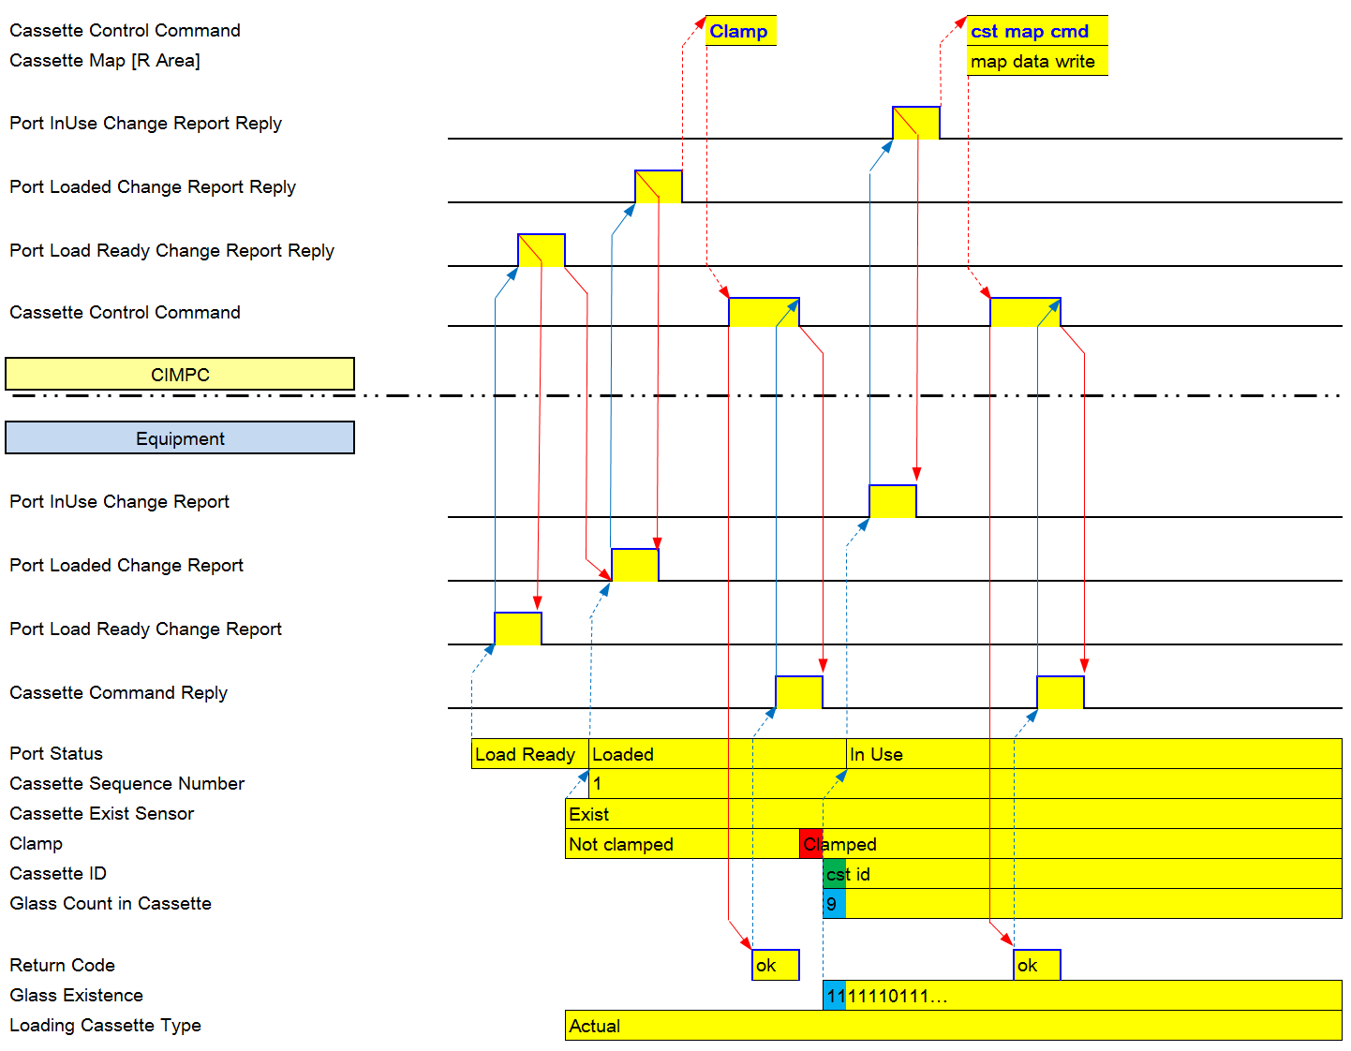

Figure 6-5 Cassette Normal Scenario
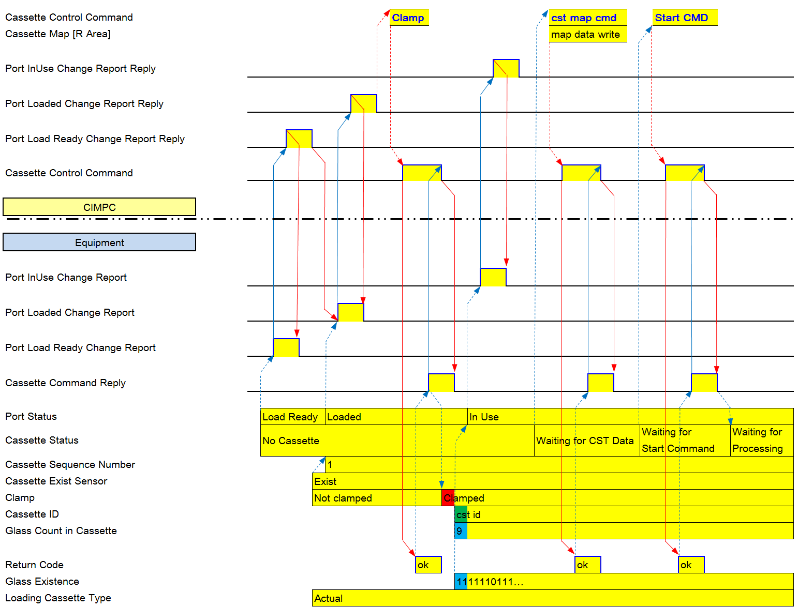

Figure 6-6 Feeder Cassette Normal Scenario

      - Unclamp
Unclamp command has to send to equipment when port status is ‘loaded’ or ‘In Use’
And Equipment can send to EAS Port Status ‘Abort/Cancel’ when need to abort/cancel the cassette on the Port.
Equipment should provide ‘Abort’, ‘Cancel’ button for operator.

When Cassette ID validate on port, EAS automatically has to unclamp if cassette ID mismatched Details are to be indexer operation scenario

- When Port status is in use

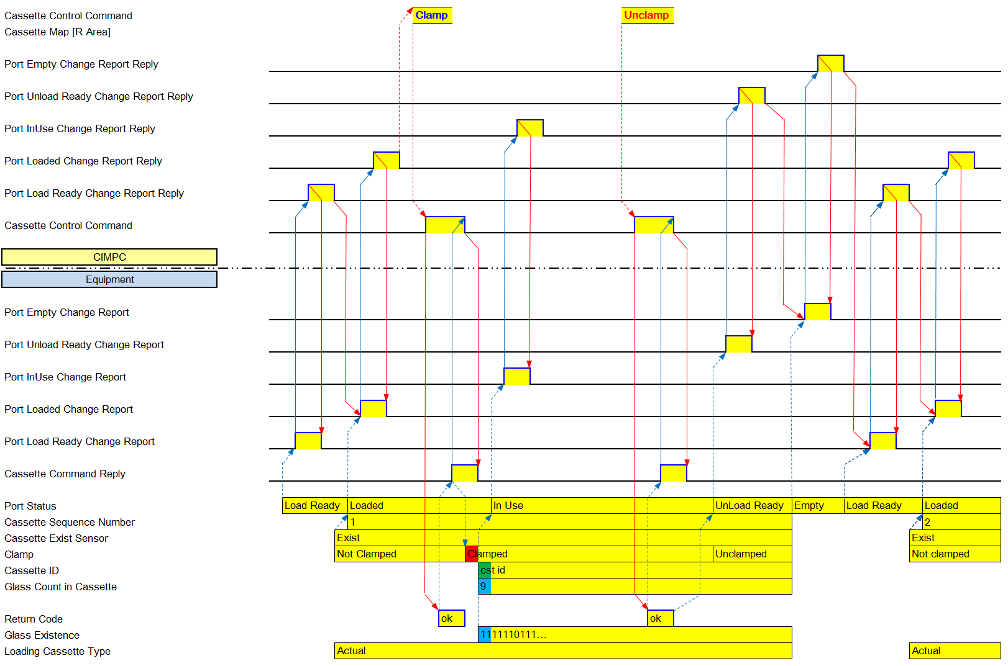

Figure 6-7 Unclamp Scenario 1

- When Port Status is loaded

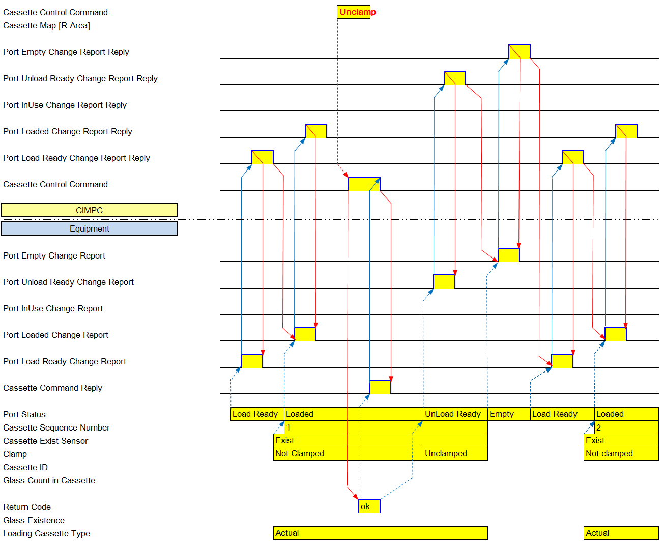

Figure 6-8 Unclamp Scenario 2

- When unclamp request on equipment touch panel

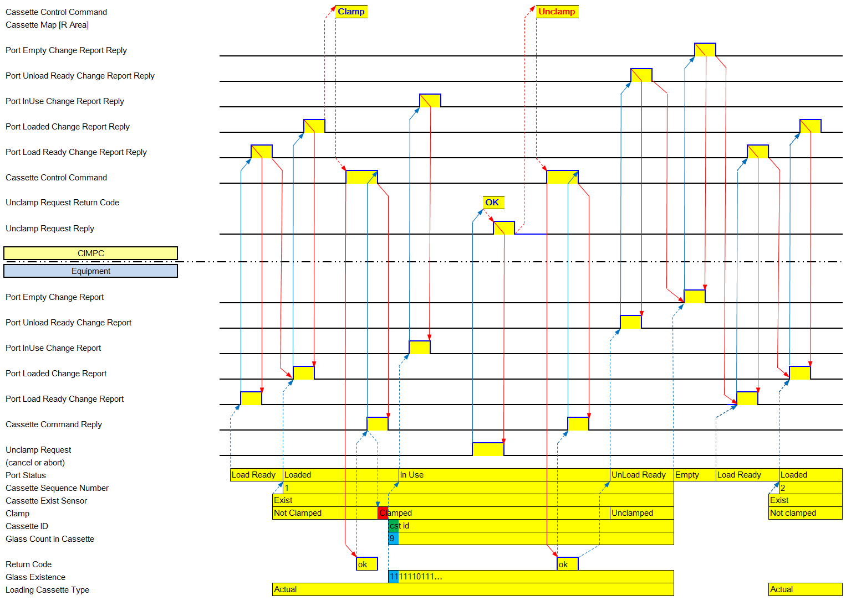

Figure 6-9 Unclamp Scenario 3

      - Clamp/Unclamp
When port status is ‘Unload Ready’

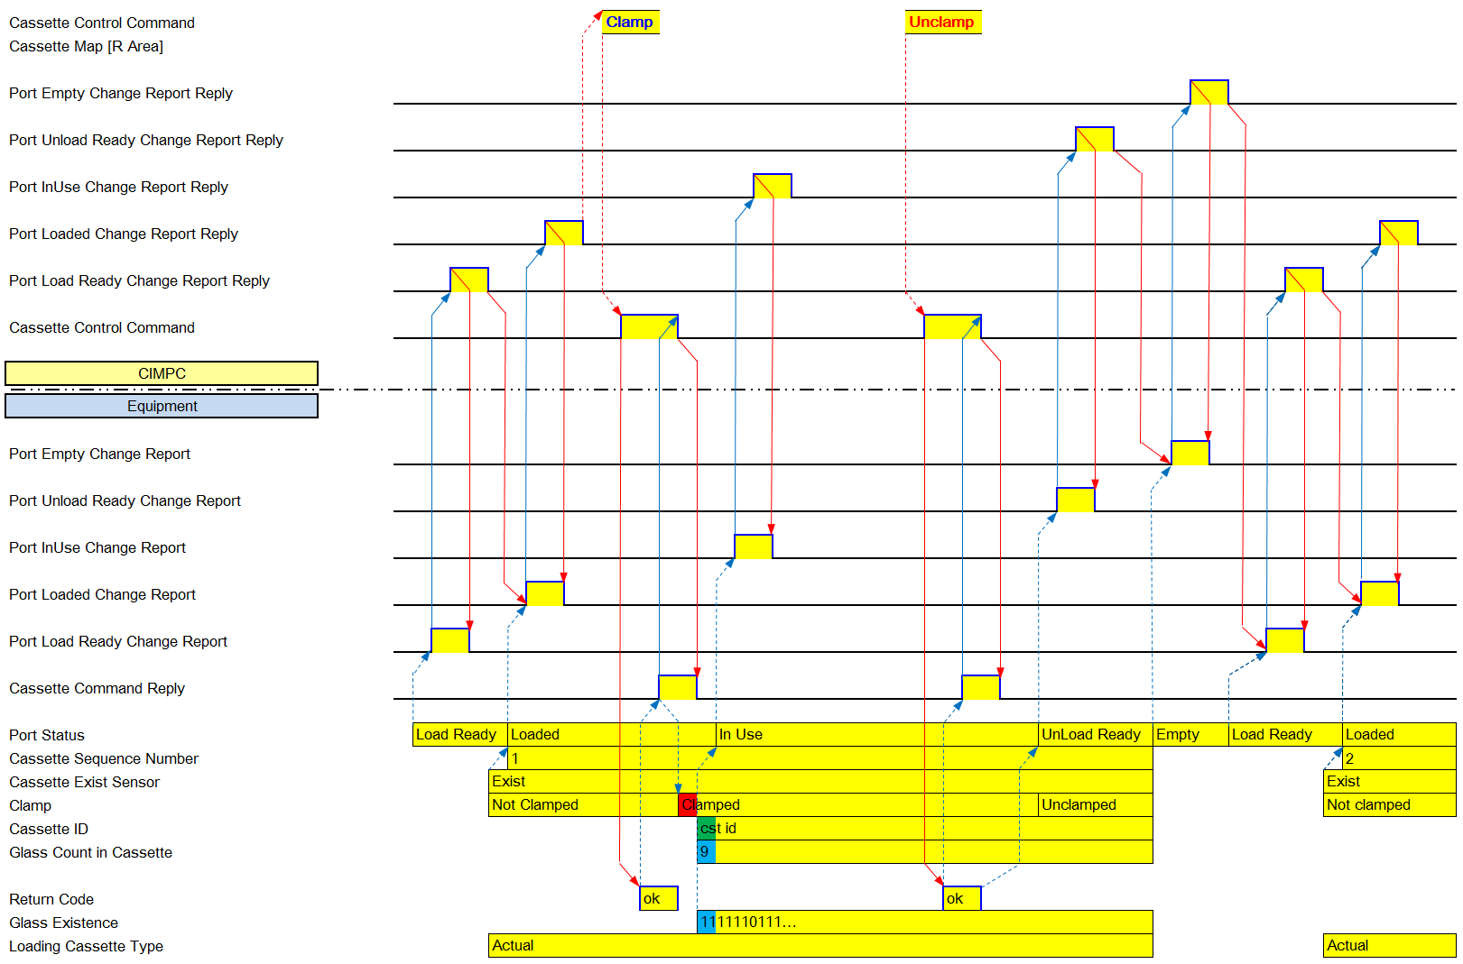

Figure 6-10 Clamp/Unclamp Command

      - Clamp/Reclamp
1) When port status is ‘InUse’

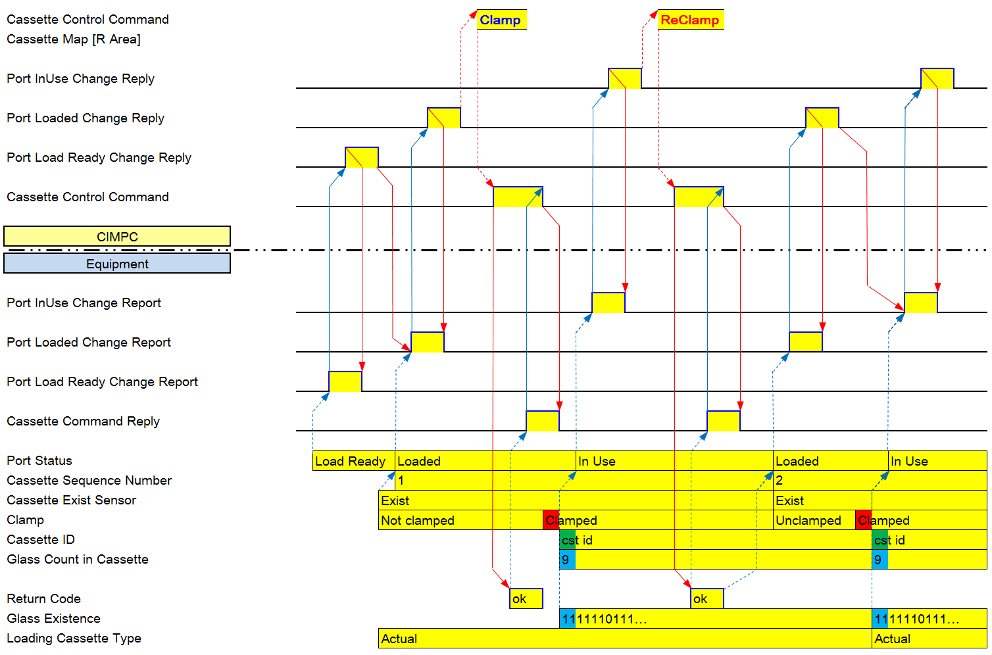
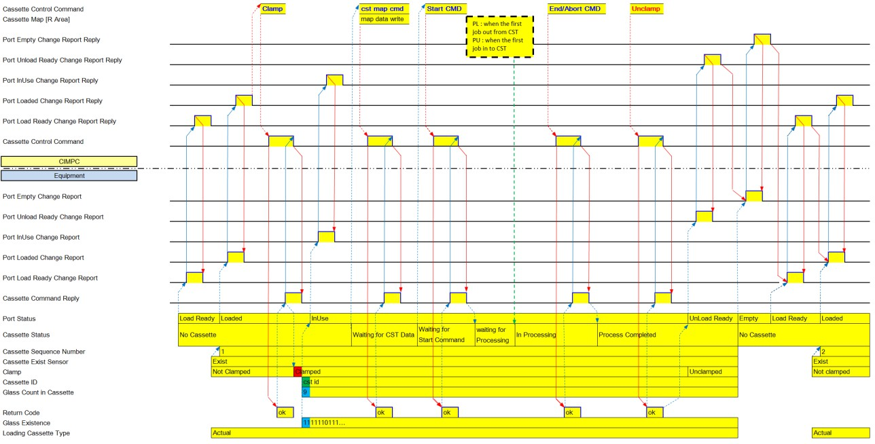

Figure 6-11 ReClamp Scenario

      - Unclamp (Feeder Type or Independent Type Indexer or Local Dispatching Mode)

Figure 6-12 Cassette Process End or Cassette Process Abort

Port WIP Management
Equipment is required to manage real time WIP (Job existence in each slot) in cassette on each Port.
- When received Cassette Map Download from Host, EQP writes Port WIP data.
- Update Port WIP data when a Job is fetched out and/or stored into the cassette.
  - remove Job existence from Port WIP data when the Job is fetched out
  - add Job existence to Port WIP data when the Job is stored in cassette on the Port
- Equipment has to manage Port WIP data in real-time according to actual Job existence status, regardless of CIM operation mode (online/offline, auto/manual, etc.)
- This requirement applies to Port in Indexer (Loader, Unloader) and Buffer that is accessed by transfer module of Indexer

PLC MAP
      - Local PLC – File Register(R Area)

Block | Item | Points | Type | Format | Sub Items
Port #1 WIP Data Block | Slot#1 Cassette Sequence No | 1 | Data | INT | 1~65535
Port #1 WIP Data Block | Slot#1 Job Sequence No | 1 | Data | INT | 1~65535
Port #1 WIP Data Block | Slot#1 Processing State | 1 | Data | INT | - Port Type : PB , PP  - : Waiting process(glass exist)  - : Process completed ( The glass is got from Process Equipment)  - : Processing( The glass is not exist in this CST and when Robot get the glass; or In Process Equipment)  -Port Type : PL  - : Waiting process(glass exist)  - : Process completed (The glass is not exist in this CST and when Robot get the glass; or In Process Equipment)  -Port Type : PU, PP  - : Waiting process(glass not exist)  - : Process completed ( The glass is got from Process Equipment)
Port #1 WIP Data Block | Slot#N Cassette Sequence No | 1 | Data | INT | 1~65535
Port #1 WIP Data Block | Slot#N Job Sequence No | 1 | Data | INT | 1~65535
Port #1 WIP Data Block | Slot#N Processing State | 1 | Data | INT | Same as Slot#1 Processing State
Port #N WIP Data Block | Same to Port#1 WIP Data Block

Port Cassette Size (only End Cell)
Indexer can set the Port Cassette Size(X, Y) value on touch screen. If Cassette Status unclamp, Port Cassette Size set

PLC MAP
      - Local PLC – Link Register (W Area)

Block | Item | Points | Type | Format | Sub Items
Port#1 Block | Port Cassette Size X | 1 | Data | INT | 1~65535
Port#1 Block | Port Cassette Size Y | 1 | Data | INT | 1~65535
… | …
Port#N Block | Port Cassette Size X | 1 | Data | INT | 1~65535
Port#N Block | Port Cassette Size Y | 1 | Data | INT | 1~65535

      - Local PLC – Link Relay (B Area)

Block | Item | Points | Type | Sub Items | Related Word Items | Master (EAS)
Port Event | Port #1 Port Cassette Size Change Report | 1 | Event | - On: Fire Event  - Off: Event End/Timeout | Port#1 Block  *That Item : Port Cassette Size X, Y | Reply for Receiving
Port Event | …
Port Event | Port #N Port Cassette Size Change Report | 1 | Event | - On: Fire Event  - Off: Event End/Timeout | Port#N Block | Reply for Receiving

      - Master (EAS) – Link Relay (B Area)

Block | Item | Points | Type | Sub Items | Related Word Items | Local PLC Action
Port Event Reply | Port #1 Port Cassette Size Change Report Reply | 1 | Reply | - On: Reply  - Off: Reply End
Port Event Reply | …
Port Event Reply | Port #N Port Cassette Size Change Report Reply | 1 | Reply | - On: Reply  - Off: Reply End

Robot Management

Robot Control Command

Command format
One command is composed of up to four (4) command items of unit movement. If more than one (1) command items are included, equipment has to conduct each item consecutively without unnecessary time gap between the movement.
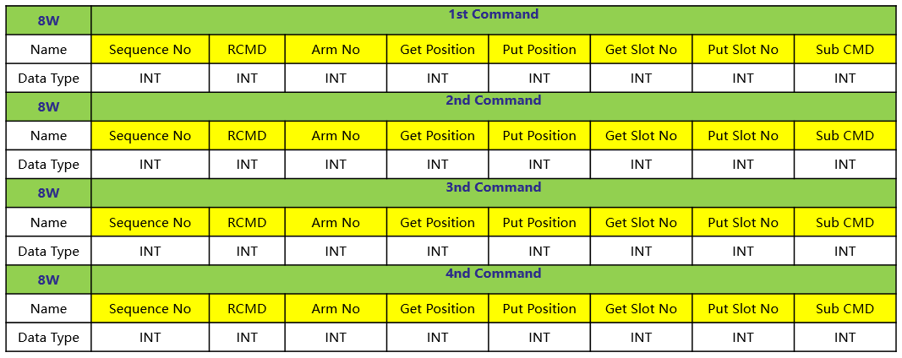

Figure 7-1 Command Format
- SequenceNo : Command sequence number generated for each command by EAS.
- RCMD : Robot Command
- Arm No : Robot Arm number. Arm number increases from bottom to up or from left to right at the same indexer.
- Get Position : If robot is received the Get command, Robot should move here.
- Put Position : If robot is received the Put command, Robot should move here.
- Get Slot No : If robot is received the Get command, it is Glass position in cassette
If robot arm move more than one at the same time, Slot No is the Arm No#1 to work with here.
- Put Slot No : If robot is received the Put command, it is Glass position in cassette
If robot arm move more than one at the same time, Slot No is the Arm No#1 to work with here.
- Sub CMD : Preparatory action

Sub CMD
None | 0 | No pre-action
Get Ready | 1 | Indexer robot moves and waits until it can execute get action
Put Ready | 2 | Indexer robot moves and waits until it can execute put action

Data Description
RCMD Arm No Index (Position /Slot)

None | 0 | None | 0 | Position | 0 ~ 65535
Robot Home  (with Robot Arm Home) | 1
Transfer (from-to) | 2
 |  |  |  | Slot No | 1 ~ 65535
Move (to) | 3 | Arm #1 | 1
Get | 4 | Arm #2 | 2
Put | 5 | All arm | 99
Exchange | 6
Two Action Exchange  (required for a specific equipment only) | 7
Command Clear | 8
Batch Get | 9
Batch Put | 10

- Put : Indexer arm un-loads its glass onto the unit of counter stream Equipment.
- Get : Indexer arm loads a glass onto its one of arms from the unit of counter stream Equipment.
- Transfer(from-to) : Indexer executes get command at the get-position, moves and put command at the put- position
- Move(to) : Indexer robot moves to the specific position
- Exchange : Default exchange command.
- Two action exchange : Indexer executes exchange command with z-axis moving.
This function is used only for selected equipment where this specific instruction is required by equipment vendor
- Batch Get/Put : Two or more robot arms conducts get or put action simultaneously(one-action), sequentially(two-action)

Command Example :

RCMD |  | Arm No | Get Position | Put Position | Get Slot No | Put Slot No | Sub CMD
Robot Home | 1 | - | - | - | - | - | --
Transfer (from- to) | 2 | O  (to get & put) | O (From) | O (To) | O (From) | O (To) | -
Move(to) | 3 | O  (to get) | O |  | O |  | Get Ready, | Wait Front to Get,
Move(to) | 3 | O  (to put) |  | O |  | O | Put Ready | Wait Front to Put
Get | 4 | O | O | - | O | - | -
Put | 5 | O | - | O | - | O | -
One Action Exchange | 6 | O (Get Arm No) | O | O | O | O | - | Get, Put position is same

Command Clear | 8 | - | - | - | - | - | --
Batch Get | 9 | O (All ) | O (Get) |  | O  (lowest slot no) |  | -
Batch Put | 10 | O (All) |  | O (Put) |  | O  (lowest slot no) | -

Robot CMD Ack

CODE | Comment | operation | Description
1 | Ack is OK
2 | Busy, Try again |  | When Command is executing and Command Buffer exists Command
3 | CIM Mode is OFF
4 | Command is already executing | Ignore | When the same command is present in Command or Command Buffer
5 | At least one parameter invalid | Check the parameter | When Command parameter is wrong
6 | Cannot perform now  (Hardware problem) |  | When the problem occurred in Robot
7 | Glass exist in slot |  | In case, Unloading
8~20 | Reserved
21~99 | Vendor Define

PLC MAP
      - Local PLC – Link Register (W Area)

Block | Item | Points | Type | Format | Sub Items
Robot CMD Reply Block | Robot CMD Sequence No | 1 | Data | INT | This is 1st Sequence No
Robot CMD Reply Block | Robot CMD Ack | 1 | Data | INT | - : Ack is OK  - : Busy, Try again  - : CIM Mode is OFF  - : Command is already executing  - : At least on parameter invalid  - : Cannot perform now 7~20: Reserved  21~99: Vendor Define

      - Local PLC – Li nk Relay(B Area)

Block | Item | Points | Type | Sub Items | Related Word Items | Master (EAS)
Robot Event | Robot CMD Reply | 1 | Event | - On: Fire Event  - Off: Event End | Robot CMD Reply  Block | Reply for Receiving

      - Master (EAS) – Link Register (W Area)

Block | Item | Points | Type | Format | Sub Items
Robot CMD Block | 1st Sequence No | 1 | Data | INT
Robot CMD Block | 1st RCMD | 1 | Data | INT | - : Robot Home  - : Transfer  - : Move  - : Get  - : Put  - : One Action Exchange 7: Two Action Exchange: 8: Command Clear  9: Batch Get  10 Batch Put
Robot CMD Block | 1st Arm No | 1 | Data | INT | 1 : Arm #1 (lower)  2 : Arm #2 (upper)

Block | Item | Points | Type | Format | Sub Items
 | 1st Get Position | 1 | Data | INT
 | 1st Put Position | 1 | Data | INT
 | 1st Get Slot No | 1 | Data | INT
 | 1st Put Slot No | 1 | Data | INT
 | 1st Sub CMD | 1 | Data | INT | - : Get Ready  - : Put Ready
 | 2st Sequence No  … … | 1 | Data | INT | Same as 1st Sequence No
 | 3st Sequence No  … … | 1 | Data | INT | Same as 1st Sequence No
 | 4st Sequence No | 1 | Data | INT | Same as 1st Sequence No
 | 4th RCMD | 1 | Data | INT
 | 4thArm No | 1 | Data | INT
 | 4th Get Position | 1 | Data | INT
 | 4th Put Position | 1 | Data | INT
 | 4th Get Slot No | 1 | Data | INT
 | 4th Put Slot No | 1 | Data | INT
 | 4th Sub CMD | 1 | Data | INT
      - Master EAS – Link Relay (B Area)

Block | Item | Points | Type | Sub Items | Related Word Items | Local PLC Action)
Robot CMD | Robot CMD | 1 | CMD | - On: Fire Event  - Off: Event End | Robot CMD Block | If robot is received the Robot command, Robot should execute

Robot Command Buffer
- EAS sends Robot/Conveyor command to INDEXER/CONVEYOR CONTROLLER.
- CONTROLLER prepares internal command buffer for buffering EAS command.
- When current sequence of robot action is completed, controller fetches the command from the internal command buffer.
- EAScould download command anytime.
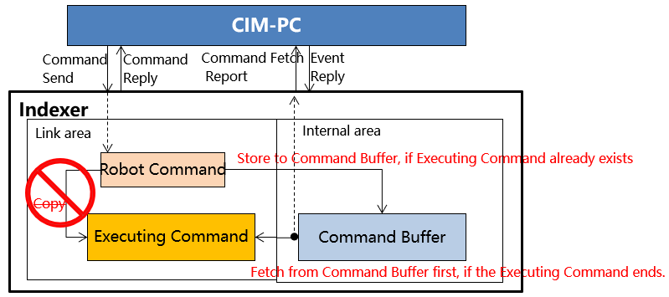

Command Fetch Report
When Indexer fetches command from command buffer, should report Command Fetch Repot

PLC MAP
      - Local PLC – Link Register (W Area)

Block | Item | Points | Type | Format | Sub Items
Robot CMD Fetch Block | Robot CMD Sequence No | 1 | Data | INT
Robot CMD Fetch Block | RCMD | 1 | Data | INT
Robot CMD Fetch Block | Arm No | 1 | Data | INT | - : Arm #1 (lower)  - : Arm #2 (upper)
Robot CMD Fetch Block | Get Position | 1 | Data | INT
Robot CMD Fetch Block | Put Position | 1 | Data | INT
Robot CMD Fetch Block | Get Slot No | 1 | Data | INT
Robot CMD Fetch Block | Put Slot No | 1 | Data | INT
Robot CMD Fetch Block | Sub CMD | 1 | Data | INT | - : Get Ready  - : Put Ready

      - Local PLC – Link Relay (B Area)

Block | Item | Points | Type | Sub Items | Related Word Items | Master (EAS)
Robot Event | Robot CMD Fetch Report | 1 | Event | - On: Fire Event  - Off: Event End | Robot CMD Fetch Block | Reply for Receiving

      - Master (EAS) – Link Register (W Area)
none.
      - Master (EAS) – Link Relay (B Area)

Block | Item | Points | Type | Sub Items | Related Word Items | Local PLC Action
Robot Event Reply | Robot CMD Fetch Reply | 1 | Reply | - On: Reply  - Off: Reply End |  | Reply for Receiving

When Indexer command buffer fetched command, Command Fetch Repot send to EAS.

Command Result Report
The indexer must be report the execution result of Robot Control Command that it is occurred by group of commands even if a lot of command of robot is executed. If the result is NG then the indexer has to OPCall.
For example, if EAS send to equipment by one command with get , put command , Equipment should report to EAS by one event with get ,put command result.
Robot CMD Sequence No is 1st Sequence No.

PLC MAP
      - Local PLC – Link Register (W Area)

Block | Item | Points | Type | Format | Sub Items
 | Robot CMD Sequence No | 1 | Data | INT | 1 ~ 65535
 | 1st CMD Result Data | 1 | Data | INT | 0: None
 | 2nd CMD Result Data | 1 | Data | INT | 1 : OK
 | 3rd CMD Result Data | 1 | Data | INT | 2 : EQ Link Signal NG (Downstream Receive Able
 |  |  |  |  | OFF)
 | 4th CMD Result Data |  |  |  | OFF)
Robot CMD |  |  |  |  | 3 : EQ Link Signal NG (Send Start not ON)
Result Data |  |  |  |  | 4 : Link Signal Timeout (T1)
Block |  |  |  |  | 5 : put error when the Exchange executes for
 |  | 1 | Data | INT | special that CVD only
 |  |  |  |  | 6 : others
 |  |  |  |  | 7: Link Signal Initial (Only use Ecell)
 |  |  |  |  | 99 : *PASS (Only use Ecell)
 | Robot Position | 1 | Data | INT | Refer to Robot Position
* Loader need Auto-Scan function because it doesn’t slot sensor and Arm of robot must get first slot.
Robot get not first slot, than dangerous because between slot and slot very narrow in Ecell.
When Arm of robot get, if slot is empty than Arm of robot is go up to next slot by Auto-Scan function And loader have to report Robot CMD Result Data Block Sub Items is “99”
      - Local PLC – Link Relay (B Area)

Block | Item | Points | Type | Sub Items | Related Word Items | Master (EAS)
Robot Event | Robot CMD Result Report | 1 | Event | - On: Fire Event  - Off: Event End | Robot CMD Result Data Block | Reply for Receiving

      - Master (EAS) – Link Relay (B Area)

Block | Item | Points | Type | Sub Items | Related Word Items | Local PLC Action
Robot Event Reply | Robot Result Report Reply | 1 | Reply | - On: Reply  - Off: Reply End

Robot Arm Event
- Robot Arm Load Report:
Report Timing: When the glass is loaded on robot arm, the indexer should report Arm Load Report.
- Robot Arm Unload Report
Report Timing: When the glass is unloaded from robot arm, the indexer should report Arm Unload Report.

PLC MAP
      - Local PLC – Link Register (W Area)

Block | Item | Points | Type | Format | Sub Items
Robot Arm Job Data Block | 1st Arm CST Sequence No | 1 | Data | INT
Robot Arm Job Data Block | 1st Arm Job Sequence No | 1 | Data | INT
Robot Arm Job Data Block | 2nd Arm CST Sequence No | 1 | Data | INT
Robot Arm Job Data Block | 2nd Arm Job Sequence No | 1 | Data | INT
Robot Arm Job Data Block | 3rd Arm CST Sequence No | 1 | Data | INT
Robot Arm Job Data Block | 3rd Arm Job Sequence No | 1 | Data | INT
Robot Arm Job Data Block | 4th Arm CST Sequence No | 1 | Data | INT
Robot Arm Job Data Block | 4th Arm Job Sequence No | 1 | Data | INT
Robot Arm Job Data Block | Arm No | 1 | Data | INT | - : Arm #1 (lower)  - : Arm #2 (upper)
Robot Arm Job Data Block | Robot Position | 1 | Data | INT

      - Local PLC – Link Relay (B Area)

Block | Item | Points | Type | Sub Items | Related Word Items | Master (EAS)
Robot Event | Robot Arm Substrate Load Report | 1 | Event | - On: Fire Event  - Off: Event End | Robot Arm Job Data Block | Reply for Receiving
Robot Event | Robot Arm Substrate Unload Report | 1 | Event | - On: Fire Event  - Off: Event End | Robot Arm Job Data Block | Reply for Receiving

      - Master (EAS) – Link Relay (B Area)

Block | Item | Points | Type | Sub Items | Related Word Items | Local PLC Action

Block | Item | Points | Type | Sub Items | Related Word Items | Local PLC Action
Robot Event Reply | Robot Arm Substrate Load Reply | 1 | Event | - On: Fire Event  - Off: Event End |  | Reply for Receiving
Robot Event Reply | Robot Arm Substrate Unload Reply | 1 | Event | - On: Fire Event  - Off: Event End |  | Reply for Receiving

Robot Monitoring Block
Robot Arm Monitoring is area to real-time monitoring the glass information on robot arms. The indexer should update the CST Sequence No/ Job Sequence No to real-time Robot Arm Monitoring Block when glass does exist or glass does not exist. If glass does not exist then CST Sequence No/ Job Sequence No is zero.

PLC MAP
      - Local PLC – Link Register (W Area)

Block | Item | Points | Type | Format | Sub Items
Robot Arm Monitoring  Block | Robot Arm#01 Cassette Sequence No | 1 | Data | INT
Robot Arm Monitoring  Block | Robot Arm#01 Job Sequence No | 1 | Data | INT
Robot Arm Monitoring  Block | Robot Arm#02Cassette Sequence No | 1 | Data | INT
Robot Arm Monitoring  Block | Robot Arm#02Job Sequence No | 1 | Data | INT
Robot Arm Monitoring  Block | Robot Arm#03Cassette Sequence No | 1 | Data | INT
Robot Arm Monitoring  Block | Robot Arm#03Job Sequence No | 1 | Data | INT
Robot Arm Monitoring  Block | Robot Arm#04Cassette Sequence No | 1 | Data | INT
Robot Arm Monitoring  Block | Robot Arm#04Job Sequence No | 1 | Data | INT

Dispatching Mode

Auto Dispatching
- EAS Dispatching Mode : This mode is that EAS controls Indexer robot. EAS should send robot control command to Indexer.
- Local Dispatching Mode : This mode is that EAS don’t control Indexer robot. EAS should not send robot control command to Indexer. Indexer robot should transfer the glass by own Indexer equipment.
When if equipment receives mode change command from EAS or mode change is set at equipment touch panel, and at that time while Robot is conducting a dispatching movement, the Mode change should be activated after Robot finishes current dispatching command. And also the mode has to be changed when all port of loader is unclamped but the unloader is decided by Operator.
At least One Mode need to On, but It can’t both mode On same time(EAS On -> Local OFF, EAS Off -> Local On)

Robot Control Mode (Indexer Only).
- Manual Mode : This is to control Job dispatching by manual at equipment. At this Mode, EAS will not download Robot Command for auto dispatching
- Auto Mode : This is to control Job dispatching by automatic Robot Command from EAS.

At least One Mode need to On, but It can’t both mode On same time(Manual On -> Auto OFF, Manual Off -> Auto On)

PLC MAP
      - Local PLC – Link Register (W Area)

Block | Item | Points | Type | Format | Sub Items
Indexer Dispatching Mode Block | Dispatching Mode | 1 | Data | INT | - : EAS  - : Local
Indexer Dispatching Mode Block | Robot Control Mode | 1 | Data | INT | - : Auto  - : Manual
Indexer Dispatching Mode Return Block | Return Code | 1 | Data | INT | - : OK  - : NG Equipment error  - : NG other OP is working

      - Local PLC – Link Relay (B Area)

Block | Item | Points | Type | Sub Items | Related Word Items | Master (EAS)
Indexer Event | Dispatching Mode Change Report | 1 | Event | - On: Fire Event  - Off: Event End | Indexer Dispatching Mode Block  -Dispatching Mode | Reply for Receiving
Indexer Event | Robot Control Mode Change Report | 1 | Event | - On: Fire Event  - Off: Event End | Indexer Dispatching Mode Block  -Robot Control Mode | Reply for Receiving
Indexer Command Reply | Dispatching Mode Command Reply | 1 | Event | - On: Fire Event  - Off: Event End | Indexer Dispatching Mode Return Block | Reply for Command
      - Master (EAS) – Link Register (W Area)

Block | Item | Points | Type | Format | Sub Items
Indexer Dispatching Mode Command Block | Dispatching Mode | 1 | Data | INT | - : EAS  - : Local
      - Master (EAS) – Link Relay (B Area)

Block | Item | Points | Type | Sub Items | Related Word Items | Local PLC Action
Indexer Command | Dispatching Mode Change Command | 1 | CMD | - On: Fire Event  - Off: Event End | Indexer Dispatching Mode Command Block
Indexer | Dispatching Mode | 1 | Event | - On: Fire Event
Event Reply | Change Report Reply |  |  | - Off: Event End
Event Reply | Robot Control Mode Change Report Reply | 1 | Event | - On: Fire Event  Off: Event End

Robot Position
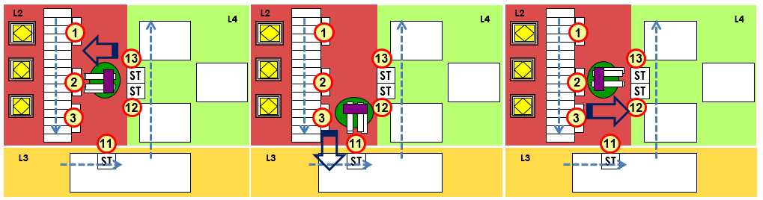

Number Assignment Rule: The position number of the robot is given to In/Out Station. Ref –Equipment Operation Scenario
Unit or buffer Position in Indexer is from 90 to 99.

Monitoring Block

C/V Monitoring
C/V Monitoring is area to real-time monitoring by Indexer This area is used to glass dispatch by EAS.
The indexer should write Cassette Sequence Number and Job Sequence Number at the plc address before send able signal turns on.
* Send able & Receive able Signal, refer to Link Signal Specification section 1.1
If glass does not exist on C/V then cassette sequence no & job sequence number is zero.

Block | Item | Points | Type | Format | Sub Items
C/V Monitoring #1 Block | CV Slot#1 Cassette Sequence No | 1 | Data | INT
C/V Monitoring #1 Block | CV Slot#1 Job Sequence No | 1 | Data | INT
C/V Monitoring #1 Block | CV Slot#2 Cassette Sequence No | 1 | Data | INT
C/V Monitoring #1 Block | CV Slot#2 Job Sequence No | 1 | Data | INT
C/V Monitoring #2 Block | Same as C/V Monitoring #1 Block | 4 | Data | -
C/V Monitoring #3 Block | Same as C/V Monitoring #1 Block | 4 | Data | -
C/V Monitoring #4 Block | Same as C/V Monitoring #1 Block | 4 | Data | -
C/V Monitoring #5 Block | Same as C/V Monitoring #1 Block | 4 | Data | -
C/V Monitoring #6 Block | Same as C/V Monitoring #1 Block | 4 | Data | -
C/V Monitoring #7 Block | Same as C/V Monitoring #1 Block | 4 | Data | -
C/V Monitoring #8 Block | Same as C/V Monitoring #1 Block | 4 | Data | -

Buffer Monitoring
* ODF equipment will use separate data are for Buffer monitoring (refer to ODF special section)

Equipment should update the Cassette Sequence No & Job Sequence No to real-time at Buffer Monitoring when glass is stored or glass is fetched out.
If glass does not exist at buffer slot then cassette sequence no & job sequence no is zero.

      - Local PLC – Link Register (R Area)
It is used the Buffer Monitoring Block in order to viewing the Buffer in Indexer when operator want to see on user interface; Such as EAS UI or Equipment touch screen.

Block | Sub Section | Item | Points | Type | Format | Sub Items
 |  | Buffer Slot#1 Cassette Sequence No | 1 | Data | INT
 |  | Buffer Slot#1 Job Sequence No | 1 | Data | INT
 |  | Buffer Slot#1 Glass ID or Panel ID | 10 | Data | ASC | GlassID
 |  | Buffer Slot#1 Dummy Type | 1 | Data | INT | This item is available when Job Type is Dummy.
 |  |  |  |  |  | 0: TFT
 |  |  |  |  |  | 1: CF
 |  | Buffer Slot#1 Job Type | 1 | Data | INT | 2: Dummy
 |  |  |  |  |  | 3: All
 |  |  |  |  |  | 4: POL
 |  |  |  |  |  | 5: Reserved
 |  | Buffer Slot#1 Used Count(only  dummy) | 1 | Data | INT | Only for Dummy
Buffer #1 Monitoring Block | Slot#1
Buffer #1 Monitoring Block | Slot#1 | Buffer Slot#1 Start Time  : Stored time | 3 | Data | BCD | 00 ~ 07 Bit :A.D Year(00~99)  08 ~ 15 Bit :Month(01~12)
 |  |  |  | Data | BCD | 00 ~ 07 Bit :Day(01~31)  08 ~ 15 Bit :Hour(00~23)
 |  |  |  | Data | BCD | 00 ~ 07 Bit :Minute(00~59)
 |  |  |  |  |  | 08 ~ 15 Bit :Second(00~59)
 |  | Buffer Slot#1 Expired Time(only dummy) |  | Data | BCD | 00 ~ 07 Bit :A.D Year(00~99)  08 ~ 15 Bit :Month(01~12)
 |  | * This item is used by set expired count by equipment (Operator) which is the time after move to buffer when the dummy reach to expired count. | 3 | Data | BCD | 00 ~ 07 Bit :Day(01~31)  08 ~ 15 Bit :Hour(00~23)
 |  |  |  | Data | BCD | 00 ~ 07 Bit :Minute(00~59)  08 ~ 15 Bit :Second(00~59)
 |  |  |  |  |  | 0: Normal
 |  | Buffer Slot#1 State | 1 | Data | INT | 1: NG
 |  |  |  |  |  | 9: Disable
 | ~ Slot #n | Same as above
Buffer #N Monitoring Block |  | Same as Buffer #1 Monitoring Block | 23 | Data | -

This is for Pol only

Block | Sub Section | Item | Points | Type | Format | Sub Items
Buffer #1 Monitoring Block | Slot#1 | Buffer Slot#1 Cassette Sequence No | 1 | Data | INT
Buffer #1 Monitoring Block | Slot#1 | Buffer Slot#1 Job Sequence No | 1 | Data | INT
Buffer #1 Monitoring Block | Slot#1 | Buffer Slot#1 POL ID | 10 | Data | ASC
Buffer #1 Monitoring Block | Slot#1 | Buffer Slot#1 Dummy Type | 1 | Data | INT | This item is available when Job Type is Dummy.
Buffer #1 Monitoring Block | Slot#1 | Buffer Slot#1 Job Type | 1 | Data | INT | 0: TFT  1: CF

Block | Sub Section | Item | Points | Type | Format | Sub Items
2: Dummy
3: All
4: POL
5: Reserved
 |  | ProductID | 10 | Data | ASC
 |  | POL Size Width | 2 | Data | F | POL Size Width
 |  | POL Size Height | 2 | Data | F | POL Size Height
 | ~ Slot #n | Same as above
Buffer #N Monitoring Block |  | Same as Buffer #1 Monitoring Block | 28 | Data | -

      - Local PLC – Link Register (W Area)
It is used the Buffer Monitoring Block in order to dispatch the glass on indexer with buffer.

Block | Sub Section | Item | Points | Type | Format | Sub Items
Buffer #1 WIP Data Block | Slot#1 | Buffer Slot#1 Cassette Sequence No | 1 | Data | INT
Buffer #1 WIP Data Block | Slot#1 | Buffer Slot#1 Job Sequence No | 1 | Data | INT
Buffer #1 WIP Data Block | ~ Slot #n | Same as above
Buffer #N WIP Data Block |  | Same as Buffer #1 WIP Data Block | 2 | Data | -

This is for POL only

Block | Sub Section | Item | Points | Type | Format | Sub Items
Buffer #1 WIP Data Block | Slot#1 | Buffer Slot#1 Cassette Sequence No | 1 | Data | INT
Buffer #1 WIP Data Block | Slot#1 | Buffer Slot#1 Job Sequence No | 1 | Data | INT
Buffer #1 WIP Data Block |  | Product ID | 10 | Data | ASC
Buffer #1 WIP Data Block |  | POL Size Width | 2 | Data | F | POL Size Width
Buffer #1 WIP Data Block |  | POL Size Height | 2 | Data | F | POL Size Height
Buffer #1 WIP Data Block | ~ Slot #n | Same as above
Buffer #N WIP Data Block |  | Same as Buffer #1 WIP Data Block | 2 | Data | -

Indexer Monitoring
8.3.1.1 Local PLC – Link Register (B Area)

Section | Sub Section | Item | Size(Bit) | Comment
Indexer Monitoring Status | Robot Status (8 Bit) | Setup | 1
Indexer Monitoring Status | Robot Status (8 Bit) | Idle  [When Robot has no command to conduct] | 1
Indexer Monitoring Status | Robot Status (8 Bit) | Run  [When Robot is received Robot Command, and robot action something.] | 1
Indexer Monitoring Status | Robot Status (8 Bit) | Pause | 1
Indexer Monitoring Status | Robot Status (8 Bit) | Stop | 1
Indexer Monitoring Status | Robot Status (8 Bit) | Moving | 1 | 1:Robot Move Start  0:Robot Move End
Indexer Monitoring Status | Robot Status (8 Bit) | Reserved | 1
Indexer Monitoring Status | Robot Status (8 Bit) | Reserved | 1
Indexer Monitoring Status | Robot Position (8 Bit) | 0 Bit | 1 | 1
Indexer Monitoring Status | Robot Position (8 Bit) | 1 Bit | 1 | 2
Indexer Monitoring Status | Robot Position (8 Bit) | 2 Bit | 1 | 4
Indexer Monitoring Status | Robot Position (8 Bit) | 3 Bit | 1 | 8
Indexer Monitoring Status | Robot Position (8 Bit) | 4 Bit | 1 | 16
Indexer Monitoring Status | Robot Position (8 Bit) | 5 Bit | 1 | 32
Indexer Monitoring Status | Robot Position (8 Bit) | 6 Bit | 1 | 64
Indexer Monitoring Status | Robot Position (8 Bit) | Reserved | 1
Indexer Monitoring Status | CV #1 State | Send Ready | 1
Indexer Monitoring Status | CV #1 State | Receive Ready | 1
Indexer Monitoring Status | CV #1 State | Exchange Enable | 1
Indexer Monitoring Status | CV #2 State | Send Ready | 1
Indexer Monitoring Status | CV #2 State | Receive Ready | 1
Indexer Monitoring Status | CV #2 State | Exchange Enable | 1
Indexer Monitoring Status | CV #3 State | Send Ready | 1
Indexer Monitoring Status | CV #3 State | Receive Ready | 1
Indexer Monitoring Status | CV #3 State | Exchange Enable | 1
Indexer Monitoring Status | CV #4 State | Send Ready | 1
Indexer Monitoring Status | CV #4 State | Receive Ready | 1
Indexer Monitoring Status | CV #4 State | Exchange Enable | 1
Indexer Monitoring Status | CV #5 State | Send Ready | 1
Indexer Monitoring Status | CV #5 State | Receive Ready | 1
Indexer Monitoring Status | CV #5 State | Exchange Enable | 1
Indexer Monitoring Status | CV #6 State | Send Ready | 1
Indexer Monitoring Status | CV #6 State | Receive Ready | 1
Indexer Monitoring Status | CV #6 State | Exchange Enable | 1
Indexer Monitoring Status | CV #7 State | Send Ready | 1
Indexer Monitoring Status | CV #7 State | Receive Ready | 1

 |  | Exchange Enable | 1
 | CV #8 State | Send Ready | 1
 | CV #8 State | Receive Ready | 1
 | CV #8 State | Exchange Enable | 1
 | CV #8 State | Reserved | 8
 | Arm State | Arm #1 | 1 | - : Off (Disable)  - : On (Enable)
 | Arm State | Arm #2 | 1 | - : Off (Disable)  - : On (Enable)
Total |  |  | 64

Position State Monitoring
Position is a specific location in equipment where Job is placed, which could be a Unit, Sub Unit or a specific location in Unit/Sub Unit. The exact location of each Position is to be determined by engineer.
Equipment should update in real-time for Job existence state at each Position. If Job does not exist in a specific Position, then cassette sequence no & job sequence no for the corresponding data should be zero.

For example) Position Definition
-Indexer
- Position 01~02 : Arm#1 ~ Arm#2

-Process Equipment
- Position 01~02 : L/L#1
- Position 03~04 : L/L#2
- Position 05~08 : Transfer Chamber robot arm#1~#4
- Position 09~10 : Process Chamber stage#1~#2

PLC MAP
      - Local PLC – Link Register (W Area)

Block | Item | Points | Type | Format | Sub Items
PositionStatu s Block | Position Glass Exist | 8 | Data | BIT | Bit : Glass Exist (0: Empty, 1 : Exist)
PositionGlass Block | Position 01  Cassette Sequence No | 1 | Data | INT | Cassette Sequence Number (1~65535)
PositionGlass Block | Position 01  Job Sequence No | 1 | Data | INT | Job Sequence Number (1~65535)
PositionGlass Block | Position 02  Cassette Sequence No | 1 | Data | INT | Cassette Sequence Number (1~65535)

Block | Item | Points | Type | Format | Sub Items
 | Position 02  Job Sequence No | 1 | Data | INT | Job Sequence Number (1~65535)
 | Position 03  Cassette Sequence No | 1 | Data | INT | Cassette Sequence Number (1~65535)
 | Position 03  Job Sequence No | 1 | Data | INT | Job Sequence Number (1~65535)
 | Position 04  Cassette Sequence No | 1 | Data | INT | Cassette Sequence Number (1~65535)
 | Position 04  Job Sequence No | 1 | Data | INT | Job Sequence Number (1~65535)
 | Position 05  Cassette Sequence No | 1 | Data | INT | Cassette Sequence Number (1~65535)
 | Position 05  Job Sequence No | 1 | Data | INT | Job Sequence Number (1~65535)
 | Position 06  Cassette Sequence No | 1 | Data | INT | Cassette Sequence Number (1~65535)
 | Position 06  Job Sequence No | 1 | Data | INT | Job Sequence Number (1~65535)
 | Position 07  Cassette Sequence No | 1 | Data | INT | Cassette Sequence Number (1~65535)
 | Position 07  Job Sequence No | 1 | Data | INT | Job Sequence Number (1~65535)
 | Position 08  Cassette Sequence No | 1 | Data | INT | Cassette Sequence Number (1~65535)
 | Position 08  Job Sequence No | 1 | Data | INT | Job Sequence Number (1~65535)
 | … | 1 | Data | INT | …
 | Position 128  Cassette Sequence No | 1 | Data | INT | Cassette Sequence Number (1~65535)
 | Position 128  Job Sequence No | 1 | Data | INT | Job Sequence Number (1~65535)

Signal Tower Lamp & Buzzer(provisional)

Detailed information can be changed by the user’s request.

Signal Light Tower Specification for Process Equipment

Color  State | Red | Yellow | Green | Blue
Idle | Off | Off | Blinking | On(Online) Off(Offline) (*1)
Run | Off | Off | On | On(Online) Off(Offline) (*1)
Down | Off | Off | Off | On(Online) Off(Offline) (*1)
Maintenance(Manual) | On | Off | Off | On(Online) Off(Offline) (*1)
Maintenance(Stop) | Off | On | Off | On(Online) Off(Offline) (*1)
Error | Blinking | Blinking | Off | On(Online) Off(Offline) (*1)
Warning | Off | Blinking | Idle : Blinking  Run : On | On(Online) Off(Offline) (*1)
(*1) Online = Communication Status with EAS is Normal Offline = Communication Status with EAS is Abnormal
- When operator pressed “Maintenance” switch, only red lamp should be light.
- If equipment mode is online, when operator pressed “Maintenance” switch, equipment send event (Change to Maintenance)to host.
- When error cleared, status return previous status.
- When power on, Equipment status is Maintenance (manual), After Original Position, Equipment status is Maintenance(Stop).

Signal Light Tower Specification for Indexer or Feeder

Color  State | Red | Yellow | Green | Blue
Manual Operation | Off | ON | Off | On(Online) Off(Offline) (*1)
Auto Operation | Off | Off | ON | On(Online) Off(Offline) (*1)
Cassette Exist | Off | Blinking | Off | On(Online) Off(Offline) (*1)
Feeder : CV Running  Index : Robot Running | Off | Off | Blinking | On(Online) Off(Offline) (*1)
Error | Blinking | Blinking | Off | On(Online) Off(Offline) (*1)
Warning | Blinking | Off | Off | On(Online) Off(Offline) (*1)
(*1) Online = Communication Status with EAS is Normal Offline = Communication Status with EAS is Abnormal

9.3 Buzzer Specification

Buzzer  State | Buzzer 1 (Fast Intermittent) | Buzzer 2 (Slow Intermittent)
Error | On | Off
Operator Call (*1) | Off | On
(*1) Conditions will be decided after consultation with the users.



The Configuration of the Signal Tower
Follows the configuration of the signal tower

Detailed product specifications will be determined by the ESWIN.

SPECIAL FUNCTION

VCR Management
The equipment maker must provide the screen which sets the allowable retry count for the VCR reading.
- VCR Enable/Disable Mode
  - Enable Mode: VCR is always used (default). (Retry Count of VCR Reading is 3)
  - Disable Mode: VCR is not used and . In this mode, equipment does not read ID and passes job through the VCR unit.
- VCR Read Fail Operation : EQ provide “Key In”
  - Key In: Equipment should wait for operator key in. Blank is not permitted.
If Glass ID received from Job Data from upstream is different from Glass ID read by VCR, Equipment updates Glass ID in Job Data with VCR input result.
It can refer to the common operation scenario for details.

PLC MAP
      - Local PLC – Link Register (W Area)

Block | Item | Points | Type | Format | Sub Items
VCR#1 Event Report Block | Glass ID or Panel ID | 10 | Data | ASC | VCR Read Data / Key-In Data
VCR#1 Event Report Block | Cassette Sequence No | 1 | Data | INT | Job Data
VCR#1 Event Report Block | Job Sequence No | 1 | Data | INT | Job Data
VCR#1 Event Report Block | Unit No | 1 | Data | INT | If no unit then set 0
VCR#1 Event Report Block | VCR No | 1 | Data | INT | 1 ~ N
VCR#1 Event Report Block | VCR Result | 1 | Data | INT | 1: VCR Reading OK & Match With Job Data Glass ID  2: VCR Reading OK & Miss Match With Job Data Glass ID  3: VCR Reading Fail & Key In & Match With Job Data Glass ID  4: VCR Reading Fail & Key In & Miss Match With Job Data Glass ID
VCR#2 Event Report Block | Same as above

      - Local PLC – Link Relay (B Area)

Block | Item | Points | Type | Sub Items | Related Word Items | Master (EAS)
Equipment Event | VCR#1 Event Report | 1 | Event | - On: Fire Event  - Off: Event End/Timeout | VCR#1 Event Report Block | Reply for Receiving
Equipment Event | VCR#2 Event Report | 1 | Event | - On: Fire Event  - Off: Event End/Timeout | VCR#2 Event Report Block | Reply for Receiving

Block | Item | Points | Type | Sub Items | Related Word Items | Master (EAS)
Equipment Status Event | VCR#1 Enable Mode | 1 | Status | - On: VCR Enabled  - Off: VCR Disabled
Equipment Status Event | VCR#2 Enable Mode | 1 | Status | - On: VCR Enabled  - Off: VCR Disabled
EAS Command Reply | VCR#1 Enable Mode Change Command Reply | 1 | Reply | - On: Reply  - Off: Reply End
EAS Command Reply | VCR#2 Enable Mode Change Command Reply | 1 | Reply | - On: Reply  - Off: Reply End

      - Master (EAS) – Link Register (W Area)

Block | Item | Points | Type | Format | Sub Items
VCR#1 Enable Mode CMD Block | VCR No | 1 | Data | INT | 1 ~ N
VCR#1 Enable Mode CMD Block | VCR Enable Mode | 1 | Data | INT | - : Enable  - : Disable
VCR#2 Enable Mode CMD Block | VCR No | 1 | Data | INT | 1 ~ N
VCR#2 Enable Mode CMD Block | VCR Enable Mode | 1 | Data | INT | - : Enable  - : Disable
VCR#1 Event Report Reply Block | Return Code | 1 | Data | INT | - : OK  - : NG  - : To request Job (Job Data Request)  - : To request Job (VCR Mismatch)
VCR#2 Event Report Reply Block | Return Code | 1 | Data | INT | - : OK  - : NG  - : To request Job (Job Data Request)  - : To request Job (VCR Mismatch)

      - Master (EAS) – Link Relay (B Area)

Block | Item | Points | Type | Sub Items | Related Word Items | Local PLC Action
Equipment Event Reply | VCR#1 Event Report Reply | 1 | Reply | - On: Reply  - Off: Reply End | VCR#1 Event Report Reply Block
Equipment Event Reply | VCR#2 Event Report Reply | 1 | Reply | - On: Reply  - Off: Reply End | VCR#2 Event Report Reply Block
EAS  Command | VCR#1 Enable Mode Change Command | 1 | CMD | - On: Fire Command  - Off: Command End | VCR#1 Enable Mode CMD Block | VCR#1 Enable Mode status have to changed
EAS  Command | VCR#2 Enable Mode Change Command | 1 | CMD | - On: Fire Command  - Off: Command End | VCR#2 Enable Mode CMD Block | VCR#2 Enable Mode status have to changed

Communication Scenario
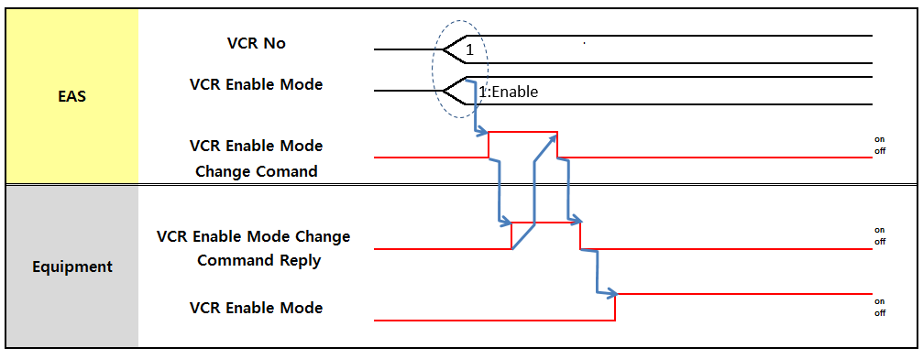
      - VCR Enable Mode Change Command

Panel Data Request
This is to request information of Panels such as Judge/Grade of each Panel in a Glass (available only Glass – before cut to Panel).
This is only used for the Equipment requiring Panel Data request. This is the signal requesting panel data to EAS.
If panel data is not exist in EAS then it will be send with null.

※ This feature is used only devices needed.

PLC Map
      - Local PLC – Link Register (W Area)

Block | Item | Points | Type | Format | Sub Items
Panel Data Request Block | Cassette Sequence No | 1 | Data | INT
Panel Data Request Block | Job Sequence No | 1 | Data | INT
      - Local PLC – Link Relay (B Area)

Block | Item | Points | Type | Sub Items | Related Word Items | Master (EAS)
Equipment Special Event | Panel Data Request | 1 | Event | - On: Fire Event  - Off: Event End | Panel Data Request Block | Reply for Receiving
      - Master (EAS) – Link Register (W Area)

Block | Item | Points | Type | Format | Sub Items
Panel Data Request Confirm Block | Cassette Sequence No | 1 | Data | INT
Panel Data Request Confirm Block | Job Sequence No | 1 | Data | INT
Panel Data Request Confirm Block | Panel Judge Data | 128 | Data | ASC

 | Panel Grade Data | 256 | Data | ASC
      - Master (EAS) – Link Relay (B Area)

Block | Item | Points | Type | Sub Items | Related Word Items | Local PLC Action
Equipment Special Event Reply | Panel Data Request Reply | 1 | Reply | - On: Reply  - Off: Reply End | Panel Data Request Confirm Block

Panel Data Report
※This feature is used only devices needed..
If is required to report Panel information update if equipment changed Grade and/or Judge value of at least one Panel in a Glass. This report is required for Glass or Q-panel.

Panel Judge Data Format Example ) panel1 Judge : 0 , Panel 2 Judge : G, Panel 3 Judge : R…

W | 0 | 1 | 2 | 3 | 4 | 5 | 6 | 7 | A | B | C | D | E | F | G | H
0 | Panel 1 Judge : 0 |  |  |  |  |  |  |  | Panel 2 Judge : G
1 | Panel 3 Judge : R |  |  |  |  |  |  |  | Panel 4 Judge
… | … |  |  |  |  |  |  |  | …
N | Panel N-1 Judge |  |  |  |  |  |  |  | Panel N Judge
Panel Grade Data Format Example ) panel 1 grade : 00 , Panel 2 grade : AA, Panel 3 grade : AB

W | 0 | 1 | 2 | 3 | 4 | 5 | 6 | 7 | A | B | C | D | E | F | G | H
0 | Panel 1 Grade: 0 |  |  |  |  |  |  |  | Panel 1 Grade : 0
1 | Panel 2 Grade: A |  |  |  |  |  |  |  | Panel 2 Grade: A
2 | Panel 3Grade: A |  |  |  |  |  |  |  | Panel 3Grade: B
… | … |  |  |  |  |  |  |  | …
N | Panel N Grade : |  |  |  |  |  |  |  | Panel N Grade
Refer to Job Grade, Job Judge for Judge/Grade Code definition.

PLC Map
      - Local PLC – Link Register (W Area)

Block | Item | Points | Type | Format | Sub Items
Panel Data Report Block | Cassette Sequence No | 1 | Data | INT
Panel Data Report Block | Job Sequence No | 1 | Data | INT
Panel Data Report Block | Panel Judge Data | 128 | Data | ASC
Panel Data Report Block | Panel Grade Data | 256 | Data | ASC

      - Local PLC – Link Relay (B Area)

Block | Item | Points | Type | Sub Items | Related Word Items | Master (EAS)
Equipment | Panel Data Report | 1 | Event | - On: Fire Event | Panel Data Report Block | Reply for Receiving

Block | Item | Points | Type | Sub Items | Related Word Items | Master (EAS)
Special Event |  |  |  | - Off: Event End

      - Master (EAS) – Link Relay (B Area)

Block | Item | Points | Type | Sub Items | Related Word Items | Local PLC Action
Equipment Special Event Reply | Panel Data Report Reply | 1 | Reply | - On: Reply  - Off: Reply End

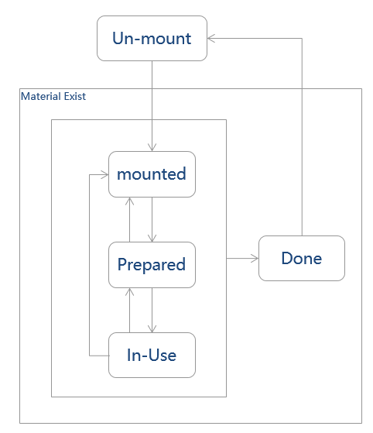

Material Management
It is that equipment manages durable materials such as reticle and consumable materials such as Polaroid and chemical. This function is only for equipment with special material which needs to be managed. If equipment has no material to be managed, please ignore this section.

Material ID
The material ID of the material is being mounted or dismounted.

Material Status
- Mount: Materials is installed into equipment to be used for processing.
- Un-mount: Material is removed from equipment.
- Prepared : Material ready to be used for processing.
- In-Use : Material processing in the unit of equipment.
- Done : Material processing complete and ready to dismount.

Figure 10-1 State Transition of material

PLC Map: Material
      - Local PLC – Link Register (W Area)

Block | Item | Points | Type | Format | Sub Items
Material Status Change Report Block | Unit No | 1 | Data | INT
Material Status Change Report Block | Stage No | 1 | Data | INT | Slot No
Material Status Change Report Block | Material ID | 10 | Data | ASC
Material Status Change Report Block | Material Status | 1 | Data | INT | 1: Un-mount  2: Mount  3: Prepared  4: In-Use  5: Done  6 ~ : reserved
Material Status Change Report Block | Material type | 1 | Data | INT | 1: PR  2: APRPlate  3: ODFAuBall  4: ODFLC  5: ODFSealant  6: ODFSiBall  7: PILiquid  8: Syringe  9: Cloth  10: Roller  11: Reserve  12: Mask  13 ~ 129 : (Ref 11.1.10 Parts Management – Dry Etch Material Type)  130 ~229 : (Ref 11.1.11 Parts Management Material Type)  230~: Reserve
Material Data Block | Tank No | 1 | Data | INT
Material Data Block | PR ID | 10 | Data | ASCII
Material Data Block | Operator ID | 4 | Data | ASCII
Material Data Block | PR Weight | 1 | Data | INT | Gram (g)
Material Data Sub Block | PPID | 1 | Data | INT
Material Data Sub Block | Operation ID | 10 | Data | ASCII
Material Validation Request Block | Material ID | 10 | Data | ASCII
Material Validation Request Block | Material Position | 1 | Data | INT | Rubbing Inline  - : Roller 1  - : Roller 2  - : Double Roller  - : Reserved PI Inline  - : PI Cleaner Tank 1  - : PI Cleaner Tank 2  - : PI Ink Tank 1  - : PI Ink Tank 2  - : PI Ink Tank 3

Block | Item | Points | Type | Format | Sub Items
- : PI Ink Tank 4 ODF Inline
- : LC Head 1
- : LC Head 2
…
- : LC Head 12
- : SD Head 1
- : SD Head 2
…
- : SD Head 16
- : UV Mask 1
 | Unit No | 1 | Data | INT

      - Local PLC – Link Relay (B Area)

Block | Item | Points | Type | Sub Items | Related Word Items | Master
Equipment Special Event | Material Status Change Report | 1 | Event | - On: Fire Event  - Off: Event End | -Material Status Change Report Block | Reply for Receiving
Equipment Special Event | Material Validation Request | 1 | Event | - On: Fire Event  - Off: Event End | - Material Validation Request Block | Reply for Receiving

      - Master PLC – Link Register (W Area)

Block | Item | Points | Type | Format | Sub Items
Material Status Change Report Reply Block | Unit No | 1 | Data | INT | If no unit then set 0
Material Status Change Report Reply Block | Return Code | 1 | Data | INT | 1: OK  2: NG
Material Validation Request Reply Block | Return Code | 1 | Data | INT | 1: OK  2: NG
Material Validation Request Reply Block | Used Count | 1 | Data | INT | 1~2000
Material Validation Request Reply Block | Thickness | 1 | Data | INT | 1.500~1.855(Data*1000)
Material Validation Request Reply Block | Limited Count | 1 | Data | INT | 200~2000
Material Validation Request Reply Block | Life Time | 3 | Data | BCD | yymmddhhmmss(ODF, PI Only)
Material Validation Request Reply Block | Due Time | 3 | Data | BCD | Yymmddhhmmss(ODF, PI Only)

      - Master PLC – Link Relay (B Area)

Block | Item | Points | Type | Sub Items | Related Word Items | Local PLC Action
Equipment Special Event Reply | Material Status Change Report Reply | 1 | Reply | - On: Reply  - Off: Reply End | Material Status Change Report Reply Block
Equipment Special Event Reply | Material Validation Request Reply | 1 | Reply | - On: Reply  - Off: Reply End | Material Validation Request Reply Block

Loading Stop (EQ to EQ)
This signal is used to request a Job transfer stop to a specific Transfer equipment (Transfer device block or Indexer) in upstream.
While equipment turn on this signal, Job in the equipment itself must flows normally.

Refer to Equipment Operation Scenario for the upstream-downstream relation where this signal is required.

PLC Map
      - Local PLC – Link Register (W Area)

Block | Item | Points | Type | Format | Sub Items
Loading Stop block | Loading Stop Source | 1 | Data | INT | Local No
Loading Stop block | Loading Stop Target | 1 | Data | INT | Local No
      - Local PLC – Link Relay (B Area)

Block | Item | Points | Type | Sub Items | Related Word Items
Equipment to Equipment Event | Loading StopRequest | 1 | Event | - On: Loading Stop  - Off: Release | Loading Stop block

Transfer Stop (EQ to EQ)
This signal is used to request a Job transfer stop to upstream equipment. If equipment is situation of not being able to receive Job from upstream, such as temporary overflow, the equipment can set this signal On to upstream.
While equipment turn on this signal, Job in the equipment itself must flows normally.

PLC Map
      - Local PLC – Link Register (W Area)

Block | Item | Points | Type | Format | Sub Items
Transfer Stop Block | Transfer Stop source | 1 | Data | INT | downstream No  * refer to equipment operation scenario
      - Local PLC – Link Relay (B Area)

Block | Item | Points | Type | Sub Items | Related Word Items
Equipment to Equipment Event | Transfer Stop Request | 1 | Event | - On: Transfer Stop  - Off: Release | Transfer Stop Block

Cancel Abort Request (EQ to EAS)
When equipment need to unclamp a cassette on manual , operator can press cancel or abort request button for unclamp a cassette from port.
EAS send reply with ‘OK’ if no problem to send ‘unclamp’ port command to equipment. And Send ‘unclamp’ port command to equipment soon after.
The other case, EAS send rely with ‘NG’.

CIM Mode | Action | Note
CIM On | EQ requests CST Unclamp to EAS.  EAS send a Unclamp command to EQ when end condition of process. | Push for 3 sec
CIM Off | It is has to unclamp the CST by EQ when end condition of process. | Push for 3 sec

PLC MAP
      - Local PLC – Link Register (W Area)

Block | Item | Points | Type | Format | Sub Items
Cancel Abort Request Block | Port No | 1 | Data | INT
Cancel Abort Request Block | Cancel or Abort |  |  |  | 1: CST ID read fail  2: mapping sensor error 3: HW error  4: others error  10: CST ID validation fail ( oven etc…)

      - Local PLC – Link Relay (B Area)

Block | Item | Points | Type | Format | Sub Items
Indexer Event | Cancel Abort Request Event | 1 | Event | - On: Fire Event  - Off: Event End | Cancel Abort request Block

      - Master (EAS) – Link Register (W Area)

Block | Item | Points | Type | Format | Sub Items
Cancel Abort Request Reply Block | Return Code | 1 | Data | INT | 1: OK  2: NG

      - Master (EAS) – Link Relay (B Area)

Block | Item | Points | Type | Sub Items | Related Word Items | Local PLC Action
Indexer Event Reply | Cancel Abort Request Event Reply | 1 | Reply | - On: Reply  - Off: Reply End | Cancel Abort Request Reply Block

Lot End Glass Report (EQ to EQ)
Specific equipment requires to know the last Glass of a Lot for its processing purpose such as recipe change preparation. For this purpose the last Glass of a Lot information should be transferred from Indexer to downstream equipment according to the physical location of the last Glass.

- Indexer should send Lot End Glass report to downstream after sending the last Glass of a Lot.
- If equipment receives Lot End Glass report from upstream, equipment should identify the Lot ID and keep the Lot information, and send the Lot End Glass report to downstream after sent the last Glass of the Lot.
- For example, if equipment has three Glass of Lot A when it is received Lot End Glass report (for Lot A) from upstream, equipment should send Lot End Glass report (for Lot A) to downstream when sending the last Glass of the three Lot A Glasses.
- Regardless of scrap, this report should be sent after the last Glass of a Lot.
- Within equipment, Glass FIFO between same Lot is not necessary but Lot FIFO should be maintained between Lots.
- Upstream should send Lot End Glass Report to downstream completion of transferring the Glass to downstream equipment

PLC Map
      - Local PLC – Link Register (W Area)

Block | Item | Points | Type | Format | Sub Items
Lot End Glass Data Report Block | Lot ID | 10 | Data | ASC
Lot End Glass Data Report Block | Cassette Sequence No | 1 | Data | INT

      - Local PLC – Link Relay (B Area)

Block | Item | Points | Type | Sub Items | Related Word Items | Local PLC Action
Equipment to Equipment Event | Lot End Glass Report | 1 | Event | - On: Fire Event  - Off: Event End | Lot End Glass Data Report Block | Reply for Receiving

      - Local PLC – Link Relay (B Area)

Block | Item | Points | Type | Sub Items | Related Word Items | Local PLC Action
Equipment to Equipment Event Reply | Lot End Glass Report Reply | 1 | Reply | - On: Reply  - Off: Reply End

Cassette Move In/Out Report
Equipment should report cassette movement within equipment when cassette moves in/out of equipment, cassette move in/out between Units.
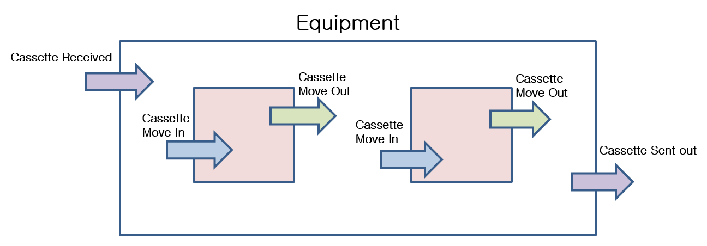

PLC MAP
      - Local PLC – Link Register (W Area)

Block | Item | Points | Type | Format | Sub Items
CST Move In Report Block | Job Data C | 23 | Data |  | Refer to Job Data C
CST Move In Report Block | Unit or Port | 1 | Data | INT | 0: Equipment, 1: Unit 2:Port
CST Move In Report Block | Unit No or Port No | 1 | Data | INT | 0 if Equipment
CST Move Out Report Block | Same as CST Move In Report Block. | 25 | Data
CST  Received Report Block | Same as CST Move In Report Block. | 25 | Data
CST Sent Out Report Block | Same as CST Move In Report Block. | 25 | Data

      - Local PLC – Link Relay (B Area)

Block | Item | Points | Type | Sub Items | Related Word Items | Master (EAS)
Equipment SpecialEven t | CST Move In Report | 1 | Event | - On: Fire Event  - Off: Event End | CST Move In Report Block
Equipment SpecialEven t | CST Move Out Report | 1 | Event | - On: Fire Event  - Off: Event End | CST Move Out Report Block
Equipment SpecialEven t | CST Received Report | 1 | Event | - On: Fire Event  - Off: Event End | CST Received Report Block
Equipment SpecialEven t | CST Sent Out Report | 1 | Event | - On: Fire Event  - Off: Event End | CST Sent Out Report Block

      - Master (EAS) – Link Register (W Area)
Equipment that processes by cassette must refer to this data for CST information instead of Common CST Map Data area.
Cassette Control Command : CST Map Download
* Equipment Applied : Cassette Cleaner (Array), Cell Test (Cell)

Block | Item | Points | Type | Format | Sub Items
Port #1 CST Data Block | Job Data C | 23 | Data |  | Refer to Job Data C
Port #2 CST Data Block | Same as Port #1 CST Data Block | 23 | Data
Port #3 CST Data Block | Same as Port #1 CST Data Block | 21 | Data
Port #4 CST Data Block | Same as Port #1 CST Data Block | 21 | Data
Port #5 CST Data Block | Same as Port #1 CST Data Block | 21 | Data
Port #6 CST Data Block | Same as Port #1 CST Data Block | 21 | Data
Port #7 CST Data Block | Same as Port #1 CST Data Block | 21 | Data
Port #8 CST Data Block | Same as Port #1 CST Data Block | 21 | Data
Port #9 CST Data Block | Same as Port #1 CST Data Block | 21 | Data
Port #10 CST Data Block | Same as Port #1 CST Data Block | 21 | Data

      - Master (EAS) – Link Relay (B Area)

Block | Item | Points | Type | Sub Items | Related Word Items | Local PLC Action
Equipment Special Event Reply | CST Move In Report Reply | 1 | Reply | - On: Reply  - Off: Reply End
Equipment Special Event Reply | CST Move Out  Report Reply | 1 | Reply | - On: Reply  - Off: Reply End
Equipment Special Event Reply | CST Received Report Reply | 1 | Reply | - On: Reply  - Off: Reply End
Equipment Special Event Reply | CST Sent Out Report Reply | 1 | Reply | - On: Reply  - Off: Reply End

Oven Initial Heating
When Oven starts heating, the others equipment should have warning Alarm. Because when Oven power start at the same time, Power in Fab maybe down.
Equipment should send Oven Heating initial to EAS when Oven start heating
EAS send to other Oven the Heating alarm that is CIM message from EAS to equipment

PLC MAP
      - Local PLC – Link Relay (B Area)

Block | Item | Points | Type | Format | Sub Items
Equipment Special Event | Oven#1 Initial Heating Start | 1 | Event | - On: Fire Event  - Off: Event End
Equipment Special Event | Oven#1 Initial Heating end | 1 | Event | - On: Fire Event  - Off: Event End
Equipment Special Event | Oven#2 Initial Heating Start | 1 | Event | - On: Fire Event  - Off: Event End
Equipment Special Event | Oven#2 Initial Heating end | 1 | Event | - On: Fire Event  - Off: Event End

      - Master (EAS) – Link Relay (B Area)

Block | Item | Points | Type | Format | Sub Items
Equipment Special EventReply | Oven#1 Initial Heating Start Reply | 1 | Event | - On: Fire Event  - Off: Event End | EAS Reply
Equipment Special EventReply | Oven#1 Initial Heating end Reply | 1 | Event | - On: Fire Event  - Off: Event End | EAS Reply
Equipment Special EventReply | Oven#2 Initial Heating Start Reply | 1 | Event | - On: Fire Event  - Off: Event End | EAS Reply
Equipment Special EventReply | Oven#2 Initial Heating end Reply | 1 | Event | - On: Fire Event  - Off: Event End | EAS Reply

Dummy Glass Request
* ODF equipment will use separate data for Dummy Request (refer to ODF special section)

This signal is to be used when equipment requires Dummy supply from Loader.

PLC MAP
      - Local PLC – Link Register (W Area)

Block | Item | Points | Type | Format | Sub Items
Dummy Glass Request Block | Dummy Glass Count | 1 | Data | INT | Count (0~28)
Dummy Glass Request Block | Dummy Type | 1 | Data | INT | Dummy Type
      - Local PLC – Link Relay (B Area)

Block | Item | Points | Type | Sub Items | Related Word Items | Master (CIMPC)
Equipment Special Event | Dummy Glass  Request | 1 | Event | - On: Fire Event  - Off: Event End | Dummy Glass  Request Block

      - Master (EAS) –– Link Relay (W Area)

Block | Item | Points | Type | Format | Sub Items
Dummy Glass Request Reply Block | Dummy Glass Request Return Code | 1 | Data | INT | 1: OK  2: NG

      - Master (EAS) –– Link Relay (B Area)

Block | Item | Points | Type | Format | Sub Items
Equipment Special EventReply | Dummy Glass Request Reply | 1 | Reply | - On: Fire Event  - Off: Event End | Dummy Glass Request Reply Block

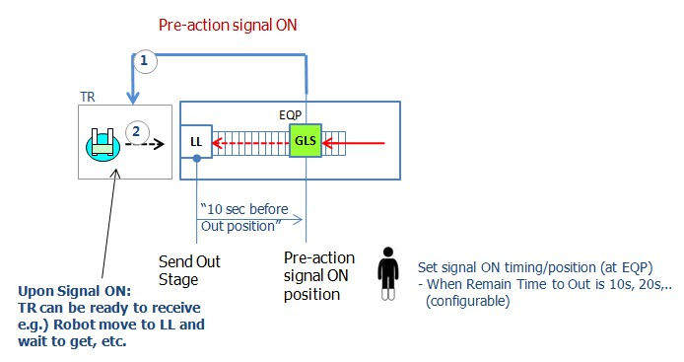

Pre-action Signal (EQ to EQ)
Pre-action signal is mainly used to decide in advance the robot waiting position, so that it is to optimize Job transferring tact time (especially for robot dispatching in Indexer or TR in equipment)
Equipment can send ‘pre-action signal ’to robot in order to notice that glass will come out soon, or glass receiving will be possible soon.
As Every equipment is different because of current tool characteristics/status and Job flow conditions, operation conditions (Grade, Judge,..), and etc., how to use Pre-action signal may different between equipment. The detail requirements on the signal ON timing and corresponding actions would be requested by equipment engineer, especially in the process of tact time optimizations.

Pre-action Signal Type
Two types of Pre-action Signal can be defined.
- Pre-action Signal to Downstream : to be used to notify downstream equipment (mainly TR) that Job is coming out (sending) soon
- Pre-action Signal to Upstream : to be used to notify upstream equipment (mainly TR) that Job receiving will be ready soon

Example of corresponding actions : details would be required by equipment engineer.
- Pre-action Signal to Downstream :
  - Downstream is process equipment: upon receiving of this signal, equipment prepares any available conditions for receiving Job, such as Shutter open, Pin up, etc..
  - Downstream is TR : upon receiving of this signal, Robot can move and wait for receiving Job.
- Pre-action Signal to Upstream :
  - Upstream is process equipment: upon receiving of this signal, equipment prepares any available conditions for sending Job, such as Shutter open, etc..
  - Upstream is TR : upon receiving of this signal, Robot can move and wait for sending out Job.

Pre-action Signal On/Off Condition
The below is guideline of the signal on/off condition. Detail required needs to be determined through tact time optimization process.

Pre-action Signal ON :
- Pre-action Signal to Downstream :
Signal ON timing is mainly determined by the remaining time to Job send-out position (stage) or specific position in equipment in the path to downstream.
Equipment has to prepare Signal ON timing setting on touch panel :

Example )
If Signal ON timing is set as '5' seconds, then if Job reaches a position where 5 seconds before send-out position, then equipment turn this signal ON to upstream.

- Pre-action Signal to Upstream :
Signal ON timing is mainly determined by specific action or event or signal : it could be different at every equipment.

Pre-action Signal OFF :
- Pre-action Signal to Downstream/Upstream :
Turn off signal when Job transfer process is initiated with the downstream/upstream (the same downstream/upstream to which the signal is on)
If equipment has trouble and is not available to start/continue Job transfer process.

Other Conditions :
- If equipment is currently Job transfer hand shaking with upstream(, downstream), equipment should turn on any Pre-action signal to downstream(, upstream) after completion of current hand shaking process.

PLC Map
      - Local PLC – Link Relay (B Area)
Block | Item | Points | Type | Sub Items | Related Word Items
Event Area | PAStoUpstream#1 | 1 | Event | - On: Fire Event  - Off: Event End
Event Area | PAStoDownstream#1 | 1 | Event | - On: Fire Event  - Off: Event End
Event Area | ...
Event Area | PAStoUpstream#6 | 1 | Event | - On: Fire Event  - Off: Event End
Event Area | PAStoDownstream#6 | 1 | Event | - On: Fire Event  - Off: Event End

Oven Over Bake

Oven Over Bake Report
When glass in oven stay more than setting time, Oven should report Overbake Report.

PLC MAP
      - Local PLC – Link Register (W Area)

Block | Item | Points | Type | Format | Sub Items
Oven Over Bake Block | Cassette Sequence No | 1 | Data | INT
Oven Over Bake Block | Job Sequence No | 1 | Data | INT
Oven Over Bake Block | Process Setting Time | 1 | Data | INT | Time is Second

      - Local PLC – Link Relay (B Area)

Block | Item | Points | Type | Sub Items | Related Word Items | EAS Action
Equipment Special Event | Oven Over Bake Report | 1 | Event | - On: Report  - Off: End | Oven Over Bake Block

      - Master (EAS) – Link Register (W Area)
None.
      - Master (EAS) – Link Relay (B Area)

Block | Item | Points | Type | Sub Items | Related Word Items | Local PLC Action
Equipment Special Event Reply | Oven Over Bake Report Reply | 1 | Reply | - On: Reply  - Off: End

DFS

Cassette ID Request
Because inspection equipment of all shopneed loading cassette ID.

PLC MAP
      - Local PLC – Link Register (W Area)
Block | Item | Points | Type | Format | Sub Items
Cassette ID Request Block | Cassette Sequence No | 1 | Data | INT
Cassette ID Request Block | Job Sequence No | 1 | Data | INT

      - Local PLC – Link Relay (B Area)

Block | Item | Points | Type | Sub Items | Related Word Items | EAS Action
Equipment Special Event | Cassette ID Request | 1 | Event | - On: Fire Event  - Off: Event End | Cassette ID Request Block
      - Master (EAS) – Link Register (W Area)

Block | Item | Points | Type | Format | Sub Items
Cassette ID Request Confirm Block | Cassette Sequence No | 1 | Data | INT
Cassette ID Request Confirm Block | Job Sequence No | 1 | Data | INT
Cassette ID Request Confirm Block | Loading Cassette ID | 5 | Data | ASC
Cassette ID Request Confirm Block | Return Code | 1 | Data | INT | - : OK  - : NG
      - Master (EAS) – Link Relay (B Area)

Block | Item | Points | Type | Sub Items | Related Word Items | Local PLC Action
Equipment Special Event Reply | Cassette ID Request Reply | 1 | Reply | - On: Reply  - Off: End | Cassette ID Request Confirm Block

CIM Online Signal On/Offline status changed

Whenever On/Offline Status changed, EAS inform the equipment using CIM Online Signal One Bit. EAS only On/Off CIM Online Signal Bit and Equipment checked CIM online signal.
- Online Status (Local/Remote) : ON
: If current online status is Local/Remote, CIM online signal bit on.
- Online Status (Offline) : OFF
: If current online status is Offline, CIM online signal bit off.

      - Master (EAS) – Link Relay (B Area)
Block | Item | Points | Type | Sub Items | Related Word Items | Local PLC Action
Special Function | CIM Online Signal | 1 | Event | - On: Local/Remote  - Off: Offline

Panel Repair Result Report
※This feature is used only devices needed..
Repair Equipment report this message to inform the repaired panel and repair type

W | 0 | 1 | 2 | 3 | 4 | 5 | 6 | 7 | A | B | C | D | E | F | G | H
0 | Panel 1 Repair Result Code : D |  |  |  |  |  |  |  | Panel 2 Repair Result Code : D
1 | Panel 3 Repair Result Code : N |  |  |  |  |  |  |  | Repaire Repair Result Code : N
… | … |  |  |  |  |  |  |  | …
N | Panel N-1 Repair Result Code : Z |  |  |  |  |  |  |  | Panel N Repaire Code : Z
Panel Repair Result Code (This code could be updated by B17 User)

A | Normal Cutting
B | Cutting Femto Managing
C | Cutting Femto No Managing
D | CVD（W）Managing
E | CVD（W） No Managing
F | CVD（Cobalt） Managing
G | CVD（Cobalt） No Managing
H | CVD（Metal Ink） Managing
I | CVD（Metal Ink） No Managing
N | No Repair
Z | Fill Blank No Managing
S | Risk Product Managing

PLC Map
      - Local PLC – Link Register (W Area)

Block | Item | Points | Type | Format | Sub Items
Panel Repair Result Block | Cassette Sequence No | 1 | Data | INT
Panel Repair Result Block | Job Sequence No | 1 | Data | INT
Panel Repair Result Block | Panel Repair Result | 128 | Data | ASC

      - Local PLC – Link Relay (B Area)

Block | Item | Points | Type | Sub Items | Related Word Items | Master (EAS)
Equipment Special Event | Panel Repair Result Report | 1 | Event | - On: Fire Event  - Off: Event End | Panel Data Report Block | Reply for Receiving
      - Master (EAS) – Link Relay (B Area)

Block | Item | Points | Type | Sub Items | Related Word Items | Local PLC Action
Equipment Special Event Reply | Panel Repair Result Report Reply | 1 | Reply | - On: Reply  - Off: Reply End

- End of document -

